WEB

Framework for Action to Prevent Violence against Women and Girls with Disabilities

A resource for governments and policymakers



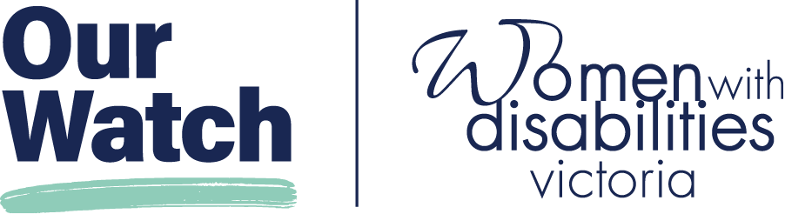

Acknowledgement of Country

Our Watch acknowledges the Traditional Owners of the land across Australia on which we work and live. We pay respects to Elders past and present and recognise the continuing connection Aboriginal and Torres Strait Islander people have to land, culture, knowledge, and language for over 65,000 years.

As a non-Aboriginal organisation, Our Watch understands that violence against Aboriginal and Torres Strait Islander women and children is an issue for the whole community. As highlighted in Our Watch’s national resource Changing the picture, the evidence clearly shows the intersection between racism, sexism, and violence against Aboriginal and Torres Strait Islander women.

Our Watch has an ongoing commitment to the prevention of violence against Aboriginal and Torres Strait Islander women and children, who continue to suffer from violence at a significantly higher rate than non-Aboriginal women. We acknowledge all Aboriginal and Torres Strait Islander people and organisations who continue to lead the work of sharing knowledge with non-Indigenous people and relentlessly advocate for an equitable, violence-free future in Australia.

Our Watch

Our Watch is a national leader in the primary prevention of violence against women and their children in Australia. We are an independent, not-for-profit organisation established in 2013. The Australian, and all state and territory governments are members of Our Watch.

Our vision is an Australia where women and their children live free from all forms of violence. We lead nationwide change in the culture, behaviours, attitudes, and social structures that drive violence against women and their children. Working with government, practitioners, and communities, we address the underlying causes of violence in settings where people live, learn, work, and socialise.

Women with Disabilities Victoria

Women with Disabilities Victoria is a not-for-profit Disabled People’s Organisation (DPO) representing women with disabilities in Victoria. The organisation is operated by and for women and non-binary people with various disability experiences. Women with Disabilities Victoria has a diverse membership of people from different backgrounds.

Women with disabilities face intersecting forms of structural gender and disability discrimination. Women with Disabilities Victoria actively advocates for our rights to safety and respect, with particular emphasis on disability policy, health services, violence prevention, workforce development and leadership. Women with Disabilities Victoria envisions a world where all women are respected and can fully experience life.

Contents

Acknowledgement of Country 2

Our Watch 2

Women with Disabilities Victoria 2

Framework for Action Summary 5

Vision 6

What informed the Framework for Action? 6

What does the Framework for Action include? 6

How should the Framework for Action be implemented? 6

What are the expected outcomes of the Framework for Action? 6

What is the purpose of this Framework for Action? 7

Why do we need this Framework for Action? 9

Violence against women and girls with disabilities: the problem 9

What drives violence against women and girls with disabilities? 10

Intersecting forms of discrimination and oppression 13

A primary prevention approach: the solution 13

The social model of disability 15

What are the essential actions to prevent this violence? 15

What role can governments play? 16

What has informed this Framework for Action? 17

Changing the landscape 17

Supporting evidence-based frameworks 17

International, national, state and territory priorities 18

The Royal Commission into Violence, Abuse, Neglect and exploitation of People with Disability 18

Consultation with Governments and Non-Government Organisations 19

Expert advice and review 19

Language and scope 20

The Framework for Action 21

A phased approach to reform 21

Proposed Actions for all Governments 23

Focus Area 1: Policy, legislative, regulatory, and institutional reform 23

Focus Area 2: Primary prevention action across priority settings, communities and in partnership 28

Design Principles 32

Human rights-based approach 32

Strengths-based 32

Intersectionality 32

Accessibility and inclusion 32

Community-ownership 32

Co-design 33

Tips for Implementation 34

Appendix 1: Alternative text for figures 36

Figure 1: Types of violence experienced by women and girls with disabilities. 36

Figure 2: Primary prevention of violence as an ‘upstream’ approach. 37

Endnotes 38

# Framework for Action Summary

* The purpose of this Framework for Action is to support governments and policy makers in their work to prevent violence against women and girls with disabilities. The Framework for Action:
  + Consolidates existing strategies, plans, and reforms and applies an evidence-based primary prevention lens.
  + Identifies a set of short, medium, and long-term proposed actions across policy, legislative and institutional reform, as well as priority settings, communities, and partnerships that governments can take. These align, build on and strengthen the significant work and reforms that are underway internationally, nationally and across states and territories to prevent violence against women and girls with disabilities.
  + Includes design principles and tips for implementation to guide and support design, development, implementation and monitoring of plans and activities.
* All governments have an important role and responsibility in leading and enabling this change.
* Our Watch and Women with Disabilities Victoria’s evidence-based framework *Changing the landscape* outlines the essential actions needed to create social, cultural, structural, and systemic change and to prevent violence before it starts.
* Violence against women and girls with disabilities is serious and prevalent.
  + 65% of women with disabilities report experiencing at least one incident of violence since the age of 15.
  + Women with disabilities are twice as likely as women without disabilities to experience sexual violence.
  + Women and girls with all types of disabilities experience all forms of violence at higher rates, over longer periods of time and by more people than men with disabilities or people without disabilities (with the exception of physical violence).
* This violence is driven by sexism and ableism as well as intersecting forms of discrimination and oppression.
* Violence against women and girls with disabilities is preventable. It requires a primary prevention approach.
* Primary prevention means stopping violence from occurring in the first place by addressing its underlying drivers.

## Vision

All women and girls with disabilities are free from violence

## What informed the Framework for Action?

* *Changing the landscape*
* National Plan to End Violence Against Women and Children 2022-2032
* Australia’s Disability Strategy 2021-2031
* Closing the Gap
* The Disability Royal Commission
* State and Territory Strategies and Plans

## What does the Framework for Action include?

* Focus Area 1: Policy, legislative, regulatory and institutional reform
  + Short term proposed actions
  + Medium term proposed actions
  + Long term proposed actions
* Focus Area 2: Primary prevention across priority settings, communities and in partnership
  + Short term proposed actions
  + Medium term proposed actions
  + Long term proposed actions

## How should the Framework for Action be implemented?

* Design Principles
* Tips for Implementation

## What are the expected outcomes of the Framework for Action?

* Governments increase their knowledge and awareness of the drivers of violence against women and girls with disabilities
* Governments consider and integrate the Framework for Action in future policy development and legislative reform
* Governments utilise the Framework for Action to complement implementation of the Disability Royal Commission recommendations

# What is the purpose of this Framework for Action?

The purpose of this Framework for Action is to support governments and policymakers in their work to prevent violence against women and girls with disabilities. This Framework has been developed specifically for governments to translate the essential actions in *Changing the landscape* into tangible proposed actions.

This Framework recognises the commitment by all governments to prevent violence against women and girls with disabilities under the National Plan to End Violence against Women and Children 2022-2032 and Australia’s Disability Strategy 2021-2031. It also recognises the Australian Government’s responsibility under the United Nations Convention on the Rights of Persons with Disabilities (CRPD) to promote, protect and ensure the full and equal enjoyment of human rights for people with disabilities.

Drawing from the national evidence-base on preventing violence against women and girls with disability, *Changing the landscape*, this Framework for Action identifies a set of short, medium, and long term proposed actions across policy, legislative and institutional reform, as well as priority settings, communities, and partnerships. This Framework also includes design principles and tips for implementation.

This Framework for Action is intended to provide an evidence-based resource to support action. While all governments have been engaged in its development, it is a matter for governments to commit to, implement, invest in and monitor outcomes associated with the specific actions in this Framework.

This framework can be used by governments and policymakers to:

* Strengthen and inform existing reforms to prevent violence against women and girls with disabilities
* Guide legislative, policy, and regulatory reform
* Identify priority settings, communities and partnerships
* Provide additional evidence and guidance to support implementation of strategies, plans and frameworks in this area, including the recommendations from the Royal Commission into Violence, Abuse, Neglect and Exploitation of People with Disability or jurisdictional domestic and family violence prevention strategies.

The actions in this Framework can be implemented using a phased approach. There are a range of ways of taking action at different levels of policy and practice, and different approaches governments can take to translate and implement them in practice in different contexts and settings.

Importantly, there have been significant changes in the Australian disability policy landscape since the release of Changing the landscape and during the development of this Framework for Action. As a result, this Framework has been developed in the context of and informed by these shifts. This includes, for example, ensuring alignment with the recommendations of the Disability Royal Commission. Full details on this policy alignment are detailed on page 19.

The Framework provides an evidence-based contribution to the tools available to governments to make systemic, structural and practical changes that can contribute to preventing violence against women and girls with disabilities.

# Why do we need this Framework for Action?

**The work of preventing violence against women and girls with disabilities is multifaceted and complex.** The work extends across various sectors, sits at the intersection of multiple plans, strategies, and reforms, and therefore requires the coordination, partnership and a shared commitment from governments, organisations, the private sector, communities, families, and individuals. However, the complexity of this work must not be a barrier to taking action.

Drawing on the evidence, this Framework for Action consolidates the multiple and overlapping components of this work, applies a primary prevention lens to existing initiatives, and identifies opportunities to build or strengthen the prevention of violence against women and girls with disabilities.

It also identifies the need to build on the existing resources, strengths, resilience and knowledge of the disability community in order to prevent violence against women and girls with disabilities over the long term.

## Violence against women and girls with disabilities: the problem

Violence against women and girls with disabilities is a serious and prevalent human rights abuse. Women and girls all types of disabilities experience all forms of violence at higher rates, over longer periods of time and by more people than men with disabilities or people without disabilities (with the exception of physical violence).[1] In Australia, sixty-five per cent of women with disabilities report experiencing at least one incident of violence since the age of 15 and women with disabilities are twice as likely as women without disabilities to have experienced sexual violence.[2] In Australia, 2.2 million Australian women have a disability.[3]

As outlined in the 2023 findings of the Royal Commission into Violence, Abuse, Neglect and Exploitation of People with Disability (DRC), violence and discrimination are more likely, frequent, and severe for some groups of women with disabilities.[4] This is the case for Aboriginal and Torres Strait Islander women, LGBTIQ people, older women and women with psychosocial disabilities, intellectual disabilities, or complex communication needs and women and girls with disabilities living in regional and remote areas.[5]

While most of the violence against women with disabilities occurs within family and domestic contexts, it can also occur in institutions including in residential care settings, aged care facilities and medical facilities, perpetrated by support workers, professionals and co-residents.[6] Forms of family and domestic violence may include threatening to or withholding supports or assistive devices; use of restrictive practices and restraints; non-consensual medical interventions such as contraception and sterilisation; and using a woman’s disabilities or her isolation to further coerce and control her.[7] Violence against women and girls with disabilities tends to occur more frequently, over a longer period of time, across a broader range of settings, have multiple instances, and be perpetrated by a greater range of people.[8]

This violence often has serious and long-term impacts on women’s health and wellbeing as well as on families, children, communities, and society.[9] Experiencing violence at any age leads to an increased likelihood of negative health outcomes, including chronic disease, mental health conditions such as anxiety and depression, suicidal ideation, suicide attempts and suicide.[10] Violence against women and girls with disabilities can also exacerbate pre-existing disabilities.[11] It can also result in new disabilities, noting that women’s disabilities can also be a result of violence.[12] Institutional responses to violence can be retraumatising for women and girls with disabilities who face barriers in accessing information and decision making in health and justice systems, such as gatekeeping practices or lack of information about their own sexual and reproductive health, due to ableist stereotypes.[13]

In addition to the individual impacts, systematic experiences and threats of violence also limit people with disabilities’ access to basic human rights, such as justice and support, the ability to participate in employment and education, as well as housing, economic independence, and freedom of movement.[14]

As with violence against women generally, violence against women and girls with disabilities is usually perpetrated by men who are known to them.[15] The evidence also indicates that it is overwhelmingly men without disabilities that perpetrate this violence.[16]

## What drives violence against women and girls with disabilities?

*Changing the landscape* demonstrates that ableism and gender inequality intersect and compound to create an environment where violence against women and girls with all types of disabilities is more likely to be perpetrated, accepted, and, in some cases, even encouraged.[17] As a result, *Changing the landscape* identifies gendered and ableist drivers that drive violence against women and girls with disabilities that must be addressed to prevent this violence. *Changing the landscape* demonstrates that community attitudes impact violence against women and girls and that ableism and gender equality intersect and compound to create an environment where violence against women and girls with all types of disabilities is more likely to be perpetrated, accepted, and, in some cases, even encouraged.

The gendered drivers of violence against women:

* **Driver 1.** Condoning of violence against women.
* **Driver 2.** Men’s control of decision-making and limits to women’s independence.
* **Driver 3.** Rigid gender stereotyping and dominant forms of masculinity and femininity.
* **Driver 4.** Men disrespecting women to bond with other men.

The ableist drivers of violence against women and girls with disabilities:

* **Driver 1.** Negative stereotypes about people with disabilities.
* **Driver 2.** Accepting or normalising violence, disrespect and discrimination against people with disabilities.
* **Driver 3.** Controlling people with disabilities’ decision-making and limiting independence.
* **Driver 4.** Social segregation and exclusion of people with disabilities.

**Figure 1:** Types of violence experienced by women and girls with disabilities.

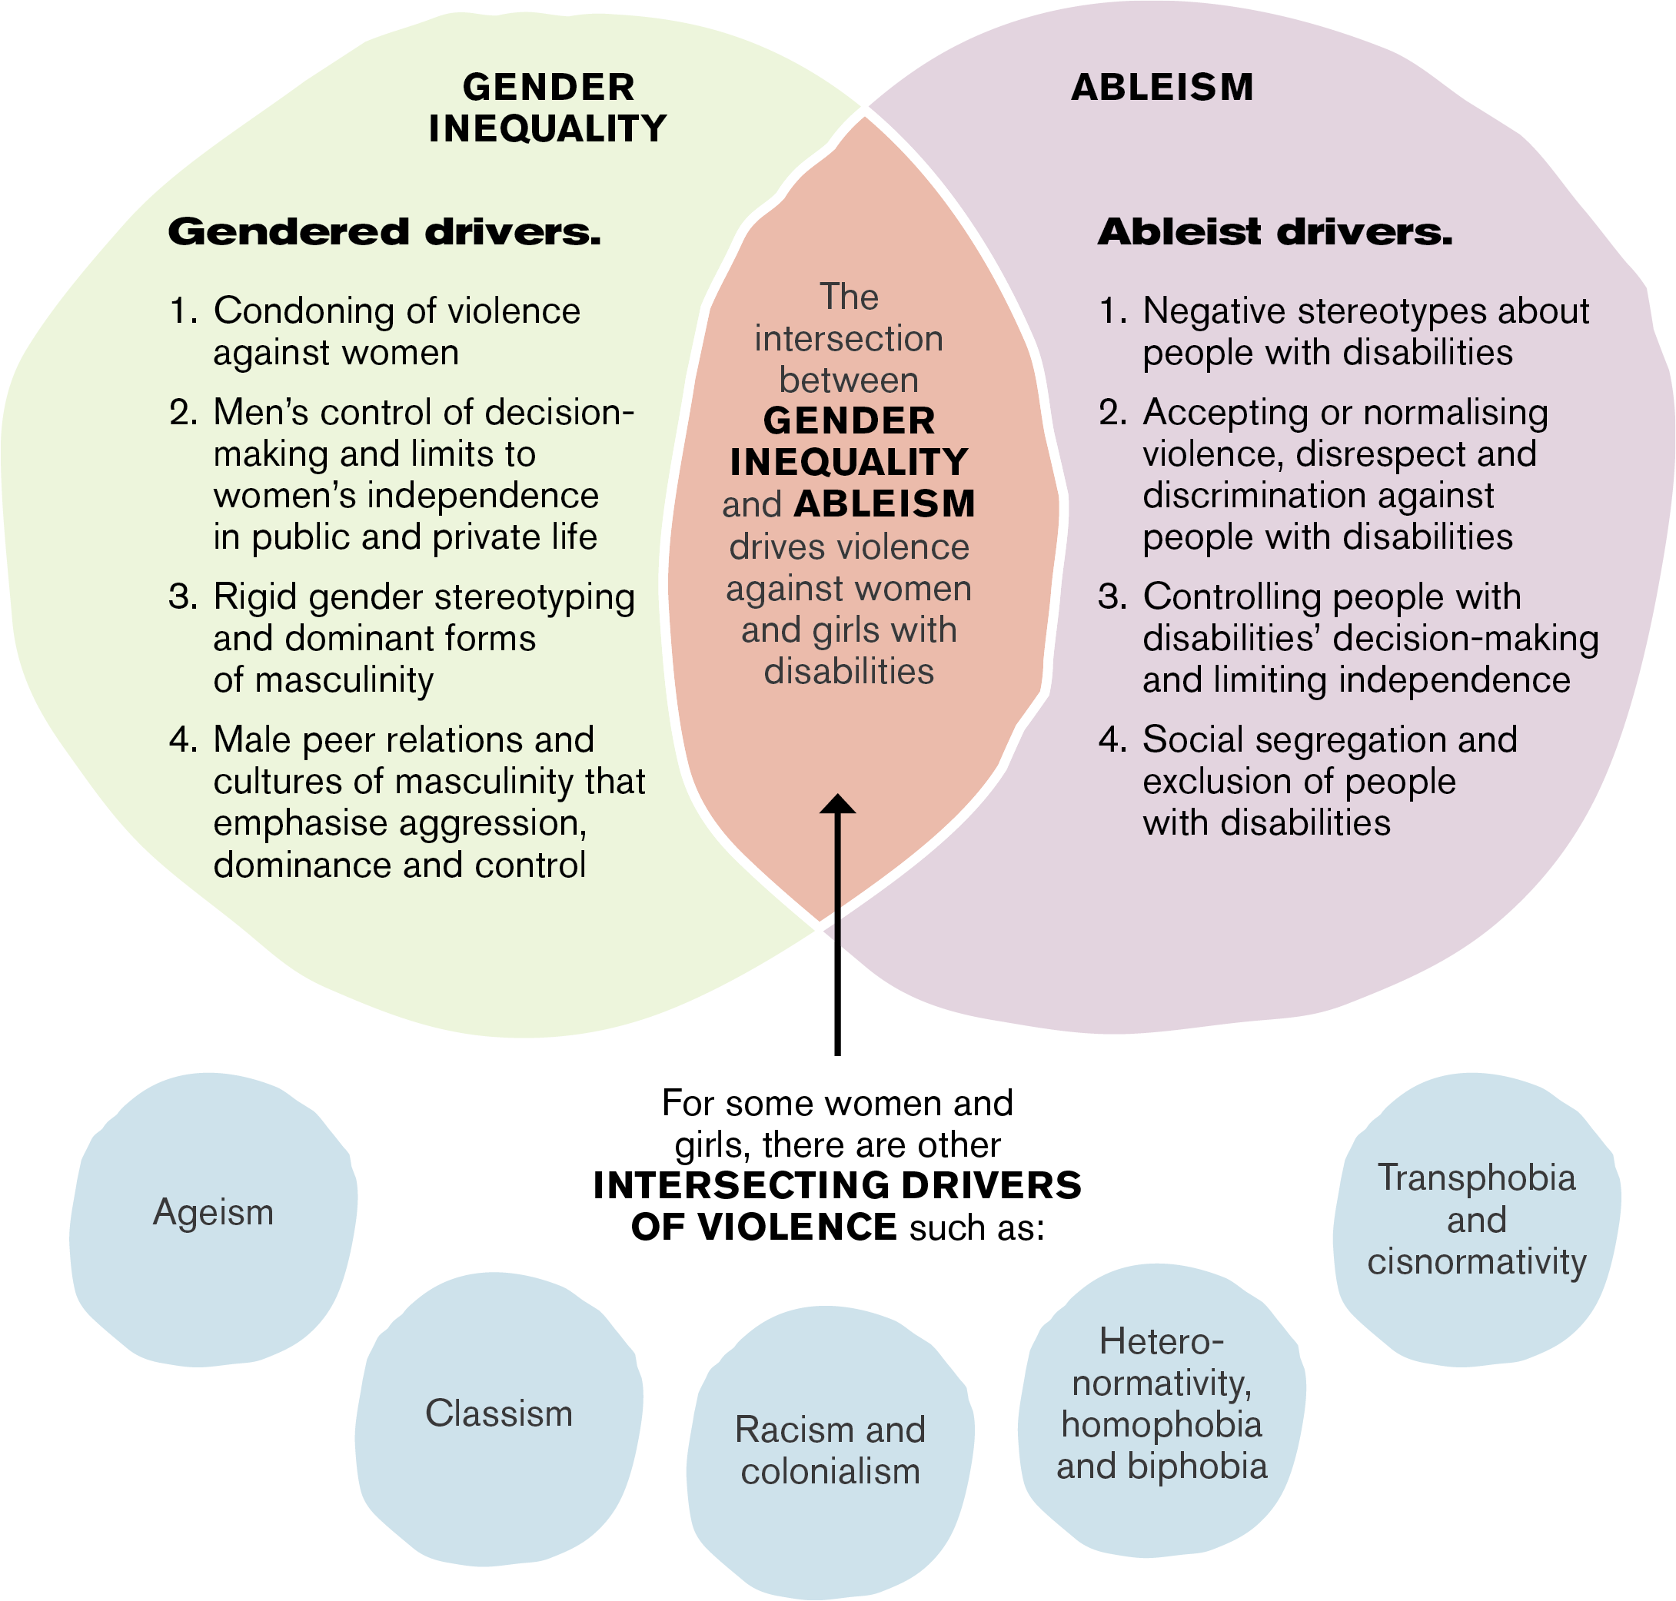

See alternative text for Figure 1.

## Intersecting forms of discrimination and oppression

Ableism and gender inequality are not necessarily the only, or the most important, drivers of violence in every context.

Other forms of oppression (and their corresponding systems of power and privilege) can intersect with gender inequality and ableism to increase the prevalence and influence the nature and dynamics of violence perpetrated against women and girls with disabilities.

These other forms of oppression and inequality include, but are not limited to heteronormativity, homophobia and biphobia; cisnormativity, transphobia and enbyphobia; racism and xenophobia; colonialism; ageism; religious discrimination; and classism, poverty, and socioeconomic disadvantage.

For example, for Aboriginal or Torres Strait Islander women and girls with disabilities, the ongoing impacts of colonisation, including intergenerational trauma, as well as the impacts of racism and social and economic disadvantage, may be as, or more, significant as drivers of violence than the impacts of ableism and gender inequality.[18]

## A primary prevention approach: the solution

To stop violence against women and girls with disabilities before it starts, we need to take a primary prevention approach.

Primary prevention means stopping violence from occurring in the first place by addressing its underlying drivers.

The term ‘primary prevention’ draws from public health approaches and refers to addressing the ‘primary’ or underlying drivers of a problem to prevent it occurring. This requires changing the social conditions that give rise to this violence; reforming the institutions and systems that excuse, justify, or even promote such violence; and shifting the power imbalances and social norms, structures and practices that drive and normalise this violence.[19] Primary prevention is distinct from early intervention and response, which intervene when there are early signs of violence or respond after violence has occurred. However, to be effective, prevention must occur in coordination with and in support of these efforts. A comprehensive and holistic approach to violence against women must involve a continuum of interdependent and interlinked strategies, with efforts across the spectrum of crisis response, early intervention, and prevention.

**Figure 2:** Primary prevention of violence as an ‘upstream’ approach.

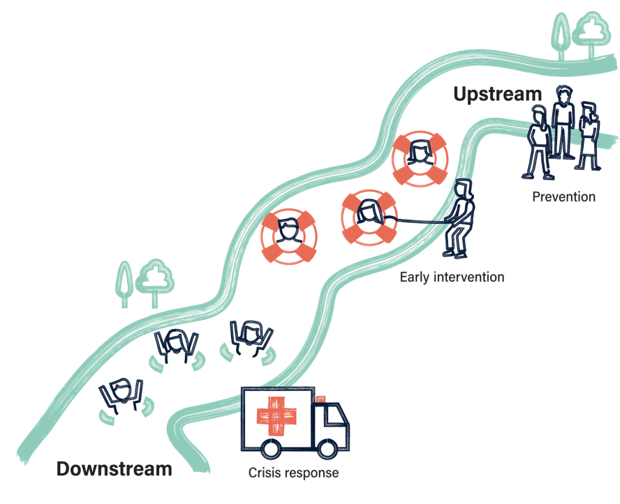

See alternative text for Figure 2.

## The social model of disability

The primary prevention approach outlined in *Changing the landscape* is framed by the social model of disability, which is embedded in the [United Nations Convention on the Rights of Persons with Disabilities (UNCRPD)](https://www.un.org/development/desa/disabilities/convention-on-the-rights-of-Persons-with-disabilities.html). The social model explains that ‘disability’ does not refer to a person’s functional limitation but rather as the result of the interaction between a person’s impairment and barriers related to environments, institutions, communication, and attitudes. The social model recognises that these barriers have a compounding and intergenerational impact on people with disabilities. It also recognises that it is society’s responsibility to recognise and remove barriers that prevent people with disabilities from effectively recognising their rights and being active members of society.[20]

## What are the essential actions to prevent this violence?

*Changing the landscape* explains the need to address gender inequality and ableism at every level of society and shift the norms, structures and practices that drive and reinforce violence against women and girls with disabilities. It outlines six essential actions to address the underlying drivers of violence against women and girls with disabilities:

The essential actions to prevent violence against women and girls with disabilities:[21]

* **Essential action 1:** Address the underlying social context that gives rise to violence against women and girls with disabilities.
* **Essential action 2:** Challenge the acceptance and normalisation of violence against women and girls with disabilities.
* **Essential action 3:** Improve attitudes towards women and girls with disabilities by challenging ableist and sexist stereotypes.
* **Essential action 4:** Promote the inclusion of women and girls with disabilities in all aspects of life.
* **Essential action 5:** Promote women and girls with disabilities’ independence, agency and participation in leadership and decision-making.
* **Essential action 6:** Engage men and boys to challenge controlling, dominant and aggressive forms of masculinity.

*Changing the landscape’s* essential actions are intentionally broad, to emphasise that there are many ways of taking action at different levels of policy and practice, and different ways stakeholders, including governments, can translate them into practice in different contexts and settings.

To be effective, the essential actions require policy, legislative, regulatory, and institutional support, as well as broad, practical, ‘on the ground’ implementation across society, in all the diverse settings where people live, work, learn, socialise, and play. These actions need to be implemented at every level of society to transform social norms, structures, and practices at all levels.

## What role can governments play?

Governments have a primary responsibility for the health, safety, and equality of all women. They play a critical leadership role in addressing inequalities across Australian society and creating an enabling environment for systemic, structural, and large-scale change.

Governments have a critical role to play in ensuring policies and programs, aimed at addressing gender inequality, violence against women and ableism, are aligned, mutually reinforcing and collectively contribute to reducing the prevalence and cost of violence against women and girls with disabilities. Governments have unique access to and influence over policy, legislative and regulatory levers that facilitate social, cultural, structural, and systemic change.[22]

*Changing the landscape* aims to support stakeholders from a broad range of communities and sectors in their work to prevent violence against women and girls with disabilities.

This Framework for Action has been developed specifically for governments and policymakers to translate the essential actions in *Changing the landscape* into tangible proposed actions.

# What has informed this Framework for Action?

## Changing the landscape

Published in 2022, [Changing the landscape: A national resource to prevent violence against women and girls with disabilities](https://www.ourwatch.org.au/resource/changing-the-landscape/) is a national, evidence-based resource to guide the prevention of violence against women and girls with disabilities*. Changing the landscape* was developed, researched, and drafted in partnership between Our Watch and Women with Disabilities Victoria. The resource development was informed by national stakeholder consultations across all states and territories and 39 experts in disability, gender equality and violence against women. It was also guided by two Project Advisory Groups which included policy and practice experts, and activists and consultants with lived experience of disability.

This Framework for Action has been developed with the aim of translating *Changing the landscape* for government audiences*.* It is part of a broader project funded by the Department of Social Services. It has been led by Our Watch and Women with Disabilities Victoria as part of their ongoing *Changing the landscape* partnership. Women with Disabilities Victoria directly contributed to the proposed actions for the Commonwealth and Victorian jurisdictions.

In addition to this Framework for Action for governments and policymakers, Our Watch and Women with Disabilities Victoria have also developed a suite of practice resources for primary prevention practitioners and disability service professionals working to prevent violence against women and girls with disabilities.

In developing the Framework for Action and suite of practice resources, Our Watch and Women with Disabilities Victoria focused on empowering individuals and communities to build on their existing resources, strengths, knowledge and abilities, as well as the many protective factors that are part of belonging to a resilient community.

## Supporting evidence-based frameworks

In addition to the key focus of translating the essential actions and principles in *Changing the landscape* into a series of proposed actions for governments, this Framework is also informed by other key Our Watch evidence-based frameworks including:

* [*Change the story: A shared framework for preventing violence against women in Australia*](https://www.ourwatch.org.au/resource/change-the-story-a-shared-framework-for-the-primary-prevention-of-violence-against-women-in-australia/)
* [*Changing the picture: A national resource to support the prevention of violence against Aboriginal and Torres Strait Islander women and their children*](https://www.ourwatch.org.au/resource/changing-the-picture/)
* [*Men in focus: practice guide and evidence review*](https://www.ourwatch.org.au/resource/men-in-focus-practice-guide-addressing-masculinities-and-working-with-men-in-the-prevention-of-mens-violence-against-women/)

## International, national, state and territory priorities

This Framework for Action has been informed by the significant work and reforms that are underway internationally, nationally and in state and territories to prevent violence against women and girls with disabilities. It has primarily been informed by the priorities outlined in the National Plan to End Violence Against Women and Children 2022-2032, Australia’s Disability Strategy 2021-2031 and state and territory level plans and strategies.

## The Royal Commission into Violence, Abuse, Neglect and exploitation of People with Disability

During the development of this Framework for Action, the Royal Commission into Violence, Abuse, Neglect and Exploitation of People with Disability (DRC) released its final report. The DRC made 222 recommendations, many of which align with the principles and essential actions outlined in *Changing the landscape* and are directed to the Australian Government and state and territory governments.

There are many important prevention actions that only governments can initiate. As a result, this Framework for Action has noted where there is alignment between a proposed action within this Framework for Action and a recommendation from the DRC.

Most notably, the DRC has recommended the development of a five-year Action Plan to End Violence Against Women and Children with Disabilities to accompany the National Plan to End Violence against Women and Children 2022–2032 (Recommendation 8.23). There is an opportunity to use this Framework for Action to inform the development of any prevention actions under the proposed five-year Action Plan to End Violence Against Women and Children with Disabilities.

## Consultation with Governments and Non-Government Organisations

All governments were provided the opportunity to have strategic input into the development of this Framework for Action. Consultations were also undertaken with 25 representatives from 23 different non-government disability, gender equality, women’s health, and primary prevention organisations.

Their combined expertise and feedback have ensured the proposed actions are aligned with current government priorities and will lead to practical outcomes in the community.

## Expert advice and review

A National Project Advisory Group was established to inform this project and Framework for Action. The Advisory Group provided strategic input and advice through bi-monthly meetings and workshops with Our Watch throughout the development of the Framework for Action. The groups’ guidance was informed by their professional expertise combined with lived experience of disability, as victim-survivors of violence, as well as members from disability, violence prevention and academic sectors. **The Project Advisory Group included:**

* Dr. Ellen Fraser-Barbour, Independent/Flinders University
* Heidi La Paglia, Independent
* Janel Manns, People with Disabilities Australia
* Juana Terpou, Independent
* Kat Reed, Women with Disabilities ACT
* Mali Hermans, First Peoples Disability Network
* Dr. Marg Camilleri, Federation University
* Nanushka Tamtam, Red Files
* Dr. Suzette Mitchell, Independent
* Talie Star, Independent
* Tess Moodie, Independent

Expert reviewer

* Natalie Wade

## Language and scope

*Changing the landscape* focuses on the prevention of violence against women and girls with disabilities (including cis and trans women and girls). This Framework for Action draws on the evidence base in *Changing the landscape* to focus on the intersecting gendered and ableist drivers that disproportionately impact women and girls with disabilities, centring an intersectional approach.

This Framework for Action uses the term ‘disabilities’ to describe a range of physical, cognitive, sensory, psychosocial, and other visible and non-visible disabilities people experience, including chronic illness.[23] The term ‘disabilities’ refers to all types of disabilities.

This Framework for Action uses the terms ‘women’ and ‘men’ despite their limitations and reliance on binary approaches to gender. It uses these terms to describe the disproportionate rates of men’s violence against women and girls that is driven by gendered factors and other inequalities. Implementation of the proposed actions will likely complement prevention of violence against other communities, such as violence against LGBTIQ and Aboriginal and Torres Strait Islander people and communities.[24]

For explanations about other terms and concepts used in this Framework for Action, please refer to the glossary (page 126) in the [National Plan to End Violence against Women and Children 2022-2032](https://www.dss.gov.au/sites/default/files/documents/10_2023/national-plan-end-violence-against-women-and-children-2022-2032.pdf).

# The Framework for Action

This section translates the essential actions outlined in Changing the landscape into a set of proposed actions for Australian, state and territory governments to prevent violence against women and girls with disabilities.

The proposed actions have also been informed by:

* International, national, state and territory policy priorities including Australia’s   
  Disability Strategy, the National Plan to End Violence against Women, The First Action Plan 2023-2027, the Aboriginal and Torres Strait Islander Action Plan 2023-2025 under the National Plan and Closing the Gap National Agreement.
* Recommendations from the Royal Commission into Violence, Abuse, Neglect and Exploitation of People with Disability.

To ensure governments can take a strategic and sustained approach, the proposed actions have been divided into two focus areas:

Focus Area 1:  
Policy, legislative, regulatory, and institutional reform

The actions governments can take to remove discriminatory structural   
barriers and create an enabling environment for the prevention of violence against women and girls with disabilities.

Focus Area 2:  
Primary prevention   
action across priority settings, communities and   
in partnership

The actions governments can take, in specific priority settings and communities, including by resourcing and forming partnerships with other stakeholders.

## A phased approach to reform

The application of these proposed actions should be informed by the design and implementation principles and guided by the suggested timeframes.

* **Short-term** – achievement within 3 years
* **Medium-term** – achievement between 4-7 years
* **Long-term** – achievement in up to 10 years and beyond

Importantly, the suggested short-, medium- and long-term timeframes are not based on the priority of the proposed actions but rather on the estimated time needed to implement them. While short term proposed actions provide opportunities for immediate action and reform, the medium- and long-term proposed actions may require more work over a longer period and build upon the proposed actions in the short to medium term. The proposed actions should be implemented in addition to existing government initiatives and be reviewed and updated regularly.

Importantly, governments will also need to consider ways to ensure appropriate monitoring, reporting and evaluation of actions implemented and alignment with existing monitoring and outcomes frameworks, or development of new frameworks.

# Proposed Actions for all Governments

Focus Area 1:  
Policy, legislative, regulatory, and institutional reform

The actions governments can take to remove discriminatory structural barriers and **create an enabling environment for the prevention** of violence against women and girls with disabilities.

### Short-term

1. Increase **understanding and awareness** about primary prevention of violence against women and girls with disabilities within advisory bodies, commissions, and ministerial councils.

What does building understanding and awareness mean?

* Explaining the gendered and ableist drivers of violence and the link between gender inequality and violence against women
* Explaining intersectional factors, including ableism and violence against women with disabilities
* Promoting the role and responsibility of government in preventing violence against women with disabilities
* Clarifying how primary prevention is different from other approaches to addressing violence against women.

1. Continue to support Equal Opportunity, Human Rights, Anti-Discrimination and Disability Commissions to protect and promote the rights of women and girls with disabilities through their educative, complaint and advisory functions.
2. Ensure that domestic, family, and sexual violence policies include a focus on primary prevention, including actions for targeted primary prevention programming that specifically addresses the gendered and ableist drivers of violence against women and girls with disabilities.
3. Apply an **intersectional approach** to the implementation of Australia’s Disability Strategy, the National Plan to End Violence against Women and Children 2022-2032 and other state and territory level primary prevention and disability plans and strategies.

What does applying an intersectional approach mean?

An effective intersectional approach to the prevention of violence against women is one that not only takes account of the diversity of people’s experiences and identities, but that explicitly seeks to address the multiple intersecting systems of oppression and discrimination, power and privilege that shape the social context in which this violence occurs, and influence men’s perpetration and women’s experiences of violence.

1. Continue to build a strong primary prevention practice **evidence base** through resourcing primary prevention initiatives and programs that address the gendered and ableist drivers of violence towards women and girls with disabilities.

Why is a strong evidence-base important?

Change the story identifies a strong evidence base, informed by ongoing research, practice and evaluation, as a critical element to the primary prevention infrastructure. There is still limited available practice evidence about what works and what does not work to prevent violence against women and girls with disabilities. As a result, it is critical that governments support prevention initiatives across a diverse range of settings, sectors, and contexts and within specific population groups, cohorts, audiences, and communities.

Building the evidence-base is a key priority within the National Plan to End Violence against Women and Children 2022-2032 and Closing the Gap Implementation Plan under Target 13: Aboriginal and Torres Strait Islander families and households are safe.

1. Ensure that **monitoring, evaluation** and learning frameworks of disability and domestic and family violence related policies and programs include outcomes, indicators and measures that address the gendered and ableist drivers of violence and identify the relevant data sources that will be monitored and reported against.

Why is ongoing monitoring and evaluation of prevention important?

Monitoring progress towards prevention at the population level is critical to determining whether we are moving towards our shared vision of an Australia where women and their children live free from all forms of violence. This includes data sets such as the National Community Attitudes Survey (NCAS), Workplace Gender Equality Agency (WGEA) and ongoing surveys from the Australian Bureau of Statistics. Counting on change provides guidance to policy makers on how to comprehensively track short, medium, and long-term progress toward prevention at the population-level.

Ongoing monitoring and evaluation of policies and programs is critical to identify which prevention strategies and activities make a difference and ultimately drive this population-level change.

It is important that governments monitor and evaluate the implementation of proposed actions and identify where existing, and the establishment of new, data sets can support this work.

1. Create, resource, and monitor professional development opportunities for the **disability and primary prevention workforces** to increase their understanding about the gendered and ableist drivers of violence against women and girls with disabilities.

Why is workforce development important?

Governments have a key role to play in developing policy and enabling coordination to grow the distinct and overlapping primary prevention and disability workforces. This means building the prevention knowledge, skills, and capabilities of the workforces that people with disabilities interact with the most (including health care professionals) and building the knowledge, skills, and capabilities of the prevention workforces to address the intersecting drivers of ableism and gender.

Our Watch’s resource Growing with change can guide government action for workforce development in these overlapping workforces.[25] Embedding prevention in the disability sector and embedding inclusive disability principles in prevention is critical for the success of preventing violence against women and girls with disability.

1. Establish or update gender responsive budgeting and policy development mechanisms to include intersectional gender impact assessment so that public policy development and cabinet submissions routinely consider the impact on women and girls with disabilities.
2. Establish or strengthen mechanisms to collect and report gender and disability disaggregated data about all forms of violence against women and girls to inform the development of targeted prevention initiatives. Ensure mechanisms align with the principles of Indigenous Data Sovereignty.
3. Continue to fund disability advocacy pathways including by providing long-term resourcing for disability peaks, disability support services, and organisations led by and for women and girls with disabilities.

What is the role of non-government organisations?

Non-government organisations led by women with disabilities who focus on representing the needs and interests of women and girls with disabilities, can identify and creatively solve many of the systemic problems faced by women and girls with disabilities in Australia. These organisations support women with disabilities, create networks, build capability, advocate for reform, build the evidence base, share knowledge, and work with institutions and organisations to promote women with disabilities’ participation in decision-making.[26] They also play a critical role in the co-design of policy, programs and legislation, the provision of technical and lived-experience expertise and the capacity building of governments in the prevention of violence against women and girls with disabilities.

1. Improve the accessibility of **public information and communications**, including information regarding family, domestic and sexual violence.

Why is making public information and communications accessible important?

As noted in Australia’s Disability Strategy, being able to access information and communicate is central to people’s safety and health, to involvement in their communities, employment, and education, and to using transport, banking, and shopping. Provision of communication in accessible formats (e.g., Braille, Auslan, Easy Read formats) can have a positive impact on the health of and opportunities for people with disabilities.[27]

In addition, it is important people with disabilities can access information and communication systems relating to family, domestic and sexual violence. As noted, as an action in the Aboriginal and Torres Strait Islander Action Plan 2023-2025, this includes accessibility to health systems, community engagement and client services for people with disabilities.[28]

### Medium-term

1. As part of Closing the Gap National Agreement priority reform one, **partner with Aboriginal and Torres Strait Islander peoples** to address the legacies and ongoing impacts of colonisation on Aboriginal and Torres Strait Islander women and girls with disabilities.

What initiatives does action 12 include?

Changing the picture, a national resource to support the prevention of violence against Aboriginal and Torres Strait Islander women and their children outlines the following initiatives as priority areas for addressing the legacies and ongoing impacts of colonisation:[29]

* Healing the impacts of intergenerational trauma, strengthening culture and identity
* Strengthening and supporting Aboriginal and Torres Strait Islander families
* Implementing specific initiatives for Aboriginal and Torres Strait Islander women and girls, boys and men, and children and young people
* Challenging the condoning of violence in Aboriginal and Torres Strait Islander communities
* Increasing access to justice for Aboriginal and Torres Strait Islander people.

Activities under each initiative will need to be designed and implemented to consider the diversity of Aboriginal and Torres Strait Islander people’s identities, experiences, and circumstances across the country.

1. Resource Legal Aid Commissions, Community Legal Centres and Aboriginal and Torres Strait Islander Legal Services to ensure greater access and inclusivity to women and girls with disabilities requiring legal assistance.
2. Update definitions of violence against women to incorporate restrictive practices and restraints and take steps to reduce and eliminate restrictive practices.
3. Ensure the implementation of the National Housing and Homelessness Plan includes dedicated measures to increase the availability of non-segregated, accessible, and safe accommodation for women and girls with disabilities in the public, social, private, and rental markets.

### Long-term

1. Review and reform guardianship and administration legislation in line with relevant DRC Recommendations.
2. Reform policies and practices that legitimise reproductive coercion such as forced sterilisation, contraception, or abortion, in line with DRC Recommendation 6.41 and embed the move towards supported decision-making in line with DRC Recommendation 6.6.
3. Support and facilitate the equal economic participation of women with disabilities to promote equal access to employment for people with disability including through supporting DRC Recommendation 7.32; to develop a National Inclusive Employment Roadmap to transform Australian Disability Enterprises and end segregated employment by 2034.
4. Review anti-discrimination legislation to introduce a positive duty to eliminate disability discrimination, harassment, and victimisation.

Focus Area 2:  
Primary prevention action across priority settings, communities and in partnership

The actions governments can take, in specific priority settings and communities, including by resourcing and forming partnerships with other stakeholders.

### Short-term

1. Improve and monitor shifts in community understanding and awareness of violence against women and girls with disabilities by funding or developing evaluated education campaigns and training programs.
2. Implement and build on the **Community Attitudes priorities** outlined in Australia’s Disability Strategy and the Community Attitudes Targeted Action Plan.

What are the Community Attitudes priorities in Australia’s Disability Strategy?

1. Employers value the contribution of people with disability make to the workforce and recognise the benefits of employing people with disability
2. Key professional workforces can confidentially and positively respond to people with disability
3. Increase representation of people with disability in leadership roles
4. Improve community attitudes and understanding of disability.
5. Create targets for women with disabilities in government boards, non-government boards and public service employment, including executive and senior leadership positions.
6. Fund or deliver leadership, mentoring, scholarship, professional development, or internship programs designed for women with disabilities.
7. As part of Closing the Gap National Agreement priority reform two, resource Aboriginal and Torres Strait Islander-led organisations to support and promote the rights of Aboriginal and Torres Strait Islander women with disabilities to individual self-determination, choice and to make decisions about their own lives and relationships.
8. Resource the design, implementation and evaluation of evidence-based programs that **promote supported decision-making** and align with the supported decision-making principles outlined in the DRC.

Why is participation and the promotion of supported decision-making important?

People with disabilities, especially women, remain significantly underrepresented in positions of power, particularly in roles responsible for decisions that affect their lives. This is despite decades of activism from disability rights advocates, including calls for ‘nothing about us without us’.

This situation has created a compounding effect, perpetuating policies of substitute decision-making. As a result, the voices, and decisions of people with disabilities are often overshadowed by the choices of others, including carers, guardians, family members, National Disability Insurance Scheme (NDIS) planners, service providers and policymakers.[30]

Supported decision-making, where people with disabilities have access to the supports and information needed to exercise choice and control and make decisions about their life, is critical to preventing violence.

1. Support initiatives that improve media reporting about violence against women and girls with disabilities, including by conveying its prevalence and eliminating stereotypes that condone ableism.
2. Fund or develop research and projects that build an understanding about the links between masculinities and men’s use of violence against women and girls with disabilities in various settings, especially in segregated and secluded settings.
3. Customise education and resources for students in special developmental schools, with a long-term goal of phasing out segregated schools in line with DRC Recommendation 7.14.

### Medium-term

1. Support and promote initiatives that address men’s use of coercive control in relationships and the normalisation of male dominance in relationships, with particular attention to the overlapping impacts of ableism and the power dynamics in intimate and care relationships.
2. Examine current primary prevention initiatives that **engage with men** to address harmful forms of masculinity and support opportunities to address ableism within those existing initiatives.

Why is engaging men and boys important?

While people of all genders perpetrate violence against women and girls with disabilities, certain forms of violence, such as sexual assault, rape, and intimate partner violence, are overwhelmingly perpetrated by cisgender men.[31] Accordingly, there is a critical need for prevention strategies that engage men and boys to challenge sexist and ableist ideas, norms and behaviours that lead to violence against women and girls with disabilities.

Supporting primary prevention interventions that support and encourage men and boys to have respectful and equal relationships, challenge dominant forms of masculinity and engage all men to be part of the change is a key focus within the National Plan to End Violence against Women and Children 2022-2032.[32]

1. Ensure that respectful relationships education is implemented in alignment with the evidence-based whole-of-school model and is accessible to people with disabilities.

### Long-term

1. Take proactive measures to end the institutionalisation of people with disabilities by **phasing out the practice of disability-based segregation** in mainstream settings, including education, housing, health care and employment.

Why is ending segregation important?

The evidence clearly outlines that segregation and exclusion of people with disabilities is a driver of violence against women and girls with disabilities.[33] Practices of segregation and exclusion are informed by harmful ableist social norms, beliefs and practices that view people with disabilities as incapable, dangerous, in need of regulation and surveillance, not ‘normal’, and less valuable.[34]

Segregated systems reduce people with disabilities’ access to community networks and support services, allow for the acceptance, downplay or justification of violence to occur in certain institutions, and violate people with disabilities’ human rights to full participation and inclusion in society.

# Design Principles

The following set of principles, drawn from *Changing the landscape*, should be used by governments and policymakers when designing primary prevention strategies and plans to strengthen the alignment between disability and gender equality policy and practice.

## Human rights-based approach

Violence against women and girls with disabilities is a fundamental, serious, and preventable violation of human rights. A human rights approach helps identify how human rights are achieved. Key principles of a human rights approach include participation, accountability, non-discrimination and equality, empowerment, and legality.[35]

## Strengths-based

A strengths-based approach focuses on empowering individuals and communities to use or build on their existing resources, strengths, resilience, knowledge, and abilities, as well as the many protective factors that are part of belonging to a resilient community.[36]

## Intersectionality

An intersectional approach acknowledges and proactively responds to the evidence that violence and gender inequality exist in relation to multiple and intersecting systems of power including sexism, racism, colonialism, classism, heteronormativity, cisnormativity, homo-, bi- and transphobia, ableism, and ageism; and their corresponding systems of power and privilege.

## Accessibility and inclusion

An accessible and inclusive approach ensures women and girls with disabilities are involved in the design, development, and implementation of prevention work on an equal basis to people without disabilities. It requires prevention practitioners to use inclusive approaches, be flexible and confident when working with people with disabilities and ensure sufficient time and funding for access requirements.

## Community-ownership

This approach addresses community identified priorities, uses community developed solutions, and ensures implementation is coordinated through appropriate community and cultural relationships. Although the proposed actions have been reviewed by governments, subject matter experts and advisory groups, consultation with place-based communities is critical to ensuring genuine community-ownership.

## Co-design

A co-design approach requires centring the voices and decisions of women and girls with disabilities at every stage of policy and program design and implementation, resourcing participant time and expertise, travel costs and accessibility requirements and ensuring timelines are sufficient for authentic participation. It requires strong partnerships and power-sharing that centres the knowledge, expertise and lived experience of women and girls with disabilities.

# Tips for Implementation

Our Watch has developed the following tips to guide and support design, development, implementation and monitoring of plans and activities to prevent violence against women and girls with disabilities. The following tips are informed by Our Watch’s evidence-based frameworks and experience working with governments across all jurisdictions to implement effective primary prevention.

**1. Take a whole of government approach** by ensuring commitment across government portfolios with centralised coordination and clear allocation of departmental responsibility. Implementation of the proposed actions will require collaboration and expertise from a range of government departments.

**2. Establish strong governance mechanisms** within government as well as those that allow for ongoing stakeholder input into implementation and appropriate monitoring and accountability. Governance structures should include a combination of representation from across government departments and representatives who hold primary prevention, disability and setting-based knowledge and expertise.

**3. Align with other priorities, strategies and plans** such as key international conventions, the National Plan to End Violence Against Women and Children 2022-2032, Australia’s Disability Strategy, Closing the Gap, the Aboriginal and Torres Strait Islander Action Plan 2023-2025, relevant state and territory strategies or action plans and government responses to the Disability Royal Commission.

**4. Draw on the evidence-base** including *Changing the landscape*, the advice and knowledge of leaders, practitioners and organisations and the emerging evidence-base of disability and domestic, family, and sexual violence-based services, systems, and programs.

**5. Allocate investment** to appropriately resource the coordination, implementation and evaluation of actions and ensure the work can be sustained. Preliminary investment can influence more sustained investment and greater responsibility by sector-based stakeholders.

**6. Build on existing efforts** by identifying opportunities to strengthen existing initiatives’ ability to prevent violence against women and girls with disabilities through applying a disability or gender equality lens.

**7. Draw on the design principles** when developing or reviewing new strategies or action plans. The design principles have been informed by evidence and consultation with the sector and provide a strong conceptual foundation for approaching this work.

**8. Take a phased approach** by building the necessary systems and structures to establish a strong foundation for primary prevention, increase understanding over time and implementing the proposed actions in line with the suggested timeframes.

**9. Monitor, evaluate and report** on implementation by defining outcomes, indicators, measures, data sources and establish reporting mechanisms to demonstrate progress against the proposed actions outlined in this Framework for Action.

# Appendix 1: Alternative text for figures

## Figure 1: Types of violence experienced by women and girls with disabilities.

Infographic of a conceptual model, which shows that the intersection between gender inequality and ableism drives violence against women and girls with disabilities.

Gender inequality is expressed through the gendered drivers:

1. Condoning of violence against women.
2. Men’s control of decision-making and limits to women’s independence in public and private life.
3. Rigid gender stereotyping and dominant forms of masculinity.
4. Male peer relations and cultures of masculinity that emphasise aggression, dominance, and control.

Ableism is expressed through the ableist drivers:

1. Negative stereotypes about people with disabilities.
2. Accepting or normalising violence against people with disabilities.
3. Controlling people with disabilities’ decision-making and limiting independence.
4. Social segregation and exclusion of people with disabilities.

For some women and girls, there are other intersecting drivers of violence such as:

* ageism
* classism
* racism and colonialism
* heteronormativity, homophobia, and biphobia
* transphobia and cisnormativity.

Return to text following Figure 1

## Figure 2: Primary prevention of violence as an ‘upstream’ approach.

Infographic showing the different stages of intervention in the problem of violence against women. The different stages of the problem are represented by a river.

Prevention is work that occurs upstream in the river, because it is trying to prevent the problem from happening in the first place. This is represented in the image as people standing on the riverbank, stopping anyone from falling in.

The second stage is early intervention. It is work that tries to help people who have only just fallen into the river. Early intervention is represented in the image by a person throwing life buoys to rescue people who are midstream in the river.

The third stage is crisis response. It occurs downstream when the problem is already advanced. It is represented in the image by an ambulance attempting to rescue people who are in very serious trouble much further downstream in the river.

Return to text following Figure 2

# Endnotes

1. Australian Bureau of Statistics. (2018). Experiences of violence and personal safety of people with disability, 2016 (cat. no. 4431.0.55.003); Dowse, L., Soldatic, K., Spangaro, J., & van Toorn, G. (2016). Mind the gap: The extent of violence against women with disabilities. Australian Journal of Social Issues, 51(3), 341–59; Woodlock, D., Healey, L., Howe, K., McGuire, M., Geddes, V., & Granek, S. (2014). Voices Against Violence, Paper 1: Summary report and recommendations. Women with Disabilities Victoria, Office of the Public Advocate & Domestic Violence Resource Centre Victoria; Australian Bureau of Statistics. (2017). Personal safety, Australia, 2016 (cat. no. 4906.0).
2. Sutherland, G., Krnjacki, L., Hargrave, J., Kavanagh, A., Llewellyn, G., & Vaughan, C. (2021). Primary prevention of violence against women with disability: Evidence synthesis. The University of Melbourne. Centre of Research Excellence in Disability and Health (CRE-DH). (2021). Nature and extent of violence, abuse, neglect, and exploitation against people with disability in Australia.
3. Australian Bureau of Statistics (ABS) Survey of Disability, Ageing and Carers, 2018.
4. Our Watch & Women with Disabilities Victoria. (2022). Changing the landscape: A national resource to prevent violence against women and girls with disabilities, p. 27.
5. Our Watch & Women with Disabilities Victoria. (2022). Changing the landscape: A national resource to prevent violence against women and girls with disabilities, p. 27.
6. Royal Commission into Violence, Abuse, Neglect and Exploitation of People with Disability. (2023). Final Report: Our vision for an inclusive Australia and Recommendations, p. 48.
7. Royal Commission into Violence, Abuse, Neglect and Exploitation of People with Disability. (2023). Final Report: Our vision for an inclusive Australia and Recommendations.
8. Frohmader, C. (2007). Forgotten sisters: A global review of violence against women with disabilities. Women with Disabilities Australia; Healey, L. (2013). Voices Against Violence, Paper 2: Current issues in understanding and responding to violence against women with disabilities. Women with Disabilities Victoria, Office of the Public Advocate and Domestic Violence Resource Centre Victoria; Thiara, R., Hague, G., & Mullender, A. (2011). Losing out on both counts: Disabled women and domestic violence. Disability & Society, 26(6), 757–71; Women with Disabilities Australia (WWDA). (2020). Response to the group homes issues paper of the Royal Commission into Violence, Abuse, Neglect and Exploitation of People with Disability.
9. Our Watch (2021). Change the story: A shared framework for the primary prevention of violence against women in Australia (2nd ed.), p. 122.
10. Ayre, J., Lum On, M., Webster, K., Gourley, M., & Moon, L. (2016). Examination of the burden of disease of intimate partner violence against women in 2011: Final report (ANROWS Horizons, issue 06/2016). Sydney, NSW: ANROWS; Costello, M., & Backhouse, C. (2019). Avoiding the 3 ‘M’s: Accurate use of violence, abuse and neglect statistics and research to avoid myths, mistakes and misinformation – A resource for NSW Health Workers. The NSW Health Education Centre Against Violence (ECAV) and Prevention and Response to Violence, Abuse and Neglect (PARVAN) Unit, Ministry of Health.
11. Dembo, R.S. et al. (2018). The psychological consequences of violence against people with disabilities.
12. Dembo, R.S. et al. (2018). The psychological consequences of violence against people with disabilities.
13. Our Watch & Women with Disabilities Victoria. (2022). Changing the landscape: A national resource to prevent violence against women and girls with disabilities, p. 45.
14. Dembo, R.S., Mirta, M., & McKee, M. (2018). The psychological consequences of violence against people with disabilities. Disability and Health Journal, 11(3), 390–97. Our Watch & Women with Disabilities Victoria. (2022). Changing the landscape: A national resource to prevent violence against women and girls with disabilities, p. 47.
15. Healey, L. et al. (2008). Building the evidence; Woodlock, D. et al. (2014). Voices Against Violence, Paper 1.
16. Australian Bureau of Statistics. (2021). Disability and violence in focus: Crime and justice statistics. ‘Characteristics of assault’; McCarthy, M. (2017). ‘What kind of abuse is him spitting in my food?’; McCarthy, M. et al. (2019). ‘Put bluntly, they are targeted by the worst creeps society has to offer’; Pestka, K., & Wendt, S. (2014). Belonging: Women living with intellectual disabilities and experiences of domestic violence.
17. Our Watch & Women with Disabilities Victoria. (2022). Changing the landscape: A national resource to prevent violence against women and girls with disabilities, p. 36.
18. Our Watch & Women with Disabilities Victoria. (2022). Changing the landscape: A national resource to prevent violence against women and girls with disabilities, p. 46.
19. Our Watch (2021). Change the story: A shared framework for the primary prevention of violence against women in Australia (2nd ed.).
20. Australian Federation of Disability Organisations. (n.d.). Social model of disability; Barnes, C., & Mercer, G. (2006). Independent futures: Creating user-led disability services in a disabling society. Scandinavian Journal of Disability Research, 8(4), 317–320; Kazou, K. (2017). Analysing the definition of disability in the UN Convention on the Rights of Persons with Disabilities; United Nations General Assembly. (2006). Convention on the Rights of Persons with Disabilities (Treaty Series, 2515, 3).
21. Our Watch & Women with Disabilities Victoria. (2022). Changing the landscape: A national resource to prevent violence against women and girls with disabilities, p. 50.
22. Our Watch. (2021). Change the story: A shared framework for the primary prevention of violence against women in Australia (2nd ed.), p. 108.
23. Our Watch & Women with Disabilities Victoria. (2022). Changing the landscape: A national resource to prevent violence against women and girls with disabilities, p. 20.
24. This Framework for Action has not included asexual people in its scope as there is limited data and evidence on the drivers and experiences of violence against asexual people, in line with Change the story, Changing the landscape and Pride in prevention Evidence Guide (developed by Rainbow Health Australia) which refers to Lesbian, Gay, Bisexual, Transgender, Intersex and Queer (LGBTIQ) people and communities only.
25. Our Watch. (2023). Growing with change: Developing an expert workforce to prevent violence against women.
26. Our Watch. (2021). Change the story: A shared framework for the primary prevention of violence against women in Australia (2nd ed.). p. 111.
27. Australian Government. (2022). Australia’s Disability Strategy 2021-2031, p. 9.
28. Australian Government. (2023). Aboriginal and Torres Strait Islander Action Plan 2023-2025, p. 70.
29. Our Watch. (2018). Changing the picture: a national resource to support the prevention of violence against Aboriginal and Torres Strait Islander women and their children, p. 16.
30. Our Watch (2022). Changing the landscape: A national resource to prevent violence against women and girls with disabilities, p. 41.
31. Australian Bureau of Statistics. (2021). Disability and violence – in focus.
32. Australian Government (2023). The National Plan to End Violence Against Women and Children 2023-2032, p. 107.
33. Our Watch & Women with Disabilities Victoria. (2022). Changing the landscape: A national resource to prevent violence against women and girls with disabilities, p. 45.
34. Women with Disabilities Australia (WWDA). (2021). WWDA response to Promoting Inclusion issues paper.
35. Australian Human Rights Commission (2023). Human rights based approaches.
36. Our Watch. (2018). Changing the picture: Background paper – Understanding violence against Aboriginal and Torres Strait Islander women; Brown, C. (2019). Hopeful together strong; Tangentyere Council. (2019). The Grow Model of family violence prevention; Robinson, S., Oakes, P., Murphy, M., Codognotto, M., Ferguson, P., Lee, F., Ward-Boas, W., Nicks, J., & Theodoropoulos, D. (2019). Building safe and respectful cultures in disability services for people with disability: Report. Disability Services Commissioner.