## Report

October 2024

Building strong foundations to support primary prevention of violence against women



Contents

Background: Primary prevention of violence against women 5

Building the foundations for prevention 8

Government actions for strong foundations 11

01. Sustained political leadership 15

02. Policy, regulatory and legislative reform 17

03. Mechanisms for coordination, collaboration and quality assurance 20

04. Mechanisms for workforce and sector development 22

[05. Strong evidence base, informed by ongoing data collection,   
research, practice and evaluation 25](#_Toc181185045)

06. Monitoring and reporting mechanisms 27

07. Private sector, civil society and community leadership 29

08. A well-resourced, independent women’s sector 31

Endnotes 33

Acknowledgement of Country

Our Watch acknowledges the Traditional Owners of the land across Australia on which we work and live. We pay respects to Elders past and present and recognise the continuing connection Aboriginal and Torres Strait Islander people have to land, culture, knowledge, and language for over 65,000 years.

As a non-Aboriginal organisation, Our Watch understands that violence against Aboriginal and Torres Strait Islander women and children is an issue for the whole community. As highlighted in Our Watch’s national resource Changing the picture, the evidence clearly shows the intersection between racism, sexism, and violence against Aboriginal and Torres Strait Islander women.

Our Watch has an ongoing commitment to the prevention of violence against Aboriginal and Torres Strait Islander women and children, who continue to suffer from violence at a significantly higher rate than non-Aboriginal women. We acknowledge all Aboriginal and Torres Strait Islander people and organisations who continue to lead the work of sharing knowledge with non-Indigenous people and relentlessly advocate for an equitable, violence-free future in Australia.

**About Our Watch**

Our Watch is a national leader in the primary prevention of violence against women* and their children in Australia. We are an independent, not-for- profit organisation established in 2013. All Australian governments are members of Our Watch.

Our vision is an Australia where women and their children live free from all forms of violence. We aim to drive nationwide change in the culture, behaviours, attitudes, social structures and systems that drive violence against women.

Guided by our national framework, [*Change the story: A shared framework for the primary prevention*](https://media-cdn.ourwatch.org.au/wp-content/uploads/sites/2/2021/11/18101814/Change-the-story-Our-Watch-AA.pdf) [*of violence against women in Australia (Change the*](https://media-cdn.ourwatch.org.au/wp-content/uploads/sites/2/2021/11/18101814/Change-the-story-Our-Watch-AA.pdf)[*story)*,](https://media-cdn.ourwatch.org.au/wp-content/uploads/sites/2/2021/11/18101814/Change-the-story-Our-Watch-AA.pdf) we work at all levels of society to address the underlying drivers of violence against women. We work with governments, practitioners and the community to address these drivers of violence in settings where people live, learn, work and socialise.

* The term ‘women’ that is used throughout this document refers to anyone that is a woman, which includes cisgender and trans women.

About this document

This brief explores the essential foundations for effective approaches to the primary prevention of violence against women – otherwise known as ***prevention infrastructure***1. It is designed to support governments to understand, establish and invest in the eight key evidence-based foundations for primary prevention. It offers guidance on key actions to establish, improve or expand on the foundations. These actions aim to support governments to make policy and investment decisions that lead to sustainable long-term change to the drivers of violence against women and ultimately end such violence.

The national primary prevention landscape

Commonwealth, state and territory governments have demonstrated strong leadership in preventing violence against women, including through the *National Plan to End Violence Against Women 2022- 2032* (National Plan) and relevant state and territory strategies and plans.

There has been progress in primary prevention, in part driven by government leadership underpinned by evidence-based approaches to preventing violence against women. There are opportunities to strengthen the foundation for this leadership and work by continuing to develop and strengthen prevention infrastructure.

# Background: Primary prevention of violence against women

Violence against women is a serious and widespread problem in Australia, but it is preventable.

Primary prevention means stopping violence against women before it starts by addressing its underlying drivers.

This requires changing the social conditions that give rise to this violence and reforming the institutions and systems that excuse, justify or even promote such violence. This also requires shifting the power imbalances and social norms, structures and practices that drive and normalise violence.

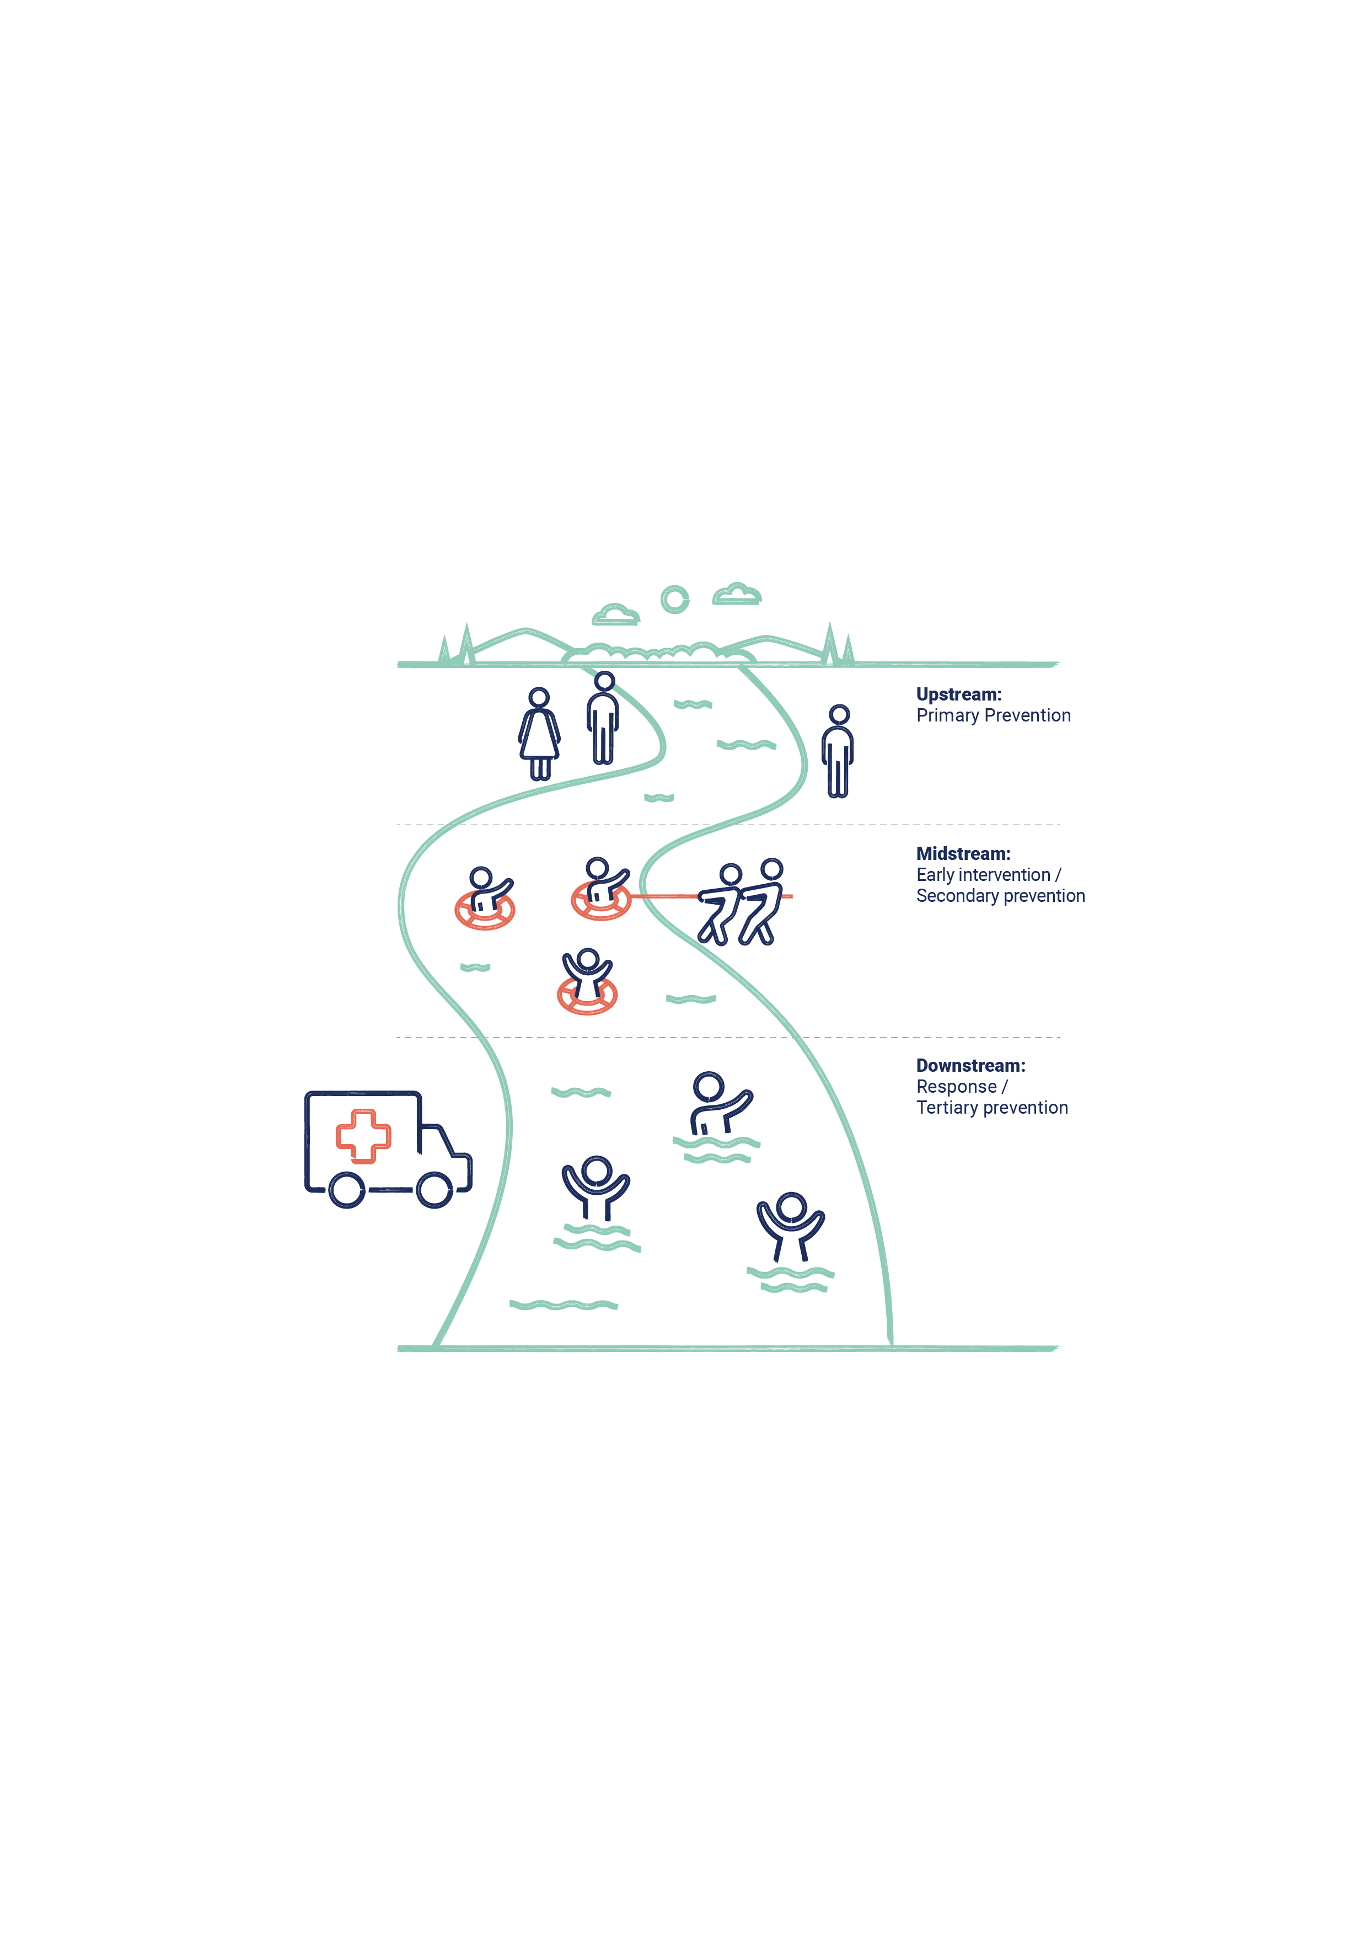A comprehensive and holistic approach to preventing violence against women must involve a continuum of interdependent and interlinked strategies, with efforts across primary prevention, early intervention, response and recovery.

***Change the story*** sets out a national population- level approach to the primary prevention of violence against women. This approach aims to drive change by framing the gendered drivers of this violence as occurring across society and affecting all women.

It aims to influence laws and policies, as well as the practices and behaviours of organisations, groups and individuals. Through a whole-of-society approach, primary prevention addresses the systems, structures, norms, attitudes, practices and power imbalances that drive violence against women.

*Change the story* identifies the four main drivers of violence against women:

* **Driver 1:** Condoning of violence against women.
* **Driver 2:** Men’s control of decision-making and limits to women’s independence in public and private life.
* **Driver 3:** Rigid gender stereotyping and dominant forms of masculinity.
* **Driver 4:** Male peer relations and cultures of masculinity that emphasise aggression, dominance and control.

Violence against women has multiple, interrelated drivers that play out across every level of society and is often experienced in combination with other forms of structural inequality and discrimination including sexism, racism, religious and cultural discrimination, colonialism, ableism, homo-, bi- and transphobia, ageism and class discrimination. These intersect with the gendered drivers of violence against women to affect the prevalence and dynamics of violence against women.

In addition, *Change the story* also identifies four reinforcing factors which each play a role in influencing the occurrence or dynamics of violence against women:

* **Reinforcing factor 1:** Condoning of violence in general.
* **Reinforcing factor 2:** Experience of, and exposure to, violence.
* **Reinforcing factor 3:** Factors that weaken prosocial behaviour (for example, natural disasters, alcohol and gambling).
* **Reinforcing factor 4:** Resistance and backlash to prevention and gender equality efforts.

As a result, **preventing this violence requires a holistic, multilayered approach.** The level of change needed requires a sustained investment in prevention, through a coordinated, long-term, national approach based on multiple, mutually reinforcing efforts.

This approach is complex and requires effective **local, state and national infrastructure to support effective primary prevention** and contribute to stopping violence against women before it starts.

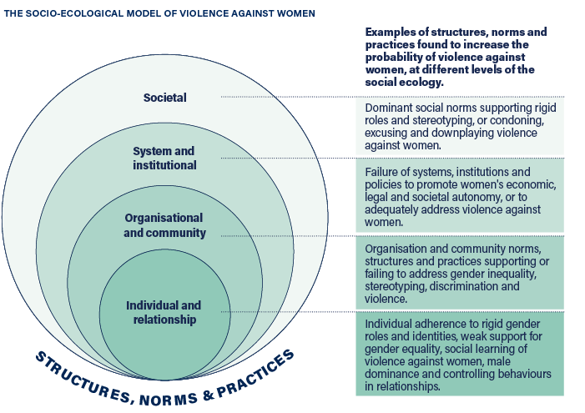

# Building the foundations for prevention

**Every government, sector, institution, organisation, community and individual has a role to play in preventing violence against women.**

As a result, it is important to create the right foundations that will ensure primary prevention efforts are coordinated, mutually reinforcing, sustainable and effective in achieving the scale of change required to stop violence before it starts.2 *Change the story* outlines what the evidence says are the key foundations for primary prevention and uses the interchangeable term*-“*prevention infrastructure”.

**‘Infrastructure’, in the context of primary prevention, is best described as the essential foundations that enable prevention efforts to be most effective and impactful**, and to ensure that they lead to sustained long term social change. Governments play a critical role in driving an effective approach to prevention and in building, investing in and supporting the prevention infrastructure.

## What are the foundations for primary prevention?3

1. Sustained political leadership
2. Policy, regulatory and legislative reform
3. Mechanisms for coordination, collaboration and quality assurance
4. Mechanisms for workforce and sector development
5. Strong evidence base, informed by ongoing data collection, research, practice and evaluation
6. Monitoring and reporting mechanisms
7. Private sector, civil society and community leadership
8. A well-resourced, independent women’s sector

### Essential foundations for primary prevention

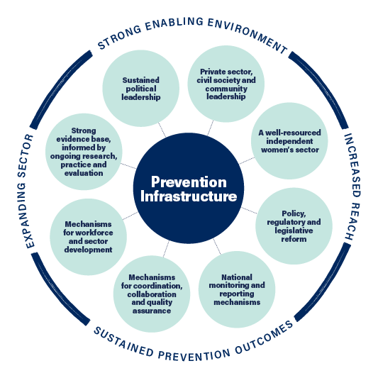

## Why focus on establishing strong foundations?

Primary prevention requires a strategic approach to ensure that the right foundations are in place to deliver effective primary prevention approaches.

**The key foundations for primary prevention are interrelated and at times interdependent.** Together the eight foundations help to ensure:

* Primary prevention is prioritised and activities sustain momentum in a strong authorising environment.
* Primary prevention activity is both evidence-based and evidence generating.
* Investment in prevention is directed to programs and initiatives that achieve outcomes.
* Primary prevention efforts within and across jurisdictions are complementary and avoid duplication.
* There is a skilled expert primary prevention workforce with sufficient investment to meet demand for prevention work and activities safely and effectively.
* A broad range of stakeholders can confidently design, implement and evaluate effective primary prevention activities.
* The impact and outcomes associated with primary prevention efforts are known, and this knowledge is used to direct investments and attention in ways that accelerate progress.

# Government actions for strong foundations

## 01. Sustained political leadership

### OUTCOME

Visible multipartisan political leadership and role modelling that sets community expectations and maintains momentum for change.

### TOP 3 ACTIONS FOR GOVERNMENTS

1. Develop and invest in evidence based primary prevention strategies and initiatives.
2. Increase the focus on men’s accountability for their use of violence, and on the role men and boys can play in prevention.
3. Develop regulatory, policy, organisational and institutional responses to increase the representation of women (from a range of diverse backgrounds and life experiences) in political systems and institutions, and formal and informal decision-making roles at all levels.

## 02. Policy, regulatory and legislative reform

### Outcome

Policy reforms directly address the gendered drivers of violence against women and drive change.

### Top 3 actions for governments

1. Develop and implement a dedicated standalone strategy for primary prevention of violence against women or include primary prevention of violence against women as a specific area within a broader strategy with dedicated actions and investment.
2. Use policy, regulatory and legislative mechanisms to increase women’s economic security, including by promoting workforce participation, equal pay and more equitable, accessible and affordable parental leave and childcare arrangements.
3. Develop and employ intersectional gender impact analysis tools in policy development, government decision making and budget processes.

## 03. Mechanisms for coordination, collaboration and quality assurance

### Outcome

Coordination, collaboration and quality assurance mechanisms ensure primary prevention efforts are evidence-based, consistent, mutually reinforcing, and able to be reproduced at scale.

### Top 3 actions for governments

1. Establish dedicated prevention agencies, peaks, organisations or networks to lead, coordinate and drive uptake of quality prevention practice, policy, research and monitoring.
2. Establish overarching coordination and advisory bodies and/or structures within and across government that guide the design, development and evaluation of prevention activities and work.
3. Develop and implement criteria for evidence-based quality assurance in program development and commissioning, including for design, implementation and evaluation.

## 04. Mechanisms for workforce and sector development

### Outcome

A strong national primary prevention workforce expands the reach and uptake of prevention policy, strategy, practice and research across the country.

### Top 3 actions for governments

1. Develop a workforce development strategy which includes the primary prevention workforce, drawing on Growing with change.
2. Invest in organisations and mechanisms to coordinate activities to develop, grow, retain and support primary prevention workforces at the national, state, regional and local levels.
3. Create opportunities for high-quality, affordable and accredited and non-accredited professional development for the existing prevention workforce, including by supporting collaborative peer learning networks and leadership programs.

## 05. Strong evidence base, informed by ongoing data collection, research, practice and evaluation

### Outcome

The evidence base clearly demonstrates what effectively prevents violence against women, how and for whom, across Australia in particular settings/sectors and contexts, and with specific population groups, cohorts, audiences and communities.

### Top 3 actions for governments

1. Invest in strategic research, data collection and data analysis into emerging issues, critical knowledge gaps, and population-level or cohort trends to continue to build the evidence base.
2. Establish mechanisms to promote strategic evidence generation, shared learning, and efficiencies, for example via establishing networks and collaborative partnerships between practitioners, researchers and policy makers.
3. Develop shared primary prevention monitoring, evaluation and learning frameworks and resources.

## 06. Monitoring and reporting mechanisms

### Outcome

Monitoring and reporting support a nuanced understanding of progress and change and promote shared learning and efficiencies, enabling governments to direct investments and attention in ways that accelerate progress.

### Top 3 actions for governments

1. Ensure that primary prevention is integrated in monitoring and evaluation frameworks of all governments.
2. Support a coordinated and consistent national approach to monitoring and reporting to demonstrate collective impact across primary prevention, early intervention, response and recovery.
3. Use established outcomes, measures and indicators (e.g., from Counting on Change) to ensure that data inputs across jurisdictions can demonstrate the collective impact of primary prevention.

## 07. Private sector, civil society and community leadership

### Outcome

Key stakeholders across the private, civil society and community sectors are mobilised to undertake prevention activity.

### Top 3 actions for governments

1. Ensure prevention strategies and plans are underpinned by the understanding that preventing violence against women is everyone’s responsibility including by outlining clear roles and responsibilities for non-government stakeholders.
2. Commission or continue to invest in promising community-led primary prevention initiatives with a goal to increase size and scale.
3. Encourage private and not-for-profit sector workplaces to promote gender equal and safe working environments and to play a role in primary prevention– for example through investing in settings-based approaches to prevention and workplace initiatives such as [Workplace Equality & Respect](https://workplace.ourwatch.org.au/).

## 08. A well-resourced, independent women’s sector

### Outcome

A well-resourced and diverse women’s sector ensures prevention efforts are informed by a well-developed understanding of the complex dynamics of violence against women, gender and other social inequalities, and holds governments accountable to their prevention commitments.

### Top 3 actions for governments

1. Support a diversity of formal and informal women’s health and rights organisations and networks to work on both preventing violence against women and advancing the rights of women more broadly.
2. Ensure equity of access to consultation and policy development opportunities, capturing from grassroots community groups and representatives of marginalised communities.
3. Adequately resource the women’s sector through short- and long-term flexible funding, and by providing other forms of capacity building support to maximise the reach and impact of their work.

# 01. Sustained political leadership

**Strong and sustained political will is crucial to drive sustainable primary prevention approaches over the long term.** Governments have the power to lead change, including through creating enabling environments to address the drivers of violence against women. Leadership is important at all levels of government, and in a multipartisan way. Political leaders can be influential in emphasising the national importance of preventing violence against women and to legitimise, support and motivate widespread efforts by a range of stakeholders.

**Political leadership has been effective in increasing the visibility of gender inequality and violence against women in Australian political discourse over the past decade**.4 It is important that political leaders continue to build on this positive momentum to achieve the social, legal, political and economic transformation required to prevent violence against women. This requires leaders to recognise and reject gendered power relationships, and to act to redistribute resources, power, authority and decision-making more equally. Political leaders can both champion gender equality and send a strong signal to the Australian public that the prevention of violence against women is a serious and urgent national priority that demands high-level action and leadership.

**CASE STUDY**

The Women’s Safety and Justice Taskforce (Queensland)

The Women’s Safety and Justice Taskforce (Taskforce) was established in March 2021 as an independent, consultative taskforce by the Queensland Government to examine coercive control and review the need for a specific offence of domestic violence and the experience of women across the criminal justice system.

The Taskforce built on the work done by the previous Special Taskforce on Domestic and Family Violence in Queensland, chaired by the Honourable Quentin Bryce AD CVO, which developed the landmark Not Now, Not Ever Report in 2015. After extensive consultation processes the Taskforce produced two Hear Her Voice reports which identified fundamental systemic and structural issues in Queensland’s justice system relating to its approach to matters of domestic, family and sexual violence and made a combined 277 recommendations for broad systemic reform. The reports have been pivotal in guiding reform priorities to address violence against women in Queensland including the establishment of a Prevention Council and the development of Queensland’s Plan for the Primary Prevention of Violence Against Women 2024-2028 to address the drivers of violence against women and prevent domestic, family and sexual violence (DFSV) from occurring.

## Key actions for government

* Develop and invest in evidence-based primary prevention strategies and initiatives.
* Increase the focus on men’s accountability for their use of violence, and the role men and boys can play in prevention.
* Develop regulatory, policy, organisational and institutional responses to increase the representation of women (from a range of diverse backgrounds and life experiences) in political systems and institutions, and formal and informal decision-making roles at all levels.
* Establish or continue to invest in dedicated, independent prevention agencies, peaks, organisations and/or networks to provide expert advice, guidance and oversight to support continued progress and momentum on prevention.
* Adopt robust approaches to prevention and gender equality across the public service.
* Make public statements about the importance of a dedicated approach to primary prevention.

# 02. Policy, regulatory and legislative reform

**Commonwealth, state and territory governments have unique access to policy, legislative and regulatory levers that are critical to facilitate large scale and long- lasting systemic and structural change across the population.** Policy, regulatory and legal reforms help drive broader societal change by shifting social norms, supporting and reinforcing prevention activities and contributing to systemic and institutional reform.

Opportunities include, for example:

* Legislation requiring workplaces to prevent (rather than only respond to) sexual harassment can help reduce this form of violence.
* Legislation requiring employers to implement gender equality strategies can help change harmful male peer relationships in the workplace and increase women’s access to positions of power and decision-making.
* Regulations to ensure safe and appropriate media reporting of violence against women can help reduce the condoning of this violence.
* Reforms to paid parental leave legislation and policy settings can enable parents to make gender equal child-rearing arrangements.

Policy levers can also create an enabling environment for other prevention activity, including in setting or sector-based work. For example, a state government policy commitment that mandates a whole-of-school approach to [*Respectful*](https://education.ourwatch.org.au/)[*Relationships Education*](https://education.ourwatch.org.au/)creates an environment that drives and supports action across the whole school sector, with the potential for broad impacts across the jurisdiction.

**CASE STUDY**

Queensland’s Plan for the Primary Prevention of Violence Against Women 2024-2028

[*Queensland’s Plan for the Primary*](https://www.publications.qld.gov.au/ckan-publications-attachments-prod/resources/5e93ad13-32a1-4444-a423-cf0bad6bc746/qld-plan-primary-prevention-violence-against-women-2024-28.pdf?ETag=acfc2622397c537fd88342a126f761ae) [*Prevention of Violence Against Women*](https://www.publications.qld.gov.au/ckan-publications-attachments-prod/resources/5e93ad13-32a1-4444-a423-cf0bad6bc746/qld-plan-primary-prevention-violence-against-women-2024-28.pdf?ETag=acfc2622397c537fd88342a126f761ae)[*2024-2028*](https://www.publications.qld.gov.au/ckan-publications-attachments-prod/resources/5e93ad13-32a1-4444-a423-cf0bad6bc746/qld-plan-primary-prevention-violence-against-women-2024-28.pdf?ETag=acfc2622397c537fd88342a126f761ae)is a 5-year plan developed by the Queensland Government to address the drivers of violence against women and prevent domestic, family and sexual violence (DFSV) from occurring.

The plan provides a blueprint for government—working in partnership with the broader community—to strengthen and expand efforts to prevent violence against women through the development and implementation of initiatives that target the underlying drivers of violence.

It sets out 4 focus areas, with corresponding strategies to be developed and implemented by the Queensland Government in partnership with

local governments, non-government organisations and the community. The four focus areas are: (1) leadership and community awareness and capability building; (2) strengthening the primary prevention workforce; (3) developing new partnerships and expanding into new

settings; and (4) engaging men and boys in primary prevention efforts. Implementation will also be supported by a dedicated Primary Prevention Monitoring and Evaluation Framework.

## Key actions for government

* Develop and implement a dedicated standalone strategy for primary prevention of violence against women or include primary prevention of violence against women as a specific area within a broader strategy or plan.
* Use policy, regulatory and legislative mechanisms to increase women’s economic security, workforce participation and pay equality including by promoting more equitable, accessible and affordable parental leave and childcare arrangements.
* Develop and employ intersectional gender impact analysis tools in policy development, government decision-making and budget processes.
* Embed gender equality goals and targets in legislation (e.g.: >40% representation for each gender on public committees and boards).
* Enact policy and legislation change to address the intersecting drivers of violence against Aboriginal and Torres Strait Islander women including the ongoing impacts of colonisation.5
* Enact or strengthen policy and legislation to address racism, ableism and other forms of structural discrimination that drive violence again women.

# 03. Mechanisms for coordination, collaboration and quality assurance

**Mechanisms that enable coordination and collaboration across jurisdictions, sectors and settings, are essential components of a national effort to prevent violence against women.** These are required both within and across government, as well as between government and other key stakeholders.

These mechanisms:

* promote consistent, evidence-based primary prevention practice
* support the scaling-up, systematisation and embedding of approaches that are effective at preventing violence against women
* ensure consistency between legislative, regulatory and policy reforms, programs, communications campaigns, and other prevention efforts
* enable mutually reinforcing activities across multiple levels and settings, alongside other social policy issues
* support whole of government approaches to prevention and the integration of gender equality and violence prevention into the work of established agencies, organisations and networks, and
* support the identification of links and connections across policies and portfolios.

Quality assurance mechanisms are important and can be embedded in program design, prevention practice and techniques, setting- or sector-based activity, workforce development, funding and/or evaluation. This includes, for example, developing consistent criteria for program funding and evaluation. The implementation and monitoring of setting/sector-specific practice standards, models and frameworks can help ensure a consistent and high-quality approach to prevention practice and programming across different levels and sectors.6

**CASE STUDY**

**NT Domestic, Family and Sexual Violence Advisory Forum (Northern Territory)**

The Northern Territory Domestic, Family, and Sexual Violence Advisory Forum advises the NT Government on the implementation, monitoring and evaluation of the NT DFSV Framework and action plans. It is intended to foster shared understanding, engagement, and collaboration among members. It promotes integrated and collaborative DFSV policy development and service delivery while clarifying roles and responsibilities across the NT Government and non-government organisations

## Key actions for government

* Establish dedicated prevention agencies, organisations or networks to lead, coordinate and drive uptake of quality prevention practice, policy, research and monitoring.
* Establish overarching coordination and advisory bodies and/or structures within and across government that guide the design, development and evaluation of prevention policy and programming
* Establish advisory groups or bodies to guide prevention work, including with diverse representation from relevant government departments, civil society, public and private sector agencies.
* Develop and implement criteria for evidence-based quality assurance in program development and commissioning, including for design, implementation and evaluation.
* Invest in sector or settings-based working groups or communities of practice. Develop, employ and monitor practice standards for prevention work across sectors and settings.

# 04. Mechanisms for workforce and sector development

The success of Australia’s efforts to prevent violence against women relies on the size and strength of the national primary prevention workforce and the capacity of this workforce to plan, implement and scale-up, primary prevention initiatives. Governments have an important role to play in establishing mechanisms to create this capacity. When governments develop primary prevention strategies or plans, it is important to prioritise the development of the workforce needed to effectively implement the actions and deliver outcomes.

The existing primary prevention workforce is small, specialist, disparate and lacking in a collective professional identity.7 Primary prevention work is occurring within a range of organsiations including those that offer early intervention and response programs and services. Significant time and resources need to be invested into developing the skills, size and coordination of the workforce in all states and territories. Workforce and sector development is needed to meet both the existing demand for prevention activities in various settings/sectors safely and effectively, and to continue to expand the reach and uptake of prevention policy, strategy, practice and research across the country.

Our Watch’s resource, [*Growing with change:*](https://www.ourwatch.org.au/resource/growing-with-change-developing-an-expert-workforce-to-prevent-violence-against-women/)[*Developing an expert workforce to prevent violence*](https://www.ourwatch.org.au/resource/growing-with-change-developing-an-expert-workforce-to-prevent-violence-against-women/)[*against women*](https://www.ourwatch.org.au/resource/growing-with-change-developing-an-expert-workforce-to-prevent-violence-against-women/)identifies the key elements to prevention workforce development: workforce planning; workforce preparation and pathways; sector governance and coordination; professional development; and working conditions. *Growing with change* outlines priority actions and case study examples within these elements.

**SPOTLIGHT**

The primary prevention workforce

The primary prevention workforce is diverse and multidisciplinary, and includes, for example:

* Specialist primary prevention practitioners delivering primary prevention initiatives.
* Specialist primary prevention policy advisors, researchers, communicators and evaluators.
* Human resource professionals leading workplace prevention programs such as those necessary to meet positive duty obligations associated with Respect@Work reforms.
* Education Departments and school staff that implement and deliver evidence-based whole-of-school Respect Relationships Education.
* Harm prevention or student wellbeing teams in universities tasked with preventing gender-based violence in higher education.
* Specialist practitioners or facilitators that work with boys and men to support the development of positive masculinities.
* Sports administrators who are leading club-based prevention activity.

**SPOTLIGHT**

T

## Key actions for government

* Develop a workforce development strategy which includes the primary prevention workforce, drawing on *Growing with change*.
* Invest in organisations and mechanisms to coordinate activities to develop, grow, retain and support primary prevention workforces at the national, state, regional and local levels.
* Establish clear pathways into the workforce, including higher education and vocational education and training courses.
* Create opportunities for high-quality, affordable and accredited and non- accredited professional development for the existing prevention workforce, including by supporting collaborative peer learning networks and leadership programs.
* Establish research and data collection mechanisms to increase understanding of the size, strengths and needs of the workforce.
* Develop capability frameworks, practice standards or codes of practice that inform shared conceptualisation and design of roles and positions and a sense of professional identity.

**CASE STUDY**

**Foundations** for Change Framework (Western Australia)

Preventing Violence Together (PVT) is a state-wide initiative supporting the growing primary prevention infrastructure in Western Australia. PVT established [Foundations for](https://pvt.org.au/framework/)  [Change](https://pvt.org.au/framework/), a primary prevention framework with a focus on building workforce capabilities to support evidence-based primary prevention programming and practice in Western Australia.

# 05. Strong evidence base, informed by ongoing data collection, research, practice and evaluation

**Primary prevention work is underpinned by decades of research, scholarship and innovation, which have together built a strong evidence base.** Like all social issues, it is important to maintain efforts to continue to build, deepen and strengthen the evidence base to ensure that prevention efforts remain responsive to changing social dynamics, emerging data and trends, and evolving needs.

Types of knowledge that inform the prevention evidence base include academic research, program evaluations, expertise from practitioners, and the knowledge held by people with diverse lived experiences of violence and/or gender and other inequalities. Ongoing investment in research and evaluation will strengthen our understanding of what effectively prevents violence against women (and what does not), how and for whom, across Australia.

Developing the evidence base should be strategic and guided by identified gaps in knowledge and needs. This requires fostering strong connections between policy makers, practitioners and academics and investing in collaborative partnerships. It also requires the development and/or implementation of evaluation frameworks for primary prevention activities to support knowledge building and sharing for the purpose of mutual learning across sectors and stakeholders.

Investing in data collection, research, monitoring and evaluation is a critical part of providing a strong foundation for ongoing prevention work.

**CASE STUDY**

**Support for monitoring and evaluation of primary prevention projects funded under the Victorian *Free from Violence* First Action Plan (Victoria)**

ANROWS was contracted by the Victorian Department of Premier and Cabinet from June 2019 to December 2020 to provide monitoring and evaluation support to the Victorian *Free from Violence* initiative.

ANROWS provided support to 44 projects across four funding streams. The capacity building support involved:

* developing coherent and easy-to-use evaluation planning and reporting templates
* providing tailored evaluation capacity building support
* synthesising evaluation reports from different funding streams, and
* developing a single survey instrument for use across all the projects.

This is a good example of how strategic government investment in skills development can build evaluation capacity within organisations to broaden and strengthen the evidence base.

## Key actions for government

* Develop or continue to support existing research strategies or priorities that identifies gaps and research needs.
* Invest in strategic research, data collection and data analysis into emerging issues, critical knowledge gaps, and population- level or cohort trends to further an understanding of violence against women.
* Establish mechanisms to promote strategic evidence generation and shared learning, for example via establishing networks and collaborative partnerships between practitioners, researchers and policy makers.
* Invest in primary prevention evaluation capacity building, including by developing evaluation and learning frameworks and standardised evaluation tools for government bodies that design and commission prevention programs and community organisations that deliver them.
* Ensure information sharing and knowledge translation so that research can be applied in practice and good practices can be identified and scaled up.

# 06. Monitoring and reporting mechanisms

Monitoring and reporting of primary prevention refers to measuring change in the norms, practices and structures that both drive and reinforce violence against women. This helps to understand the efficacy of primary prevention initiatives and assists governments to report on the outcomes of their investment in prevention strategies.

Analysing and applying data gathered during monitoring and reporting can help identify where, across society, positive changes occur. This enables policy makers to build and share knowledge about enablers and barriers to preventing violence against women and ultimately to direct investments in ways that accelerate progress.

The Our Watch resource [*Counting on change*](https://www.ourwatch.org.au/change-the-story/counting-on-change)provides a framework for this kind of monitoring, and the [*Tracking progress in prevention*](https://www.ourwatch.org.au/change-the-story/tracking-progress-in-prevention)report translates this into practice, providing both a baseline report on progress, and an example of how monitoring could be done on an ongoing basis*.*

The Outcomes Framework under the National Plan and joint Australian, state and territory government initiatives under the Plan present efforts towards

a more consistent approach to monitoring and reporting of progress. The Reporting Framework underpinning [*Working for Women: A Strategy for*](https://genderequality.gov.au/)[*Gender Equality*](https://genderequality.gov.au/)also presents further efforts to map out outcomes related to gender equality more broadly.

However, there are opportunities for all levels of government to significantly improve the monitoring of outcomes in relation to primary prevention and ensure coordination of reporting efforts across these frameworks.

**CASE STUDY**

Family Violence Reform Implementation Monitor (Victoria)

The Family Violence Reform Implementation Monitor (FVRIM) was established in

2017 after the Royal Commission into Family Violence. The FVRIM oversaw Victoria’s efforts in implementing the recommendations for reform, engaging with government and sector stakeholders to identify best practices and emerging risks. Annual reports from 2017 to 2020 tracked the progress and effectiveness

of reforms, including a focus on primary prevention system architecture. The Primary Prevention report evaluated efforts to establish effective primary prevention structures and enhance collaboration between government and non-government sectors, offering insights for ongoing improvement.

## Key actions for government

* Ensure that primary prevention is integrated in monitoring and evaluation frameworks of all governments.
* Support a coordinated and consistent national approach to monitoring and reporting to demonstrate collective impact across primary prevention, early intervention, response and recovery.
* Use established outcomes, measures and indicators (e.g., from *Counting on Change*) to ensure that data inputs across jurisdictions can demonstrate the collective impact of primary prevention.
* Monitor progress and collect data against short-, medium-, and long-term measures contained in relevant jurisdictional outcomes frameworks to strengthen the connection between government-funded initiatives and population-level change.
* Ensure a whole-of-government approach to data collection, analysis and dissemination to demonstrate progress against outcomes.
* Foster a culture of continuous improvement within and across governments and the prevention sector by establishing mechanisms for reporting and sharing data.
* Provide capacity building and training in monitoring and reporting to the public service and funded organisations so they can improve data collection and quality.
* Develop guidance documents (e.g., data dictionaries) that outline common standards and include standardised templates and tools to support high-quality data collection and analysis that can be aggregated.
* Establish and support mechanisms, offices and bodies which have responsibility for contributing to national, state and territory monitoring to ensure appropriate expertise and visibility of primary prevention.

# 07. Private sector, civil society and community leadership

**Effective private sector, community and civic leadership supports delivery of consistent and mutually reinforcing prevention strategies across the country, and helps build broad, nationwide support for such efforts.** This leadership has the potential to draw national attention – across the public, media, institutions, and all levels of government – to the importance of prevention and help to promote widespread participation by a range of stakeholders. Leadership from organisations that represent specific settings and sectors (such as tertiary education, workplaces or sporting codes), and those that represent specific communities (such as migrant and refugee communities) is particularly valuable.

Private sector, civil society and community organisations can use their influence to shape community attitudes and have a critical role to play in advocating for gender equality and setting an expectation of zero tolerance for violence within their spheres of influence. There are also increasing expectations and requirements on private sector organisations to play a role in prevention and in many areas they are taking a leadership role. Governments can contribute to and support this work through legislative, policy and regulatory reform, including for example through positive duty obligations, or in regulating private sector activities where their good and services interact with the drivers or reinforcing factors associated with violence against women, such as pornography, social media or dating apps

**CASE STUDY**

Respect in Mining (Western Australia)

The Respect in Mining Program, a collaboration between the Department of Communities and the Department of Mines, Industry Regulation and Safety,

aims to embed gender equality within the Western Australian mining sector. Through a comprehensive suite of tools and resources, the program supports small and medium mining organisations in implementing gender equality policies and practices. It addresses the gendered drivers of violence, the impact of gender inequality on women’s safety and economic security, and gender disparities in leadership. The program emphasises setting clear standards, policies, and procedures

to address sexual harassment improve workplace culture and practices. The Respect in Mining program is strategically aligned with the outcomes of [Stronger](https://www.wa.gov.au/government/publications/stronger-together-was-plan-gender-equality) [Together - WA’s Plan for Gender Equality](https://www.wa.gov.au/government/publications/stronger-together-was-plan-gender-equality), implementation of the [Respect@Work](https://humanrights.gov.au/our-work/sex-discrimination/publications/respectwork-sexual-harassment-national-inquiry-report-2020) [Repor](https://humanrights.gov.au/our-work/sex-discrimination/publications/respectwork-sexual-harassment-national-inquiry-report-2020) , recommendations of the [Enough](https://www.parliament.wa.gov.au/parliament/commit.nsf/(Report%2BLookup%2Bby%2BCom%2BID)/EF1DF1A3F5DF74A848258869000E6B32/%24file/20220621%20-Report%20No%202.pdf) [is Enough Report](https://www.parliament.wa.gov.au/parliament/commit.nsf/(Report%2BLookup%2Bby%2BCom%2BID)/EF1DF1A3F5DF74A848258869000E6B32/%24file/20220621%20-Report%20No%202.pdf) and the development of WA’s first Sexual Violence Prevention and Response Strategy.

## Key actions for government

* Ensure prevention strategies and plans are underpinned by the understanding that preventing violence against women is everyone’s responsibility including by outlining clear roles and responsibilities for non-government stakeholders.
* Commission or continue to invest in promising community-led primary prevention initiatives with a goal to increase size and scale.
* Encourage private and not-for-profit sector workplaces to promote gender equal and safe working environments and to play a role in primary prevention– for example through investing in settings-based approaches to prevention and workplace initiatives such as [Workplace Equality & Respect](https://workplace.ourwatch.org.au/resource/workplace-equality-and-respect-standards/).
* Strengthen the prevention capability of private and community organisations by creating opportunities for cross sector partnerships with specialist primary prevention organisations, including in specific settings (i.e. tertiary education, sports).
* Consider government regulation of private sector activity to improve women’s safety.
* Encourage companies to advance equality in leadership, representation and decision including by increasing representation on private boards and in executive positions.

# 08. A well-resourced, independent women’s sector

Meaningfully and sustainably engaging women’s civil society in advocacy, leadership, awareness-raising, and community education, is critical to the success of prevention activity in Australia.Maintaining support for the women’s sector includes supporting women’s rights and women’s health civil society organisations, networks and alliances. There is value in governments working in partnership with women’s organisations, specialist services and community-controlled organisations which are working on gender equality, women’s health, and domestic, family and sexual violence.

These types of organisations are uniquely placed to:

* provide thought leadership and subject matter expertise, including place-based knowledge and practice wisdom.
* build evidence and share knowledge to inform evidence-based policy and decision making.
* ensure that prevention efforts are informed by a well-developed understanding of the complex dynamics of violence against women, gender and other social inequalities.

**CASE STUDY**

Victorian Women’s Health Services Network

The [Victorian Women’s Health Services](https://www.whsn.org.au/our-priorities) [Network](https://www.whsn.org.au/our-priorities) is a collective of 12 state government- funded women’s health services. As a self- organised network, the services champion gendered health promotion, primary prevention and gender equity across settings, policy and practice. The Network leads and coordinates local and statewide health promotion activities that reach across every region of the state and embed prevention across a range of portfolios. The Network is a crucial conduit between population-level health frameworks and community-level action, supporting all three levels of government to achieve the visions set out in their legislation, policies and strategies.

This includes delivering key components of the Victorian Government’s gender equality strategy [Our equal stat](https://www.vic.gov.au/our-equal-state-victorias-gender-equality-strategy-and-action-plan-2023-2027)e and implementing [Free from violence: Victoria’s strategy to](https://www.vic.gov.au/free-violence-victorias-strategy-prevent-family-violence) [prevent family violence and all forms of](https://www.vic.gov.au/free-violence-victorias-strategy-prevent-family-violence) [violence against women](https://www.vic.gov.au/free-violence-victorias-strategy-prevent-family-violence). The Network leads more than 500 Victorian public, community and private organisations to develop, deliver and evaluate coordinated best practice prevention work through the nine regional violence prevention partnerships and strategies.8

These partnerships cover every Victorian local government area and deliver high-quality evidence-based training and professional development for the state’s violence prevention workforce and contributors.

## Key actions for government

* Support a diversity of formal and informal women’s health and rights organisations and networks to work on both preventing violence against women and advancing the rights of women more broadly.
* Ensure equity of access to consultation and policy development opportunities, capturing a diversity of voices from grassroots community groups and representatives of marginalised communities.
* Adequately resource the women’s sector, through a range of short- and long-term flexible funding, and by providing other forms of capacity building support to maximise the reach and impact of their work. Ensure people with lived experience and women’s organisations are meaningfully involved in contributing to decision-making processes. This may include for example, establishing mechanisms for partnership, collaboration and co-design of any development, implementation, monitoring, and reporting of activity associated with prevention policy, program, grants and investment.
* Design governance and funding arrangements to recognise and support the development and preservation of independence.

# Endnotes

1. Our Watch. (2021). [*Change the story: A shared framework for the primary prevention of violence against women in Australia.*](https://www.ourwatch.org.au/change-the-story)
2. See for example, Michau, L., Horn, J., Bank, A., Dutt, M., & Zimmerman, C. (2014). Prevention of violence against women and girls: Lessons from practice. Lancet, 385(9978), 1672–84; UN Women and World Health Organization. (2020). Strengthening the enabling environment for VAW prevention; and Dyson, S. (2012). *Preventing violence against women and girls: From community activism to government policy: Working paper*, Partners for Prevention.
3. Our Watch. (2021). [Change the story](https://www.ourwatch.org.au/change-the-story), p.100.
4. Our Watch. (2020). [Tracking progress in prevention](https://www.ourwatch.org.au/change-the-story/tracking-progress-in-prevention), p. 14.
5. Our Watch. (2018). *Changing the picture: A national resource to support the prevention of violence against Aboriginal and Torres Strait Islander women and their children.* This evidence-based framework outlines a range of actions that address the drivers of violence against Aboriginal communities.
6. Carmody, M., Evans, S., Krogh, C., Flood, M., Heenan, 8M., & Ovenden, G. (2009). *Framing best practice: National standards for the primary prevention of sexual assault through education.* National Sexual Assault Prevention Education Project for NASASV, University of Western Sydney
7. Our Watch. (2023). [*Growing with change:*](https://www.ourwatch.org.au/change-the-story/growing-with-change)[*Developing an expert workforce to prevent violence*](https://www.ourwatch.org.au/change-the-story/growing-with-change)[*against women*](https://www.ourwatch.org.au/change-the-story/growing-with-change)*.*
8. Impact Economics and Policy. (2023*).* [*Return*](https://www.whsn.org.au/an-economic-case)[*on Equity - Health and economic dividends from*](https://www.whsn.org.au/an-economic-case)[*investing in Women’s Health Services.*](https://www.whsn.org.au/an-economic-case) Women’s Health Services Network.