Our Watch submission to the State Disability Plan and the Victorian Autism Plan 2027 – 2031
Prepared by Our Watch
31 July 2026

Acknowledgement of Country
Our Watch acknowledges the Traditional Owners of the land across Australia on which we work and live. We pay respects to Elders past and present and recognise the continuing connection Aboriginal and Torres Strait Islander people have to land, culture, knowledge, and language for over 65,000 years.
As a non-Aboriginal organisation, Our Watch understands that violence against Aboriginal and Torres Strait Islander women and children is a whole of community issue. As highlighted in Our Watch’s national resource Changing the picture, there is an intersection between racism, sexism, and violence against Aboriginal and Torres Strait Islander women.
Our Watch has an ongoing commitment to the prevention of violence against Aboriginal and Torres Strait Islander women and children, who continue to experience violence at significantly higher rates than non-Aboriginal women. We acknowledge all Aboriginal and Torres Strait Islander people who continue to lead the work of sharing knowledge with non-Aboriginal people and relentlessly advocate for an equitable, violence-free future in Australia.

About Our Watch
Our Watch is a national leader in the primary prevention of violence against women and their children in Australia with the vision of an Australia where women and their children live free from all forms of violence. We are an independent, not for profit organisation established by the Commonwealth and Victorian Governments in 2013. All Australian governments are members of Our Watch.
As the national leader in prevention, Our Watch has developed a series of national frameworks built upon decades of evidence, engagement with advocates, and embedded lived experience to prevent violence against women and their children. The frameworks focus on addressing the gendered drivers of violence and identify essential actions to prevent violence before it occurs or is at risk of occurring.
- Change the story – a national evidence-based framework to guide a coordinated and effective national approach to preventing violence against women
- Changing the picture - A national resource to support the prevention of violence against Aboriginal and Torres Strait Islander women and their children
- Changing the landscape - A national resource to prevent violence against women and girls with disabilities developed in partnership between Our Watch and Women with Disabilities Victoria.
Our Watch also has a forthcoming framework to prevent violence against LGBTQIA+ people, produced in partnership with Rainbow Health Australia.

About this submission
Our Watch acknowledges the significant progress achieved to date under the Inclusive Victoria: State Disability Plan (2022–2026) and the Victorian Autism Plan (2023-2025) to embed intersectional and disability-inclusive approaches and welcomes the opportunity to contribute to the development of the State Disability Plan and the Victorian Autism Plan 2027 – 2031.
This submission focuses on opportunities to better integrate primary prevention evidence into the State Disability Plan and the Victorian Autism Plan 2027 – 2031 informed by the findings and recommendations of Changing the landscape and the accompanying Framework for Action developed by Our Watch and Women with Disabilities Victoria.
The Framework for Action translates Changing the landscape into short, medium, and long-term actions for change that can be implemented by governments. A tailored version of the Framework for Action has been provided to the Victorian Government.

Summary of recommendations
Our Watch recommends that the Victorian Government:
- Strengthen focus on gender as a factor influencing disability across the State Disability Plan and the Victorian Autism Plan 2027-2031 and continue to work in partnership with women and girls with disability and autistic women and girls.
- Review priority area commitments and actions across all Pillars of the Plans to identify and address the specific needs of women and girls with disability and autistic women and girls.
- Maintain the Inclusive Communities Pillar and an action to Change Community Attitudes, with a focus on transforming ableist and sexist attitudes.
- Maintain the Fairness and Safety Pillar in the next Plans and align with Changing the landscape.
- Include actions in the State Disability Plan 2027-2031 that continue to foster and support collaboration between disability and primary prevention organisations and sectors to understand, counter and prevent gender-based violence.
- Incorporate primary prevention actions in the Victorian Autism Plan 2027 – 2031, which are co-designed with autistic women and girls with expertise in violence prevention.
- Continue to implement Respectful Relationships Education with an intersectional approach that meets the needs of students with disability and consider including digital literacy and online safety education.
- Continue to provide support for disability advocacy pathways.
- Review the employment priority to include outcomes of increasing employment pathways and economic independence of women with disability and autistic women, including representation in leadership roles.
- Actions to enhance inclusive workforces should address gender inequality and ableism.
- Actions under Pillar 2 should leverage other Victoria Government housing strategies to improve equitable access for women and girls with disability and autistic women and girls to secure affordable housing.
- Align with Changing the Picture in future development of actions to prevent violence against Aboriginal and Torres Strait Islander women and girls with disability and continued focus on agencies delivering the systemic reforms including self-determination.
- As part of Closing the Gap National Agreement priority reform one, partner with Aboriginal and Torres Strait Islander peoples to address the legacies and ongoing impacts of colonisation on Aboriginal and Torres Strait Islander women and girls with disabilities.
- As part of Closing the Gap National Agreement priority reform two, resource Aboriginal and Torres Strait Islander led organisations to support and promote the rights of Aboriginal and Torres Strait Islander women with disabilities.
- Strengthen the evidence base about what works to prevent violence against women and girls with disabilities through program-level reporting and evaluation that addresses the gendered and ableist drivers of violence.
- Address data gaps in the Outcomes Framework through inclusion of measures drawn from the National Community Attitudes Towards Violence Against Women Survey (NCAS), and through improved disaggregation of data by disability, gender, age, location, sexual orientation, and cultural and linguistic diversity.
- Implement the recommendations to adopt an intersectional approach to reporting for the Outcomes Framework for the Disability Plan and Autism Plan presented in the Mid-Way Review Report.

Please contact Sanjugta Vas Dev, Director Government Relations, Policy and Evidence, at sanjugta.vasdev@ourwatch to discuss.

Ending violence against women and girls with disabilities
Violence against women is a national emergency, but for women and girls with disability who face both sexism and ableism, the rates of abuse are both higher and more severe than for women without disability.
Women with disability experience disproportionately high rates of violence in Australia. In the 2016 Personal Safety Survey, more than half (57%) of women with disability reported having experienced sexual harassment since the age of 15. Nearly one in three reported having experienced emotional abuse by a partner (32%) or intimate partner violence (30%), while one in four (25%) had experienced sexual violence. Across all four measures, women with disability reported higher rates than men with disability.
Women and girls with disability not only experience the same forms of violence as other women, but also disability-specific forms of violence. This violence occurs across a wider range of settings and from a broader range of perpetrators, including carers and support workers. In 2021–22, women with disability were more likely than women without disability to have experienced physical violence, sexual violence, and emotional abuse by a cohabiting partner in the previous two years. The difference was particularly marked for sexual violence, experienced by 4.0% of women with disability compared with 2.5% of women without disability.
Experiences of violence are shaped further by other forms of intersecting oppression and discrimination. This includes racism, heteronormativity, classism, and ageism. Evidence from the Royal Commission into Violence, Abuse, Neglect and Exploitation of People with Disability found that young women with disability, Aboriginal and Torres Strait Islander women with disability, and women with psychosocial or intellectual disabilities are at particularly high risk of violence.
Limitations in the available data mean these figures are likely to underestimate the prevalence of violence against women with disability. Participants may not disclose violence, while the exclusion of people living in care facilities and sensitive questions from proxy interviews means women with profound or severe communication disability are under-represented. Research, while limited, suggests autistic women experience higher rates of domestic, family and sexual violence when compared to autistic men and non-autistic women. There is limited evidence on the intersection of autism and experiences of family violence, including the prevention of gender-based violence for people with autism.

Changing the landscape: a prevention framework
Our Watch’s national framework, Changing the landscape highlights gender inequality and ableism as the two consistent intersecting drivers of violence against women and girls with disability. The framework outlines the gendered and ableist drivers of this violence as follows:
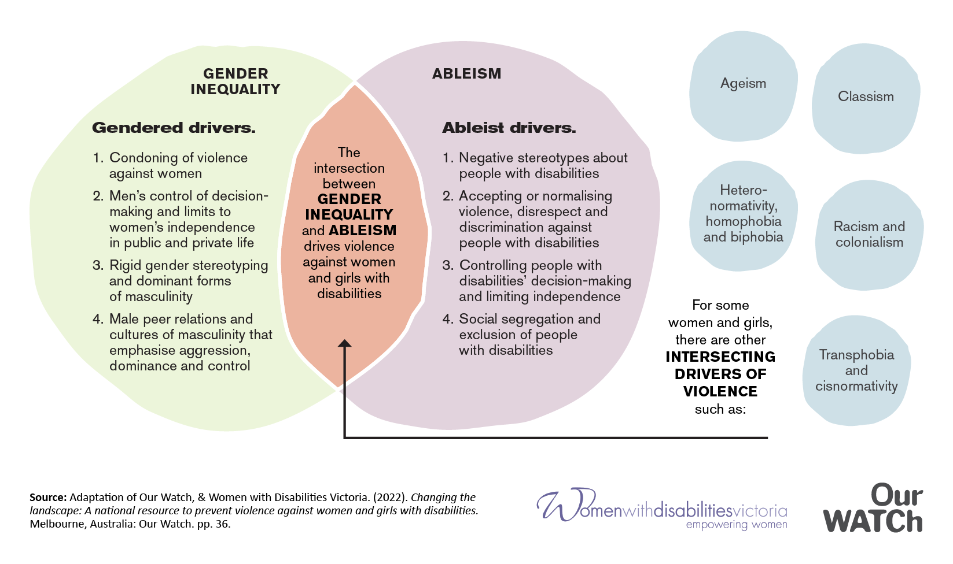
As a prevention framework, Changing the landscape sets out the essential actions needed to address these intersecting drivers and stop violence before it starts. It makes clear that to stop violence against women and girls with disability we need to:
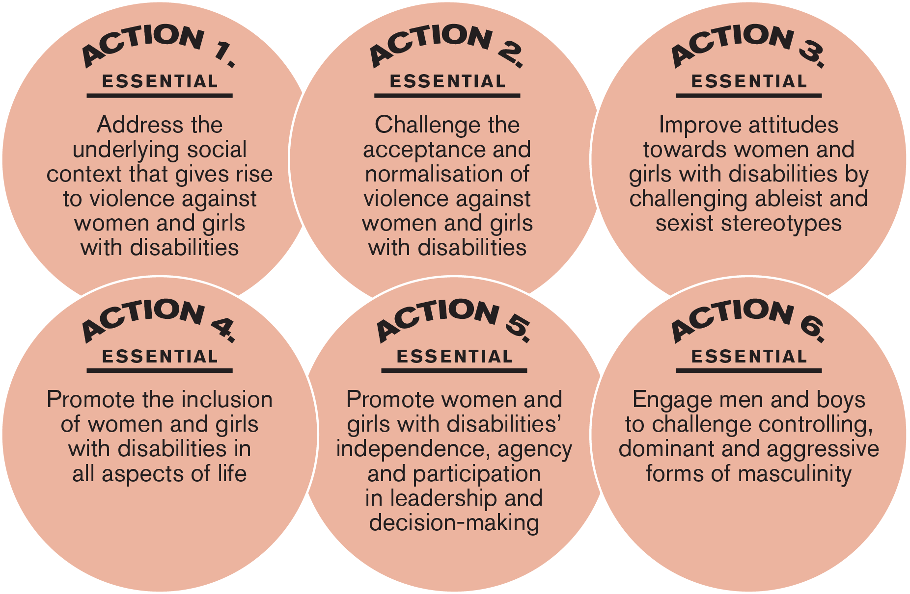

Applying a gendered lens
Overall, Our Watch recommends that the Victorian Government strengthen its consideration of gender as a factor shaping the life experiences of women and girls with disability across all Pillars of the State Disability Plan and the Victorian Autism Plan 2027 – 2031. This will support the ability of both the plans to address the drivers of violence and contribute to preventing violence against women and girls with disability.
Recommendations
- Strengthen focus on gender as a factor influencing disability across the State Disability Plan and the Victorian Autism Plan 2027-2031, and continue to work in partnership with women and girls with disability and autistic women and girls to prevent violence through understanding and highlighting the gendered and ableist drivers of violence.
- Review priority area commitments and actions across all Pillars of the Plans to identify and address the specific needs of women and girls with disability and autistic women and girls. The format of this review should be co-designed with women and girls with disability and autistic women and girls, with expertise in violence prevention.

Response to Engagement Paper

Pillar 1: Inclusive Communities & Pillar 3: Fairness and safety
Pillar 1 – Inclusive Communities
Our Watch is supportive of the current structure of the Disability Plan (2022–2026) and Victorian Autism Plan (2023-2025) as they provide the opportunity to address the key drivers of violence against women and girls with disability (ableism and gender inequality) in Pillars 1 and 3.
Our Watch commends the intersectional approach to Changing Community Attitudes under the Inclusive Communities Pillar in the Disability Plan (2022–2026). Changing community attitudes includes 5 actions to collectively co-design campaigns with people with disability that promote inclusive employment, challenge attitudes towards family violence, and showcase positive representation of LGBTIQA+, First Nations, multicultural and multi-faith communities.
The Autism Plan Refresh 2023 also included actions under the Inclusive Communities Pillar to implement public education campaigns applying an intersectional lens to enhance community education and awareness around the needs and experiences of autistic people, including autistic women and girls. Our Watch considers these as strengths in the current plans that should be carried forward and built upon in the State Disability Plan and the Victorian Autism Plan 2027 – 2031.

Pillar 3 – Fairness and Safety
Our Watch supports the inclusion of a Fairness and Safety Pillar as this Pillar incorporates actions to address the high levels of violence experienced by people with disability. Engagement on the State Disability Plan and the Victorian Autism Plan 2027 – 2031 in 2026 highlighted significant concerns about discrimination, abuse and safety for people with disability. Of the respondents, 74% identified as women and 29% as LGBTQIA+.
Half of all respondents reported experiencing abuse, discrimination or unfair treatment from services in the previous 12 months. These experiences were particularly common among autistic and neurodivergent people and those with neurodevelopmental, psychosocial or chronic illness-related disabilities. Despite the prevalence of these experiences, 62% of those affected did not report what had happened.
The Disability Plan (2022–2026) explicitly acknowledges the need to prevent the high rates of gender-based violence by understanding and highlighting its drivers as a commitment under action 3.4 – Family and Sexual Violence. This has included work led by Women with Disabilities Victoria, and specifically the Gender and Disability Workforce Development Program.
Research undertaken by The University of Melbourne with women with disability indicates that disability support workers are a key setting for the primary prevention of violence. The State Disability Plan 2027 – 2031 has the opportunity to recognise the importance of primary prevention in disability support workers by including actions to build capability within the disability services sector to address the drivers of violence. The primary prevention actions in the State Disability Plan 2027 – 2031 require a continued focus, including those aimed at building capability of the sector to prevent violence.
While the Autism Plan Refresh 2023 saw the inclusion of several actions around family and sexual violence reforms under the Fairness and Safety Pillar these initiatives are largely focused on intervention, response, and recovery.
Change the Story highlights that a comprehensive and holistic approach to ending violence against women must involve a continuum of interdependent and interlinked strategies addressing primary prevention, intervention, response, and recovery collectively. As such, co-designed actions to support the primary prevention of violence against autistic women and girls should be incorporated into the Victorian Autism Plan 2027 – 2031.
Recommendations
- Maintain the Inclusive Communities Pillar and an action to Change Community Attitudes in the State Disability Plan and the Victorian Autism Plan 2027 – 2031. Actions to change community attitudes include a focus on transforming ableist and sexist attitudes towards women and girls with disabilities, and autistic women and girls. For example, this could include investment in community education and behaviour change initiatives that challenge sexist and ableist stereotypes.
- Maintain the Fairness and Safety Pillar in the next Plans. Align with Changing the landscape and include an acknowledgement of the gendered and ableist drivers underpinning violence against women and girls with disabilities and autistic women and girls.
- Include actions in the State Disability Plan 2027-2031 that continue to foster and support collaboration between disability and primary prevention organisations and sectors to understand, counter and prevent gender-based violence. Build upon the primary prevention actions and partnerships in the Disability Plan (2022–2026) and include building the capability of disability support workers to address the gendered drivers as a key primary prevention setting.
- Incorporate primary prevention actions in the Victorian Autism Plan 2027 – 2031, which are co-designed with autistic women and girls with expertise in violence prevention. Build on existing actions in intervention, response and recovery.

Pillar 2: Health, Housing, and Wellbeing & Pillar 4: Opportunity and Pride
Respectful Relationships Education
Our Watch notes the importance of continuing action under the Inclusive Victoria: State Disability Plan (2022–2026) Opportunity and Pride Pillar to embed a Respectful Relationships Education whole-of-school approach, with tailored, intersectional approaches to meet the needs of students with disability. Respectful Relationships Education which engages schools as workplaces, education institutions and community hubs, offers the most promising approach to embedding gender equality and addressing the drivers of gender-based violence through education settings.
Our Watch recommends considering inclusion of digital literacy and online safety education, due to the prevalence of technology facilitated gender-based violence in Australia to support the safety of women and girls with disability. Women and girls with disability are at higher risk of experiencing technologically facilitated abuse within the context of family, domestic and sexual violence, and people with disability experience more barriers to help-seeking.
Addressing reinforcing factors
While gender inequality and ableism are the two consistent drivers of violence against women and girls with disability, there are a range of other reinforcing factors that may play a role. Change the Story points to four reinforcing factors of violence against women including the condoning of violence in general, experience of, and exposure to violence, factors that weaken prosocial behaviour and backlash and resistance to prevention and gender equality.
Change the story explains that these reinforcing factors are different to the gendered drivers as they do not in themselves explain the prevalence of violence against women. However, they can interact with the gendered drivers to increase the probability or frequency of violence against women.
Changing the landscape identifies additional reinforcing factors that interact with gender inequality and ableism and can increase the likelihood, frequency or severity of violence against women and girls with disability. These reinforcing factors are outcomes of ableism and include employment discrimination, economic inequality, and limited access to housing, transport, education and other public services.
Our Watch acknowledges the important work of the Disability Plan (2022–2026) and Victorian Autism Plan (2023-2025) in addressing the reinforcing factors for people with disability through the Health, Housing, and Wellbeing Pillar and Opportunity and Pride Pillar. Our Watch commends the intersectional approach taken regarding the health actions including to:
- Develop health promotion and training materials about sexual and reproductive health for women with disability, and
- create resources for healthcare workers about working with autistic people, including information about autism in women and girls.
More broadly, other actions and commitments across Pillars 2 and 4 focus on enhancing housing, health, and employment access and do not address the specific needs for women and girls with disability, including young women, Aboriginal and Torres Strait Islander women, and LGBTQIA+ women. Furthermore, the mid-term review of the Disability Plan (2022–2026) found that people with disability are more likely to live in lower income households, less likely to access emergency funds, and more likely to spend more than 10% of their income on healthcare, considered ‘catastrophic healthcare expenditure’. These findings, however, do not include gender-disaggregated data to identify unique experiences of women and girls with disability or autistic women and girls.
Changing the landscape highlights that for women and girls with disability low income and employment levels, and lack of access to services, can mean that they struggle to meet the costs of living independently. For some women with disability in this position, their only option is reliance on others (for example, partners or relatives). This can limit choice and autonomy, reduce independence, and increase vulnerability to violence, exclusion, and discrimination. Therefore it is important that all commitments and actions across Pillars 2 and 4 focus incorporate a gendered lens to address the unique needs of women and girls with disability, including autistic women and girls.
Recommendations:
- Continue to implement Respectful Relationships Education with an intersectional approach that meets the needs of students with disability, including autism, in all Victorian education settings and consider including digital literacy and online safety education.
- Continue to provide support for disability advocacy pathways including by providing long-term resourcing for disability advocacy services, disability support services, and organisations run by and for women and girls with disability, including autistic women and girls.
- Review the employment priority to include outcomes of increasing employment pathways and economic independence of women with disability and autistic women, including representation in leadership roles.
- Actions to enhance inclusive workforces should address gender inequality and ableism experienced by women and girls with disability and autistic women and girls for inclusion in the State Disability Plan and the Victorian Autism Plan 2027 – 2031.
- Actions under Pillar 2 should leverage other Victoria Government housing strategies to improve equitable access for women and girls with disability and autistic women and girls to secure affordable housing. This may include the new Plan Melbourne under development as an action from the Victoria’s Housing Statement 2024-2034, and any refresh or renewal of Our equal state: Victoria’s gender equality strategy and action plan 2023–2027.

Systemic reforms – making government services and programs better
Changing the landscape principles
The six systemic reforms align broadly with the prevention principles in Changing the landscape. Changing the landscape developed a series of principles to guide the implementation of actions to stop violence against women and girls with disability. The principles include:
- centring the input of women and girls with disability,
- ensuring autonomy, community ownership and control,
- co-design, using strength-based approaches,
- ensuring the physical, emotional and cultural safety of women and girls with disability, and
- ensuring prevention work is informed by critical frameworks and contribute to the evidence base.
Our Watch supports the inclusion of the same systemic reforms in the next State Disability Plan and the Victorian Autism Plan 2027 – 2031 prioritising the advice of people with disability during engagement on what should be changed and amended.
Aboriginal and Torres Strait Islander self determination
We note the significant importance of Aboriginal self-determination as a system reform element for preventing violence against Aboriginal and Torres Strait Islander women with disability. Aboriginal and Torres Strait Islander women experienced physical or threatened violence in the past 12 months at 3.1 times the rate of non-Indigenous women and 25.9% of Aboriginal and Torres Strait Islander women had disability in 2022.
There is no single cause of violence against Aboriginal and Torres Strait Islander women, however, the research underpinning Changing the picture identifies the ongoing impacts of colonisation including systemic racism and intergenerational trauma, together with the gendered drivers of violence, as intersecting structural factors that shape Aboriginal and Torres Strait Islander women’s experiences of violence. Supporting the leadership and decision-making of Aboriginal and Torres Strait Islander women is one important action toward addressing these drivers.
Recommendations
- Align with Changing the Picture in future development of actions to prevent violence against Aboriginal and Torres Strait Islander women and girls with disability in the State Disability Plan and the Victorian Autism Plan 2027 – 2031 and continued focus on agencies delivering the systemic reforms including self-determination.
- As part of Closing the Gap National Agreement priority reform one, partner with Aboriginal and Torres Strait Islander peoples to address the legacies and ongoing impacts of colonisation on Aboriginal and Torres Strait Islander women and girls with disabilities, by:
  - Healing the impacts of intergenerational trauma
  - strengthening culture and identity
  - Strengthening and supporting Aboriginal and Torres Strait Islander families
  - Implementing specific initiatives for Aboriginal and Torres Strait Islander women and girls, boys and men, and children and young people
  - Challenging the condoning of violence in Aboriginal and Torres Strait Islander communities
  - Increasing access to justice for Aboriginal and Torres Strait Islander people
- As part of Closing the Gap National Agreement priority reform two, resource Aboriginal and Torres Strait Islander led organisations to support and promote the rights of Aboriginal and Torres Strait Islander women with disabilities.

Outcomes reporting
To effectively monitor population-level progress under the Disability Plan (2022–2026) and Victorian Autism Plan (2023-2025), data gaps relating to the outcomes Safety, and Respect, need to be addressed. For the Safety outcome, only one out of the four measures have a data source, and no data was available for the Disability Plan 2022-24 Mid-Way Review. Under the Respect outcome, both indicators lack data, which prevents the development of measures that can be monitored over time.
The PSS provides the best measure for experiences of violence. However, the 2021 National Attitudes Towards Violence Against Women Survey (NCAS) included new items to examine community understanding and attitudes regarding the intersection between gender-based violence and discrimination against people with disability.
Where possible, data development efforts include enhanced disaggregation, , to provide information about how gender, age, location, sexual orientation, and cultural and linguistic diversity, and intersect with disability in ways that increase experiences of violence and discrimination.
Our Watch supports the recommendations in the Disability Plan 2022-24 Mid-Way Review that future iterations of the Outcomes Framework adopt an intersectional co-designed approach to data development and analysis that is undertaken in partnership with the communities and individuals represented in the data. Our Watch supports the commitment to release a specific report on intersectionality in the next reporting period.
Recommendations:
- Strengthen the evidence base about what works to prevent violence against women and girls with disabilities through program-level reporting and evaluation that address the gendered and ableist drivers of violence. This evidence should be shared with government and sector stakeholders to support continuous improvement of policies and programs.
- Address data gaps in the Outcomes Framework through inclusion of measures drawn from the National Community Attitudes Towards Violence Against Women Survey (NCAS), and through improved disaggregation of data by disability, gender, age, location, sexual orientation, and cultural and linguistic diversity.
- Implement the recommendations to adopt an intersectional approach to reporting for the Outcomes Framework for the Disability Plan and Autism Plan presented in the Mid-Way Review Report.

Australian Government. Australian Institute of Health and Welfare (AIHW). (2026, July 30). People with disability - Australian Institute of Health and Welfare.
Australian Bureau of Statistics. Disability and Violence - In Focus: Crime and Justice Statistics. Reference period Disability and violence - April 2021. Disability and Violence - In Focus: Crime and Justice Statistics, Disability and violence - April 2021 | Australian Bureau of Statistics.
Our Watch and Women with Disabilities Victoria. (2022). Changing the landscape: A national resource to prevent violence against women and girls with disabilities. Our Watch, page 27-33.
Australian Government. AIHW. (2026, July 28). People with disability in Australia 2026. https://www.aihw.gov.au/reports/disability/people-with-disability-2026/contents/summary#safety-rights-justice
Royal Commission into Violence, Abuse, Neglect and Exploitation of People with Disability (2023). Final Report Executive Summary, Our vision for an inclusive Australia and Recommendations. Commonwealth Government. https://disability.royalcommission.gov.au/system/files/2023-11/Final report - Executive Summary%2C Our vision for an inclusive Australia and Recommendations.pdf
Cazalis F., Reyes E., Leduc S., Gourion D. (2022). Evidence that nine Autistic women out of ten have been victims of sexual violence. Frontiers in Behavioral Neuroscience, 16, 1 20. https://doi.org/10.3389/fnbeh.2022.852203 Cooke K., Ridgway K., Pecora L., Westrupp E., Hedley D., Hooley M., Stokes M. A. (2024). Individual, social, and life course risk factors for experiencing interpersonal violence among autistic people of varying gender identities: A mixed methods systematic review. Research in Autism Spectrum Disorders, 111, 1–46. https://doi.org/10.1016/j.rasd.2023.102313 Gibbs V., Hudson J., Pellicano E. (2022). The extent and nature of autistic people’s violence experiences during adulthood: A cross-sectional study of victimisation. Journal of Autism & Developmental Disorders, 53(9), 3509–3524. https://doi.org/10.1007/s10803-022-05647-3
Safe and Equal (2023). Letter to the National Autism Strategy. https://safeandequal.org.au/wp-content/uploads/LET_231030_Safe-and-Equal-Letter-to-the-National-Autism-Strategy.pdf
Department of Families, Fairness and Housing (2022). Inclusive Victoria: state disability plan (2022–2026) https://www.vic.gov.au/sites/default/files/2023-03/Inclusive-Victoria-state-disability-plan-2022-2026.pdf
Department of Families, Fairness and Housing (2023). Victorian autism plan 2023 refresh. Victorian Government. https://www.vic.gov.au/sites/default/files/2023-11/Victorian-autism-plan-2023-refresh.pdf
Department of Families, Fairness and Housing (2026). Disability Plan and Victorian Autism Plan 2027 to 2031 Survey findings snapshot as of 15 June 2026. Victorian Government. https://engage.vic.gov.au/download/document/47057
Department of Families, Fairness and Housing (2026). Disability Plan and Victorian Autism Plan 2027 to 2031 Survey findings snapshot as of 15 June 2026. Victorian Government. https://engage.vic.gov.au/download/document/47057
Department of Families, Fairness and Housing (2022). Inclusive Victoria: state disability plan (2022–2026) https://www.vic.gov.au/sites/default/files/2023-03/Inclusive-Victoria-state-disability-plan-2022-2026.pdf
Sutherland G, Krnjacki L, Hargrave J, Vaughan C, Llewellyn G & Kavanagh A. No More Excuses: Final report - primary prevention of violence against women with disability. Melbourne: The University of Melbourne, (2021). ‘No More Excuses’ – Primary Prevention of Violence Against Women with Disability | Respect Victoria
Department of Families, Fairness and Housing (2023). Victorian autism plan 2023 refresh. Victorian Government. https://www.vic.gov.au/sites/default/files/2023-11/Victorian-autism-plan-2023-refresh.pdf
Our Watch. (2021). Change the story: A shared framework for the primary prevention of violence against women and their children in Australia (2nd ed).
Our Watch. (2021). Change the story: A shared framework for the primary prevention of violence against women and their children in Australia (2nd ed).
eSafety Commissioner. (2023) Technology-facilitated abuse: family, domestic and sexual violence literature scan. Australian Government. Technology-facilitated-abuse-family-domestic-sexual-violence-literature-scan.pdf
Our Watch. (2021). Change the story: A shared framework for the primary prevention of violence against women and their children in Australia (2nd ed).
Our Watch and Women with Disabilities Victoria. (2022). Changing the landscape: A national resource to prevent violence against women and girls with disabilities. Our Watch.
Department of Families, Fairness and Housing (2024). Inclusive Victoria State disability plan midway report 2022–2024. Victorian Government. https://www.vic.gov.au/sites/default/files/2025-01/inclusive-victoria_state-disability-plan-midway-report.pdf
Department of Families, Fairness and Housing.(2025) Victorian autism plan progress report. Victorian Government. https://www.vic.gov.au/victorian-autism-plan-progress-report
Department of Families, Fairness and Housing (2024). Inclusive Victoria State disability plan midway report 2022–2024. Victorian Government. https://www.vic.gov.au/sites/default/files/2025-01/inclusive-victoria_state-disability-plan-midway-report.pdf
Our Watch and Women with Disabilities Victoria. (2022). Changing the landscape: A national resource to prevent violence against women and girls with disabilities. Our Watch, page 47-48.
Our Watch and Women with Disabilities Victoria. (2022). Changing the landscape: A national resource to prevent violence against women and girls with disabilities. Our Watch, page 65.
Steering Committee for the Review of Government Service Provision. (2016). Overcoming Indigenous Disadvantage: Key Indicators 2016. Canberra: Productivity Commission. Data are retrieved from ABS National Aboriginal and Torres Strait Islander Social Surveys.
Australian Bureau of Statistics (2025). Aboriginal and Torres Strait Islander peoples with disability. Survey of Disability, Ageing and Carers 2022. https://www.abs.gov.au/articles/aboriginal-and-torres-strait-islander-peoples-disability-2022
Our Watch. (2018) Changing the Picture. A national resource to support the prevention of violence against Aboriginal and Torres Strait Islander women and their children.
Department of Families, Fairness and Housing (2024). Inclusive Victoria State disability plan midway report 2022–2024. Victorian Government. https://www.vic.gov.au/sites/default/files/2025-01/inclusive-victoria_state-disability-plan-midway-report.pdf
Department of Families, Fairness and Housing (2024). Inclusive Victoria State disability plan midway report 2022–2024. Victorian Government. https://www.vic.gov.au/sites/default/files/2025-01/inclusive-victoria_state-disability-plan-midway-report.pdf

