EVIDENCE BRIEF

Whole-of-system opportunities for primary prevention

2024

# Acknowledgement of Country



Our Watch acknowledges the Traditional Owners of the land across Australia on which we work and live. We pay respects to Elders past and present and recognise the continuing connection Aboriginal and Torres Strait Islander people have to land, culture, knowledge, and language for over 65,000 years.

As a non-Aboriginal organisation, Our Watch understands that violence against Aboriginal and Torres Strait Islander women and children is an issue for the whole community. As highlighted in Our Watch’s national resource *Changing the picture*, the evidence clearly shows the intersection between racism, sexism, and violence against Aboriginal and Torres Strait Islander women.

Our Watch has an ongoing commitment to the prevention of violence against Aboriginal and Torres Strait Islander women and children, who continue to suffer from violence at a significantly higher rate than non-Aboriginal women. We acknowledge all Aboriginal and Torres Strait Islander people and organisations who continue to lead the work of sharing knowledge with non-Indigenous people and relentlessly advocate for an equitable, violence-free future in Australia.

Contents

Acknowledgement of Country 2

Background and purpose of brief 4

Overview 5

Opportunities for prevention across the continuum 5

Whole-of-system opportunities for prevention in response settings 5

The importance of an intersectional approach 5

1. Opportunities for prevention across the continuum 6

2. Whole-of-system opportunities for prevention in response settings 8

Endnotes 11

# Background and purpose of brief

[Our Watch](https://www.ourwatch.org.au/) is a national leader in the primary prevention of violence against women and their children in Australia. We are an independent, not-for-profit organisation. All Australian governments are members of Our Watch, including the Commonwealth Government.

In 2021, Our Watch developed the second edition of [*Change the story*](https://www.ourwatch.org.au/change-the-story/change-the-story-framework), an evidence-based framework to guide a coordinated and effective national approach to preventing violence against women.

Our Watch has prepared this brief as part of its ongoing work and commitment to provide clear and accessible evidence, information and advice to inform primary prevention work across Australia. The brief was also prepared in the context of the Commonwealth Rapid Review of Prevention Approaches. It forms part of a series of five briefs, including:

* **Brief 1:** Primary prevention across the life cycle
* **Brief 2:** Settings for primary prevention
* **Brief 3:** Reinforcing factors for gender-based violence
* **Brief 4:** Whole of system opportunities for primary prevention
* **Brief 5:** Opportunities to engage with men to support primary prevention

This brief has two key parts:

1. The opportunities for prevention within different parts of the system that prevents and responds to violence against women and the need to work together so that strategies are mutually reinforcing.
2. Whole-of-system opportunities for prevention in key aspects of the response system including within youth justice, corrections, police, courts and legal services.

# Overview

In line with Our Watch’s expertise and evidenced-based frameworks, this brief is grounded in the primary prevention of violence against women and their children.

Opportunities for prevention across the continuum

A comprehensive and holistic approach to preventing violence against women must involve a continuum of interdependent, interlinked and mutually reinforcing strategies. A national approach to prevention must connect policy, program and funding work across primary prevention, early intervention, crisis response, and recovery – and all elements of this work should be adequately funded and supported. There are key opportunities to support prevention across the spectrum, including by increasing perpetrator accountability, reducing the impacts of, experiences of, and exposure to violence and addressing the impacts of intergenerational trauma, through healing strategies.

Whole-of-system opportunities for prevention in response settings

There are opportunities to adopt whole-of-system (or ‘settings-based’) approaches to prevention in key response settings including youth justice, corrections, police, courts and legal services. This work should include addressing social, institutional and structural inequalities that create hurdles and disadvantages for women within these settings. A key focus of this work should be shifting attitudes and practices within these systems that may inadvertently tolerate, justify, minimise or excuse violence against women.

The importance of an intersectional approach

In developing any prevention initiatives, whether in response settings or in any part of the system, an intersectional approach is critical to address the intersections between sexism and gender inequality and racism; colonialism; heteronormativity; cisnormativity; homo-, bi- and transphobia; ageism; ableism and class discrimination and oppression.

An intersectional approach should be integrated in both policy and practice, and at all stages of an activity, from design through to implementation and evaluation. An effective intersectional approach to the prevention of violence against women is one that explicitly addresses the multiple intersecting systems of oppression and discrimination, power and privilege that shape the social context in which this violence occurs, and influence men’s perpetration and women’s experiences of violence.

Action 6 in *Change the story* outlines a range of activities that need more attention to address the intersections between gender inequality and other forms of systemic and structural oppression and discrimination, and to promote broader social justice. The approach outlined in this brief should be read in conjunction with these actions.

# Opportunities for prevention across the continuum

A comprehensive and holistic approach to preventing violence against women must involve a continuum of interdependent and interlinked strategies, with efforts across the spectrum illustrated in the figure below.

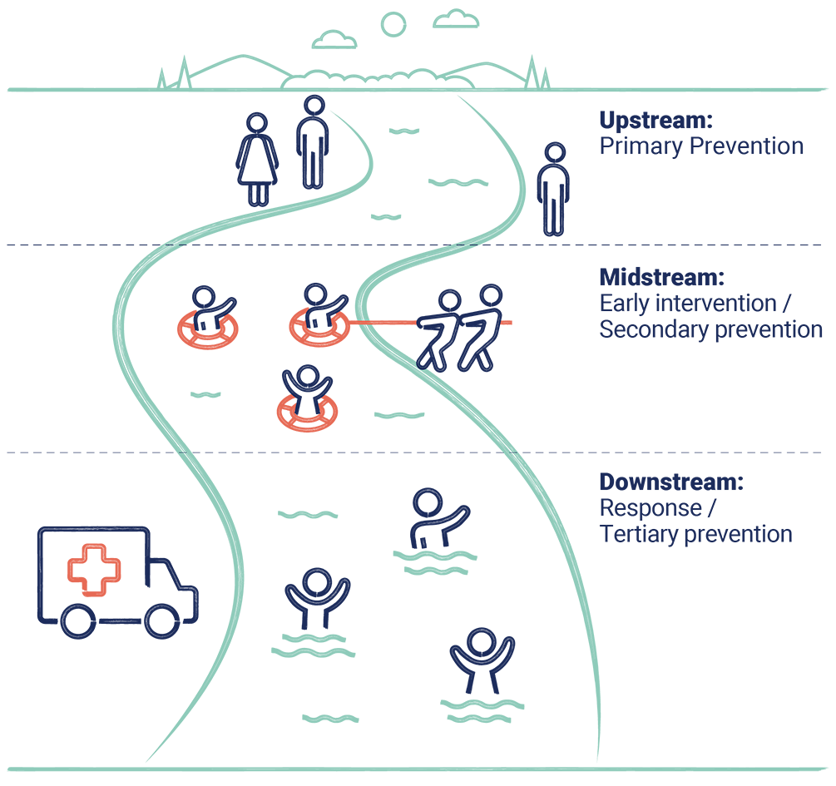

All approaches across the continuum are essential, and require support, investment and effective links to create a comprehensive and holistic strategy for addressing violence against women. To ensure efforts are mutually reinforcing, a national approach to prevention should connect policy, program and funding work across all levels – primary prevention, early intervention, crisis response, and recovery.

There are opportunities for prevention within early intervention, response and recovery work, for example, by:

* Stopping early signs of violence from escalating.
* Preventing the recurrence of violence.
* Shifting attitudes and practices within the police, justice and support service systems that may inadvertently contribute to the broader social conditions that tolerate, justify or excuse violence against women.
* Reducing impacts of, experiences of, and exposure to violence. Responsive, flexible and comprehensive early intervention, recovery and healing services can have a preventative effect by disrupting pathways to future perpetration and victimisation.
* Addressing inequalities within other settings that create additional hurdles and disadvantages for women on their recovery journey. Enabling effective recovery and healing can help prevent women from experiencing recurrences of violence.
* Addressing the impacts of intergenerational trauma through healing strategies. There is a particularly critical and urgent need to increase the number, scale, availability and long-term sustainability of individual and community healing strategies for Aboriginal and Torres Strait Islander people.

These examples show that, while there are differences between primary prevention and other approaches, there are also many connections and overlaps. As a result, there are opportunities for collaboration and mutually reinforcing approaches.

In addition, and while there is a clear need for an evidence base and dedicated work, investment in and understanding of primary prevention, for many organisations and services on the ground, the distinction between prevention, early intervention, response, recovery and healing is not always meaningful or practical. Many are using elements of all these approaches in their daily work – particularly in smaller services or communities and in regional and remote settings where there are fewer services, and one agency or organisation needs to serve multiple purposes.

# Whole-of-system opportunities for prevention in response settings

*Note: this brief should be read in conjunction with Brief 2 which describes a setting-based approach to prevention.*

While the legal and justice system is primarily focused on intervening in and responding to violence against women, there are a range of opportunities to embed and strengthen prevention actions within this system.

Australia’s justice system operates within a broader social context of gender inequalities and intersecting forms of discrimination, oppression, power and privilege. The gendered drivers of violence against women play out not just in wider society, but also within the services, institutions and organisations responsible for responding to this violence (including police, justice and support systems). These systems both influence and are influenced by wider community norms.

As in society more broadly, there are limited and inconsistent understandings within the legal and justice system about the dynamics of gender-based violence. Social myths and misconceptions about this violence also persist in these systems. These dynamics can cause significant harm to women engaging in the system, reduce perpetrator accountability and limit overall public trust and confidence in the system.

Systemic and institutional expressions of gender inequality within the response system can reinforce or perpetuate the gendered drivers of violence against women. This includes structural factors – such as poor organisational cultures, a lack of effective policies, a lack of cultural leadership and inadequate penalties – which may reinforce, support or excuse violence supportive, homophobic or sexist attitudes and behaviour in these contexts.[1]

Aboriginal and Torres Strait Islander women in particular are less likely to seek help or report violence to police.[2] This reluctance to engage with the response system is the result of a range of factors including racism, past government practices, contemporary experiences of negative interactions with police, and a mistrust of police and mainstream services often arising from previous experiences of reporting violence, misidentification of victims as perpetrators, lack of service availability, and experiences of incarceration and child removal.[3]

Primary prevention aims to stop violence against women before it starts by addressing the broader social context for this violence. As part of a holistic national approach, there are opportunities for primary prevention in the legal and justice sectors, including in police, courts, and legal services. In the same way other ‘systems’ have been used for prevention (for example the whole-of-school system approach to prevention via Respectful Relationships Education) there are opportunities to adopt whole-of-system approaches to prevention within these key response settings, including for example, by using a workplace approach (as described in Brief 2).

Prevention in the response system: practice example

[Women’s Legal Service Victoria’s *It Starts With Us Framework: a g**uide to create gender equitable and safe legal and justice workplaces.*](https://www.womenslegal.org.au/starts-with-us-framework/)

This framework provides a guide and resources to help legal and justice workplaces to plan and implement activities that will drive the cultural and systemic change needed to prevent gendered violence in legal and justice organisations. It aims to help legal and justice sector workplaces:

eliminate unfair and harmful attitudes and behaviours towards people based on gender

make sure their systems, procedures and practices support gender equality fairness and safety

build organisational cultures that reflect gender equitable behaviour, attitudes, and expectations, internally and in work with the community, with clients and with stakeholders

ensure robust and effective reporting systems that ensure safety, compliance and consequences for perpetrators.

Gaps and opportunities for prevention in the response system

There are numerous opportunities for services, institutions and organisations responsible for intervening in and responding to violence against women (including police, justice and support systems) to play a role in prevention. Actions that can be taken in these settings include:

Support the development of whole-of-system primary prevention frameworks in key response settings such as youth justice, corrections, police, courts and legal services. This could include undertaking [*Workplace Equality & Respect*](https://www.ourwatch.org.au/workplace), and/or developing tailored frameworks like those developed for other settings (such as[*Educating for Equality*](https://www.ourwatch.org.au/universities/resources/educating-for-equality)and[*Respect & Equality in TAFE*](https://www.ourwatch.org.au/tafe/resources/respect-and-equality-in-tafe-victoria-and-national-guides)).

Strengthen early intervention mechanisms for children and young people that aim to address the gendered impacts of exposure to violence against women and promote alternative models of healthy, equitable and non-violent relationships, characterised by respect and equality, and not limited by gender norms and stereotypes.

Support and advocate for healing strategies and other efforts to mediate the impacts of past and ongoing occurrences of violence such as child abuse, colonial violence experienced by Aboriginal and Torres Strait Islander communities, racist violence, violence against women with disabilities, war-related trauma and torture experienced by refugees and asylum seekers, or violence occurring in prisons and detention centres.

Encourage, support and raise the profile of individuals who have experienced violence and are, or wish to be, antiviolence advocates in public or in their own communities.

Strengthen efforts in policy and strategy to prevent all other forms of violence (such as racist, community, public or lateral violence and child abuse), especially through the provision of specialist expertise on the gendered dynamics of these forms of violence.

Develop regulatory, policy, organisational and institutional responses to increase the representation of women (with diverse backgrounds and life experiences) in legal and justice systems.

Ensure that legal and justice system professionals and workforces have a comprehensive understanding of violence against women including its gendered drivers and the intersecting forms of oppression and discrimination that impact the forms, dynamics, prevalence of this violence.

Engage in genuine partnership with Aboriginal and Torres Strait Islander communities, their representative bodies, and Aboriginal and Torres Strait Islander Community Controlled Organisations to design system reforms which promote the safety of Aboriginal and Torres Strait Islander women and their children.

The implementation of Action 9 of the [Second National Plan to End Violence Against Women and Children 2022-2032](https://www.dss.gov.au/ending-violence) which aims to improve police responses and the justice system to better support victim-survivors through the provision of trauma-informed, culturally safe supports that promote safety and wellbeing, and hold people who choose to use violence to account.

# Endnotes

1. Corboz, J., Flood, M., & Dyson, S. (2016). Challenges of bystander intervention in male-dominated professional sport: Lessons from the Australian Football League. *Violence against Women, 22(3),* 324–43.
2. Langton, M., Smith, K., Eastman, T., O’Neill, L., Cheesman, E., & Rose, M. (2020). Improving family violence legal and support services for Aboriginal and Torres Strait Islander women (Research report, 25/2020). Sydney: ANROWS.
3. Commonwealth Government. (2023). Aboriginal and Torres Strait Islander Action Plan 2023–2025 Under the National Plan to End Violence against Women and Children 2022–2032.