**Submission to the Inquiry into the United Nations Declaration on the Rights of Indigenous People (UNDRIP)**

Contact: Director Government Relations, Policy and Evidence

Amanda Alford [amanda.alford@ourwatch.org.au](mailto:amanda.alford@ourwatch.org.au).

Executive Summary 3

Summary of Recommendations 4

About Our Watch 5

Background to the Submission 5

Response to Term of Reference ii 10

Focus Area One: Address the legacies and ongoing impacts of colonisation for Aboriginal and Torres Strait Islander peoples, families, and communities. 11

Focus Area Two: Address the legacies and ongoing impacts of colonisation for non-Indigenous people, and across Australian society. 13

Focus Area Three: Address the gendered drivers of violence against Aboriginal and Torres Strait Islander women. 15

Supporting Actions 17

References 19

# Executive Summary

Our Watch welcomes the opportunity to contribute to the Joint Standing Committee on Aboriginal and Torres Strait Islander Affairs Inquiry into the United Nations Declaration of the Rights of Indigenous Peoples (UNDRIP).

Under UNDRIP, along with various other international human rights instruments, Australia is subject to multiple obligations to prevent violence against Aboriginal and Torres Strait Islander women. Article 22 of UNDRIP explicitly creates a positive duty for States to prevent violence and discrimination and to pay particular attention to the rights of Indigenous Elders, women, youth, children, and people with disabilities. However, as the statistics make clearand the voices of advocates continue to call attention to, Aboriginal and Torres Strait Islander women continue to experience violence at disproportionate and severe rates.[1]

Our Watch’s[*Changing the picture*](https://media-cdn.ourwatch.org.au/wp-content/uploads/sites/2/2019/11/05233003/Changing-the-picture-AA-3.pdf) *(2018),* a national framework to support the prevention of violence against Aboriginal and Torres Strait Islander women and their children, outlines that Aboriginal and Torres Strait Islander women face ‘dual oppressions’ characterised by the intersection of gender inequality with the impacts of colonisation, as well as the dynamics of racism and racial discrimination more generally. In line with this, efforts to address violence against Aboriginal and Torres Strait Islander women should utilise a gendered analysis within the context of the legacies of colonisation for both Indigenous and non-Indigenous peoples in Australia.

Published in 2018, *Changing the picture* was produced in collaboration with Aboriginal and Torres Strait Islander stakeholders. Guided by an Aboriginal and Torres Strait Islander Women’s Advisory Group, the project was informed by consultation with Aboriginal and Torres Strait Islander people around the country, and by a literature review that prioritised documents authored or produced by Aboriginal and Torres Strait Islander people, organisations and services. In producing the framework, Our Watch’s aim was to respect and reflect publicly available Aboriginal and Torres Strait Islander knowledge, and make central the voices, experiences, knowledge, ideas, decades-long activism, and solutions of Aboriginal and Torres Strait Islander people.

Drawing on *Changing the Picture,* this submission details the mechanisms through which efforts to prevent violence against Aboriginal and Torres Strait Islander women can be realised and adherence to the principles of UNDRIP can be improved. Specifically, this submission responds to the second Term of Reference: ‘options to improve adherence to the principles of UNDRIP in Australia.’

In response to this Term of Reference, this submission draws on the three focus areas outlined in *Changing the picture*.[2] These focus areas provide a set of comprehensive actions to improve adherence to the principles of UNDRIP in Australia. Much of the content of this submission has been summarised from *Changing the picture* and the accompanying background paper.

This submission was developed in consultation with Our Watch’s internal Aboriginal and Torres Strait Islander Steering Committee which brings together Aboriginal and Torres Strait Islander Board members, staff, and other key organisational representatives to consider and provide advice on Our Watch’s work in relation to violence against Aboriginal and Torres Strait Islander women.

Our Watch recommends that, in combination with other legislative and policy actions, *Changing the picture* be used to inform the development and implementation of key national strategies, action plans and frameworks. As this submission will examine further, *Changing the picture* provides a domestic framework, designed and informed by Aboriginal and Torres Strait Islander people, through which Australia can meet their human rights obligations and improve adherence to eighteen of the forty-six UNDRIP Articles.

## Summary of Recommendations

Our Watch recommends that:

1. The Australian Government develop and implement an UNDRIP Implementation Action Plan, which is led by Aboriginal and Torres Strait Islander people.
2. The Australian Government support initiatives that address the ongoing legacies of colonisation for Aboriginal and Torres Strait Islander peoples, families, and communities and that are informed and developed by Aboriginal and Torres Strait Islander people.
3. The Australian Government continue to support the development of a National Anti-Racism Framework by the Australian Human Rights Commission as well as its implementation with a specific focus the legacies and ongoing impacts of colonisation for non-Indigenous people, and across Australian society.
4. The Australian Government apply a gendered and intersectional approach in the development and implementation of policies, programs and services that impact and support Aboriginal and Torres Strait Islander people.

## About Our Watch

Our Watch is a national leader in the primary prevention of violence against women and their children in Australia. We are an independent, not for profit organisation established in 2013. All Australian governments are members of Our Watch.  Our vision is an Australia where women and their children live free from all forms of violence. We aim to drive nation-wide change in the culture, behaviours, attitudes, and social structures that drive violence against women and their children.

Guided by our ground-breaking national frameworks, [*Change the story*](https://www.ourwatch.org.au/resource/change-the-story-a-shared-framework-for-the-primary-prevention-of-violence-against-women-in-australia)(2nd ed 2021)[3], *Changing the picture* (2018)[4] and *Changing the landscape* (2022),[5] we work at all levels of our society to address the deeply entrenched, underlying drivers of violence against women, especially those stemming from gender inequality. We work with governments, practitioners, and the community, at all levels of Australian society, to address these drivers of violence in all settings where people live, learn, work, and socialise.

As a non-Indigenous organisation, Our Watch emphasises the importance of meaningful engagement with Aboriginal and Torres Strait Islander communities, leaders, and organisations to ensure that any actions or decisions that affect Aboriginal and Torres Strait Islander peoples are carried out in accordance with the internationally recognised principles of UNDRIP. Our Watch is committed to playing our part in addressing racism, power inequalities and other ongoing impacts of colonisation, and to working in solidarity with Aboriginal and Torres Strait Islander people to support culturally safe, and community-owned and led solutions.

## Background to the Submission

### United Nations Declaration on the Rights of Indigenous Peoples (UNDRIP)

UNDRIP is the most comprehensive instrument detailing the rights of Indigenous peoples in international law and policy, containing minimum standards for the recognition, protection, and promotion of these rights. UNDRIP is particularly significant for Australia because Aboriginal and Torres Strait Islander peoples were involved in its drafting.

UNDRIP was adopted by the United Nations General Assembly on 13 September 2007 and was endorsed by the Australian Government in 2009.

UNDRIP provides for states to take measures, in conjunction with Indigenous peoples, to ensure that Indigenous women and children enjoy full protection and guarantees against all forms of violence and discrimination (Article 22). Article 22 explicitly endorses a positive duty for states to prevent such violence. Together with the Universal Declaration on Human Rights (UDHR) and the Convention on the Elimination of All Forms of Discrimination Against Women (CEDAW) General Recommendations 35 and 39, Australia has made repeated international commitments to prevent violence against Aboriginal and Torres Strait Islander women.

However, in her visit to Australia in 2017, the United Nations Special Rapporteur on the Rights of Indigenous Peoples observed “a disturbing pattern of violence against Aboriginal and Torres Strait Islander women… [that was fostered by] discrimination on the grounds of gender, race and class [that] is structurally and institutionally entrenched.”[6] In 2018, the Special Rapporteur on Violence against Women echoed these concerns, noting that:

***“Aboriginal and Torres Strait Islander women face institutional, systemic, multiple, intersecting forms of discrimination... [and] … experience higher rates of domestic/family violence and more severe forms of such violence as compared to other women.”[7]***

Australia has identified the Closing the Gap Strategy, and most recently, the Aboriginal and Torres Strait Islander Action Plan 2023-2025, as its key policy platforms to give effect to the principles of UNDRIP.

However, there are limited references to UNDRIP in the Strategy and Plan and significant opportunities to strengthen the practical application and visibility of UNDRIP in the Australian policy context.

While it is beyond the scope of Our Watch’s role to make overarching recommendations regarding appropriate mechanisms, this submission identifies opportunities to improve adherence to UNDRIP through government action in the primary prevention of violence against Aboriginal and Torres Strait Islander women and their children.

### Primary prevention as a framework to support the incorporation of UNDRIP into domestic legislation.

Adherence to the principles of UNDRIP in Australia requires a range of complementary actions. The primary prevention of violence against Aboriginal and Torres Strait Islander women, as outlined in *Changing the picture,* provides a practical set of focus areas and actions that would support a move towards UNDRIP adherence, while also addressing the specific and disproportionate experiences of violence that Aboriginal and Torres Strait Islander women face compared with non-Indigenous women.

Violence against Aboriginal and Torres Strait Islander women is disproportionately prevalent and serious:

* Aboriginal and Torres Strait Islander women report experiencing violence at 3.1 times the rate of non-Indigenous women.[8]
* Three in five Aboriginal and Torres Strait Islander women have experienced physical or sexual violence perpetrated by a male intimate partner.[9]
* Aboriginal and Torres Strait Islander women are nearly 11 times more likely to die due to assault than non-Indigenous women.[10]
* Intimate partner violence contributes to 10.9% of the burden of disease for Aboriginal and Torres Strait Islander women aged 19-44, more than any other health risk factor, including alcohol or tobacco use and being overweight or obese.[11]

### Changing the picture: a national framework to support the prevention of violence against Aboriginal and Torres Strait Islander women and their children.

*Changing the picture* identifies violence against Aboriginal and Torres Strait Islander women as an urgent national priority and is aimed at supporting a national effort to prevent this violence. *Changing the picture* comprises of two parts:

* a comprehensive background paper, which outlines the evidence on violence against Aboriginal and Torres Strait Islander women and is aimed at promoting a deeper understanding of the nature and dynamics of this violence and its underlying, and intersecting drivers.
* A solutions-focused actions framework, which outlines a comprehensive set of prevention actions to address these drivers and support the prevention of this violence.

*Change the story* identifies four gendered drivers of violence against women. These drivers most consistently predict this violence at a population level and explain its gendered patterns.[12] *Changing the picture* builds upon the evidence of the four gendered drivers of violence against women outlined in *Change the story,* explaining that these drivers alone do not account for prevalence, severity and particular dynamics and impacts of violence against Aboriginal and Torres Strait Islander women today. Instead, for Aboriginal and Torres Strait Islander women, gender inequality intersects with the impacts of colonisation, as well as the dynamics of racism and racial discrimination more generally. As such, *Changing the picture* identifies additional drivers of violence against Aboriginal and Torres Strait Islander women. These drivers are:

1. The ongoing impacts of colonisation for Aboriginal and Torres Strait Islander people.
2. The ongoing impacts of colonisation for non-Indigenous people and in Australian society.
3. Gendered factors – both gender and inequality in a general sense, and specific gendered drivers of violence that are a consequence of colonisation.

Each of these drivers is described in significantly more detail in the *Changing the picture* background paper and Our Watch refers the Committee to pages 50-66 of that publication, for further discussion and evidence on each.

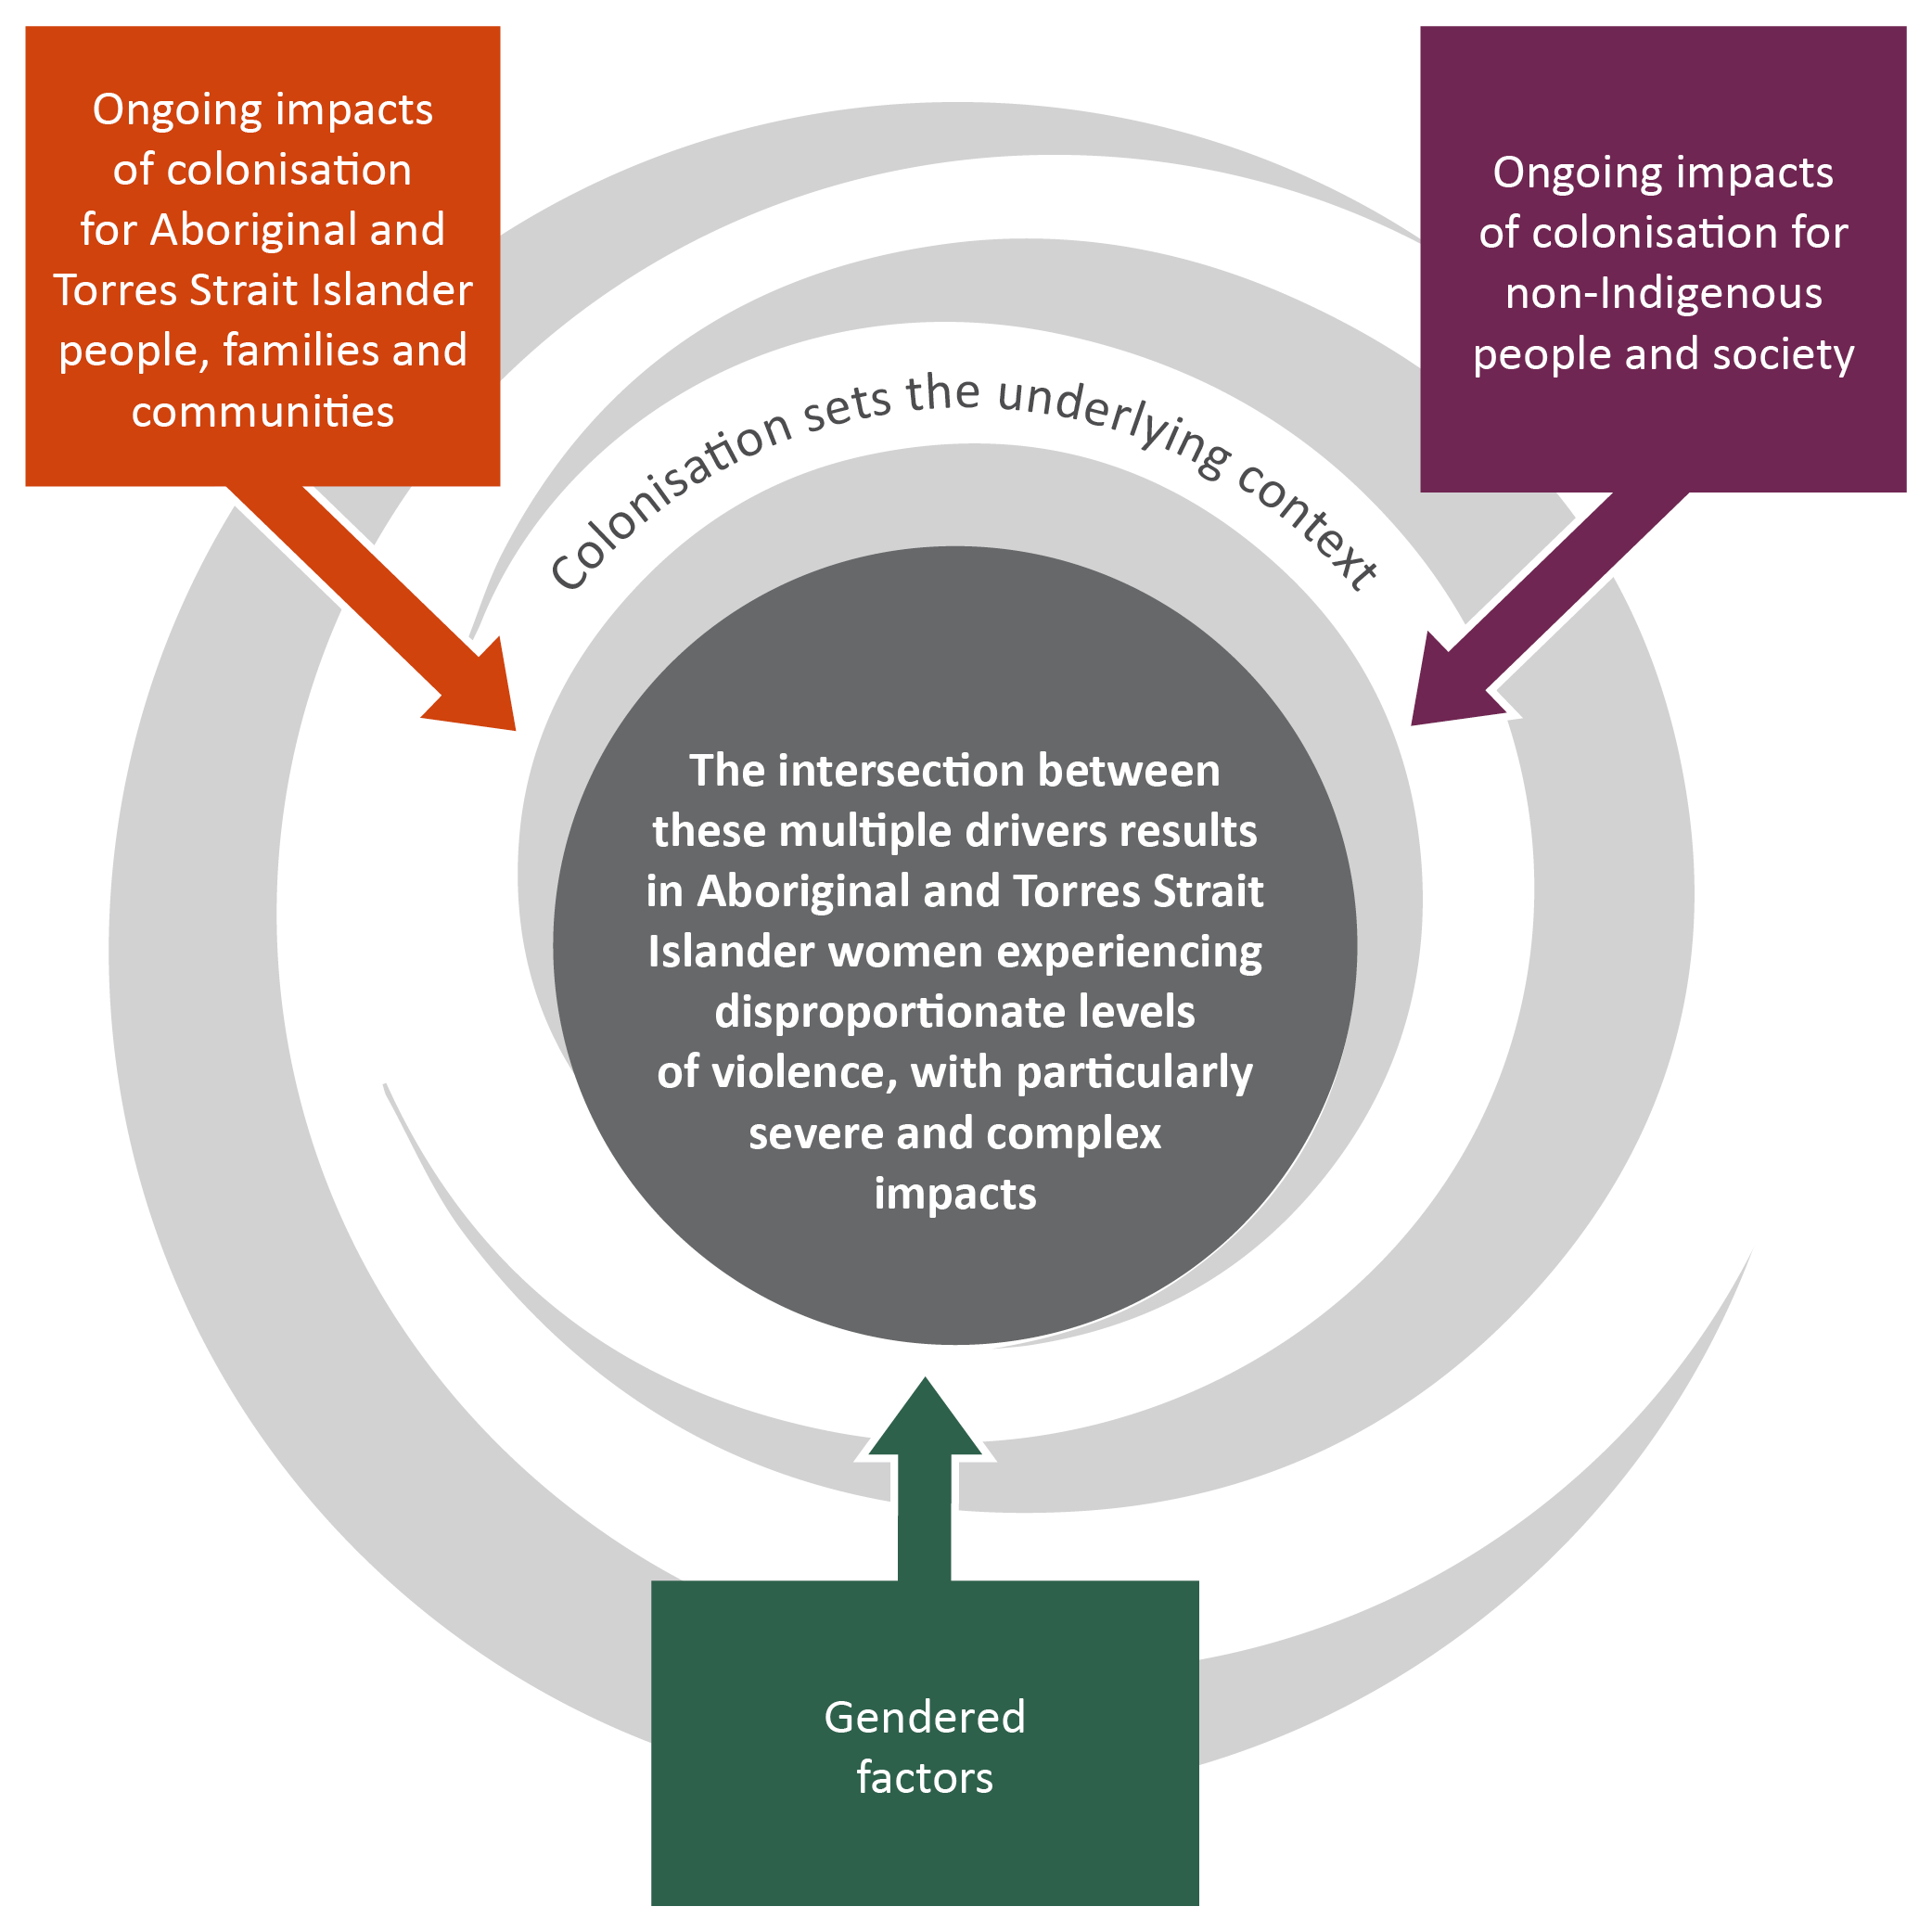

Reference: Our Watch (2018) Changing the picture.

While there is increasing awareness of the scale and severity of the problem of violence against Aboriginal and Torres Strait Islander women, often the focus is on how to respond to its impacts. However, treating the symptoms of a problem are unlikely to reduce incidents over the long term. As Aboriginal and Torres Strait Islander service providers and advocates point out, this approach also tends to rely heavily on simplistic, punitive solutions that fail to address the drivers of violence and perpetuate cycles trauma and disadvantage.[13]

Importantly, *Changing the picture* recognises the various forms of colonial violence and the need to understand and address these impacts in order to reduce violence against Aboriginal and Torres Strait Islander women.[14] *Changing the picture* also recognises that violence against Aboriginal and Torres Strait Islander women is not part of traditional culture and is perpetrated by men from many cultural backgrounds.[15]

Addressing the three underlying drivers of violence against Aboriginal and Torres Strait Islander women outlined above requires clear actions. *Changing the picture* outlines three focus areas with a set of comprehensive actions which form the basis of this submission and are outlined in the diagram below.

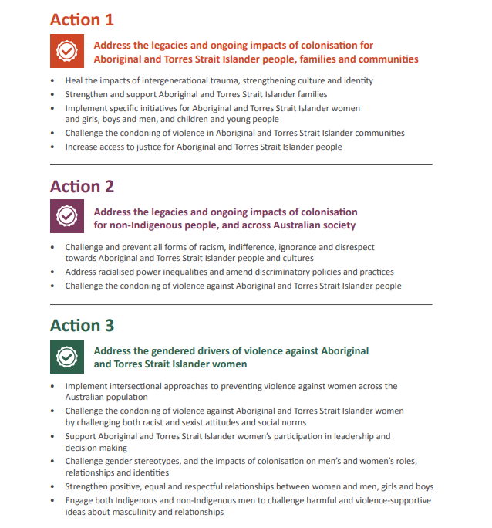

Reference: Our Watch (2018) Changing the picture.

# Response to Term of Reference ii

### The application of the United Nations Declaration on the Rights of Indigenous Peoples (UNDRIP) in Australia:

**ii. options to improve adherence to the principles of UNDRIP in Australia.**

In combination with other legislative and policy actions, the prevention of violence against Aboriginal and Torres Strait Islander people is an approach through which adherence to the principles of UNDRIP in Australia could be strengthened. Our Watch suggests that the three focus areas outlined in *Changing the picture* provide a useful basis for guiding these efforts. The three focus areas include:

1. Address the legacies and ongoing impacts of colonisation for Aboriginal and Torres Strait Islander peoples, families, and communities.
2. Address the legacies and ongoing impacts of colonisation for non-Indigenous people, and across Australian society.
3. Address the gendered drivers of violence against Aboriginal and Torres Strait Islander women.

As outlined above, this submission will examine each of the three focus areas and make connections to the relevant UNDRIP Articles they could contribute to strengthening in an Australian context.

In addition to the three focus areas*, Changing the picture* recognises the primacy of self-determination, through community ownership, control, and leadership, as an overarching principle across all three actions. Self-determination identifies the need for initiatives, services, and policy solutions to grow from, and be driven by, Aboriginal and Torres Strait Islander leaders, organisations, and communities, to address community-identified needs and priorities, use community-developed solutions, and be implemented via strong community relationships.

Ensuring a clear and coordinated approach to domestic implementation of UNDRIP, accompanied by mechanisms to support reporting would support improved adherence to the principles of UNDRIP and practical application. As a result, Our Watch recommends development of an Implementation Plan to support UNDRIP. In line with the principle of self-determination, any Plan should be developed and led by Aboriginal and Torres Strait Islander people. This would help consolidate efforts such as auditing existing laws, policies, and practices, progressing existing policies into enforceable, national law, and proposing new initiatives that would improve and strengthen adherence to the principles of UNDRIP.

**Recommendation 1:** The Australian Government develop and implement an UNDRIP Implementation Action Plan, which is led by Aboriginal and Torres Strait Islander people.

## **Focus Area One: Address the legacies and ongoing impacts of colonisation for Aboriginal and Torres Strait Islander peoples, families, and communities**.

As outlined in *Changing the picture*, the process of colonisation in Australia has involved acts of violence, in various forms, against Aboriginal and Torres Strait Islander peoples.[16] This process has led to a series of highly traumatic impacts for Aboriginal and Torres Strait Islander people, families, and communities in Australia that continue today.[17] Acts of violence, including practices such as forced child removal and widespread institutionalisation, as well policies of protectionism and assimilation, have significantly disrupted family and community relationships. Parenting practices have been disrupted and there has been a significant loss of culture, language, and knowledge. In addition, dispossession from land and economic exclusion, have produced anguish, disempowerment and enforced dependency.[18]

As *Changing the picture* identifies, the effects of colonial violence, both historical and ongoing processes and practices, have created traumatic experiences for Aboriginal and Torres Strait Islander communities.[19] This intergenerational trauma is one of the underlying drivers of violence against Aboriginal and Torres Strait Islander people generally, particularly where this violence occurs within families and communities.

In intersection with a set of gendered drivers (discussed under focus area three), the traumatic intergenerational legacies of colonisation form the context in which violence is perpetrated against Aboriginal and Torres Strait Islander women, particularly when perpetrated by Aboriginal and Torres Strait Islander men. The ways in which the legacy and ongoing impacts of colonisation contribute to violence against Aboriginal and Torres Strait Islander women is discussed in-depth in the *Changing the picture* background paper.[20]

Building on the evidence provided in the background paper, *Changing the picture* identifies that an essential action to address violence against Aboriginal and Torres Strait Islander women is to address the legacies and ongoing impacts of colonisation for Aboriginal and Torres Strait Islander people, families, and communities. This requires increasing the scale, accessibility and resourcing to address a range of actions, the implementation of which, either within the UNDRIP Implementation Action Plan or under relevant national, state or territory strategies and plans, would improve Australia’s adherence to UNDRIP’s principles. These actions include:

* Action 1: Address the impacts of intergenerational trauma, through healing strategies.
* Action 2: Strengthen connection to culture, language, knowledge and cultural identity.
* Action 3: Implement specific initiatives for Aboriginal and Torres Strait Islander children and young people.

### Action 1: Address the impacts of intergenerational trauma, through healing strategies.

This action requires increasing the scale, accessibility and resourcing of healing programs and services that address the intergenerational trauma experienced by Aboriginal and Torres Strait Islander people. This includes opportunities for individual and collective healing that are trauma informed, evidence-based and culturally driven, developed, and implemented. This action recognises healing and primary prevention as mutually reinforcing processes that address the legacies of colonisation and establish new ways of addressing violence in Aboriginal and Torres Strait Islander communities.[21] This action could improve adherence to the following UNDRIP Articles: 8 (2) and 29 (3).

### Action 2: Strengthen connection to culture, language, knowledge and cultural identity.

This action requires increasing the scale, accessibility and resourcing of initiatives that support and strengthen Aboriginal and Torres Strait Islander cultures, knowledge, languages, and perspectives. It recognises the need for cultural connection and strengthening to provide the foundation to prevent violence. It requires greater recognition of the cultural determinants of health, wellbeing and safety and the protective properties of cultural connection for Aboriginal and Torres Strait Islander people. Implementing this action could improve adherence to the following UNDRIP Articles: 11; 13; and 24 (2).

### Action 3: Implement specific initiatives for Aboriginal and Torres Strait Islander children and young people.

This action requires increasing the scale, accessibility and resourcing of a range of formal and informal primary prevention initiatives, services, and programs for all Aboriginal and Torres Strait Islander young people. This includes respectful relationship education, services, and supports focused on health and wellbeing, as well as mentoring and leadership programs. These programs should provide connections back to culture, build belonging and self-worth, tackle educational inequality and support educational success.[22] It is important initiatives are accessible for Aboriginal and Torres Strait Islander children and young people in out-of-home-care and are developed and implemented either by, or with the engagement of Aboriginal and Torres Strait Islander parents, Elders, and community members. Implementing this action could improve adherence to the following UNDRIP Articles:14 (1), (2), (3).

**Recommendation 2:** The Australian Government increase support initiatives that address the ongoing legacies of colonisation for Aboriginal and Torres Strait Islander peoples, families, and communities and that are informed and developed by Aboriginal and Torres Strait Islander people.

## Focus Area Two: Address the legacies and ongoing impacts of colonisation for non-Indigenous people, and across Australian society.

Violence against Aboriginal and Torres Strait Islander women is not an Aboriginal and Torres Strait Islander problem, but an Australian one. Contemporary violence against Aboriginal and Torres Strait Islander women must be understood in the broader context of colonisation in Australia. While some of this violence is ‘historical’, much of it is ongoing, with significant enduring impacts on Aboriginal and Torres Strait Islander peoples.[23]

While the devastating legacy of colonisation continues to impact on the lives of Aboriginal and Torres Strait Islander people, colonisation has also left significant legacies for non-Indigenous people and has influenced and shaped Australian society and culture in general, creating racist and discriminatory norms, structures, and practices.

These legacies continue to influence society’s perception and response to violence against Aboriginal and Torres Strait Islander women, media representations, public discourse, and contemporary policy. In turn, these factors help perpetuate the underlying social conditions that devalue the lives of Aboriginal and Torres Strait Islander women and make violence against them more likely.

In recognising this relationship and reinforcing the need for non-Indigenous organisations and people to take responsibility, *Changing the picture* identifies an essential action to address violence against Aboriginal and Torres Strait Islander women is to: Address the legacies and ongoing impacts of colonisation for non-Indigenous people, and across Australian society. This requires non-Indigenous organisations and people — both men and women —to examine, take responsibility.

In 2021, the Australian Human Rights Commission launched a plan to develop a National Anti-Racism Framework intended to guide actions on anti-racism by governments and others across the community. This type of Framework would provide a useful mechanism for identifying clear actions, the implementation of which would improve Australia’s adherence to UNDRIP’s principles. For example, the relevant actions in *Changing the picture* in relation to this focus area could include:

* Action 4: Challenge and prevent all forms of racism.
* Action 5: Challenge indifference, ignorance and disrespect towards Indigenous people and cultures.
* Action 6: Address power inequalities, particularly in decision-making positions.
* Action 7: Identify and amend racist and discriminatory laws, policies, and organisational and institutional practices.
* Action 8: Challenge the condoning of violence against Aboriginal and Torres Strait Islander people.

### Action 4: Challenge and prevent all forms of racism.

Racism in Australia is widespread in the attitudes, social norms, and practices of non-Indigenous people.[24] Racism drives many kinds of racist violence. However, when racism intersects with gendered factors, it also drives the specific perpetration of violence against Aboriginal and Torres Strait Islander women by non-Indigenous men.

In alignment with Australia’s obligations under the International Convention on the Elimination of All Forms of Racial Discrimination (ICERD), this action requires the implementation of a range of strategies using multiple mechanisms, and in multiple settings to challenge and prevent racism and discrimination, both interpersonal and institutional, and promote equality and the specific human rights of Aboriginal and Torres Strait Islander peoples. Implementing actions under a National Anti-Racism Framework to address to challenge racist, discriminatory, and disrespectful social norms, attitudes and practices that reproduce and perpetuate a culture of racism and drive racist violence could improve adherence to the following UNDRIP Articles: 1; 2; 7; 8 (2) (e); 15 (2).

### Action 5: Challenge indifference, ignorance and disrespect towards Indigenous people and cultures.

Increasing non-Indigenous people's understanding of Aboriginal and Torres Strait Islander history, cultures, knowledge and perspectives, and the significance and value these are afforded in Australia, as well as increasing the meaningful, public recognition and acknowledgement of Aboriginal and Torres Strait Islander peoples and cultures is fundamental to addressing racist social norms, attitudes, and practices, which would in turn lay the foundation for prevention work, and improve adherence to the following UNDRIP Articles: 15 (1), (2) and 16 (2).

### Action 6: Address power inequalities, particularly in decision-making positions.

The development and implementation of a framework to increase the representation of Aboriginal and Torres Strait Islander peoples (including both women and men) in positions of power and decision-making — particularly those responsible for decisions that directly affect the lives of Aboriginal and Torres Strait Islander people — could assist in addressing the structural inequality whereby social and economic and political privilege, power, resources and opportunities are disproportionately held by non-Indigenous people, and could improve adherence to the following UNDRIP Articles: 18.

### Action 7: Identify and amend racist and discriminatory laws, policies, and organisational and institutional practices.

Some contemporary laws and policies have a disproportionate negative structural impact on Aboriginal and Torres Strait Islander people. There is a significant opportunity to strengthen the protection of Indigenous people’s human rights and the needs of Aboriginal and Torres Strait Islander people in legislation to ensure it addresses the structural inequalities that exist as a result of historical and ongoing colonial violence.[25] Implementing this action either through the auditing of existing laws, policies and practices either through an UNDRIP Implementation Action Plan or a National Anti-Racism Framework could improve adherence to the following UNDRIP Article: 2 and 19.

### Action 8: Challenge the condoning of violence against Aboriginal and Torres Strait Islander people.

As has been shown in relation to violence against women,[26] the condoning of violence against particular groups is in itself a driver of violence against those groups.[27] The prevention of violence against Aboriginal and Torres Strait Islander women requires the challenging of social norms, practices and structures that excuse, trivialise, or downplay violence against Aboriginal and Torres Strait Islander peoples. This could include actions in a National Anti-Racism Framework for example to improve media reporting to increase the visibility of all forms of violence against Aboriginal and Torres Strait Islander peoples, eliminate the use of stereotypes, and centre the voices of Indigenous peoples in commentary and analysis. Implementing this action could improve adherence to the following UNDRIP Articles: 15 (2); 16 (2); and 22 (2).

**Recommendation 3:** The Australian Government continue to support the development of a National Anti-Racism Framework by the Australian Human Rights Commission as well as its implementation, with a specific focus the legacies and ongoing impacts of colonisation for non-Indigenous people, and across Australian society.

## Focus Area Three: Address the gendered drivers of violence against Aboriginal and Torres Strait Islander women.

While the combined, ongoing impacts of colonisation and racism are a significant driver of violence against Aboriginal and Torres Strait Islander peoples,[28] this alone cannot explain the gendered patterns or nature of this violence.

Gender inequality, which affects all women, including Aboriginal and Torres Strait Islander women, has been shown to set the underlying conditions for violence against women, as outlined in the national prevention framework *Change the story,* which identifies four gendered drivers of violence against women.[29] These gendered drivers are additionally shaped by the intersection of racism and sexism, which creates a ‘double bind’ of oppression for Aboriginal and Torres Strait Islander women, and the contemporary impacts of imposed ‘colonial patriarchy’ on Aboriginal and Torres Strait Islander cultures, gender roles and men and women.[30]

Aboriginal and Torres Strait Islander women experience gender inequality in ways that cannot be separated either from their experiences of racism and racial discrimination or from the legacies of colonisation and colonial violence. The *Changing the picture* background paper outlines why a gendered analysis of colonisation is necessary[31] and discusses the intersection between gender inequality, racism and colonisation in more depth.[32]

While policies such as the Closing the Gap (Target 13) and most recently, the Aboriginal and Torres Strait Islander Action Plan 2023-2025, include actions aligned with the Articles of UNDRIP that focus on the prevention of violence against women and promotion of gender equality, there is an opportunity to strengthen the application and visibility of UNDRIP in the Australian policy context. *Changing the picture* provides a framework through which UNDRIP’s international principles can be applied in a domestic context.

As outlined in *Changing the picture*, this requires a range of actions, the implementation of which could contribute to improving Australia’s adherence to UNDRIP’s principles. These actions include:

* Action 9: Implement intersectional approaches to prevent violence against women, across the Australian population.
* Action 10: Challenge the condoning of violence against Aboriginal and Torres Strait Islander women, by challenging both racist and sexist attitudes and social norms.
* Action 11: Support Aboriginal and Torres Strait Islander women’s participation in leadership and decision-making.

### Action 9: Implement intersectional approaches to prevent violence against women, across the Australian population.

*Change the story* outlines five actions needed to address the gendered drivers of violence against women across the Australian population.[33] These actions are part of the work necessary to prevent violence against Aboriginal and Torres Strait Islander women, which is perpetrated by men of all cultural backgrounds. However, to ensure that they are as effective as possible in preventing violence against Aboriginal and Torres Strait Islander women in particular, actions to address the gendered drivers of violence must be implemented in an intersectional way. While Aboriginal and Torres Strait Islander people, as a group, face unique issues by virtue of their social, political and economic status as Indigenous people, there are also a number of cross-cutting or intersecting forms of discrimination, oppression and inequality that impact on some Aboriginal and Torres Strait Islander people. These include those based on classism, sexism, disability discrimination, homophobia and transphobia, for example. It is important that an intersectional analysis and approach is taken in the development and implementation of policies, programs and services that impact and support Aboriginal and Torres Strait Islander people. Applying an intersectional approach could improve adherence to the following UNDRIP Articles: 22 (1) and 23.

### Action 10: Challenge the condoning of violence against Aboriginal and Torres Strait Islander women, by challenging both racist and sexist attitudes and social norms.

Multiple actions are required to challenge the condoning of violence against Aboriginal and Torres Strait Islander women, including challenging racist and sexist attitudes towards Aboriginal and Torres Strait Islander women and enabling Aboriginal and Torres Strait Islander peoples to explore the ways in which the condoning or minimising of violence against women might be happening in their own communities, and develop effective ways to challenge this. Community ownership and community-driven solutions that centre the voices and perspectives of Aboriginal and Torres Strait Islander women are fundamentally important. Implementing this action could improve adherence to the following UNDRIP Articles: 15 (2); 22; 23; and 24 (2).

### Action 11: Support Aboriginal and Torres Strait Islander women’s participation in leadership and decision-making.

This action encourages support for Aboriginal and Torres Strait Islander women’s participation in leadership and decision-making. An important part of facilitating this action is ensuring national and jurisdictional gender equality strategies and actions to promote women’s independence and decision-making are inclusive of, and responsive to, the specific issues that are relevant to Aboriginal and Torres Strait Islander women. Actions should enable and support the development of specific Aboriginal and Torres Strait Islander women’s leadership strategies and diverse models of leadership with the aim of amplifying Aboriginal and Torres Strait Islander women’s voices.[34] Strategies should promote Aboriginal and Torres Strait Islander women’s’ right to participate equally in leadership, decision-making and governance processes at all levels, both in their own communities and in non-Indigenous organisations. Implementing this action could improve adherence to following UNDRIP Article: 18.

**Recommendation 4:** The Australian Government apply a gendered and intersectional approach in the development and implementation of policies, programs and services that impact and support Aboriginal and Torres Strait Islander people.

## Supporting Actions

In addition to the key drivers of violence against Aboriginal and Torres Strait Islander women discussed above, there are a number of other relevant factors that can be considered as contributing, or reinforcing, factors for violence against Aboriginal and Torres Strait Islander women. As discussed in the *Changing the picture: Background paper*, these include socio-economic stressors, health and psychological factors, and alcohol and other drugs.

As a result, actions to address these reinforcing factors can make a significant contribution to overall prevention efforts, provided that they are undertaken in parallel with the essential actions, rather than in isolation.[35] Actions that address such factors can help create a more supportive or enabling environment for primary prevention work. By generally improving individual life circumstances and wellbeing, or by changing particular behaviours, such supporting actions can help create the social conditions in which it is possible to address the deeper, underlying causes of violence, improving the efficacy of the essential actions.

### Action 12: Address socio-economic inequality, disadvantage and exclusion and improve Aboriginal and Torres Strait Islander people’s physical and mental health.

The current levels of socio-economic inequality and disadvantage experienced by Aboriginal and Torres Strait Islander peoples including poor living conditions, poor health, inadequate housing, poverty, limited access to economic resources and opportunities, unemployment, and underemployment, amplify the impacts of violence against Aboriginal and Torres Strait Islander women.[36] Inequality, disadvantage, and exclusion create significant stressors in Aboriginal and Torres Strait Islander peoples’ lives.[37] Policies and strategies that improve the material and economic circumstances of Aboriginal and Torres Strait Islander people’s lives would not only greatly improve people’s general wellbeing but would also provide an enabling environment for violence prevention work. Improving people’s physical and mental health and wellbeing also greatly reduces the stressors in their lives and can therefore remove or reduce some of the potential triggers for violence or barriers to behaviour change, and some of the potential barriers to reporting or escaping violence.

Implementing this action could improve adherence to the following UNDRIP Articles: 21; 17; 23; and 24 (2).

# References

1. Our Watch (2018). Changing the picture background paper: Understanding violence against Aboriginal and Torres Strait Islander women and their children, p.28. Retrieved from: <https://media-cdn.ourwatch.org.au/wp-content/uploads/sites/2/2020/09/20231756/Changing-the-picture-Part-1-AA.pdf>
2. Our Watch (2018). Changing the picture, p. 14. Retrieved from: [Changing the picture (ourwatch.org.au)](https://media-cdn.ourwatch.org.au/wp-content/uploads/sites/2/2019/11/05233003/Changing-the-picture-AA-3.pdf)
3. Our Watch (2021). Change the story. Retrieved from: [Change the story: A shared framework for the primary prevention of violence against women in Australia (2nd ed.). (ourwatch.org.au)](https://media-cdn.ourwatch.org.au/wp-content/uploads/sites/2/2021/11/18101814/Change-the-story-Our-Watch-AA.pdf)
4. Our Watch (2018). Changing the picture. Retrieved from: [Changing the picture (ourwatch.org.au)](https://media-cdn.ourwatch.org.au/wp-content/uploads/sites/2/2019/11/05233003/Changing-the-picture-AA-3.pdf)
5. Our Watch (2022). Changing the landscape. Retrieved from: <https://media-cdn.ourwatch.org.au/wp-content/uploads/sites/2/2022/08/01135647/Changing-the-landscape-AA.pdf>
6. Special Rapporteur on Rights of Indigenous Peoples. (2017). Report of the Special Rapporteur on rights of indigenous peoples on her visit to Australia. Retrieved from: https://digitallibrary.un.org/record/1303201?ln=en
7. Special Rapporteur on Violence against Women. (2018). Report of the Special Rapporteur on Violence against Women, its Causes and Consequences on her mission to Australia. Retrieved from: <https://digitallibrary.un.org/record/1627464?ln=en>
8. Calculations based on hospitalisation rates for Aboriginal and Torres Strait Islander family violence-related assaults of 530 females per 100 000 female population and 191 males per 100 000 male population cited in Steering Committee for the Review of Government Service (2016), 4.12.1.
9. Ayre, J., Lum On, M., Webster, K., Gourley, M., & Moon, L. (2016). Examination of the burden of disease of intimate partner violence against women: Final report. Sydney: Australian National Research Organisation for Women’s Safety. Retrieved: <https://anrowsdev.wpenginepowered.com/wp-content/uploads/2019/02/BoD-Horizons.pdf>
10. Olsen, A. & Lovett, R. (2016). Existing knowledge, practice, and responses to violence against women in Australian Indigenous communities: State of knowledge paper, p. 13. Retrieved from: <https://www.researchgate.net/publication/293768448_Existing_knowledge_practice_and_responses_to_violence_against_women_in_Australian_Indigenous_communities_State_of_knowledge_paper>, Al-Yaman et al (2006) ‘Family violence among Aboriginal and Torres Strait Islander peoples’, retrieved from: <https://www.aihw.gov.au/getmedia/34fea687-d980-4e54-8826-256b6acfdd0f/fvaatsip.pdf.aspx?inline=true>
11. Ayre, J., Lum On, M., Webster, K., Gourley, M., & Moon, L. (2016). Examination of the burden of disease of intimate partner violence against women: Final report. Sydney: Australian National Research Organisation for Women’s Safety. Retrieved: <https://anrowsdev.wpenginepowered.com/wp-content/uploads/2019/02/BoD-Horizons.pdf>
12. Our Watch (2021). Change the story, p. 36-47.
13. See, for example: Human Rights Law Centre and Change the record (2017). Over-represented and overlooked: the crisis of Aboriginal and Torres Strait Islander women’s growing over-imprisonment. Retrieved from: <https://static1.squarespace.com/static/580025f66b8f5b2dabbe4291/t/59378aa91e5b6cbaaa281d22/1496812234196/OverRepresented_online.pdf>; Braybrook, B. and Duffy, S. (2017). ‘Indigenous incarceration rates are not an intractable problem – we have the solutions.’ Retrieved from: https://www.theguardian.com/australia-news/2017/feb/20/indigenous-incarceration-rates-are-not-an-intractable-problem-we-have-the-solutions
14. Our Watch (2018). Changing the picture background paper: Understanding violence against Aboriginal and Torres Strait Islander women and their children, p.44.
15. Our Watch (2021). Change the story, p. 6.
16. Our Watch (2018). Changing the picture background paper: Understanding violence against Aboriginal and Torres Strait Islander women and their children, p.51.
17. ANROWS. (2018). Warawarni-Gu Guma Statement. Retrieved from: [STATEMENT-Aboriginal-and-Torres-Strait-Islander-Forum.2.pdf (anrowsdev.wpenginepowered.com)](https://anrowsdev.wpenginepowered.com/wp-content/uploads/2019/02/STATEMENT-Aboriginal-and-Torres-Strait-Islander-Forum.2.pdf)
18. Our Watch (2018). Changing the picture background paper: Understanding violence against Aboriginal and Torres Strait Islander women and their children, p.51.
19. Our Watch (2018). Changing the picture background paper: Understanding violence against Aboriginal and Torres Strait Islander women and their children, p.51.
20. Our Watch (2018). Changing the picture background paper: Understanding violence against Aboriginal and Torres Strait Islander women and their children, p.51-60.
21. ANROWS. (2018). Warawarni-Gu Guma Statement. Retrieved from: [STATEMENT-Aboriginal-and-Torres-Strait-Islander-Forum.2.pdf (anrowsdev.wpenginepowered.com)](https://anrowsdev.wpenginepowered.com/wp-content/uploads/2019/02/STATEMENT-Aboriginal-and-Torres-Strait-Islander-Forum.2.pdf)
22. Ware, V.A. (2013). Mentoring programmes for Indigenous youth at-risk. Retrieved: <https://www.researchgate.net/publication/299596442_Vicki-Ann_Ware_2013_Mentoring_programmes_for_Indigenous_youth_at-risk_Resource_sheet_no22_Canberra_Closing_the_Gap_Clearinghouse>
23. Our Watch (2018). Changing the picture background paper: Understanding violence against Aboriginal and Torres Strait Islander women and their children, p.44.
24. Our Watch (2018). Changing the picture background paper: Understanding violence against Aboriginal and Torres Strait Islander women and their children, p.62.
25. Our Watch (2018). Changing the picture background paper: Understanding violence against Aboriginal and Torres Strait Islander women and their children, p.54.
26. Our Watch (2021). Change the story.
27. Our Watch (2018). Changing the picture.
28. See, e.g., Our Watch (2021). Change the story, p. 9.
29. Our Watch (2021). Change the story, p. 22-26.
30. Our Watch (2018). Changing the picture background paper: Understanding violence against Aboriginal and Torres Strait Islander women and their children, p.25.
31. Our Watch (2018). Changing the picture background paper: Understanding violence against Aboriginal and Torres Strait Islander women and their children, p.72-73.
32. Our Watch (2018). Changing the picture background paper: Understanding violence against Aboriginal and Torres Strait Islander women and their children, p. 64-67.
33. Our Watch (2021). Change the story, p. 33.
34. Our Watch (2018). Changing the picture background paper: Understanding violence against Aboriginal and Torres Strait Islander women and their children, p.24.
35. Our Watch (2018). Changing the picture background paper: Understanding violence against Aboriginal and Torres Strait Islander women and their children, p.73-74.
36. Our Watch (2018). Changing the picture background paper: Understanding violence against Aboriginal and Torres Strait Islander women and their children, p.72-73.
37. Our Watch (2018). Changing the picture background paper: Understanding violence against Aboriginal and Torres Strait Islander women and their children, p.72-73.