## Summary

October 2024

Building strong foundations to support primary prevention of violence against women



Acknowledgement of Country

Our Watch acknowledges the Traditional Owners of the land across Australia on which we work and live. We pay respects to Elders past and present and recognise the continuing connection Aboriginal and Torres Strait Islander people have to land, culture, knowledge, and language for over 65,000 years.

As a non-Aboriginal organisation, Our Watch understands that violence against Aboriginal and Torres Strait Islander women and children is an issue for the whole community. As highlighted in Our Watch’s national resource Changing the picture, the evidence clearly shows the intersection between racism, sexism, and violence against Aboriginal and Torres Strait Islander women.

Our Watch has an ongoing commitment to the prevention of violence against Aboriginal and Torres Strait Islander women and children, who continue to suffer from violence at a significantly higher rate than non-Aboriginal women. We acknowledge all Aboriginal and Torres Strait Islander people and organisations who continue to lead the work of sharing knowledge with non-Indigenous people and relentlessly advocate for an equitable, violence-free future in Australia.

**About Our Watch**

Our Watch is a national leader in the primary prevention of violence against women* and their children in Australia. We are an independent, not-for- profit organisation established in 2013. All Australian governments are members of Our Watch.

Our vision is an Australia where women and their children live free from all forms of violence. We aim to drive nationwide change in the culture, behaviours, attitudes, social structures and systems that drive violence against women.

Guided by our national framework, [*Change the story: A shared framework for the primary prevention*](https://media-cdn.ourwatch.org.au/wp-content/uploads/sites/2/2021/11/18101814/Change-the-story-Our-Watch-AA.pdf) [*of violence against women in Australia (Change the*](https://media-cdn.ourwatch.org.au/wp-content/uploads/sites/2/2021/11/18101814/Change-the-story-Our-Watch-AA.pdf)[*story)*,](https://media-cdn.ourwatch.org.au/wp-content/uploads/sites/2/2021/11/18101814/Change-the-story-Our-Watch-AA.pdf) we work at all levels of society to address the underlying drivers of violence against women. We work with governments, practitioners and the community to address these drivers of violence in settings where people live, learn, work and socialise.

* The term ‘women’ that is used throughout this document refers to anyone that is a woman, which includes cisgender and trans women.

About this document

This brief explores the essential foundations for effective approaches to the primary prevention of violence against women – otherwise known as ***prevention infrastructure***. It is designed to support governments to understand, establish and invest in the eight key evidence-based foundations for primary prevention. It offers guidance on key actions to establish, improve or expand on the foundations. These actions aim to support governments to make policy and investment decisions that lead to sustainable long-term change to the drivers of violence against women and ultimately end such violence.

The national primary prevention landscape

Commonwealth, state and territory governments have demonstrated strong leadership in preventing violence against women, including through the *National Plan to End Violence Against Women 2022- 2032* (National Plan) and relevant state and territory strategies and plans.

There has been progress in primary prevention, in part driven by government leadership underpinned by evidence-based approaches to preventing violence against women. There are opportunities to strengthen the foundation for this leadership and work by continuing to develop and strengthen prevention infrastructure.

# BACKGROUND: Primary prevention of violence against women

Violence against women is a serious and widespread problem in Australia, but it is preventable.

Primary prevention means stopping violence against women before it starts by addressing its underlying drivers.

This requires changing the social conditions that give rise to this violence and reforming the institutions and systems that excuse, justify or even promote such violence. This also requires shifting the power imbalances and social norms, structures and practices that drive and normalise violence.

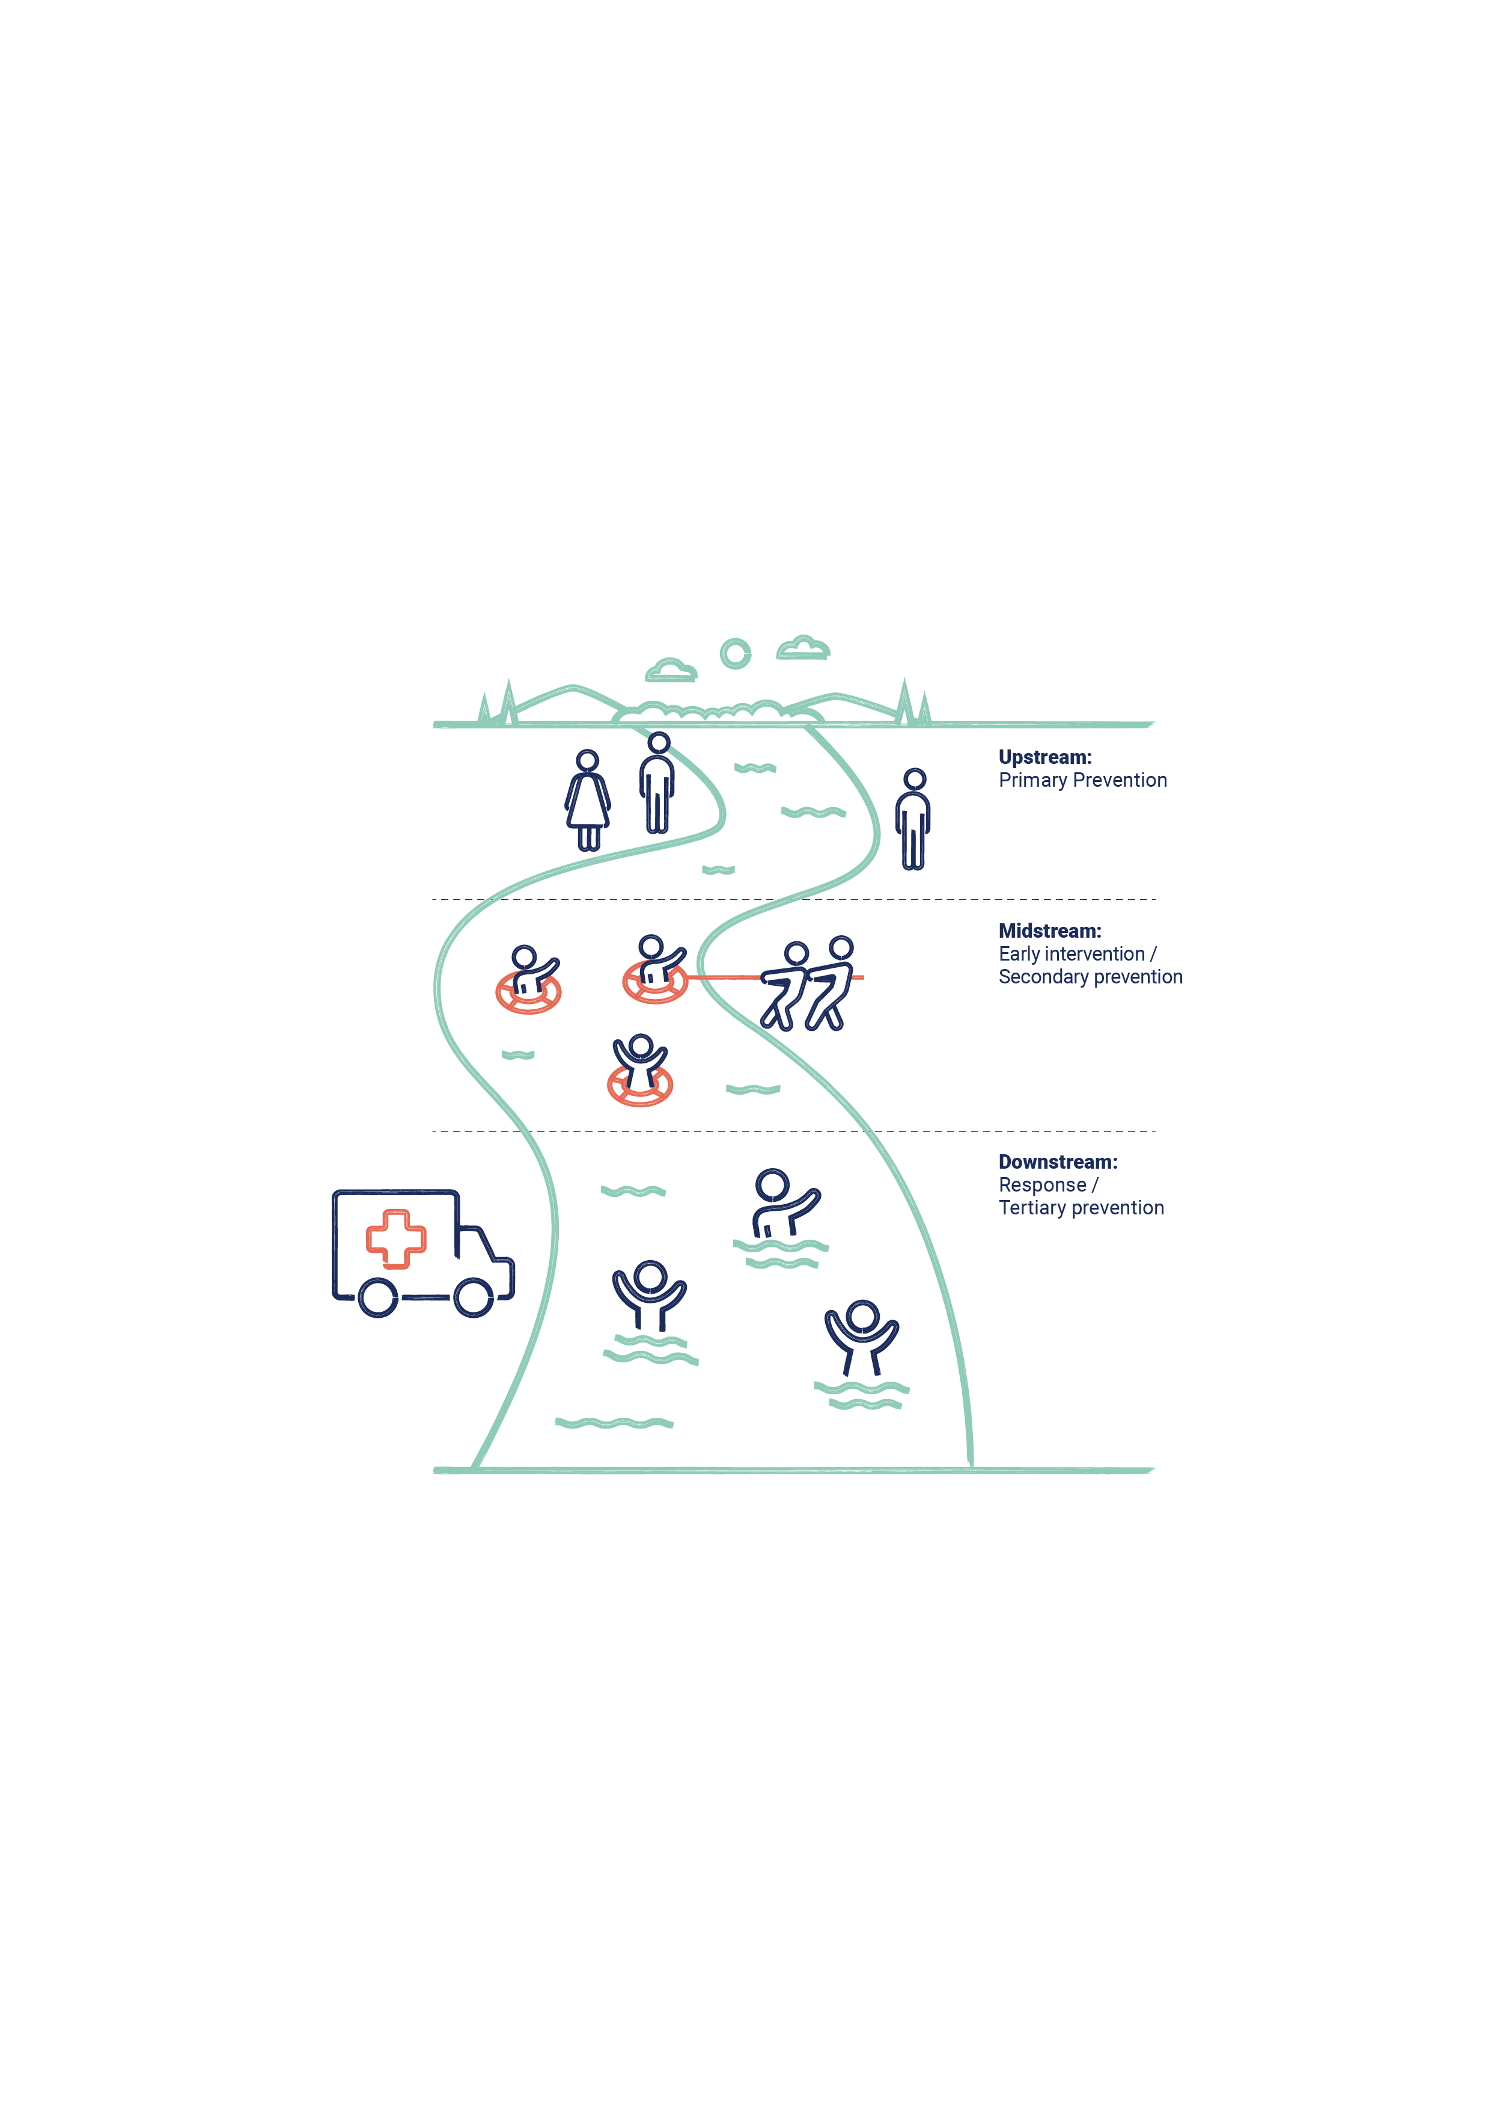A comprehensive and holistic approach to preventing violence against women must involve a continuum of interdependent and interlinked strategies, with efforts across primary prevention, early intervention, response and recovery.

***Change the story*** sets out a national population- level approach to the primary prevention of violence against women. This approach aims to drive change by framing the gendered drivers of this violence as occurring across society and affecting all women.

It aims to influence laws and policies, as well as the practices and behaviours of organisations, groups and individuals. Through a whole-of-society approach, primary prevention addresses the systems, structures, norms, attitudes, practices and power imbalances that drive violence against women.

*Change the story* identifies the four main drivers of violence against women:

* **Driver 1:** Condoning of violence against women.
* **Driver 2:** Men’s control of decision-making and limits to women’s independence in public and private life.
* **Driver 3:** Rigid gender stereotyping and dominant forms of masculinity.
* **Driver 4:** Male peer relations and cultures of masculinity that emphasise aggression, dominance and control.

Violence against women has multiple, interrelated drivers that play out across every level of society and is often experienced in combination with other forms of structural inequality and discrimination including sexism, racism, religious and cultural discrimination, colonialism, ableism, homo-, bi- and transphobia, ageism and class discrimination. These intersect with the gendered drivers of violence against women to affect the prevalence and dynamics of violence against women.

In addition, *Change the story* also identifies four reinforcing factors which each play a role in influencing the occurrence or dynamics of violence against women:

* **Reinforcing factor 1:** Condoning of violence in general.
* **Reinforcing factor 2:** Experience of, and exposure to, violence.
* **Reinforcing factor 3:** Factors that weaken prosocial behaviour (for example, natural disasters, alcohol and gambling).
* **Reinforcing factor 4:** Resistance and backlash to prevention and gender equality efforts.

As a result, **preventing this violence requires a holistic, multilayered approach.** The level of change needed requires a sustained investment in prevention, through a coordinated, long-term, national approach based on multiple, mutually reinforcing efforts.

This approach is complex and requires effective **local, state and national infrastructure to support effective primary prevention** and contribute to stopping violence against women before it starts.

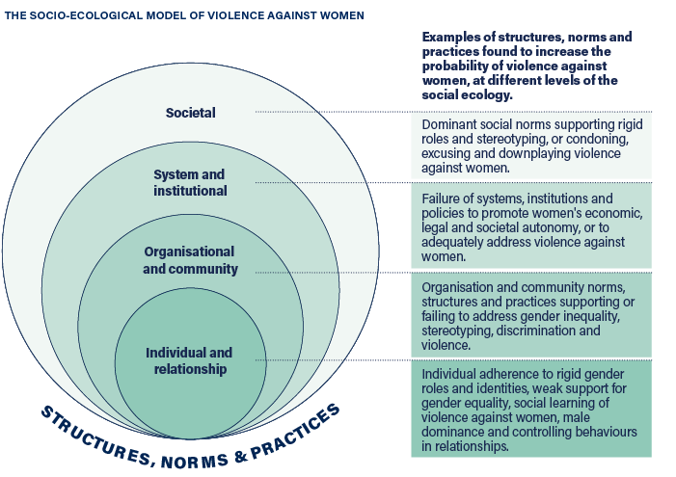

# Building the foundations for prevention

**Every government, sector, institution, organisation, community and individual has a role to play in preventing violence against women.**

As a result, it is important to create the right foundations that will ensure primary prevention efforts are coordinated, mutually reinforcing, sustainable and effective in achieving the scale of change required to stop violence before it starts. *Change the story* outlines what the evidence says are the key foundations for primary prevention and uses the interchangeable term*-“*prevention infrastructure”.

**‘Infrastructure’, in the context of primary prevention, is best described as the essential foundations that enable prevention efforts to be most effective and impactful**, and to ensure that they lead to sustained long term social change. Governments play a critical role in driving an effective approach to prevention and in building, investing in and supporting the prevention infrastructure.

## What are the foundations for primary prevention?

1. Sustained political leadership
2. Policy, regulatory and legislative reform
3. Mechanisms for coordination, collaboration and quality assurance
4. Mechanisms for workforce and sector development
5. Strong evidence base, informed by ongoing data collection, research, practice and evaluation
6. Monitoring and reporting mechanisms
7. Private sector, civil society and community leadership
8. A well-resourced, independent women’s sector

### Essential foundations for primary prevention

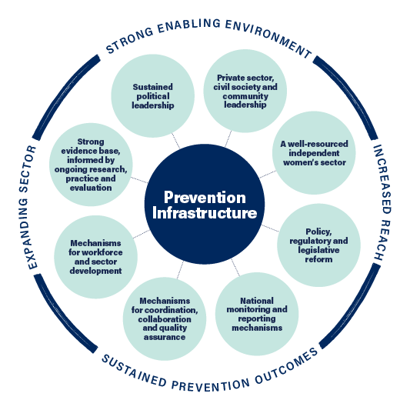

## Why focus on establishing strong foundations?

Primary prevention requires a strategic approach to ensure that the right foundations are in place to deliver effective primary prevention approaches.

**The key foundations for primary prevention are interrelated and at times interdependent.** Together the eight foundations help to ensure:

* Primary prevention is prioritised and activities sustain momentum in a strong authorising environment.
* Primary prevention activity is both evidence-based and evidence generating.
* Investment in prevention is directed to programs and initiatives that achieve outcomes.
* Primary prevention efforts within and across jurisdictions are complementary and avoid duplication.
* There is a skilled expert primary prevention workforce with sufficient investment to meet demand for prevention work and activities safely and effectively.
* A broad range of stakeholders can confidently design, implement and evaluate effective primary prevention activities.
* The impact and outcomes associated with primary prevention efforts are known, and this knowledge is used to direct investments and attention in ways that accelerate progress.

# Government actions for strong foundations

## 01. Sustained political leadership

### OUTCOME

Visible multipartisan political leadership and role modelling that sets community expectations and maintains momentum for change.

### TOP 3 ACTIONS FOR GOVERNMENTS

1. Develop and invest in evidence based primary prevention strategies and initiatives.
2. Increase the focus on men’s accountability for their use of violence, and on the role men and boys can play in prevention.
3. Develop regulatory, policy, organisational and institutional responses to increase the representation of women (from a range of diverse backgrounds and life experiences) in political systems and institutions, and formal and informal decision-making roles at all levels.

## 02. Policy, regulatory and legislative reform

### Outcome

Policy reforms directly address the gendered drivers of violence against women and drive change.

### Top 3 actions for governments

1. Develop and implement a dedicated standalone strategy for primary prevention of violence against women or include primary prevention of violence against women as a specific area within a broader strategy with dedicated actions and investment.
2. Use policy, regulatory and legislative mechanisms to increase women’s economic security, including by promoting workforce participation, equal pay and more equitable, accessible and affordable parental leave and childcare arrangements.
3. Develop and employ intersectional gender impact analysis tools in policy development, government decision making and budget processes.

## 03. Mechanisms for coordination, collaboration and quality assurance

### Outcome

Coordination, collaboration and quality assurance mechanisms ensure primary prevention efforts are evidence-based, consistent, mutually reinforcing, and able to be reproduced at scale.

### Top 3 actions for governments

1. Establish dedicated prevention agencies, peaks, organisations or networks to lead, coordinate and drive uptake of quality prevention practice, policy, research and monitoring.
2. Establish overarching coordination and advisory bodies and/or structures within and across government that guide the design, development and evaluation of prevention activities and work.
3. Develop and implement criteria for evidence-based quality assurance in program development and commissioning, including for design, implementation and evaluation.

## 04. Mechanisms for workforce and sector development

### Outcome

A strong national primary prevention workforce expands the reach and uptake of prevention policy, strategy, practice and research across the country.

### Top 3 actions for governments

1. Develop a workforce development strategy which includes the primary prevention workforce, drawing on Growing with change.
2. Invest in organisations and mechanisms to coordinate activities to develop, grow, retain and support primary prevention workforces at the national, state, regional and local levels.
3. Create opportunities for high-quality, affordable and accredited and non-accredited professional development for the existing prevention workforce, including by supporting collaborative peer learning networks and leadership programs.

## 05. Strong evidence base, informed by ongoing data collection, research, practice and evaluation

### Outcome

The evidence base clearly demonstrates what effectively prevents violence against women, how and for whom, across Australia in particular settings/sectors and contexts, and with specific population groups, cohorts, audiences and communities.

### Top 3 actions for governments

1. Invest in strategic research, data collection and data analysis into emerging issues, critical knowledge gaps, and population-level or cohort trends to continue to build the evidence base.
2. Establish mechanisms to promote strategic evidence generation, shared learning, and efficiencies, for example via establishing networks and collaborative partnerships between practitioners, researchers and policy makers.
3. Develop shared primary prevention monitoring, evaluation and learning frameworks and resources.

## 06. Monitoring and reporting mechanisms

### Outcome

Monitoring and reporting support a nuanced understanding of progress and change and promote shared learning and efficiencies, enabling governments to direct investments and attention in ways that accelerate progress.

### Top 3 actions for governments

1. Ensure that primary prevention is integrated in monitoring and evaluation frameworks of all governments.
2. Support a coordinated and consistent national approach to monitoring and reporting to demonstrate collective impact across primary prevention, early intervention, response and recovery.
3. Use established outcomes, measures and indicators (e.g., from Counting on Change) to ensure that data inputs across jurisdictions can demonstrate the collective impact of primary prevention.

## 07. Private sector, civil society and community leadership

### Outcome

Key stakeholders across the private, civil society and community sectors are mobilised to undertake prevention activity.

### Top 3 actions for governments

1. Ensure prevention strategies and plans are underpinned by the understanding that preventing violence against women is everyone’s responsibility including by outlining clear roles and responsibilities for non-government stakeholders.
2. Commission or continue to invest in promising community-led primary prevention initiatives with a goal to increase size and scale.
3. Encourage private and not-for-profit sector workplaces to promote gender equal and safe working environments and to play a role in primary prevention– for example through investing in settings-based approaches to prevention and workplace initiatives such as [Workplace Equality & Respect](https://workplace.ourwatch.org.au/).

## 08. A well-resourced, independent women’s sector

### Outcome

A well-resourced and diverse women’s sector ensures prevention efforts are informed by a well-developed understanding of the complex dynamics of violence against women, gender and other social inequalities, and holds governments accountable to their prevention commitments.

### Top 3 actions for governments

1. Support a diversity of formal and informal women’s health and rights organisations and networks to work on both preventing violence against women and advancing the rights of women more broadly.
2. Ensure equity of access to consultation and policy development opportunities, capturing from grassroots community groups and representatives of marginalised communities.
3. Adequately resource the women’s sector through short- and long-term flexible funding, and by providing other forms of capacity building support to maximise the reach and impact of their work.