Respect and Equality icon and the Our Watch brand logo.

SELF ASSESSMENT INSTRUCTION PAPER FOR DUAL SECTORS

Our Watch  
Respect and Equality

Our Watch acknowledges the support of the Victorian Government in the development of the Respect and Equality Framework.

Our Watch acknowledges the support of the Department of Social Services.

© Our Watch 2025

A hand drawn map of Australia and the Torres Strait Islands.

Our Watch acknowledges the Traditional Owners of the land across Australia on which we work and live. We pay respects to Elders past and present and recognise the continuing connection Aboriginal and Torres Strait Islander people have to land, culture, knowledge, and language for over 65,000 years.

As a non-Aboriginal organisation, Our Watch understands that violence against Aboriginal and Torres Strait Islander women and children is an issue for the whole community. As highlighted in Our Watch’s national resource Changing the picture, the evidence clearly shows the intersection between racism, sexism, and violence against Aboriginal and Torres Strait Islander women.

Our Watch has an ongoing commitment to the prevention of violence against Aboriginal and Torres Strait Islander women and children, who continue to suffer from violence at a significantly higher rate than non-Aboriginal women. We acknowledge all Aboriginal and Torres Strait Islander people and organisations who continue to lead the work of sharing knowledge with non-Indigenous people and relentlessly advocate for an equitable, violence-free future in Australia.

# Acknowledgement of Country

# Contents

Acknowledgement of Country 2

Contents 3

Assessing your institute’s progress across the six key domains of Respect and Equality 4

Introduction 4

Undertaking the self-assessment 5

Self-assessment tool documents 9

# Assessing your institute’s progress across the six key domains of Respect and Equality

## Introduction

No two dual sector institutes are the same. An effective approach to promoting gender equality and preventing violence against women needs to be tailored to suit the individual resources, capacity and cultural needs of your organisation. It also needs to factor in any progress already made and initiatives currently underway.

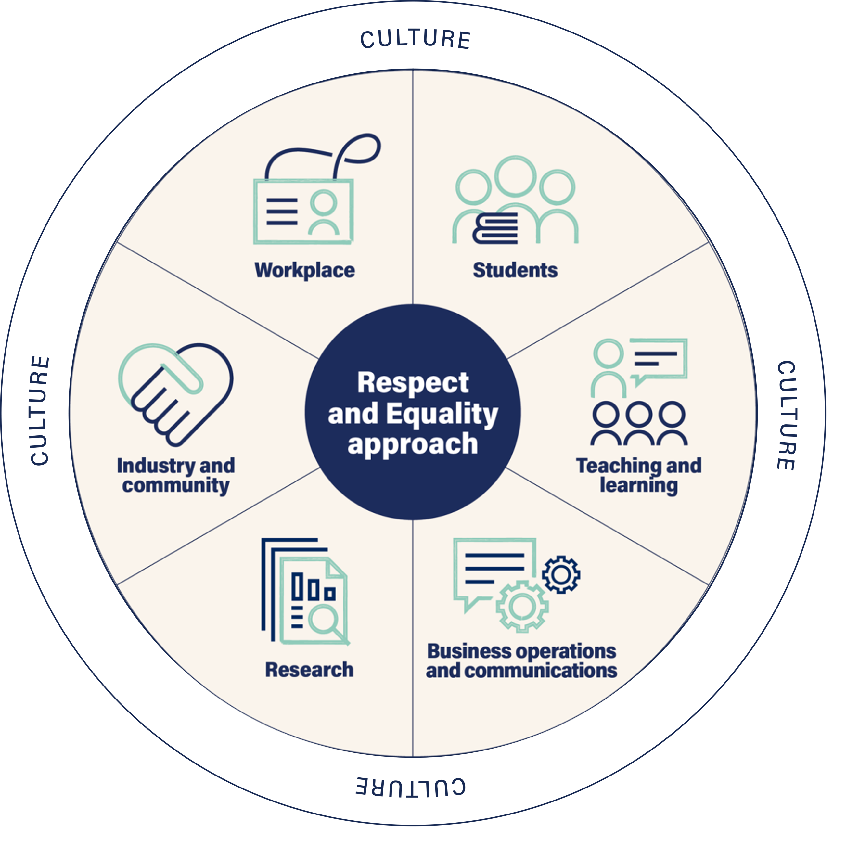

To ensure the gender equality activities your organisation undertakes are evidence-based, aligned to your strategy and achieve the change you want to see, it is important to consider your current progress across the following six domains: workplace, students, teaching and learning, business operations and communications, industry and community, and research.

This self-assessment tool will help you to reflect on your experience, practice, culture and processes to date, and identify key areas on which to focus your future efforts. The document outlines how to go about undertaking the self-assessment in your dual sector. It provides information about what to look for under each of the domains as well as examples of actions you can take to progress your work. Once you have completed the self-assessment, it will help you to begin the process of developing your Respect and Equalityaction plan.

**Figure 1: The six key domains of the Respect and Equality approach**

## Undertaking the self-assessment

#### When to undertake the self-assessment:

The self-assessment is a key part of implementing the Respect and Equality approach. It should take place after you have secured leadership commitment for this work and identified who will lead the work. You should also have completed data collection (referred to as an audit or ‘stocktake’ in Respect and Equality: Working together to prevent violence against women National Guide for TAFE, VET and dual sector institutions) to create a baseline of gender equality across your organisation. This self-assessment tool can assist in this data collection.

You will need to make sure that systems are in place to respond appropriately to disclosures of violence from staff and students, including those who may participate in this process. This includes training for staff in how to respond in a safe and supportive manner when someone discloses their experience of violence; having documented referral pathways to specialist family violence and sexual assault support services for both staff and students experiencing violence, and for perpetrators of violence; and having appropriate workplace policies to support staff. Refer to the ‘Ensuring the safety of staff and students’ section of the Respect and Equality: Working together to prevent violence against women National Guide for TAFE, VET and dual sector institutions (page 20) for more information on safely engaging in prevention work.

#### What is involved:

Completing a self-assessment across the six Respect and Equality domains will help you understand where good practice is currently happening in your institute, as well as where further action is needed. You will need to pull together a team from across departments, job levels, backgrounds and perspectives, who can realistically assess your progress across all six domains. This means they have knowledge of the drivers of violence against women and primary prevention work as well as of what is happening in one or more domain that intersects with this approach. The group that undertakes the self-assessment might be the Respect and Equality Working Group members, or it may involve other staff members and student representatives.

Alternatively, you can discuss one domain at a time with the specific staff who represent the area being discussed, e.g., student services, enrolments and counselling to assess the students domain. It is good to try to get a range of perspectives across gender, cultural background, age and job level to participate under each domain. If they are not familiar with drivers of violence against women and primary prevention concepts, then this information should be presented prior to discussing what’s happening under each domain. The self-assessment workshops can be conducted online or in person. You can conduct the workshop over one long session or multiple shorter sessions. We recommend if possible that the self-assessment workshops take place in person and that they are conducted in one session.

#### How long will it take?

It is recommended you allow approximately four hours for the facilitated group discussion/s. Depending on participant availability, and whether you are conducting sessions online, you might choose to break up the four hours over a number of shorter one- or two-hour sessions (allowing reflection time between the sessions). Depending on how many participants you involve, you may decide to run the self-assessment sessions with more than one group to ensure a wide range of experiences and perspectives are included.

#### Who should facilitate the self-assessment process?

The self-assessment can be facilitated by yourself or someone outside your institute. The facilitator will help your group stick to time, provide additional information and steer you through tricky discussions. Having an external facilitator can sometimes be important to challenge usual ways of thinking, to overcome power imbalances and to bring expertise and examples to enrich discussions. For example, you may like to engage someone with expertise in the field of prevention of violence against women or the promotion of gender equality. Whoever is chosen as a facilitator, they should be familiar with the gender data that you have collated.

#### How to prepare:

Prior to the session/s, collate and prepare your gender equality data using the Information Collection Tool so that it can be used as part of your discussion. You may also have other data that is useful to bring to the discussion, including staff and student survey data, organisational plans and policies related to gender equality and respect, or [*Workplace Gender Equality Act*](https://www.legislation.gov.au/Details/C2012C00899) data.

On the day, you will need:

* Copies of *Assessing progress across the six domains* and *Individual scorecard* for each person in the group (handout 1 and 2 for participants). It is useful to share this worksheet with participants in advance and have them read it before the session.
* Someone to take notes during group discussions using the *Group discussion sheet* (handout 3). If possible, display the sheet using a projector (or screen sharing if the session is online) so participants can keep track of the notes being taken. You might also wish to note down any other important details that arise during the discussion, such as what additional information you still need to develop your strategy and whose voice is missing from discussions.

Table 1: Suggested timing for a four-hour session

|  |  |  |  |  |  |  |  |  |  |
| --- | --- | --- | --- | --- | --- | --- | --- | --- | --- |
| Introduction | Domain 1 | Domain 2 | Domain 3 | Break | Domain 4 | Domain 5 | Domain 6 | Final discussion & next steps | TOTAL |
| 30 mins | 45 mins | 30 mins | 30 mins | 30 mins | 30 mins | 30 mins | 30 mins | 15 mins | **240 mins** |

#### How to introduce the session:

It is useful to schedule time to introduce the process and talk through some of the key ideas behind Respect and Equality.

#### Points to cover in the introduction of the workshops include:

* Information on who to talk to if the discussion brings up issues for participants related to violence that they or someone they know may have experienced. It is always advisable to provide the 1800RESPECT (national sexual assault, domestic and family violence counselling service) telephone number whenever presenting on or discussing violence against women.
* Encouragement to the group for the conversation to be open and frank but noting that it is not appropriate to disclose stories about other people that are identifying, or stories about violence that may cause distress.
* An explanation of the link between gender equality and the prevention of violence against women, and how to consider intersectionality when scoring.
* An overview of the Respect and Equality approach, including the six domains, and why your institute is engaged in this process.
* A description of the process for undertaking the self-assessment activity (see below) and what the group will have at the end of the process: a qualitative assessment of how the organisation is doing across each domain, including examples of current good practice and ideas for future actions.
* Note that the conversation may feel negative because you are assessing the extent to which your institute is delivering a whole-of-institution approach. It is normal for your self-assessment to yield low scores as these highlight areas to build on.

#### Instructions for using the self-assessment tool:

* Provide participants with copies of *Assessing progress across the six domains* (including the Individual score cards).
* If possible, display the *Group discussion sheet* using a projector or shared screen so that participants can track the note-taker’s notes.
* Starting with the Workplace domain, read through the goals and example actions.
* Give participants a few minutes to complete the domain’s *Individual score card*, considering each of the goals, providing an overall score and making note of either current good practice or possible future actions.
* Once they have scored each goal, facilitate a group discussion. Ensure your note-taker is taking notes using the Group discussion sheet. Prompt questions include:
  + How did you decide on your score?
  + What’s an example of good work in this area? Is there evidence of progress?
  + What are some of the ways actions towards this goal could improve?
  + Do you think other staff would agree with this score?
  + Does your score change or stay the same when you consider intersectionality?
* Reflecting on the discussion, come to a group agreement about what score you will allocate to the domain. If there is not uniform agreement, you can find the average score by adding together each individual score then dividing by the number of participants. Try and land on a whole number.
* Repeat the process for the remaining domains. You should aim to spend approximately 30–45 minutes on each domain. See suggested timing above (which is based on the number of goals within each domain).
* Once you have completed all the domains, discuss the outcomes with the group, noting any concerns as well as what the group thinks might be priority areas to focus on. These priority areas will need to be approved and endorsed later by the leadership group (CEO, board, executive, etc.), who will also need to allocate necessary resources.
* Collect *the Individual score cards*. You will be able to review these later for any examples of current good practice or areas for improvement that may not have been included in the discussion.
* Depending on the level of authority of the group, you may like to spend time discussing next steps. These might include deciding how the findings will be communicated to the leadership group for their sign-off, setting a meeting to begin action planning, or undertaking further investigation to better understand key issues or areas for improvement.

#### Next steps:

Once you have completed your self-assessment group sessions, you will be able to collate all the information you have gathered for review. This includes actioning any next steps discussed, such as following up any areas that need additional investigation and communicating your findings to others.

Depending on the level of authority of the team leading the self-assessment process, you many need to prepare a summary and presentation for your leadership group so they understand the key findings from the process and endorse the identified actions to be taken. In the case that the self-assessment has been conducted across multiple groups, an additional workshop may need to be held with the leadership group in order to prioritise key actions.

Now that you have completed both the gender equality data collection and self-assessment, you will be able to use the combined results to inform the development of your Respect and Equality action plan. You may also have identified some immediate or short-term gender equality actions that you can get working on straight away.

For more information on developing your Respect and Equality action plan, refer to Step 4: Develop an action plan for your institute in Respect and Equality: Working together to prevent violence against women and Respect and Equality Action Planon the [Respect and Equality website](https://action.ourwatch.org.au/resource/resources-vocational-education-and-training-vet-sector/).

## Self-assessment tool documents

In this section you will find the documents that make up the self-assessment tool.

Table 2: The documents that make up the self-assessment tool

|  |  |  |
| --- | --- | --- |
| Document | How to use | Who needs a copy? |
| *Instruction Paper* | This document outlines how to use the suite of Self-Assessment tool documents. | Provide a copy to your Project Lead and Project Sponsor so that they are aware of the process.  Provide a copy to the facilitator.  You may choose to provide this to participants beforehand to assist their preparation. |
| *Assessing progress across the six domains and* | Provides examples of the goals and actions across each domain to help the group assess your current standing and opportunities for future action.  This document includes the *Individual scorecard* for participants to fill out at the start of each domain discussion. | Provide a copy to each participant and to the facilitator.  You may choose to provide this to participants beforehand to assist their preparation. |
| *Group discussion sheet* | For the note-taker to fill out during the group discussion. | Enlarge and display during the group discussion.  If possible, have the note-taker take notes on the projected sheet. |

# 