Evaluation of the respect and equality at tafes 2 project
final EVALUATION REPORT
march 2025

Table of Contents
1 Acknowledgements 3
2 Acronyms and terminology 4
3 Executive summary 6
Evaluation findings 6
Key learnings and future considerations 7
4 Introduction 9
4.1 Overview of the Respect and Equality in TAFEs 2 project 9
4.2 About this evaluation 10
4.3 About this report 11
5 Evaluation findings 13
5.1 Problem definition, program rationale and design 13
5.2 Program delivery 22
5.3 Program impact 30
6 Key learnings and future considerations 36
7 Appendices 41
Appendix A: Data sources 41
Appendix B: Respect and Equality in TAFE Framework 42
Appendix C: Theory of Change (ToC) 43
Appendix D: Respect and Equality in TAFE 2 Project model 44
Appendix E: Evaluation framework 45
Appendix F: List of stakeholders consulted 49
Appendix G: Methodology 49
Appendix H: dandolo Analysis Sources 51

Acknowledgements

Acknowledgement of Country
dandolopartners acknowledges the traditional owners of the lands and water on which we live and work.
We acknowledge Aboriginal and Torres Strait Islander people’s deep spiritual connection to this land and water and that Aboriginal sovereignty has never been ceded.
We pay our respect to Elders past and present and extend that respect to any Aboriginal and Torres Strait Islander readers.
We recognise the disproportionate rate that Aboriginal and Torres Strait Islander women, and Aboriginal and Torres Strait Islander women with disabilities, experience violence, and acknowledge their strength and resilience in facing sexism, ableism, racism and the effects of colonisation.

Acknowledgement of those who contributed to this report
dandolopartners sincerely thanks the individuals from Our Watch, involved TAFEs and other key stakeholders who worked with us on this project, gave us their time and shared their reflections with us.
This evaluation would not have been possible without the generous contributions of fieldwork participants, all of whom provided invaluable insights into our evaluation.

Acronyms and terminology
ACT | Australian Capital Territory
ASQA | Australian Skills Quality Authority
BIITE | Batchelor Institute of Indigenous Tertiary Education
CDU | Charles Darwin University
CEO | Chief Executive Officer
CIT | Canberra Institute of Technology
CoP | Communities of Practice
EA | Enterprise Agreement
DEI | Diversity, equity and inclusion
DEWR | Department of Employment and Workplace Relations
DSS | Department of Social Services, Australian Government (project funder)
JSC | Jobs and Skills Council
LOTE | Languages other than English
MoU | Memorandum of Understanding
NT | Northern Territory
Our Watch | Our Watch is a national leader in the primary prevention of violence against women and their children in Australia. They work to embed gender equality and prevent violence where Australians live, learn, work and socialise.  Our Watch were the grant recipient and project leader for the Changing the landscape project, and they commissioned us to complete this evaluation.
RET | Respect and Equality in TAFE
RET framework | Refers to the Respect and Equality in TAFE framework that was developed during the earlier stage of the project conducted in Victoria.
RET2 project | Refers to the current project, the implementation and testing of the framework in four new jurisdictions: Australian Capital Territory (ACT), South Australia (SA), Tasmania and Northern Territory (NT).
RTO | Registered Training Organisation
SA | South Australia
Stakeholders | In this report we use the term stakeholders to collectively refer to the relevant groups and individuals relevant to implementation of the Respect and Equality in TAFE project we consulted with as part of this report.
TAFE | Technical and further education institutions, that provide vocational qualifications
TAFE SA | TAFE South Australia
TasTAFE | Tasmania TAFE
TDA | TAFE Directors Australia
TEQSA | Tertiary Education Quality Standards Agency
ToC | Theory of Change
VET | Vocational education and training

Executive summary
The Respect and Equality in TAFEs 2 (RET2) project, led by Our Watch and funded by the Australian Government Department of Social Services (DSS), aimed to support TAFEs to enhance gender equality and prevent violence against women. Building on the foundational Respect and Equality in TAFE (RET) framework developed in Victoria, RET2 expanded to four jurisdictions—the Australian Capital Territory (ACT), South Australia (SA), Tasmania, and Northern Territory (NT)—engaging five TAFEs to implement and test the framework. These TAFEs were Batchelor Institute of Indigenous Tertiary Education (BIITE), Charles Darwin University (CDU), Canberra Institute of Technology (CIT), TAFE SA and TasTAFE (based in South Australia and Tasmania respectively).
The project adopted a whole-of-institution approach (as outlined in Change the Story: A shared framework for the primary prevention of violence against women and their children in Australia (Change the story)) addressing systemic drivers of violence against women across five key domains: workplace, students, teaching and learning, communications, and industry and community; and a sixth domain of research for dual-sector universities.
Our Watch engaged dandolopartners to evaluate the RET2 project, and:
- Assess whether RET2 achieved its intended outcomes
- Identify barriers and enablers influencing implementation
- Generate insights and key learnings for scaling the framework across TAFEs nationally
Our evaluation was informed by a review of project plans, reports, data from events, team reflections, and case studies, alongside stakeholder interviews involving internal Our Watch stakeholders and representatives from five TAFEs.

Evaluation findings
TAFEs are central to Australia's vocational education and training (VET) sector and are well-positioned to implement whole-of-institution approaches to prevent violence against women due to their significant reach and influence. Despite their potential, primary prevention work in TAFEs lags behind other settings due to the inherent challenges of designing and implementing such approaches in diverse and complex settings. For example the lack of sector wide national requirements about primary prevention in VET and the variation in institutional contexts between TAFEs makes it difficult to implement effective policies consistently, and means prevention policies for TAFEs aren’t fully embedded into gender equality strategies at a national level.
Between 2021 and 2024, the RET2 project was delivered to five TAFEs across four jurisdictions, adapting the RET Framework to diverse contexts. RET2 delivered:
- A series of facilitated sessions delivered by the Our Watch team with the TAFE working group – these were to help guide them through the process of developing their gender equality action plans
- Supporting TAFEs with subject matter expertise on primary prevention through the project team, training, guidance, resources, tools and templates
- Opportunities for TAFEs to connect with each other through their primary prevention journey, including via Communities of Practice (CoPs) and summits with participating TAFEs
This allowed TAFEs to progress through the process of developing their gender equality action plans including collecting data on current progress and initiatives and setting up monitoring plans to evaluate future progress against goals.
There were some challenges in implementation, including:
- Significant variation between TAFE contexts influenced the implementation of RET2
- A lack of authorising environment at the system level caused delays in getting the work off the ground and required the Our Watch team to use alternative mechanisms to engage TAFEs. These delays:
- Influenced the strategic decision to forgo engaging system actors in the form initially planned
- Impacted the time it took to engage TAFEs and for them to complete project activities
These challenges were generally effectively managed and overcome due to the responsiveness and adaptability of the project team, supported by the project principles.
RET2 has produced positive outcomes, including:
- Foundational changes – most TAFEs developed their first gender equality action plans, focusing on achievable goals such as policy reviews, inclusive language adjustments, and monitoring processes
- Individual impact – participants reported increased understanding of gender equality and confidence in addressing primary prevention within their institutions
- Institutional impact – examples of change included revised recruitment practices, inclusion-focused enterprise agreements, and greater integration of gender equality into teaching practices
- Sector-wide impact – CoPs enabled knowledge sharing across jurisdictions
Leadership buy-in and embedding gender equality action plans within broader organisational strategies led to more significant changes (such as in policy and practice). Some TAFEs showed evidence of sustainability of both the changes and ongoing commitment to promoting gender equality and preventing violence against women. For some TAFEs, reliance on individual champions may pose a risk to sustainability, and the reduction in support from Our Watch may mean work loses momentum.

Key learnings and future considerations
The RET2 project laid strong foundations for promoting gender equality in TAFE settings through a whole-of-institution approach. It generated valuable insights into what works for fostering systemic change in vocational education settings.
Effective approaches to engaging with TAFEs and supporting changes in practice to promote gender equality and prevent violence against women should:
- Tailor engagement approaches. Flexibility to adapt resources and approaches based on each TAFE’s context was critical to engaging TAFEs, building relationships, and creating an environment for learning and progress. This adaptation and iteration required a sufficient time investment.
- Support the work with resourced backbone relationships. This requires trust-building through consistent communication, in-person engagement and regular check-ins fostered commitment to the work. Critically, the resourcing of this needs to provide sufficient time and capacity to engage and build relationships.
- Be clear on the value of leadership buy-in. TAFEs with executive sponsorship and engagement were more likely to show evidence of sustainability of changes, particularly where the work was embedded in broader strategies.
- Provide mechanisms for learning and accountability. Regular working group meetings, CoPs, and summits provided accountability and shared learning opportunities. This supported engagement and gave mechanisms for participation and knowledge sharing.
- Establish clear authorising environments. Future projects should secure system-level support from governments or regulatory bodies to create impetus for participation.
- Work with TAFEs to identify opportunities to embed change. Integrating gender equality into broader strategies (e.g., diversity frameworks) can mitigate reliance on individual champions and insulate the work against resistance and backlash.
To unlock the full potential of the VET sector as a key setting for primary prevention of violence against women, Our Watch should:
- Enhance internal capability. Continue to strengthen Our Watch’s organisational understanding of the VET sector's complexities, cultural differences from higher education, and opportunities for industry collaboration.
- Leverage the learnings of RET2 as the work continues to scale, by:
  - Advocating to funders to support this work by factoring in the policy levers available to support the work, the authorising environment required at the system-level to enable it to be prioritised, and the funding required to resource time and capacity
  - Ensuring sufficient time is available for effective engagement and relationship building, which is required to support participation and establish leadership buy-in at the system and TAFE level
  - Continuing to draw on principled ways of working that prioritise relationships and leadership buy-in, and share these learnings with TAFEs
  - Exploring opportunities to work with private Registered Training Organisations (RTOs) specialising in male-dominated industries like construction or mining
- Engage system-level actors. Collaborate with state/territory governments, regulatory bodies (e.g., the Australian Skills Quality Authority (ASQA), and industry stakeholders to embed primary prevention into policy frameworks and advocate for national alignment with VET sector priorities. This includes consideration of what this means in the context of the new National Code.
- Expand its presence in the VET sector. Expand Our Watch’s presence, and build credibility and trust within the VET sector by:
  - Staying informed about policy reforms
  - Advocating for the strategic importance of primary prevention in VET
  - Investing resources to maintain VET as a priority area within Our Watch
  - Promoting available supports and resources from Our Watch to TAFEs

Introduction

Overview of the Respect and Equality in TAFEs 2 project

The RET2 project seeks to enhance gender equality and prevent violence in TAFEs.
The RET2 project followed the first iteration of this work, the Respect and Equality in TAFE (RET1) project. The RET1 project commenced in October 2019 and was piloted in five TAFE institutions in Victoria. It aimed to develop a whole-of-institution approach to primary prevention in TAFEs, and to develop a toolkit of communication resources.
RET2 marked the next stage of this work, which aimed to implement the whole-of-institution approach developed in RET1 in TAFEs in jurisdictions outside of Victoria, and to test and refine the approach to ultimately be delivered at a national scale. RET2 worked alongside TAFEs to support them to implement the Respect and Equality in TAFE (RET) framework in the ACT, SA, Tas and the NT - to enhance gender equality and prevent violence in TAFEs. The TAFEs involved in RET2 were BIITE (NT), CDU (NT), CIT (ACT), TAFE SA and TasTAFE.

RET2 was funded approximately $2.3 million by DSS at the end of September 2021.
Project implementation was originally due to end June 2024. A Deed of Variation was signed in November 2023 which documented agreement to extend activity completion to December 2024, with the final evaluation report due in June 2025, aligned with Agreement End Date on June 30 2025. The project also had an underspend in FY23 of $1,393,597 and in FY24 of $817,745.07. The cause of project timeline delays and project underspend was because the project experienced delays in implementation due to the time taken to engage TAFEs and a need to align to the TAFE academic year.

The RET framework is intended to support TAFEs to foster safe, inclusive, and equitable environments, ultimately shaping a future workforce that values respect and equality.
The RET framework outlines a whole-of-TAFE model for building a TAFE environment that promotes gender equality and respect. It encompasses five key domains: workplace, students, teaching and learning, communications, and industry and community. These domains work together to embed principles of respect and equality throughout all aspects of TAFE operations. The RET framework outlines eight key steps for implementing this model, as outlined in Figure 1 below.
Figure 1: RET Framework
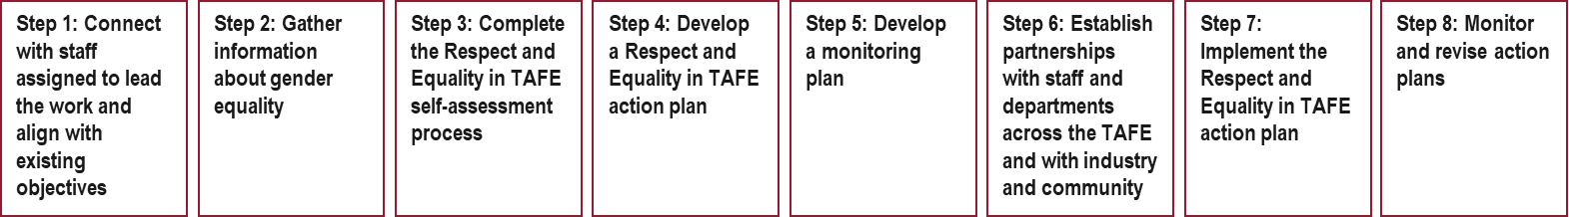

RET2 implemented and tested the RET framework in five TAFEs across four jurisdictions.
The framework is intended to support TAFEs to foster safe, inclusive and equitable environments, ultimately shaping a future workforce that values respect and gender equality.
A previous evaluation of the framework found:
- The whole-of-TAFE approach was acceptable, feasible and relevant to the pilot TAFEs
- The self-assessment tool, monitoring guide and action plan template were seen as valuable, comprehensive and helpful to the pilot TAFEs’ prevention work
- That there was a need for further investment (such as staff and time) to support the implementation of the approach
Our Watch aimed to engage directly with TAFEs in the set jurisdictions, and to deliberately promote the integration of systemwide actions to prevent violence against women in vocational education and training. This approach aimed to recognise TAFEs as an education institution, a workplace and a community hub through a ‘whole-of-institution’ approach as identified in Change the story. Change The story is Our Watch’s evidence-based framework to guide a coordinated and effective national approach to preventing violence against women.

RET2 aimed to build the evidence base around what works to implement a whole-of-institution approach within a TAFE environment by engaging with four different jurisdictions with both a developmental and exploratory focus.
RET2 project aims for participating:
- TAFEs to have increased commitment and momentum for change, that will be sustained to some degree beyond the end of the project
- Actors at a TAFE and system level have increased recognition of their role in promoting gender equality and preventing violence within TAFEs
- System actors to be active advocates within their sphere of influence for promotion of gender equality and prevention of violence against women
- TAFEs and system actors to have taken actions to address at least one of the domains in the RET framework

About this evaluation

Our Watch engaged dandolopartners (dandolo) to evaluate RET2.
The aim of this evaluation is to understand how the RET2 project went in achieving its aims and objectives and generate learnings on best practice in implementing the Respect and Equality in TAFE Framework developed in Victorian RTOs in 2019-2021. The purpose of this RET2 project evaluation is to determine if the project has:
- Successfully achieved its intended outcomes and to determine the sustainability of those outcomes in TAFEs
- Been implemented as planned, including identifying barriers and enablers that could influence scalability
- Engaged stakeholders effectively throughout the process to foster collaboration and support
- Provided actionable opportunities to inform strategies for enhancing gender equality and violence prevention in TAFE settings
Our Watch will draw on the learnings of the RET2 Project to inform the design and implementation of the RET framework at other TAFEs across different jurisdictions.
Our evaluation is underpinned by an evaluation framework, which can be found at Appendix E.

Our evaluation commenced in October 2024, with fieldwork and analysis taking place between December 2024 and January 2025.
Key evaluation activities including ethics and safety considerations are documented in our evaluation plan, which was provided to Our Watch in December 2024.
The evaluation was informed by a document and desktop review of the broader policy landscape and project documentation provided by Our Watch. These include but are not limited to:
- Project plans and reports
- Evaluation Plan
- Theory of Change (ToC)
- Data collected from project events, including attendance data and feedback / satisfaction surveys
- Records and documentation from project team reflection and review processes, including the RET team monthly and activities-specific evaluation reflections (e.g. end of year RET2 team reflection)
- Collated (aggregated and anonymous) data collected through the duration of the developmental evaluation relevant to the key project activities
- Case studies developed by Our Watch staff during project implementation
We also interviewed key stakeholders who contributed to the project including internal Our Watch stakeholders and stakeholders from the five TAFEs. In total we completed 13 interviews which had a total of 18 attendees.
A more detailed overview of stakeholder consultation can be found in Appendix F.
Our methodology was:
- Stage 1 – Initiation and establishment. This included a project kick off meeting and evaluation framework workshop, the development of an evaluation plan and a data and a document request to Our Watch requesting project data documentation relevant to this evaluation.
- Stage 2 – Data collection and analysis for evaluation. This included reviewing project data and documentation, developing fieldwork instruments, scheduling consultations and completing fieldwork. This stage also included the analysis of qualitative data collected through fieldwork and undertaken through thematic coding to ensure robustness and credibility of our findings.
- Stage 3 – Submission of evaluation findings and report. This included submitting a draft evaluation report to Our Watch and presenting on our findings.
An overview of the full methodology, including ethics and safety principals for this evaluation is included in Appendix G.

There are some limitations to this evaluation and our findings, and therefore to the conclusions made in this report.
As with all evaluations, this evaluation has some limitations. These include:
- Jurisdictional Differences. The project has been implemented across very different jurisdictions compared to the original jurisdiction where the framework was developed. These differences make it challenging to draw comprehensive, whole-of-program findings. Our evaluation has drawn on the Our Watch project team’s reflections to identify cross-jurisdictional learnings and insights where possible.
- Timeframes and timing. This evaluation took place from October 2024 to February 2025 and therefore occurred over the end of year / holiday period. This made it more challenging to schedule stakeholder consultation, at a time of year many stakeholders are taking leave. We’ve addressed this by being flexible, responsive and communicative both with stakeholders and the Our Watch team.
- While not a limitation of the evaluation itself, it is important to note that the scope of the evaluation was limited to understanding the design, implementation and outcomes of implementing the RET framework, which focusses on the development of gender equality action plans in each of the participating TAFEs. We have not made findings on the implementation of these action plans as this is out of scope in the RET2 project, and therefore out of scope of this evaluation.

About this report

This report includes a chapter on our evaluation findings, structured under four key areas.
Findings have been presented thematically to address the key questions outlined in the evaluation framework, including:
- Problem definition, program rationale and design – was there a clear rationale for this project, and how did the design of the project set it up for success?
- Program delivery – how has the project been implemented? How has it responded to different jurisdictional contexts? How have the project principles influenced project implementation and outcomes?
- Program impact – what type and level of changes has the project contributed to?
- Key learnings and future considerations – what are the key learnings from this project that should be taken forward in future iterations of this work?

It also includes a chapter on key learnings and future considerations informed by our evaluation findings.
The key lessons and future considerations are primarily targeted at Our Watch, as the organisation delivering the RET2 project. They may also be relevant for other project stakeholders, including the Australian Government as the project funder.
These key learnings and future considerations are designed to support Our Watch in the development, design and administration of future projects like this one and to add value to any relevant funding opportunities.
As a result, we have designed these as ‘principles-based’ lessons and considerations to ensure they are applicable and relevant in the current context and will continue to be relevant in future.

Evaluation findings

Problem definition, program rationale and design
Key insights
- Violence against women is driven by deeply entrenched societal norms and beliefs that perpetuate gender inequality. Primary prevention aims to change these societal norms.
- As critical institutions in Australia's VET sector, TAFEs are well-positioned to implement whole-of-institution approaches to prevent violence against women by promoting gender equality and respect.
- Primary prevention efforts in TAFEs are less advanced compared to other sectors, facing inherent design challenges compounded by the diverse and complex nature of TAFE settings. Mitigating this complexity requires a system level authorising environment, buy-in from leadership within TAFEs and strong relationships, support and trust with the people doing the work day-to-day.
- The design of the project supports its objectives well and shows evidence of mitigating design challenges. We found:
  - The RET2 ToC was logical but overly ambitious, making some elements unfeasible.
  - The project model successfully prioritised relationship-building and leadership engagement as key enablers for progress. Underpinning principles helped with this.
  - RET2 has been sufficiently resourced to deliver on its scope.

Violence against women is driven by deeply entrenched societal norms and beliefs that perpetuate gender inequality. Primary prevention aims to change these societal norms.
Violence against women in Australia is widespread and devastating. It manifests in many forms, including intimate partner violence, sexual assault and workplace harassment, occurs in many settings, including homes, workplaces, public spaces and online, and represents both a symptom and cause of gender inequality, severely impacting society.
Gender inequality is the core driver that creates the social conditions for violence to occur. This contributes to other drivers, including harmful stereotypes that define what roles are appropriate for men and women, which may reinforce an environment where disrespectful behaviour is normalised, can result in harmful consequences such as career opportunities being restricted.
Primary prevention describes work done across communities, organisations and society in settings where people live, learn, work, socialise and play to stop violence from happening in the first place. Primary prevention approaches work across the whole population to address the attitudes, norms, practices, structures and power imbalances that drive violence against women’.
Primary prevention is a longer-term goal rather than early intervention, response or recovery. The drivers of violence against women play out at every level of society, and therefore primary prevention initiatives are most effective where a holistic, whole-of-setting approach is used.

As educational settings with extensive reach and community influence, TAFEs are well positioned to promote gender equality and challenge these harmful norms.
Vocational education and training (VET) is a broad term that is used to describe all vocational training in Australia. TAFEs are Technical and Further Education institutes, that are government owned and provide VET courses. The VET sector makes up a significant proportion of the Australian education landscape, and TAFEs within that are key institutions with substantial reach and influence. The VET sector has a large student population, workforce and number of providers and institutions, including TAFEs (see Figure 2 for more information).
- Student population. In 2022 an estimated 4.5 million students were enrolled in VET with an Australia training provider, representing a nearly a quarter of the Australian population aged 15-64 years. In the same year 4.0 million students were enrolled in Australian schools and in 2021, 1.6 million students were enrolled at higher education institutions.
- Workforce. A 2024 report by Jobs and Skills Australia estimates the VET workforce in 2021 was between 70,000 and 110,000.
- Institutions. There are approximately 4,000 registered training organisations (RTOs) in Australia. In 2022, 3.4 million students (76.2%) were enrolled at private training providers and 717,760 students (15.9%) were enrolled at TAFE institutes.
The VET sector presents an opportunity for Our Watch and primary prevention organisations in terms of potential reach, both in terms of scale and also in engaging people who have more limited connection with other settings (e.g. international students, recent migrants and refuges, young adults with disabilities and Aboriginal and Torres Strait Islander communities).

As places of learning and community engagement, TAFEs have the potential to influence attitudes and behaviours among a diverse student body. However, systemic issues persist within these environments that reflect the broader social issue of violence against women. Some marginalised groups, such as First Nations women and women with disabilities, report discontinuing vocational training due to personal reasons, unmet expectations, and inflexible conditions. In contrast, non-minority men generally do not face these challenges. This disparity highlights how biases and stereotypes are perpetuated within education and training systems, funnelling graduates into fields dominated by their gender. This underscores the opportunity for industry to actively contribute to challenging gender inequality.
TAFEs are well positioned to continue promoting gender equality and preventing violence against women, but this requires a comprehensive and intentional institutional approach.

Figure 2: VET and TAFE Sector Statistics
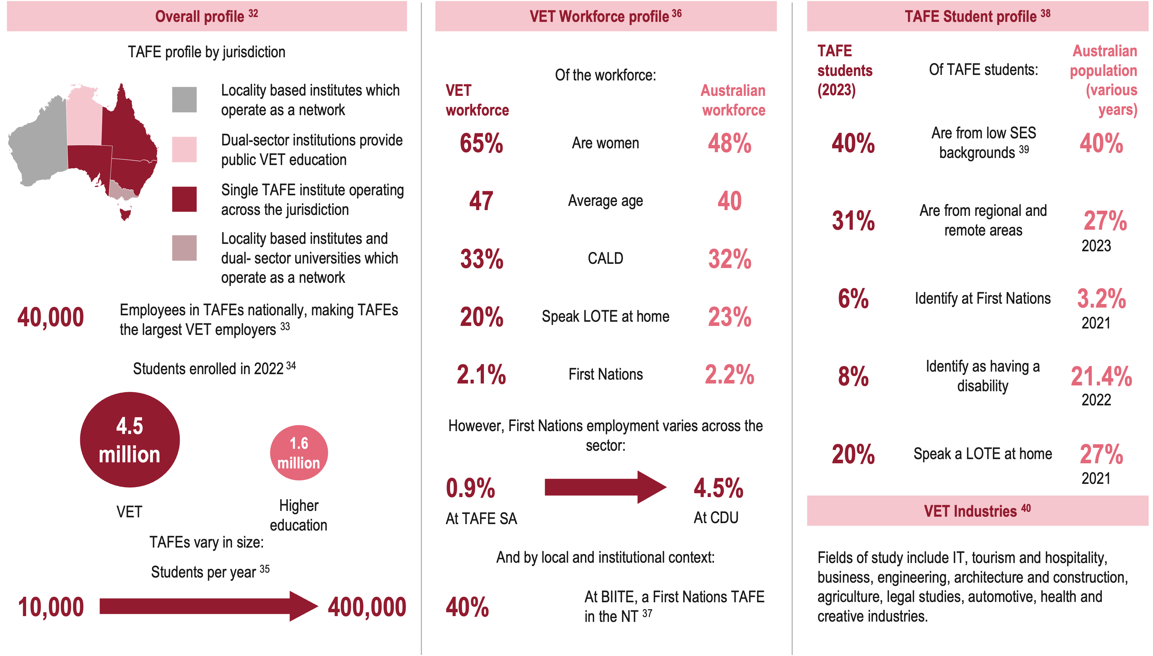

TAFEs are well positioned to drive whole-of-institution approaches to primary prevention of violence against women.
There is a logical rationale to engaging people across settings such as TAFEs and involve the people, professionals and communities that are part of these settings. Addressing a complex social problem like violence against women requires engagement with as many people as possible across institutions, organisations and systems. Institutions such as TAFEs are the places and social contexts in which environmental, social and personal factors interact, where policy frameworks come to life and where social and cultural values are produced and reinforced. Critically, TAFEs:
- Provide access to education and training for students from diverse backgrounds including those who have experienced barriers to accessing education.
- Play a key role in fostering equitable access to education from a gendered perspective including promoting women’s economic participation through skills and training.
Equal access to education and employment for women is a key aspect of primary prevention of violence against women. As such, TAFE is identified in Change the story as a key setting for the prevention of violence against women.
Legally, organisations and businesses now have a positive duty to take proactive and meaningful action to prevent relevant unlawful conduct (e.g. discrimination, sexual harassment) from occurring in the workplace or in connection to work. This requires organisations and businesses to shift their focus to actively preventing workplace sexual harassment, sex discrimination and other relevant unlawful conduct, rather than responding only after it occurs.

Despite this, primary prevention work is less progressed in TAFEs than in other sectors.
As identified in the RET1 project evaluation, many TAFEs have been doing work in responding to violence against women and in addressing what drives violence against women. However when this is compared with the University sector, work there is more advanced for example:
- Action Plan Addressing Gender-based Violence in Higher Education was agreed to and released by Education Ministers in 2024
- Australian Universities Accord was released containing explicit recommendations regarding prevention of violence against women
- Establishment of a cross‑jurisdictional Working Group with an expert on the prevention of violence against women and children as an example of an action has already been taken by the Australian Government
- National Student Safety Survey which collects data on the scale and nature of university student experiences of sexual harassment and sexual assault
In 2020, Our Watch launched Educating for Equality, a world-leading holistic model to help universities prevent gendered violence. However, there has been less attention, prior to the RET1 and RET2 projects, on a transferable whole-of-institution approach that recognises TAFE as an education institution, a workplace and community hub.
This means there is clear rationale for Our Watch working with TAFEs to determine what works in implementing a whole-of-institution approach in these settings.

Whole of institution primary prevention approaches face inherent challenges in design.
‘Prevention work in any given setting needs to be multi-dimensional. It needs to encompass the individuals and groups within that setting, the organisations, institutions and systems that define it, and the laws, policies and regulations that govern it.’ – Change the story
The RET framework is a whole-of-institution approach to preventing violence against women as the evidence suggests that it is necessary to work across all areas of an institution to make lasting change. However whole-of-institution primary prevention approaches are innately challenging and complex because they:
- Need joint commitment from the entire TAFE community, including buy-in from decision makers and authorisation from system actors.
- Require addressing systemic factors. The RET framework utilises a sociological model for understanding violence against women and challenges the structures, norms and practices found to increase the probability of violence against women at different levels of the socio ecology. This can be inherently challenging in institutions as structures, norms and practices can be deeply engrained within institutions.
- Requires work across multiple domains. The RET framework has been divided into five key domains: workplace, students, teaching and learning, communications, industry and community. While this is essential to support a culture of respect and equality across the entire institution, it’s challenging to realise the necessary depth and breadth of change necessary across all aspects of an institution.
- Include other inbuilt challenges such as resistance to change or backlash, resource limitations that make engagement and participation logistically difficult, and ensuring sustained engagement and the ongoing sustainability of any approach implemented.
The significant variation and complexities of TAFE settings compounds these challenges.
Design challenges of whole-of-institution approaches are further compounded by:
- The diversity and variation of individual TAFE institutions. TAFEs are non-homogenous, with diverse student demographics and varied industry focuses which necessitates an adaptable approach. There is significant diversity between TAFE institutions, as outlined in Figure 2, that intensifies the challenges associated with implementing a whole-of-institution approach in TAFEs.
- Historically male-dominated leadership structures and industries served by the VET sector, which can exacerbate challenges of implementing a primary prevention approach. The VET sector is now 57.2% female, and leadership is 56.6% female, but historically the VET sector has been male dominated, and this culture can take time to shift.
- A lack of robust data on violence against women within the VET sector, which complicates evidence-based design. Understanding the baseline regarding gender equality and violence against women in TAFEs is a challenge due to limited data collection. While there is limited data from VET, over the last several years evidence has shown that sexual violence continues to occur in university and dual sector communities at significant rates.

Mitigating this complexity requires a system level authorising environment, buy-in from leadership within TAFEs and strong relationships, support and trust with the people doing the work day-to-day.
A whole-of-TAFE approach includes buy-in and engagement with system level actors, leadership and from people working across all operational areas of the TAFE. Our Watch’s whole-of-TAFE approach is supported by research, which to date has predominately been done in university contexts, emphasising the importance of:
- Whole-of-institution approaches to primary prevention
- Addressing gendered drivers at all levels of the socio-ecological model
- Support from leadership, that is coordinated and sustained
- Implementation at scale
- Collaboration across and beyond the institution
The RET1 evaluation of the development of the framework in a Victorian context, identified contextual factors which influenced the implementation of the of the approach and found the key enablers of a whole-of-TAFE approach were:
- Senior leadership commitment to a whole-of-TAFE approach
- Previous and current activity in primary prevention and gender equality conducted in TAFEs
- Willingness to focus on primary prevention in addition to response
- Resourcing for dedicated staff
This was reflected in the design of the RET2 framework which outlines key foundational factors necessary to start implementing the RET approach. These include:
- Securing commitment from leadership
- Appointing a gender equality lead within the TAFE
- Understanding a whole-of-institution approach across the five domains: workplace, students, teaching and learning, communications, industry and community
- Establishing policies and practices to prioritise the safety of staff, by responding appropriately to any staff or students who experience violence
- Increasing key staff’s understanding of violence against women

RET2’s ToC was logical but overly ambitious, which meant some elements were not feasible.
The RET2 project team developed a ToC to articulate how the project aimed to facilitate the desired change and overall outcomes (see Figure 3).
The ToC outlines a logical approach to progressing toward the overall outcome of greater understanding of what works to support changes in TAFE to promote gender equality and prevent violence against women. However, it is ambitious in targeting both TAFE level outcomes and system level actors across multiple jurisdictions. The mechanisms intended to engage system level actors beyond the foundation phase are unclear in design, and resourcing didn’t support the level of intention to undertake the system actor engagement.
A strategic decision was made early to instead primarily focus efforts on engagement with TAFEs (See 2.2 implementation for further discussion on the involvement of system level actors).

Figure 3: Our Watch's ToC for the RET2 Project
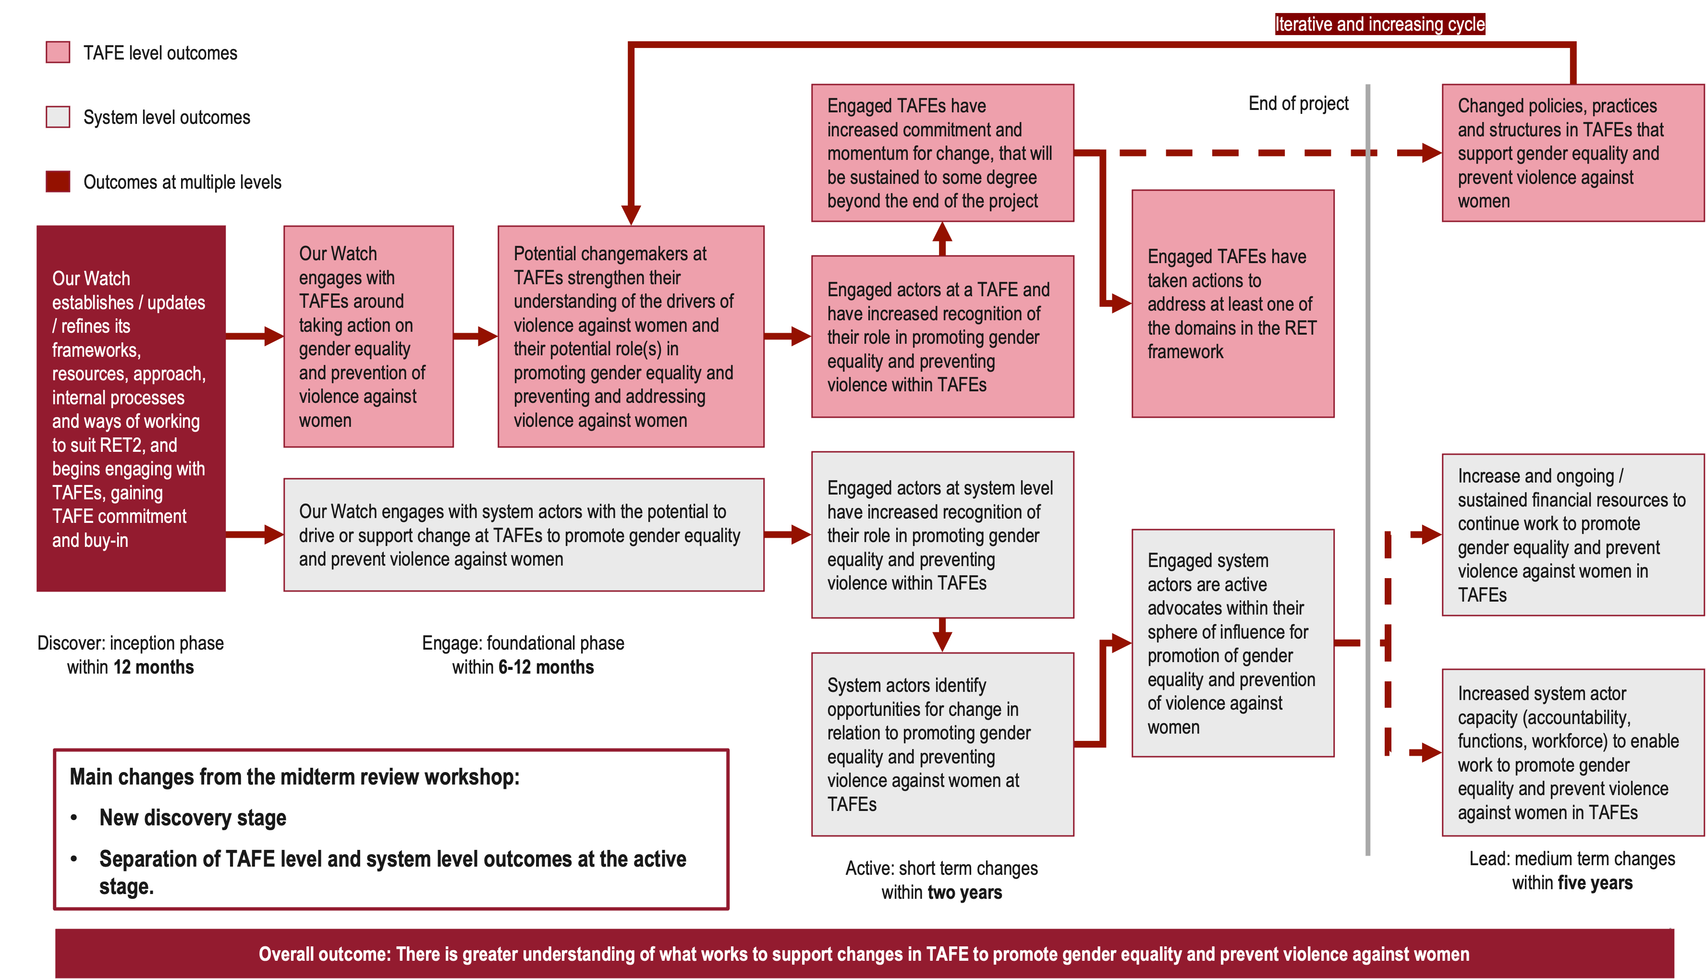

The project model for engaging with TAFEs was sound, and set the project up to prioritise key enabling factors of relationships building and leadership buy-in.
RET framework includes eight key steps for engaging with TAFEs to develop gender equality action plans, and is based on the evidence for whole-of-institutional approaches (see 1.2. Overview of the Respect and Equality in TAFEs 2 project). The RET2 project team drew on the RET framework to develop a project model for engagement with TAFEs (see Figure 4 below), designed so that TAFEs could progress through the framework with support from Our Watch.

Figure 4: RET2 Project model
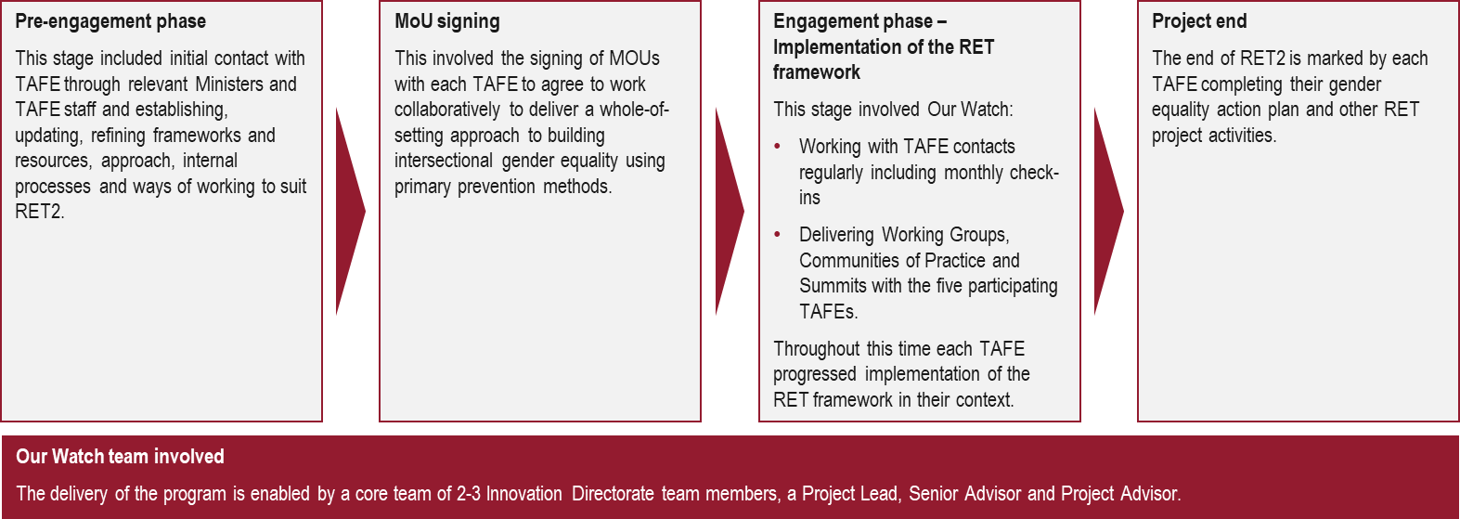
Support from the Our Watch team included:
- A series of structured engagements with the TAFE working group – these were facilitated sessions to help guide them through the process of developing their action plans
- Supporting TAFEs with subject matter expertise on primary prevention through the project team, training, guidance, resources, tools and templates
- Providing opportunities to connect with other TAFEs working through their primary prevention journey, including via CoPs and summits with participating TAFEs
This allowed TAFEs to progress through the process of developing their gender equality action plans including collecting data on current progress and initiatives and setting up monitoring plans to evaluate future progress against goals.

The RET2 project team developed underpinning principles to inform ways of working.
A series of project principles were developed by the Our Watch RET2 project implementation team, and underpinned how the project was implemented. They were:
- We understand one approach does not fit all, and we need to meet TAFE and system actors where they are at in their jurisdictions
- We foster strong mutual engagement and understanding to encourage TAFE and system actors to recognise their role in primary prevention based on the evidence base
- We engage in continuous learning and evidence generation to support TAFEs, system actors and ourselves to learn about what works
- We use comprehensive thinking and action to redress the inter-related causes of sexual harassment, violence against women and gender inequality at all levels of the socio-ecological model
- We focus on long term change, by supporting the building blocks
- We centre intersectionality in our approach by listening to and learning from diverse perspectives and evidence bases, to support meaningful and inclusive change for all
The use of principles gave the project team the scope and remit to be adaptable, work flexibly and make adjustments during implementation and to ensure the framework and project model were fit for purpose and they were working with TAFEs as effectively as they could.

The process of identifying and selecting the jurisdictions to work with was outside of Our Watch’s remit, and there was limited support for engagement with TAFEs.
Our Watch’s involvement in the RET2 project marked its first national-scale initiative in the VET sector. The organisation had prior experience working with TAFEs in Victoria during RET1, where the Minister for Skills and TAFE collaborated with the TAFE Network to prioritise gender equality actions, embedding Respect and Equality initiatives into their annual Statement of Priorities. Also in Victoria TAFEs are ‘defined entities with obligations’ under the Gender Equality Act 2020. This means they are required to develop and implement a gender equality action plan, publicly report on their progress and promote gender equality in policies, programs and services. This established framework and legally defined obligation provided the impetus for TAFEs to engage in such work, which was absent in other jurisdictions.
In RET2, Our Watch had no role in selecting jurisdictions or TAFEs. Instead, TAFEs were approached individually, often as the sole institution within their jurisdiction, without prior introductions or system-level facilitation. This lack of support required Our Watch to build relationships and credibility from scratch in a sector unfamiliar with their work. One stakeholder noted:
‘At the beginning they thought we were a marketing organisation, they did not know us at all.’ - Our Watch stakeholder
Greater system-level support in the design of the project, could have set the project up for smoother implementation. For example, external actors articulating the importance of this work to TAFEs might have encouraged them to prioritise gender equality initiatives more efficiently.

RET2 has been sufficiently resourced to deliver on its scope.
This project was given a significant budget, accompanied by a high-level Activity Work Plan, and a scoping document on the VET sector that was able to be used as a guide rather than a source of truth.
‘This AWP was really loose, it basically said we deliver a project plan, evaluation plan.’ – Our Watch stakeholder
‘We had a scoping report another consultant prepared in 2021, but it was huge, broad and out of date by the time I arrived… the scoping work became a template or guiding document, rather than instructions.’ – Our Watch stakeholder
This enabled Our Watch to develop a more comprehensive project plan and evaluation plan to design the project approach, and resourcing to hire a team of two to three (this varied throughout the project) who could dedicate the time needed to make impact and realise this approach.

Program delivery
Key insights
- Between 2021 and 2024, Our Watch delivered the RET2 project to five TAFEs across four jurisdictions.
- Variation in TAFE contexts influenced implementation.
- A lack of authorising environment caused delays in getting the work off the ground and required the Our Watch team to use alternative mechanisms to engage TAFEs.
- The delays influenced the strategic decision to forgo engaging system actors as initially planned.
- Our Watch recruited a capable team to deliver this work. They developed and practiced approaches that built productive relationships with the TAFEs.
- RET2 applied the RET Framework to different TAFE contexts.
- Despite early delays and challenges, there has been strong engagement from TAFEs, and the work has progressed effectively largely due to the approach by the Our Watch team.
- Project principles have contributed to an effective implementation, and influenced positive outcomes.

Between 2021 and 2024, Our Watch delivered the RET2 project to five TAFEs across four jurisdictions.
Project funding for the RET2 project was awarded in September 2022, which also marked the start of initial contact and pre-engagement with the TAFEs. Official engagement with each of the TAFEs was marked by the signing of Memorandums of Understanding (MoUs) with each of the TAFEs which took place between August 2023 and August 2024, due the delays in engagement with TAFEs. TAFEs worked through the RET framework at their own pace, and the formal engagement periods continued from MoU signing to the completion of project work in December 2024. Figure 5 below outlines the RET2 project timeline.
Figure 5: RET2 Project Timeline
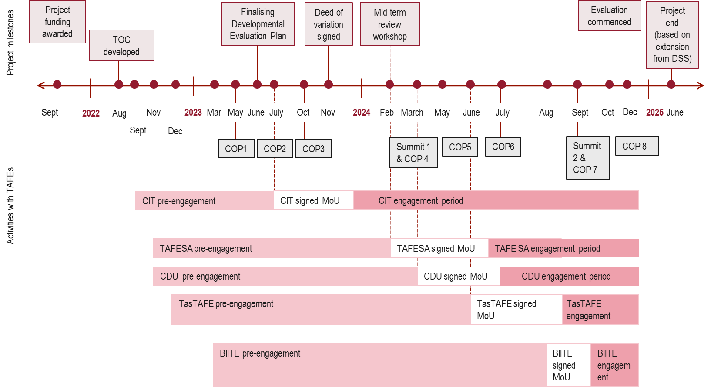

Variation in TAFE contexts influenced implementation.
Jurisdictional governments in the ACT, Tasmania and SA have a legislated responsibility to provide public VET institutions. TAFEs also largely aligned in:
- Some student cohort demographics. The TAFEs have majority male student bodies (~60% male), a high percentage of students from low socioeconomic statis backgrounds and most students over the age of 25.
- Majority female staff cohort. Excluding BIITE who does not publish this data, the remaining four TAFEs have ~55% female staff.
The contrasting demographics of predominantly male students and female staff in TAFEs may pose challenges in fostering inclusive learning environments and addressing gender-based violence through institutional culture.
There are significant variations between the TAFEs in:
- Size, geographic distribution, and jurisdictional context. For example, CDU had 9,305 TAFE student enrolments while TAFE SA had 49,000 in 2023, with corresponding variation in staff numbers. Campus distribution differs widely, from highly localised campuses (e.g., CIT with 4 campuses in Canberra) to extensive networks serving regional and remote students. BIITE also provides VET education in prison with over 50 teaching locations in the NT. However, size of organisation did not correspond with rapidity of activities nor depth of impact.
- Student demographics. The distribution of CALD, Indigenous and international student cohorts varied in accordance with TAFEs local context. BIITE as an Indigenous RTO has almost 100% Indigenous cohort and 40% Indigenous staff cohort. These contexts present a unique environment for primary prevention advocacy to respond to differing cohort and demographic needs.
- Organisational structure. CDU and BIITE are dual-sector universities, offering both TAFE and higher education qualifications. At CDU, we heard that the vast majority of Working Group members were from the higher education divisions, raising questions about extent the TAFE division were able to engage with this work in a dual-sector context. CDU also found it challenging to be interpreting TAFE-specific content for their context. The Our Watch team were responsive to the unique needs of these TAFEs and developed dual sector specific content in mid-2023.
There were also variations in the organisational and funding circumstances of TAFEs which effected their ability to prioritise this work. All TAFEs were operating in complex and tight resourcing environments, two TAFEs were undergoing governance restructuring, and one TAFE underwent massive staff turnover and sweeping policy changes. In the case of CIT, changes were implemented to the types of free services staff could receive or participate in, which resulted in CIT being unable to attend the second summit.

Prior TAFE involvement in gender equality work was not an indicator for level of readiness to engage in primary prevention work.
Governments in all jurisdictions were taking action in primary prevention and gender equity, through specific strategies for women and gendered violence action plans upon commencement of this project. CDU and CIT were the only TAFEs who reported having actively approached work in the gender equality space prior to engaging with Our Watch. These activities were primarily awareness raising rather than intensive and institution-wide primary prevention activities, with more reactive than proactive approaches. Despite prior engagement, readiness to engage with primary prevention at TAFEs overall was low and we heard from Our Watch stakeholders that there was lower awareness of primary prevention and a higher level of resistance than they experienced in other sectors.
A lack of authorising environment caused delays in getting the work off the ground and required the Our Watch team to use alternative mechanisms to encourage TAFEs to participate.
DSS preselected jurisdictions for this project, and Our Watch engaged with TAFEs who were the primary public VET providers in each jurisdiction. This meant that TAFEs did not voluntarily opt-in to this project, nor did DSS or any system level actors have input in the selection of TAFEs or add imperative to participate in the work. As a result, we repeatedly heard from TAFEs that this work was slow to start as it was not a priority for them.
‘[This work] is not our priority. It’s important, but day to day you tend to focus on the fires. Sitting down and taking the time to do something meaningful like this is not something a lot of us can do.’ – TAFE Stakeholder
In RET1, a clear remit for Victorian TAFEs to do this work came from the Minister who placed this work on the TAFE statement of priorities, which outlines the strategic objectives, priorities and outcomes expected of the Victorian TAFE network. This was not possible in RET2 due to:
- Operating across numerous different jurisdictions, not just one where there could be a coordinated approach as in RET1.
- Jurisdictions having Minister’s with different levels of engagement and investment and having a different level of input into TAFE operations, or a different relationship with TAFEs. Our Watch sent letters to Ministers responsible for TAFEs in the four jurisdictions. Of those four:
- In South Australia, the letter was internally passed onto TAFE SA who contacted the RET2 project team.
- In the ACT, the Minister responded and connected the team with an executive at CIT.
- In Tasmania, Our Watch’s engagement was delayed as TAFE had moved to a different portfolio than where the letter was originally sent, but they were able to meet with the Minister who set up a meeting with TasTAFE. For TasTAFE’s operating context, it did not make sense for Our Watch to approach their minister first and they did not respond well to this tactic to engage them.
- In NT, no response was received, so connection was made directly with TAFEs.
- Jurisdictions not funding TAFEs to undertake this work, which also could have acted as an authorising mechanism. TAFEs also cited a tight resourcing environment as a reason this work was challenging to undertake.
- DSS staff turnover between RET1 and RET2, resulting in loss of knowledge of this project.
Without a clear system-level remit to support prioritisation, attempts to engage with TAFEs were challenging. Despite having an experienced team, Our Watch encountered difficulties in gaining traction with TAFE executives. In some cases, TAFEs would filter Our Watch's communications or fail to attend scheduled meetings. These issues varied across different jurisdictions.
‘Trying to find time to fit into people's already very stretched schedules, particularly when it may not be seen as a priority, was difficult.’ Our Watch stakeholder
Our Watch's CEO and TAFE executives actively collaborated on strategic initiatives with government departments and TAFE CEOs. This participation was strong for high-profile elements like MoU signings and project launches, and there was also executive-level involvement in some of the initial meetings with TAFEs. However, executive-level involvement was less consistent for day-to-day operations and relationship building, nor was it intended for routine aspects. While this may have been appropriate from a scope perspective, some felt it may also be a result of TAFEs being a lower priority in Our Watch more broadly.
‘I think [TAFEs] are considered a relatively new space in terms of settings… [and there is] a perception in Our Watch that it’s the least evolved of the settings we work in, and therefore a lower level of engagement and understanding of where the TAFE work sits across the organisation.’ Our Watch stakeholder
To mitigate the effects of the lack of authorising environment, Our Watch used replacement mechanisms to encourage engagement. This included building trusting relationships with internal champions to get work started and signing MoUs with the TAFEs. The MoUs acted as an internal authorising environment within each institution to motivate this work and hold the institution accountable. These were effective, if resource intensive, mechanisms.

Delays influenced the strategic decision to forgo engaging system actors as initially planned.
The project’s ToC included engagement of system actors to support changes occurring in TAFEs and begin to bring about more widespread awareness of Our Watch, the RET framework and encourage organic expansion of this project to other TAFEs. The team made the strategic decision at the beginning of 2023 not to pursue system level actors due to:
- Delays with engaging TAFEs had already pushed out the timelines of the project requiring increased resources from the team, and therefore less resources available to engage with system level stakeholders.
- Challenges getting traction with system levels actors Our Watch did try to engage, as described above in Our Watch’s attempt to engage Ministers.
‘We realised there are two projects here, [working with] TAFEs, and [working with] system level actors. Being a small team we could not give [system actors] the time and space to be fully engaged.’ – Our Watch stakeholder
However, through connections with the TAFEs in the RET2 project, Our Watch did engage with TAFE Directors Australia (TDA) who disseminated information about the project through newsletters and on their website, and HumanAbility Jobs and Skills Council (JSC) who sent a representative to the second summit.

Our Watch recruited a capable team to deliver this work. They developed and practiced approaches that built productive relationships with the TAFEs.
Our Watch recruited a team with the experience and attributes to deliver this work. The team were heavily praised in interviews with TAFE participants. This included their approach, manner and ways of working and their primary prevention knowledge.
‘The project team were friendly, kind and caring and were really knowledgeable about the project and the issue and were very evidence-based and backed up their statements. That really brought in the trust factor and made everyone feel comfortable.’ – TAFE stakeholder
The team engaged positively and productively with TAFEs by:
- Adapting their approach and modes of engagement depending on TAFEs preferences and building strong relationships. An Our Watch stakeholder emphasised that TAFEs do not have the same online culture that other organisations do, and that the team had exponential success with in-person engagement. The Our Watch team also noted that in-person engagement made a deeper impact on the relationship with BIITE and CDU.
‘We understood that the context was so different and was going to be different from place to place.’ – Our Watch stakeholder
‘[TAFEs] told us that was valuable because it showed we were committed. The fact we made that journey to spend time with, them, they appreciated it a lot.’ – Our Watch stakeholder
- Being responsive to the pace at which TAFEs could meaningfully engage. TasTAFE was unable to engage in the work until 2024, and Our Watch provided informal support in the lead up to full engagement.
- Being careful, thoughtful and strategic about how they pitched the work to TAFEs. The Our Watch team thought creatively about how they could link the RET2 project with TAFE priorities and ‘sell’ the project to TAFEs.
- Scaling up or down the level of support provided and making it easy for TAFEs to engage with this work. This included doing ‘whatever TAFEs needed’ (Our Watch stakeholder), such as filling out paperwork and developing and delivering presentations.
- Responding to and implementing feedback on content and trainings delivered. TAFEs reported that they gave feedback on the content of training and how they would like it to be adapted and the Our Watch team were able to do this. This built trust with the TAFEs.
‘We gave feedback and they adapted the next workshop perfectly and that was really impressive. It’s been a really equal partnership.’ – TAFE stakeholder
‘Listening, responding and actioning [feedback] in a timely way, I have not seen this follow through in most organisations.’ – TAFE stakeholder
- Spending time upfront researching and gaining understanding on the TAFEs, but not presuming to know everything. In the NT, Our Watch tailored their approach using the Changing the picture: A national resource to support the prevention of violence against Aboriginal and Torres Strait Islander women and their children (Changing the picture) resource to better situate and land primary prevention content with a First Nations context. During delivery, they framed their presentations with the caveat that this is what they currently understand, but they are open to being corrected by participants.
‘They came in with confidence about the subject, but not the confidence that they know about TAFE or our TAFE in particular. They did not come assuming they knew us.’ – TAFE stakeholder
- Supporting TAFEs to manage backlash. One TAFE experienced backlash to the Change the story training. Our Watch were able to provide resources and support them to manage backlash and make adjustments to the training environment to accommodate further engagement.

RET2 applied the RET Framework to different TAFE contexts.
The RET1 project worked with Victorian TAFEs to create the RET framework. To make the framework more approachable for TAFEs, the team condensed the framework to four steps rather than eight (see the full framework at Appendix B) so that approaching the framework was less overwhelming. The framework shows a clear prioritisation of connecting with staff to champion and drive the work from the ground-up, and gaining leadership buy in to authorise the work from the top-down.
Figure 6: RET Framework operationalised for the RET2 project
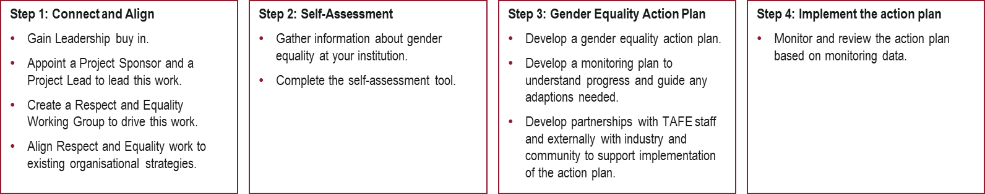

Despite early delays and challenges, there has been strong engagement from TAFEs, and the work has progressed effectively.
Our Watch was eventually able to gain buy in from all TAFEs, which is an achievement given the challenges of the TAFE context (see Figure 7 for more information).
Figure 7: Summary of outputs of the RET2 project
Activity | BIITE | CDU | CIT | TAFE SA | TasTAFE
Signed an MoU with Our Watch, which is both an enabler for this work and also represents a broader and significant commitment to continue work in this space after the project has ended. The MoUs also represent buy in from executive and leadership, and can be used to hold TAFEs to account. The presence of the MoUs and the traditional and social media generated around them may have acted as a motivating factor between the TAFEs involved in this project to push forward and keep up with their TAFE colleagues. | ✓ | ✓ | ✓ | ✓ | ✓
Organised an internal Working Group and participated in meetings arranged by and supported by Our Watch. This involved receiving tasks to be completed in between meetings, holding space for meetings and participating in respectful and collaborative discussion. | ✓ | ✓ | ✓ | ✓ | ✓
Participated in Communities of Practice meetings with colleagues from other TAFEs. These were praised by TAFE stakeholders as valuable opportunities to share stories, ideas, wins and discuss common problems they were having. | ✓ | ✓ | ✓ | ✓ | ✓
Attended in-person Summits organised by Our Watch. Summit 1 included TAFE colleagues only in the RET 2 project, and Summit 2 included TAFEs from other jurisdictions, Our Watch stakeholders from other departments and one JSC stakeholder. | ✓ | ✓ | ✓ | ✓ | ✓
Are developing or have completed their Gender Equality Action Plan. At the time of writing, CIT is the only TAFE to have completed their action plan and have it currently being implemented. The four remaining TAFEs are in various stages of developing their plan: TAFE SA have completed the plan and are awaiting executive endorsement, and CDU, BIITE and TasTAFE are continuing to develop their action plans. | - Is currently developing their action plan. | - Is currently developing their action plan. | - Has completed and is currently implementing their action plan. | - Has completed their action plan and is awaiting executive endorsement. | - Is currently developing their action plan couched within a broader diversity, equity and inclusion (DEI) strategy.

Project principles have contributed to an effective implementation, and influenced outcomes.
In Figure 8 below we have assessed what each project principle looked like in practice and the influence we believe it had on project outcomes. We found that the majority of project principles had a strong influence, meaning there is evidence that the ways of working these principles stipulated had a significant impact on the outcomes achieved. We found that the principle regarding use of ‘comprehensive thinking and action to redress the inter-related causes of violence against women’ had some influence on project outcomes due to there being some evidence that this principle influenced project outcomes, but limited influence across the whole of TAFEs, due to not all being directly involved in working groups or training. The influence of the principles regarding ‘centring intersectionality’ remains unclear - while intersectionality was a key focus of the project team’s approach, the link between this and the impact on outcomes remains uncertain (see table below for further explanation). These principles may also have wider applicability for broader prevention work and other prevention initiatives.
Figure 8: Assessment of influence of project principles on outcomes
Principle | Adaptable approach to meet TAFEs | Strong mutual engagement and understanding | Continuous learning and evidence generation
Influence | Strong influence | Strong influence | Strong influence
What it looked like in practice | The project team:  - Adapted engagement approach to be fit-for-purpose for each TAFE  - Tailored their approach in the NT to use Changing the picture to ground the approach in the evidence in preventing violence against Aboriginal and Torres Strait Islander women  - Adapted resources and materials, including adding a sixth domain to the RET framework for dual-sector institutions | The project team:  - Engaged in two-way learning with the TAFEs  - Brought subject matter expertise to encourage TAFEs to recognise their role in primary prevention  - Understood of the variation in TAFE context and listened and learnt from each TAFE  - Fostered mutual respect and trust  - Formed strong learning relationships with each TAFE | The team participated in:  - Monthly reflection sessions  - Regular post event or working group reflections sessions  - Case studies  - A mid-term project review workshop  - Integrating learnings into project processes and materials as a result  This was strengthened through project team working alongside the internal Our Watch evaluation team.
How it influenced outcomes | Adopting a tailored, flexible adaptable approach supported engagement with TAFEs, participation in the project, and ultimately the achievement of outcomes within each TAFE. | This approach has used clarity of roles and two-way learning to build strong trusting relationships and a sense of partnership which has supported engagement, led to buy-in and ownership of action plans. | This approach allowed the project team to identify key learnings throughout the project, to ensure they were using this project to trial, test and identify what working in supporting TAFEs, a key project outcome.
 | ‘One approach not fitting all has been so important for this work’ – Our Watch stakeholder  ‘I think it shifted along the way, it was a very adaptive program for sure, they were constantly bringing in learnings from the other TAFEs’ – Our Watch stakeholder | ‘It’s been a really equal partnership’ – TAFE stakeholder  ‘They came in looking for a conversation and not telling us how to do it, we call it two-way learning, it’s embracing our First Nations knowledge but also bringing in the western knowledge and melding them’ – TAFE stakeholder | ‘Our team are really strong on learning and reflection, and I think that’s because the evaluation lead had that approach in mind and so that became embedded.’ – Our Watch stakeholder  ‘We had monthly reflections as part of regular team check ins…we could share learnings’ – Our Watch stakeholder

Principle | Comprehensive thinking and action | Supporting building blocks for long term change | Centring intersectionality
Influence | Some influence | Strong influence | Unclear
What it looked like in practice | The project team:  - Built understanding and capability around primary prevention using the socio-ecological model in working group sessions, and the Change the story training  - Encouraged people to move beyond their individual experience to focus on the organisational level  - Ensured project resources and materials supported a holistic approach to prevention | - Gender equality action plans targeted ‘low hanging fruit’ and laid the foundations for future change, including reviewing policies, gathering data and setting up monitoring processes  - Working group sessions and Change the story training focussed on building foundational understanding of gender equality and primary prevention including the drivers of violence against women | The project team:  - Included intersectionality content in training  - Encouraged working groups to consult widely within their TAFE to ensure gender equality action plans were informed by diverse perspectives  - Considered the inclusiveness and accessibility of events and sessions  - Tools and resources emphasise intersectionality e.g., self-assessment
How it influenced outcomes | This principle had a strong influence on the knowledge, understanding and commitment of direct project participants, however it had a limited influence across the whole of TAFEs, due to not all being directly involved in working groups or training. | For many TAFEs, these action plans were the first step in this journey. Laying solid foundations, and setting realistic goals to facilitate future change was seen as motivating, with some TAFEs becoming more aspirational over time, contributing to the sustainability of outcomes. | It is unclear the impact of this principle of project outcomes. This principle was prioritised by the project team in their ways of working with TAFEs, however the link between this and the impact on outcomes remains unclear.
 | ‘Going back to the beginning, understanding the drivers. I always thought it was drugs, or angry people, but understanding and seeing the statistics behind what the drivers were, it helped us understand in a whole different light and the evidence to back it up.’ – TAFE stakeholder  ‘We changed the session to include more info on the socioecological model, although complex to describe, it will be helpful to do in other future iterations’ – Our Watch stakeholder | ‘This is about knocking off low hanging fruit and putting in place some foundational processes’ – TAFE stakeholder  ‘This first plan isn’t going to change the world. It will support to build a foundation for work into the future’ – Our Watch stakeholder | ‘The reason we wanted a group is the knowledge is within numerous places, not just one, inclusive and diverse backgrounds will result in a much richer conversation and hopefully richer outcomes.’ – Our Watch stakeholder

Program impact
Key insights
- We found evidence of:
  - Foundational changes - most TAFEs developed their first Gender Equality Action Plans, focusing on achievable goals such as policy reviews, inclusive language adjustments, and monitoring processes.
  - Individual impact - participants reported increased understanding of gender equality and confidence in addressing primary prevention within their institutions.
  - Institutional impact - examples of change included revised recruitment practices, inclusion-focused enterprise agreements, and greater integration of gender equality into teaching practices.
  - Sector-wide impact - CoPs enabled knowledge sharing across jurisdictions.
- There are positive signs of lasting change and sustainability of outcomes at some of the TAFEs. However, reliance on individual champions over broader buy-in, and lack of resourcing to maintain momentum are barriers to achieving sustainable, whole of institutional change beyond the life of RET2.
- The project has contributed to the evidence-base about what works to support changes to promote general equality and prevent violence against women in TAFEs, and what is needed to make this work sustainable.

For most TAFEs, RET2 marked the beginning of their journey with primary prevention, meaning changes are more foundational.
For most TAFEs RET2 was the start of their work in gender equality and primary prevention. Even for those who had done work in this space, the focus had previously been more on awareness raising than on whole of institution change. As such, the gender equality action plans TAFEs developed as part of this project were focussed on laying the foundation for future changes. While some TAFEs felt they could be more aspirational, there was general understanding that this foundational element was necessary.
‘This first plan isn’t going to change the world. It will support you to build a foundation for work into the future.’ – Our Watch stakeholder
‘I would have loved our plan to be more ambitious but it’s not the stuff that’s shiny that matters, it’s about better evaluation, connections between activities, but it’s also about systems, and bringing in equity to policy and default stuff. It’s not shiny, but it will make a difference to the day to day.’ – TAFE stakeholder
Some examples of foundational actions in the current action plans which demonstrate the goals being set at this stage include:
- Establishing monitoring and evaluation processes and activities to measure progress from this point onwards
- Reviewing current systems, policies and key documents with an equity and inclusion lens
TAFE stakeholders we spoke to discussed that bringing a group of people together, and co-creating a gender equality action plan that now has the support and buy-in from TAFE leadership was a key outcome, regardless of the level of ambition of the current actions within the action plans. Passionate project participants within the TAFEs are hopeful that subsequent action plans will be more ambitious, although this may be representative of individual champions than a TAFE-wide view.
‘My hope is that in two years there’s a more ambitious plan that will come out. This is about knocking off low hanging fruit and putting in place some foundational processes and evaluation processes as we go.’ – TAFE stakeholder

Individual participants felt they have greater knowledge and understanding of primary prevention because of the project.
Some key examples of changes in individuals included participants:
- Gaining a greater understanding of gender equality and the drivers of violence against women
- Identifying language, practices and behaviour that are not respectful and inclusive within their TAFE setting
- Gaining confidence speaking about gender equality and primary prevention of violence against women both within their TAFE but also in other settings such as conferences
‘I had not realised until working with Our Watch, even Mates in Construction is full of language that is misogynistic, because culturally this has just happened and we accept it.’ – TAFE stakeholder
‘We have a person on our team, a casual plumbing lecturer who is a woman…We witnessed some experiences firsthand, and she would say yeah that happens every day. I’m looking at that like that’s bulls***.’ – TAFE stakeholder
‘We spoke about the different ways gender equality manifests, and someone who worked in the hairdressing department wanted to change how gendered the language is. We have seen big wins with the people we have worked with directly.’ – Our Watch stakeholder
Beyond the changes observed in the individuals involved in the project, the mechanism of the working group has meant that changes have also been observed in the groups of people within the TAFEs involved in this project.
‘We also brought together a group of people who want this to be a priority, and that momentum is important.’ – TAFE stakeholder
‘Our Watch’s legacy in [redacted TAFE] is as much a group of people who know more and each other.’ – TAFE stakeholder

There is evidence of institutional change in across the TAFEs including changes to policy and practice, as well as broader cultural change.
While some stakeholders emphasised the changes within project participants within TAFEs, stakeholders also shared examples of changes in policy, practice and culture across the five participating TAFEs.
Examples of policy change observed in participating TAFEs included:
- Reviewing policies to align with equity and inclusion principles
- Including leave for menstruation, menopause and gender affirmation surgery in a new Enterprise Agreement (EA) for staff
Examples of changes in practice shared with us by TAFE stakeholders included:
- Adjusting the language in documentation send out by student services to students to reflect inclusive language
- Introducing a role in student engagement focused on equity for students
- Revising recruitment and marketing strategies to ensure they are open to diverse backgrounds
- Incorporating discussions on domestic violence and gender equality into classroom conversations, including in traditionally male-dominated fields like trades and infrastructure
And examples of cultural change TAFE stakeholders observed included:
- Greater awareness and understanding of issues impacting gender equality and primary prevention more broadly
- Increase in communication and discussion about gender equality and primary prevention including between leadership and operations staff
We are profiled as a very conventional culture, but we are acknowledging that and wanting to take our culture to move towards more constructive and intentional…their part in changing the story and preventing violence is a profound part of our cultural journey. That’s the part it is playing for us and on a deeper level from a cultural perspective beyond the initiative’ – TAFE stakeholder
For some TAFEs, observable changes have been limited to learning and attitude shifts in individuals directly participating in the program and the development of the action plans.

The most significant changes have occurred in those TAFEs with leadership buy-in, and where the work has been embedded in broader strategies.
Most TAFEs have individual champions of the work – someone who has led and prioritised the engagement and sought to keep it on the agenda. However, TAFEs had varying levels of leadership buy-in. All TAFEs had an executive who was allocated some form of oversight of this project as part of their role. In TAFEs with more significant leadership buy-in, there are examples of significant changes already in effect, and in some cases have been enabled by the gender equality action plans being situated within broader organisational strategies.
One TAFE made changes to their EA and introduced new leave entitlements including five days menstrual and menopausal leave and 30 days gender affirmation surgery leave. These leave entitlements were new since this TAFE had been part of the RET2 project. There have also been cultural shifts such as using pronouns in email signatures, and conversations about language used in teaching and resources such as student guides and assessments. Stakeholders at this TAFE credited their CEO’s support as a key reason they have been able to make these changes, along with buy-in from other key decision makers and leaders.
‘Our CEO's support…In May last year our CEO commenced and created two Deputy CEOs, Operations and Academics, it means decisions can be made at that level really quickly so we do have that benefit.’ – TAFE stakeholder
Another example of this came from a TAFE that shared that they had senior leadership buy-in, and chose to embed the gender equality action plan developed in this project as part of a wider equality strategy.
‘We are embedding it into the board inclusion and equity framework which has that solid governance from board chief exec and such. In terms of sustainability its being at it and making sure we dedicate the resource yearly and continue that education.’ – TAFE stakeholder
This TAFE experienced some resistance from some executives who participated in the Change the story training delivered by Our Watch. Due to the CEO’s commitment to this work, and the gender equality action plans being couched within a broader strategy, it meant that this resistance wasn’t enough to derail the work, and in some ways, it was insulated from the resistance.
‘[Redacted] said with some senior managers, he said to us the training is uncomfortable, but it should be, and we have to be ok with that because its real and important, that message from the CEO down, it does resonate with people.’ – TAFE stakeholder
‘[Redacted]’s leadership was unwavering through that period which made a significant difference in making sure it did not fall over.’ – TAFE stakeholder
In other TAFEs executive were allocated to oversee this work, but didn’t engage as deeply, or make it as much of a priority. This has meant that at other TAFEs the work has not been embedded in broader strategies, and there is less willingness to embed this work further in their organisation. For example, a champion of the work at one TAFE was unable to get 30 minutes on the agenda on a professional development day to speak about gender equality.
‘We have a [professional development] day coming up in a few weeks and I’m asking for some time to talk about this. I’ve noticed it’s not on the agenda…Even though I’ve asked for only 30 minutes, it did not rise to the level of importance for me to get that much time.’ – TAFE stakeholder

The project fostered connections between TAFEs, enabling knowledge sharing and discussions on primary prevention across institutions.
We heard from stakeholders that the CoPs and summits played a key role in allowing TAFEs to build relationships, foster community and share learnings.
‘I think the Community of Practice really helped me personally because we could hear stories, find common problems and share information which was so valuable.’ – TAFE stakeholder
‘It worked well, the Community of Practice was really good to hear from other TAFEs and where they are at, it was comforting to know that we are at the same stages for the most part and it’s a lot of good learning. Feeling like we’re not alone in facing challenges. It’s also really good to hear from other dual sectors, as that’s a different context than TAFE.’ – TAFE stakeholder
‘The Communities of Practice, when we would have a session they loved learning from each other and it was really important to us to foster a community to cheer each other on rather than compete. They connect with each other outside of this work, they met up at conferences and went out for dinner, and they are putting in that effort.’ – Our Watch stakeholder
Our Watch stakeholders also believe that this has also been due to their attempts at broader engagement in the VET sector including at conferences and submitting articles in the TAFE Directors Australia (TDA) newsletter.
‘More people in TAFE know who Our Watch is, at the beginning they thought we were a marketing organisation, they did not know us at all. And not just with our TAFEs, conferences, articles, TDA newsletters, we have benefitted because more people in the community know about us now. We have had some system level actors join our Summits, they have invited us to conferences, this would not have happened without this work. People at the beginning thought we were a scam.’ – Our Watch stakeholder
As a result, TAFEs have more avenues to connect and share learnings on gender equality and primary prevention across TAFEs and the broader VET sector.
‘The TAFE community feels better connected on this issue, there’s some collegiality… They are working together to find gaps and work together to fill them.’ – Our Watch stakeholder
‘There was an increase in awareness of what the issue is and then also where TAFEs then fit.’ – Our Watch stakeholder
As a result of this project, more of the VET sector have visibility of Our Watch and the work they do, and a greater understanding of the role TAFEs and VET providers can play in primary prevention. This is crucial for the future sustainability of this work.
The RET2 team has reconnected with the Victorian TAFEs who were part of RET1 and begun connecting with other TAFEs nationally who haven’t worked with Our Watch yet, but will in future iterations of the project. A key mechanism for this was summit 2, where all TAFEs nationally were invited and 21 out of 27 attended. These connections are critical if Our Watch wishes to continue working in the VET space which, as discussed earlier, presents a significant opportunity.

There are positive signs of sustained commitment at some of the TAFEs.
There is evidence of forward momentum of primary prevention at the TAFEs, and some positive changes have occurred because of RET2. These have been achieved with significant support from Our Watch, and a key evaluation question asked for evidence of the sustainability of those changes (both the momentum and commitment) beyond the end of the project.
To assess this, we looked for evidence of the attitudes of stakeholders, what they had done to date, and the surrounding conditions and enablers that would support sustainability going forward.
‘It’s been really satisfying and I’m really proud of our involvement.’ – TAFE stakeholder
‘And I think we are committed, there is enough of us on that team who is committed and will keep driving something until we can publish it.’ – TAFE stakeholder
This positivity and ambition are an important aspect of sustainability so that people involved remain enthusiastic and ambitious about the work, and therefore hopefully will continue to drive it forward.
All TAFEs had multiple people in their Working Group, usually from across the organisation which is a positive step to preventing this work having a single point of failure and may be sustained in the future. By having opt in representatives from across the institutions, this may:
- Leverage passion and buy in of individual actors to maintain and share information about the work in TAFEs
- Produce actionable plans and have a Working Group member in each area of the institution to carry them out
TAFEs commented that they are hopeful about the success of the implementation of the gender equality action plans because of having a group of people that are passionate and motivated to continue to drive this work forward.
‘I look at [the gender equality plan] and think we can absolutely do this because the actions were created by the people who will actually do them.’ – TAFE stakeholder
‘We just did a big look at sexual harassment policy with staff and the fact that during the policy review the person doing that came to us to check the new policy. We had a whole working group and network who are interested and passionate about this work. It’s that change we went for.’ – TAFE stakeholder
Other key enabling factors for sustainability include senior leadership and executive buy-in and shepherding of the work, and the fact the gender equality action plan produced as part of this project has been embedded in broader organisation strategies.

Signs of sustainability were less clear in TAFEs that had relied on individual champions over broader buy-in, and where there was a lack of resourcing.
Reliance on individual champions is a limitation to sustainability, leaving it at risk of de-prioritisation due to lack of broader buy-in or staff turnover. It's important in future iterations of this work to mitigate the risk of a key champion of this work leaving an organisation. The mechanism of the working group is already a good step toward ensuring a group of people are brought on the journey not just one person.
‘I try never to be the lynchpin for anything I do. I think the important thing is the web of trust that you build in the working group between people. I’m hoping that me leaving will likely impact but hopefully not make a difference…It’s the working group that makes this happen, not just one person.’ – TAFE stakeholder
Stakeholders acknowledged that this work needs to be held by many, requiring continued education and resourcing to be dedicated to this work.
‘The challenge for us is to keep doing that…to keep educating the people, the change leads, the people leaders, the staff who have direct contact with students, those cohorts, you have to keep those conversations going, and the governance of this work.’– TAFE stakeholder
RET2 involved a team of two to three people working with five TAFEs. Participating TAFEs have received intensive logistical, understanding, and engagement support and accountability mechanisms to develop their gender equality action plans. As support is rolled back, and resourcing in Our Watch reduces, there are questions about sustainability.
‘There will be light touch support provided in the future for this.’ – Our Watch stakeholder
‘Ideally, we would be able to support them more in that process it’s such a key part of the journey, but because of the way this project is structured it feels like we are leaving them midway, they have made this plan, but don’t know how to deliver it and we’re leaving them without having someone to fall back on in the way they could previously.’ – Our Watch stakeholder
TAFEs noted the necessity of the support Our Watch provided.
‘[Our Watch] really drove it and by having that it kept us on top of it... Our Watch kept us on task, we will continue with the great work we started, but I just don’t think it will be as regular, and that’s the reality, other things take priority.’ – TAFE stakeholder

‘They kept us on track; we would not have gotten here on our own.’ – TAFE stakeholder

‘Without Our Watch support we would not be here now and I don’t think there is enough acknowledgment of this piece of work if it were not for [project team member name] and [their] team’s efforts with us at that given point in time.’ – TAFE stakeholder

The project contributed to the evidence-base about what works to support changes to promote general equality and prevent violence against women in TAFEs.
Through implementing the RET framework in five TAFEs in four jurisdictions, the Our Watch project implementation team have learnt a lot about what works in supporting TAFEs to promote gender equality and prevent violence against women. This was supported by the project principle of engaging in continuous learning and evidence generation to support TAFEs, system actors and ourselves to learn about what works. This approach allowed the project team to identify key learnings throughout the project, to ensure they were using this project to trial, test and identify what working in supporting TAFEs, a key project outcome.
To reflect, identify key learnings and contribute to the evidence on what works, the project team engaged in:
- Case studies of the starting conditions in each TAFE to learn and reflect on engagement approaches
- Monthly reflection sessions
- Regular post event such as working group, communities of practice or summit reflections sessions
- Post working group surveys
- Registers of learnings, evaluation findings and project adaptations
- A mid-term project review workshop
- Integrating learnings into project processes and materials as a result
Learning more about what works to support TAFEs in primary prevention work was a key outcome of the project, which was strengthened through project team working alongside the internal Our Watch evaluation team.
The following section, ‘Key learnings and future considerations’, covers the key lessons generated through the RET2 project implementation that should be applied to future iterations of this work within Our Watch, and more broadly to working with TAFEs and the VET sector in promoting gender equality and primary prevention.

Key learnings and future considerations
Key insights
- Engaging successfully with TAFEs relies on a combination of tailored approaches, trust-building, and leadership buy-in.
- Several approaches appear useful in supporting changes in TAFEs to promote gender equality and prevent violence against women, including using principles to establish shared ways of working, and providing backbone support.
- While there are successful approaches, there are also clear challenges to success and sustainability, including the need for a clear authorising environment and the resource intensity of backbone support.
- There is an opportunity to take these learnings and embed them in future work Our Watch does with TAFEs, and in the VET sector more broadly.
- Unlocking the full opportunity of this work will require bringing system levels actors on the journey, continuing to develop a robust understanding of the VET sector including cultural differences with higher education and the potential of working with industry through VET.

Engaging successfully with TAFEs relies on a combination of tailored approaches, trust-building, and leadership buy-in.
Key learnings from the RET2 project include when engaging with TAFEs future iterations of this work should:
- Use tailored and flexible approaches. Adapting engagement strategies to meet TAFEs where they are in their journey has been critical in the engagement and participation Our Watch has achieved.
  - TAFE contexts were highly varied, including both in their standard ways of working (more online versus preferring face-to-face), to their experience in primary prevention work. This meant that the way TAFE participants approached the work, how the project team could capture interest and build relationships, and how different levels of the TAFE could be brought along the journey were highly varied.
  - Our Watch responded to the variation in TAFEs by tailoring materials, shifting timelines, offering alternative modes of delivery, and refining approaches to fit the unique contexts. This flexibility fostered trust and demonstrated Our Watch’s commitment to supporting TAFEs at their own pace.
- Build relationships and trust. Establishing strong, trusting relationships with TAFE stakeholders has been foundational in progressing this work.
  - Primary prevention can be a confronting topic for all sectors, and we heard that in the TAFE sector specifically there was a higher level of resistance that had been encountered in other settings.
  - Our Watch were able to work through this by communicating consistently, showing curiosity and respect, and being open to the challenges for TAFEs. Their willingness to adapt, and their commitment to two-way learning, helped TAFE participants build their understanding in a safe environment, and ultimately remain invested in the work. Ensuring there is appropriate resourcing to be able to be flexible is crucial to supporting this approach.
- Invest in leadership buy-in. Investing time and effort in securing leadership sponsorship ensures that gender equality initiatives are prioritised across the organisation. RET2 work was progressed in all the TAFEs, but those who demonstrated more significant changes (such as changes to policy and practice, not just the work on the action plans), had good leadership buy-in from multiple levels in the organisation. This involvement creates an authorising environment that drives strategic communication, resource allocation, and organisational commitment, and is likely to contribute to the sustainability of the work going forward.
- Provide mechanisms for learning and accountability. Providing regular touchpoints such as working group meetings, ad hoc support, and CoPs has been effective in scaffolding change efforts. The working group meetings and ad hoc support have allowed TAFEs to progress their internal work with clear accountability check-ins, while external connections through CoPs and summits allowed TAFEs to connect with others in their sector. This was seen to have fostered collaboration across jurisdictions, enabling shared problem-solving and idea exchange.

Several approaches appear useful in supporting changes in TAFEs to promote gender equality and prevent violence against women.
Key learnings in the approach necessary to support changes and achieve gender equality outcomes in TAFEs include:
- Principles as shared ways of working. The principles that the RET2 project team established have created guidance around ways of working that have supported them to engage effectively with TAFEs and have supported project outcomes. These principles align with the RET framework's whole-of-organisation approach by fostering consistency and clarity in how gender equality work is approached.
- The principles provided a consistent framework for collaboration while allowing flexibility to adapt to the unique contexts of each institution. In practice, this helped Our Watch tailor their approach to each TAFE’s specific needs, such as adapting resources for dual-sector institutions or incorporating culturally relevant materials for First Nations contexts. This adaptability built trust and engagement. The principles also prioritised the two-way learning and foundational focus, both of which seem to have contributed directly to outcomes.
- These principles themselves may also have applicability to broader prevention work.
- Focusing on foundational change. Implementing realistic, context-specific goals has helped TAFEs achieve meaningful progress without overextending their capacity.
- This project centred around Our Watch supporting TAFEs to implement the RET Framework, and developing their action plans. TAFEs found Our Watch’s support stepping them through the process helpful.
- Our Watch acted as a critical friend for some TAFEs in fostering their enthusiasm but also remaining realistic in what their organisation was ready for and could achieve. This approach builds on the tailored and flexible approach needed to work with TAFEs to centre achievable, foundational change.
- Strong backbone support. Providing strong backbone support was instrumental in enabling TAFEs to participate effectively in this work despite their resource constraints. In this way, Our Watch’s team played a central role in maintaining momentum and accountability.
- The project team brought expertise in both gender equality initiatives and the TAFE sector, which allowed them to provide tailored guidance. They facilitated relevant engagements, including handling the logistics and coordination, and delivered these in modes and at times that would best work for different TAFEs’ individual contexts.
- This support structure enabled busy TAFE staff to engage meaningfully with the project and focus on implementing changes rather than navigating administrative hurdles.
These successful approaches align closely with the RET framework's whole-of-organisation approach by embedding gender equality initiatives across multiple levels of TAFE operations. This included integration across systems enabled by leadership buy-in and developing collaborative structures such as mechanisms for accountability. Critically, the tailored approach aligns with the RET framework's recognition of diverse organisational contexts, ensuring that strategies are relevant and support sustainability of outcomes.

While there are successful approaches, there are also clear challenges to success and sustainability.
Several challenges—such as the lack of systemic endorsement, over-reliance on individual champions, and resource-intensive processes—highlight areas requiring attention to ensure the long-term sustainability of gender equality efforts in TAFEs. These included:
- A lack of broader authorising environment can delay progress. Without clear support from system-level actors (e.g., government bodies), some TAFEs struggled to prioritise this work. Unlike Victorian TAFEs in the RET1 project, which benefited from ministerial directives and legal obligations under the Gender Equality Act 2020, TAFEs in RET2 lacked a similar authorising environment. This absence made it challenging for TAFEs to allocate resources and attention to the work, and delayed the project.
- Our Watch relied on alternative mechanisms, such as MoUs, to create internal accountability within TAFEs. While effective, these mechanisms were resource-intensive and time-consuming, highlighting the need for systemic endorsement to streamline engagement and prioritisation.
- Future efforts should be supported by systemic endorsement to create a stronger imperative for action.
- The work still relies significantly on individual champions. Long-term sustainability of this work ultimately needs full leadership buy-in and backbone support through being embedded across TAFEs`. While individual champions have driven progress, reliance on them creates vulnerabilities if these individuals leave or disengage.
- This is often outside of Our Watch’s control, but speaks to the need to create mechanisms for embedding gender equality work into organisational structures, which is essential for sustainability. This may involve structuring this work with DEI strategies that are required in TAFEs that guide whole-of-organisation policy. This would future-proof the work and embed it with organisations.
- The resource-intensive nature of this work poses scalability challenges. This work is resource-intensive as it involves behavioural change, which requires sufficient time and capacity to effectively engage people and build trust. There are ways to streamline and speed up engagement, such as providing an adequate authorising environment or embedding gender equality initiatives into broader organisational strategies. However, delivering the right level of backbone support requires sufficient resourcing of the project team, and without this there are risks to success and scaling.

There is an opportunity to take these learnings and embed them in future work Our Watch does with TAFEs, and in the VET sector more broadly.
In working with TAFEs and stepping into the VET sector, Our Watch took the opportunity to step into a setting that is earlier on its primary prevention journey than other settings, and in doing so, is beginning to leverage the scale of the opportunity of doing prevention work in the VET sector.
We understand the immediate next stage of this work involves scaling to all TAFEs nationally. It will be important to embed the key learnings from RET2 in implementing this phase of the work. It is important that this work is done well, and is appropriately resourced, planned for and set out with a clear scope. Not doing this may create risks, including:
- Limited reach and engagement due to insufficient capacity for relationship building
- Superficial or inconsistent implementation that undermines objectives
- Inadequate adaptation to context, meaning applicability of training, resources and engagement is limited
- Limited monitoring and evaluation hindering the ability to refine and learn from engagements and contribute further to understandings of what works in primary prevention in TAFE settings
While we acknowledge the scale of work required to undertake this work with TAFEs nationally, beyond this there is an opportunity for Our Watch to engage RTOs outside of TAFEs, such as private RTOs, who make up a much larger proportion of the VET sector than TAFEs, with approximately 80% of the students enrolled in nationally recognised training, enrolled at private RTOs. Also where TAFEs offer programs across many industries, private RTOs are more likely to be specialised, and focussed on training for a particular industry or training area.
This provides the opportunity for Our Watch to work with RTOs who deliver training for traditionally male dominated industries such as mining and construction, which research demonstrates are more likely to strongly reinforce masculine norms and behaviours that emphasise sexism, homophobia, disrespect and violence against women. For example, in December 2024, a class action lawsuit was launched against mining companies Rio Tinto and BHP, for systemic sexual harassment and gender discrimination across their operation. Our Watch could consider working with private RTO MINRES who is the largest RTO in the resources sector.
Working with RTOs offers a commercial opportunity to provide training and support that helps them fulfill their legal obligations under the positive duty provisions of the Sex Discrimination Act. This duty requires proactive measures to prevent unlawful conduct, such as discrimination and sexual harassment, in workplaces or work-related contexts. Many RTOs value training that enables them to meet these responsibilities effectively, fostering safer and more inclusive environments.
This work is evolving, with increasing structural and regulatory support creating further opportunities for expansion. For example, the introduction of a new national code addressing gender-based violence at universities highlights the growing emphasis on prevention and accountability. Although this code currently excludes the VET sector, it reflects a shifting landscape that could present future opportunities for similar initiatives in VET.

Unlocking the full opportunity of this work will require leveraging learnings, engaging system-level actors, expanding Our Watch’s presence in the VET sector and continuing to enhance internal capability.
The following elements will be important elements to take forward in future iterations of this work and Our Watch continuing to work in the VET sector.
To unlock the broader opportunity we recommend Our Watch:
- Leverage learnings from RET2 in future iterations of this work. In taking this work forward, either with TAFEs or the VET sector more broadly, it will be important to embed the key learnings from RET2 project to leverage what has worked best for engaging with TAFEs to support primary prevention work.

- Bring system level actors on the journey. As this work scales to a national level, it is important to bring system level actors along the journey. Our Watch should seek to engage and share learnings with state, territory actors such as state skills departments, and state regulators and where relevant national stakeholders such as the Department of Employment and Workplace Relations (DEWR), JSCs, and regulatory bodies such as ASQA and the Tertiary Education Quality and Standards Agency (TEQSA). Supported by sufficient resources, this strategy may enable Our Watch to champion system-level change, such as policy reform and regulatory and legislative amendments to support primary prevention work.

- Continue to build Our Watch’s footprint in the VET sector. This will leverage the opportunity to build upon the work of RET1 and RET2 and continue to support building credibility and trust in Our Watch among VET stakeholders. This may include:
- Continuing to build knowledge on how to contribute effectively to the VET space, to support with government relations, policy and advocacy efforts
- Remaining aware of ongoing TAFE and VET policy reform, in order to make submissions to policy processes and advocate to system level actors
- Emphasising the significant strategic opportunity the VET sector provides for the primary prevention sector, both internally within Our Watch and externally
- Ensuring the VET sector remains a key priority setting internally, including through investing resourcing, and collaborating with relevant directorates to work together on leveraging the opportunity the VET sector provides

- Continue to build internal capability for TAFE and VET sector engagement. As Our Watch continues working with TAFEs and in the VET sector it will be important to continue to build internal VET capability and understanding. This may include:
- Continuing to develop organisational knowledge around the complexity of the VET sector, and the key differences between VET and other sectors Our Watch works with.
- For example, continuing to build understanding of the structural and cultural differences between higher education and VET sector. This can be leveraged from the key learnings of the RET2 project team and from continued mutual engagement with TAFE and VET stakeholders. A robust internal Our Watch understanding of the key differences between VET and higher education would support future project teams to adapt their engagement approach to be fit-for-purpose.
- Understanding and unlocking the opportunity of working with industry. As outlined above, working in the VET sector is likely to unlock and require work with industry, due to the alignment between VET and industry. This will create opportunities that may require a different approach to working within the VET sector.
While Our Watch has an opportunity to expand its presence in the VET sector and continue building internal capability, elements of success sit outside of the organisation's remit. There is a critical role for system-level actors, including funders, in support this work. This includes funders creating the enabling environment required to deliver on objectives, such as:
- Funding future projects
- Delivering an appropriate, clear authorising environment
- Ensuring the policy levers necessary for success are in place
- Supporting the work throughout the life of engagements
Fundamentally, the success of this initiative depends on a collaborative effort between Our Watch, VET institutions, industry partners, and government bodies to create a comprehensive approach to embedding gender equality and primary prevention in the VET sector.

Appendices

Appendix A: Data sources
Chapter | Data sources
Introduction | This section draws on RET2 project documentation including the project plan and underspend proposals. It also draws on the RET1 evaluation findings. In outlining information about this evaluation, we drew on our evaluation plan.
Problem definition, program rationale and design | This section draws on evidence from desktop analysis on the VET sector and TAFEs within that, from Our Watch resources and evidence-based frameworks, research on whole-of-institution approaches and documentation from the RET2 project and evaluation teams including but not limited to the RET2 Project Plan and original Evaluation Plan, Activity Work Plans, the RET1 Evaluation report and stakeholder interviews with Our Watch and TAFE stakeholders.
Program delivery | This section draws on evidence from desktop analysis on the TAFEs included in the RET2 project, Our Watch resources and evidence- based frameworks, interviews with Our Watch and TAFE stakeholders, and Our Watch internal project documentation, including but not limited to Asana updates, case studies and records of projects reflections.
Program impact | This section draws on evidence from stakeholder interviews with Our Watch and TAFE stakeholders and documentation from the RET2 project and evaluation teams including but not limited to monthly monitoring and reflection documents, reflections after project events such as working groups, CoPs and Summits and evaluation reflection summaries drafted by the Our Watch evaluation team.
Key learnings and future considerations | This section draws on evidence from desktop analysis, stakeholder interviews with Our Watch and TAFE stakeholders, and dandolo’s expertise.

Appendix B: Respect and Equality in TAFE Framework
Figure 9: RET Framework
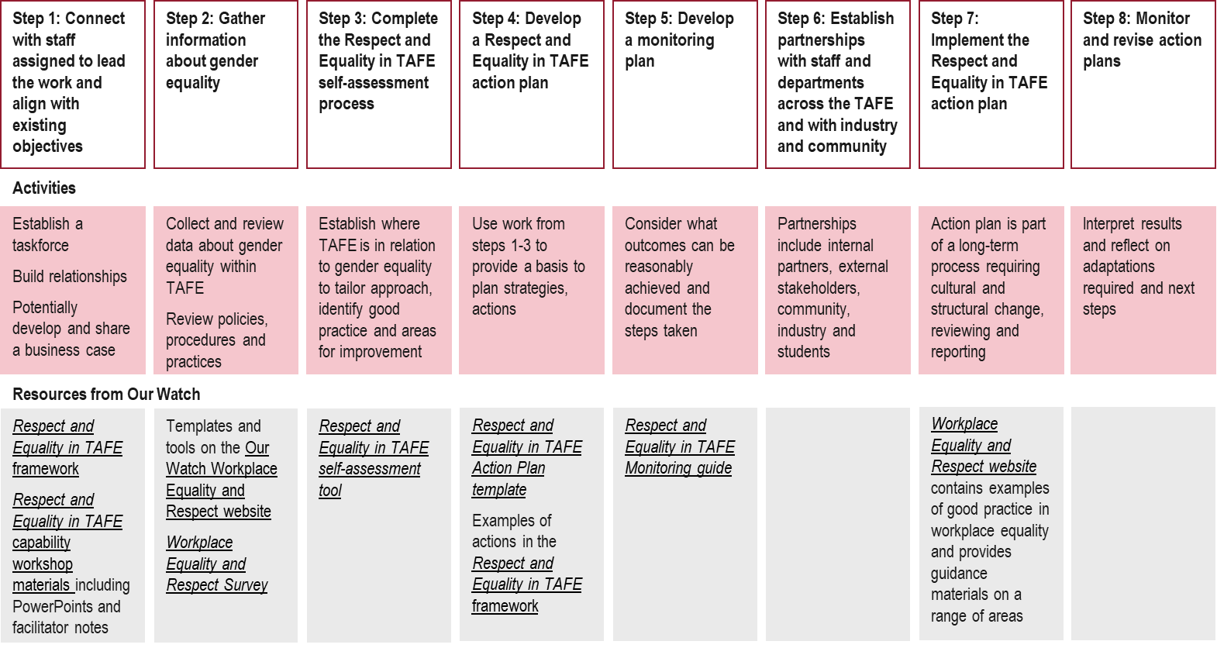

Appendix C: Theory of Change (ToC)
Figure 10: Theory of Change
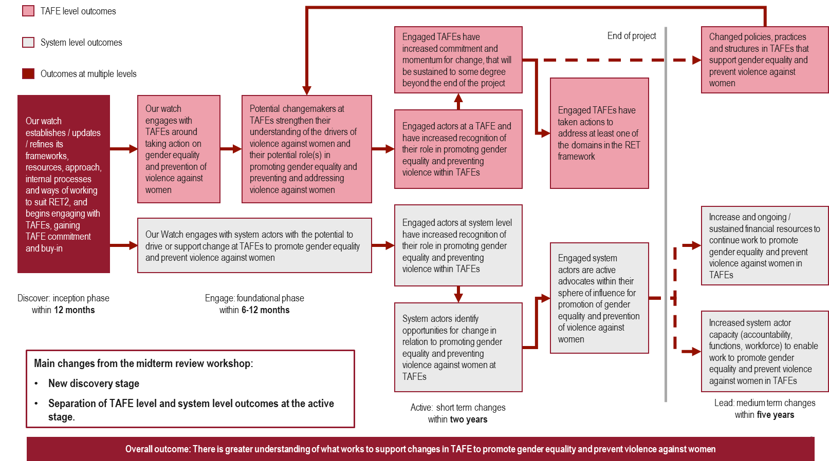

Appendix D: Respect and Equality in TAFE 2 Project model
Figure 11: RET2 Project Model
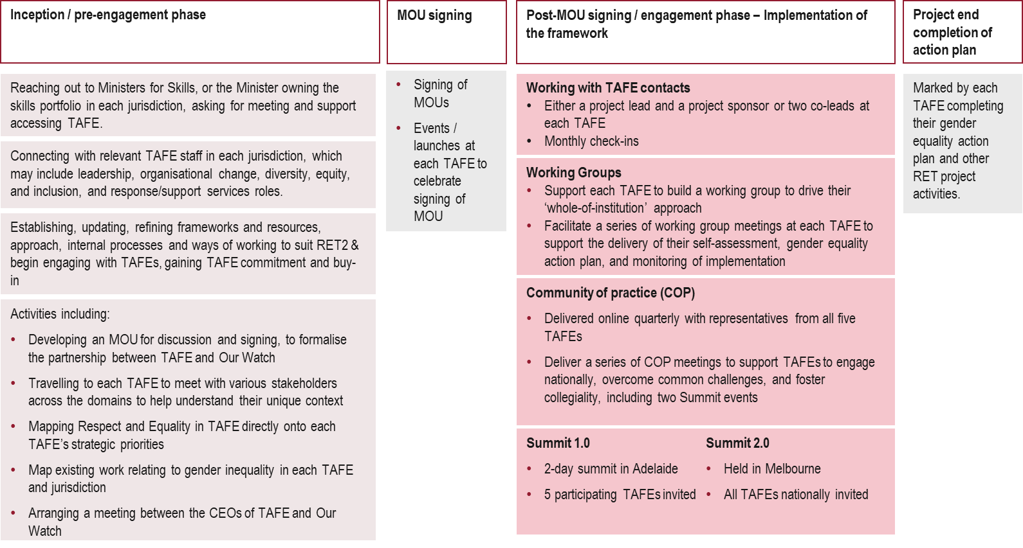

Appendix E: Evaluation framework
The evaluation of RET2 sets out to answer the following four evaluation questions:
- Implementation: How are we implementing the project, including responding to the different context in each jurisdiction?
- Principles: How are the project principles influencing project implementation and outcomes?
- Learning: To what extent are we learning about what works to support changes to promote gender equality and prevent violence against women in TAFEs?
- Changes: What type and level of changes are we contributing to?
Note the ‘we’ in evaluation questions 1 and 2 refer to the Our Watch team who were responsible for project implementation, including the development of the project principles. The ‘we’ in evaluation questions 3 and 4 refer to the Our Watch project implementation team, as well as the actors the team was working with at TAFE and system levels in each jurisdiction.
Under each evaluation question are ‘lines of enquiry’ that were explored at both the earlier phases and later phases of the project - see Figure 12 and Figure 13. This structure accounts for the implementation and testing nature of the overall project, and the differing emphasis of project activities and expected changes at different implementation stages. The intention was that what was being explored through the evaluation was tailored to be the most appropriate and useful to the stage of project implementation, with findings from the evaluation being able to inform ongoing refinement and testing of approaches. dandolo explored supplementary questions to answer key evaluation questions, these are listed in Figure 14.

Figure 12: Evaluation questions and lines of inquiry - Earlier Phase of Project
1. Implementation:  How are we implementing the project, including responding to the different context in each jurisdiction? | 2. Principles:  How are the project principles influencing project implementation and outcomes? | 3. Learning:  To what extent are we learning about what works to support changes to promote gender equality and prevent violence against women in TAFEs? | 4. Changes  What type and level of changes are we contributing to?
- What are the starting conditions for change for each jurisdiction?  - Which entry points and levers have been identified for influencing change at both the TAFE organisational level and the system level?  - How is the choice of entry points influencing the way we are working across jurisdictions?  - How effective has our engagement been with actors at a TAFE and system level?  - What enablers and challenges are emerging for actors at a TAFE and system level, and how are we responding to these?  - How can we enhance what is working well, and improve what is not? | - How, and to what extent, are the project principles being applied and ‘showing up’ in the project? | - In what ways have we embedded learning processes across and within jurisdictions for this project?  - How is Our Watch able to use its expertise, learning, tools, resources and prior experience to inform and influence the actions taken by actors at a TAFE and system level? | - To what extent have TAFE leaders, change makers and system actors been able to identify their goals for change during the project?  - To what extent are the types of changes identified aligning to particular domains in the RET framework?

Figure 13: Evaluation questions and lines of inquiry - Later Phase of Project
1. Implementation:  How are we implementing the project, including responding to the different context in each jurisdiction? | 2. Principles:  How are the project principles influencing project implementation and outcomes? | 3. Learning:  To what extent are we learning about what works to support changes to promote gender equality and prevent violence against women in TAFEs? | 4. Changes  What type and level of changes are we contributing to?
- To what extent are we responding and adapting the way we work, including how we support the implementation of the RET framework, to the RET framework and the way we work to differing contexts  - To what extent, and in what ways is Our Watch supporting TAFEs to achieve their goals?  - What about the implementation process is appearing the most effective, for whom and why | - To what extent are the project principles contributing to the changes being seen in the project? | - What are we learning about what it takes to create and sustain engagement with actors at a TAFE and system level?  - What approaches are working best to support changes in TAFEs to promote gender equality and prevent violence against women? (within and across jurisdictions)  - How, if at all, do these successful approaches align with the whole-of-organisation approach outlined in the RET framework?  - What approaches haven’t been working, and why? | - How do TAFE leaders, change makers and system actors understand their role in promoting gender equality and preventing violence against women at TAFE, and has this changed since the start of the project?  - To what extent have the engaged TAFEs been successful in achieving their goals for change during the project?  - What enabled or prevented these goals being achieved?  - What (if any) evidence is there that the engaged actors at a TAFE and system level will be able to sustain their commitment to promote gender equality and prevent violence against women in TAFEs beyond the end of the project?

Figure 14: Supplemental evaluation questions
Design | Implementation | Measures / outputs
- Was there a clear problem definition, and was the project designed to address the identified gaps?  - Was the project designed in line with evidence and best practice?  - Was the RET2 project designed to enable the localisation of the RET framework?  - How were stakeholders engaged appropriately in the design of the RET framework?  - Was the project designed to include appropriate governance and reporting arrangements?  - Did the design of the RET2 project consider and plan for the capacity and readiness of TAFEs and system actors to effectively engage with and implement the RET framework?  - Were there appropriate mechanisms in place for monitoring and adapting the design throughout the project? | - How was the project implemented in practice, and did it stay within the planned budget, time, and scope?  - What deviations occurred from what was planned, and how were they managed?  - How did the project adapt to the different contexts and needs of each jurisdiction?  - What specific barriers were encountered during the implementation of the RET framework?  - How actively did TAFEs and system stakeholders engage with the RET framework during implementation?  - What feedback mechanisms were established to assess the effectiveness of the implementation process? | - Number of TAFEs across the jurisdictions that actively participated in the RET2 project.  - Number of localised RET framework adaptations developed for each jurisdiction.  - Number of new resources and capacity building materials developed and disseminated or that are in the pipeline.  - Number of training programs that have taken place or are planned to take place.  - Number of advocacy initiatives or campaigns conducted that have taken place or are planned to take place.  - Number of stakeholders engaged or anticipated to engage in the project, including TAFE staff, students, and community partners.

Appendix F: List of stakeholders consulted
We consulted with 18 stakeholders overall. This included:
- Eight Our Watch stakeholders
- One BIITE stakeholder
- Three CDU stakeholders
- One CIT stakeholder
- One TAFE SA stakeholder
- Four TasTAFE stakeholders

Appendix G: Methodology
Our methodology involved three stages over a period of 5 months.
Figure 15 below outlines the timelines and activities at each stage of the evaluation.
Figure 15: Evaluation methodology
Stage 1: Initiation and establishment | Stage 2: Data collection and analysis | Stage 3: Reporting
September 2024 – October 2024 | October 2024 – January 2025 | February 2025 – March 2025
Project kick off meeting: We held a kick-off meeting with Our Watch to confirm scope, approach and administrative arrangements.  Data and document request: We requested relevant data and documentation from Our Watch, including project plans, evaluation reports, project data, event data.  Evaluation framework workshop: We confirmed Our Watch’s evaluation framework and our understanding of that framework including proposed supplemental questions.  Document review: We reviewed documentation to inform the design of fieldwork instruments and to develop initial hypothesis. This stage was paired with desktop research related to the implementation of gender equality frameworks in educational settings.  Evaluation plan: We refined and continued to develop a detailed methodology which encompasses initial ToC, responsibilities, timelines, recruitment and sampling strategies, evaluative approaches, ethical considerations, key principles for evaluation to ensure an accessible, trauma-informed and inclusive approach, limitations, and risk and mitigation strategy. This was submitted to DSS and was approved. | Preparation for fieldwork: We developed accessible data collection tools to be used in consultations to capture a range of perspectives and not duplicate what has been covered in the developmental evaluation  Interviews or group sessions (~ 14): To further our insights into the project’s implementation, outcomes, and key learnings, we ran interviews and / or small group discussions with key external stakeholder groups:  - Working group members from participating TAFEs  - Internal Our Watch project team and other stakeholders  Analysis: Throughout fieldwork we synthesised insights and data provided by Our Watch to develop thematic findings. | Presentation of key findings – We will hold a findings workshop with key staff to share, unpack and seek feedback on key findings from our evaluation activities.  Draft report – We will provide you with this draft report which comprises of findings and recommendations as well as a succinct executive summary.  Presentation of final report findings – We will review your feedback and prepare a presentation on the final report findings.  Final report – Provide you with a final report that incorporates your feedback from the draft report.  Summary presentation – Provide you with an accessible evaluation summary presentation to be used to disseminate learnings with a range of audiences. The specific format will be agreed on with Our Watch.  Theory of Change workshop: We will conduct a workshop with the RET2 project team and other Our Watch staff to test our findings from the evaluation to refine the existing Theory of Change.  Updated Theory of Change: We will refine the Theory of Change discussed in the workshop, incorporating feedback and findings. This updated version will integrate adjustments based on implementation learnings, ensuring it serves as a practical guide for future efforts.

Our evaluation was underpinned by several ethics and safety principles outlined in our evaluation plan.
There are several ethical considerations associated with the RET2 evaluation, several of which are described in more detail below.
We completed Our Watch Ethical Information Collection and Use Plan as a third-party contractor responsible for some information collection and use purposes.
The overall evaluation approach has been designed in accordance with relevant documents and standards, including:
- Guidelines for Ethical Conduct of Research (2023)
- National Statement on Ethical Conduct in Human Research 2023
- Australian Code for the Responsible Conduct of Research
- Commonwealth Privacy Act 1988
- The Australian Privacy Principles
- The Australian Evaluation Society Guidelines for the Ethical Conduct of Evaluations
Although the overall project focuses on a sensitive topic (violence against women), the evaluation processes were not designed or intended to collect any sensitive information, and the focus of the project is on organisational and system responses rather than individual experiences. New data is only anticipated to be collected from TAFE and system actors and Our Watch project staff, and there is no intent to collect data directly from TAFE students. Thus, the overall evaluation was considered low risk.
Further information on the ethics principles of the evaluation is captured in our evaluation plan including informed consent, privacy, do no harm, data sharing, secure management and use of data and data management.

Appendix H: dandolo Analysis Sources
dandolo undertook desktop analysis of the TAFE sector from publicly available information and starting condition case studies produced by Our Watch. These sources can be seen below.
A Vanstone, ‘Evaluation of the Practices, Policies and Procedures of TAFE SA’, Independent Commission Against Corruption South Australia, 2023, https://www.icac.sa.gov.au/documents/TAFE-SA-Evaluation.pdf
Australian Bureau of Statistics, ‘Cultural diversity: Census’, Australian Bureau of Statistics, 2021, https://www.abs.gov.au/statistics/people/people-and-communities/cultural-diversity-census/2021
Australian Bureau of Statistics, ‘Australia: Aboriginal and Torres Strait Islander population summary’, Australian Bureau of Statistics, 2022, https://www.abs.gov.au/articles/australia-aboriginal-and-torres-strait-islander-population-summary
Australian Bureau of Statistics, ‘Disability, Ageing and Carers, Australia: Summary of Findings’, Australian Bureau of Statistics, 2022, https://www.abs.gov.au/statistics/health/disability/disability-ageing-and- carers-australia-summary-findings/2022
Australian Bureau of Statistics, ‘Population estimates by LGA, Significant Urban Area, Remoteness Area, Commonwealth Electoral Division and State Electoral Division, 2001 to 2023’, Australian Bureau of Statistics, 2024, https://www.abs.gov.au/statistics/people/population/regional-population/2022-23
Batchelor Institute of Indigenous Tertiary Education, ‘Annual Report 2023’, Batchelor Institute, 2023, https://www.batchelor.edu.au/uploads/About/Annual_Report_2023_polished-digital.pdf
C Smith, ‘CDU responds as Motor Trades slams Territory Tafe trade training’, NT News, 2024, https://www.ntnews.com.au/business/nt-business/motor-trades-slams-cdu-tafe-trade-training/news-story/c444fdfe378e3d9a6ce997087ed272e5
Canberra Institute of Technology, ‘Annual Report 2023’, Canberra Institute of Technology, 2023, https://cit.edu.au/__data/assets/pdf_file/0005/298373/6211855950_CIT_2023_Annual_Report_FA.pdf
Canberra Institute of Technology, ‘Gender Equality Action Plan 2024-2026’, Canberra Institute of Technology, 2024, https://cit.edu.au/__data/assets/pdf_file/0008/311768/cit_gender_equity_action_plan.pdf
Charles Darwin University, ‘CDU responds to National Student Safety Survey results’, Charles Darwin University Newsroom, 2022, https://www.cdu.edu.au/news/cdu-responds-national-student-safety-survey-results
Charles Darwin University, ‘Annual Report 2023 year in review’, Charles Darwin University, 2023, https://www.cdu.edu.au/files/2024-06/annual-report-2023.pdf
Charles Darwin University, ‘CDU TAFE Student Guide 2023’, CDU TAFE, 2023, https://www.cdu.edu.au/files/2022-02/vet-student-guide.pdf
Charles Darwin University, ‘University launches CDU TAFE to better support the Territory’s training and skills’, Charles Darwin University Newsroom, 2023, https://www.cdu.edu.au/news/university-launches-cdu-tafe-better-support-territory’s-training-skills
Charles Darwin University, ‘$3.5 million to fund new CDU TAFE Trades Training Centre in Katherine’, Charles Darwin University Newsroom, 2024, https://www.cdu.edu.au/news/35-million-fund-new-cdu-tafe-trades-training-centre-katherine#:~:text=The%20funding%20has%20come%20from,in%20collaboration%20with%20Department%20Industry
D Wood, ‘Auditor-General again finds serious operational and financial problems with Batchelor Institute’, NT Independent, 2024, https://ntindependent.com.au/auditor-general-again-finds-serious-operational-and-financial-problems-with-batchelor-institute/
F James, ‘ICAC review of Batchelor Institute recommends 'critical' changes to corporate culture’, ABC News, 2023, https://www.abc.net.au/news/2023-02-09/icac-review-of-batchelor-institute-recommends-culture-changes/101947158
Legislative Council Government Administration Committee “A”, ‘Short inquiry process report on the financial and operational performance of TasTAFE’, Parliament of Tasmania, 2024. https://www.parliament.tas.gov.au/__data/assets/pdf_file/0033/83868/GAA-SIP-Final-Report-TasTAFE-18-July-2024.pdf
M Riches, ‘General Report: Review of Batchelor Institute of Indigenous Tertiary Education’, Independent Commissioner Against Corruption NT, 2023, https://icac.nt.gov.au/__data/assets/pdf_file/0005/1206284/Tabled-Paper-770-Independent-Commissioner-Against-Corruption-General-Report-January-2023.pdf
NCVER, ‘Data Builder’, NCVER, 2025.
O Jacques, ‘Jesus Christ’: CIT CEO found guilty of ‘serious corrupt conduct' received $465,000 in entitlements’, PS News, 2024, https://psnews.com.au/jesus-christ-cit-ceo-found-guilty-of-serious-corrupt-conduct-received-465000-in-entitlements/139535/ https://psnews.com.au/jesus-christ-cit-ceo-found-guilty-of-serious-corrupt-conduct-received-465000-in-entitlements/139535/
Our Watch, ‘TasTAFE partners with Our Watch to prevent violence against women’, Our Watch Latest News, 2024, https://www.ourwatch.org.au/news/tastafe-partners-with-our-watch-to-prevent-violence-against-women
Our Watch, ‘RET2 Case Study Starting Conditions_BIITE’, Our Watch, 2023.
Our Watch, ‘RET2 Case Study Starting Conditions_CDU’, Our Watch, 2023.
Our Watch, ‘RET2 Case Study Starting Conditions_TAFE SA’, Our Watch, 2023.
Our Watch, ‘RET2 Case Study Starting Conditions_Tas TAFE’, Our Watch, 2023.
Our Watch, ‘RET2 Case Study_CIT Starting Conditions v4’, Our Watch, 2023.
Our Watch, ‘Our Watch Submission to the South Australian Royal Commission into Domestic, Family and Sexual Violence’, Our Watch Reports, 2024, https://assets.ourwatch.org.au/assets/Submissions/OW-Submission-to-the-SA-Royal-Commission-into-Domestic-Family-and-Sexual-Violence.pdf
TAFE Directors Australia, ‘Canberra Institute of Technology developing gender equality action plan’, TAFE Directors Australia Newsletters, N.D., https://tda.edu.au/canberra-institute-of-technology-developing-gender-equality-action-plan/
TAFE Directors Australia, ‘Partnership to end gendered violence’, TAFE Directors Australia Newsletters, N.D., https://tda.edu.au/partnership-to-end-gendered-violence/
TAFE SA, ‘TAFE SA 2022-23 Annual Report’, TAFE SA, 2023, https://www.tafesa.edu.au/docs/default-source/about_tafesa/tafe-sa-annual-report-2022---2023.pdf?sfvrsn=e378fd14_6
TasTAFE, ‘Annual Report 2023-2024’, TasTafe, 2024, https://www.tastafe.tas.edu.au/__data/assets/pdf_file/0017/153053/Tastafe-Annual-Report-2024.pdf
TasTAFE, ‘TasTAFE partners with Our Watch to prevent violence against women’, TasTAFE News, 2024, https://www.tastafe.tas.edu.au/news-folder/tastafe-partners-with-our-watch-to-prevent-violence-against-women

Primary prevention work often lags because the policy work that enables it is also behind compared to other sectors.
A gender equality action plan is a strategic document outlining specific steps an organisation will take to address gender inequality within its workforce and operations, aiming to achieve equal opportunities and outcomes for all genders by implementing targeted initiatives and monitoring progress over time; it typically includes measures like promoting gender diversity in leadership, addressing pay gaps, fostering inclusive workplace culture, and providing flexible work arrangements.
Our Watch, ‘Evaluation findings: Respect and Equality in TAFE’, 2021.
Ibid.
Ibid.
Our Watch, ‘Respect and Equality in TAFE Project Plan’, 2022.
Our Watch, ‘Respect and Equality in TAFE Project Plan’, 2022.
‘Final underspend proposal’, 2024.
‘Grant recipient underspend proposal form’, 2024; ‘Final underspend proposal’, 2024.
‘Grant recipient underspend proposal form’, 2024; ‘Final underspend proposal’, 2024.
The evaluation report for RET1 is titled ‘Evaluation findings: Respect and Equality in TAFE’ and was drafted in October 2021 by Trang Ngyugen with support from Catherine Gow, Melalie Collie, Sarah Kearney, Jayne Pilkinton and Joanna Brislane.
We use key themes and quotes from consultations to answer our key evaluation questions. Any information drawn from consultations has been de-identified and compiled into key emerging themes, and any quotes have been de-identified. We do not attribute any perspectives or quotes to an individual to protect individual privacy.
Our Watch, Change theory: A shared framework for the primary prevention of violence against women and children (second edition), 2021.
Ibid.
Ibid.
Ibid.
Ibid.
Ibid.
Ibid.
Ibid.
Study Australia, ‘Vocational Education and Training (VET)’, n.d., https://www.studyaustralia.gov.au/en/plan-your-studies/vocational-education-and-training#:~:text=and%20paramedic%20roles.-,What%20is%20VET%3F,the%20largest%20provider%20of%20VET.
Ibid.
C Ey, ‘The vocational education and training sector: a quick guide’, Parliament of Australia, 2023, https://www.aph.gov.au/About_Parliament/Parliamentary_departments/Parliamentary_Library/Research/Quick_Guides/2023-24/VocationalEducationandTraining
Ibid.
Jobs and Skills Australia, ‘VET Workforce Study’, Australian Government, 2024, https://www.jobsandskills.gov.au/sites/default/files/2024-10/vet_workforce_study_2024.pdf
C Ey, ‘The vocational education and training sector: a quick guide’, Parliament of Australia, 2023, https://www.aph.gov.au/About_Parliament/Parliamentary_departments/Parliamentary_Library/Research/Quick_Guides/2023-24/VocationalEducationandTraining: Note The remaining students enrolled in VET were enrolled at community education providers, enterprise providers, schools and universities.
Our Watch, ‘Change the story: A shared framework for the primary prevention of violence against women in Australia (2nd ed.)’, 2021, https://assets.ourwatch.org.au/assets/Key-frameworks/Change-the-story-Our-Watch-AA.pdf.
NCVER (2022) VOCSTATS: Research and Statistics, NCVER, accessed 13 April 2023.
Ibid
SFPARC 2017 SFPARC (Senate Finance and Public Administration References Committee) (2017) Gender segregation in the workplace and its impact on women's economic equality, Canberra: Australian Parliament House, accessed 17 April 2023.
Jobs and Skills Australia, ‘VET Workforce Study’, Australian Government, 2024, https://www.jobsandskills.gov.au/sites/default/files/2024-10/vet_workforce_study_2024.pdf
Ibid.
C Ey, ‘The vocational education and training sector: a quick guide’, Parliament of Australia, 2023, https://www.aph.gov.au/About_Parliament/Parliamentary_departments/Parliamentary_Library/Research/Quick_Guides/2023-24/VocationalEducationandTraining
Skills and Workforce Ministerial Council, ‘VET Workforce Blueprint’, Department of Employment and Workplace Relations, 2024, https://www.dewr.gov.au/download/16477/vet-workforce-blueprint/38784/vet-workforce-blueprint/pdf.
Jobs and Skills Australia, ‘VETWorkforce Study’, Australian Government, 2024, https://www.jobsandskills.gov.au/sites/default/files/2024-10/vet_workforce_study_2024.pdf
Dandolo analysis of publicly available data, sources listed in Appendix H.
Ibid.
Our Watch, ‘Change the story: A shared framework for the primary prevention of violence against women in Australia’ (2nd ed.)’, 2021, https://assets.ourwatch.org.au/assets/Key-frameworks/Change-the-story-Our-Watch-AA.pdf.
Our Watch, ‘Change the story: A shared framework for the primary prevention of violence against women in Australia’ (2nd ed.)’, 2021, https://assets.ourwatch.org.au/assets/Key-frameworks/Change-the-story-Our-Watch-AA.pdf.
Skills and Workforce Ministerial Council, ‘VET Workforce Blueprint’, Department of Employment and Workplace Relations, 2024, https://www.dewr.gov.au/download/16477/vet-workforce-blueprint/38784/vet-workforce-blueprint/pdf.
Our Watch, ‘Change the story: A shared framework for the primary prevention of violence against women in Australia’ (2nd ed.)’, 2021, https://assets.ourwatch.org.au/assets/Key-frameworks/Change-the-story-Our-Watch-AA.pdf.
Sex Discrimination Act 1984 (Cth) s 47C
Our Watch, ‘Evaluation findings: Respect and Equality in TAFE, 2021.
Universities Australia, ‘2021 National Student Safety Survey’, 2025, https://universitiesaustralia.edu.au/project/2021-nsss/.
Our Watch, ‘Education for Equality’, 2020.
Our Watch, ‘Evaluation findings: Respect and Equality in TAFE, 2021.
Our Watch, ‘Respect and Equality in TAFES: National guide’, 2021, https://assets.ourwatch.org.au/assets/TAFE-resources/Respect-and-Equality-in-TAFE-National-Guide.pdf.
Our Watch, ‘Respect and Equality in TAFES: National guide’, 2021, https://assets.ourwatch.org.au/assets/TAFE-resources/Respect-and-Equality-in-TAFE-National-Guide.pdf.
Our Watch, ‘Change the story: A shared framework for the primary prevention of violence against women in Australia’ (2nd ed.)’, 2021, https://assets.ourwatch.org.au/assets/Key-frameworks/Change-the-story-Our-Watch-AA.pdf.
Our Watch, ‘Respect and Equality in TAFES: National guide’, 2021, https://assets.ourwatch.org.au/assets/TAFE-resources/Respect-and-Equality-in-TAFE-National-Guide.pdf.
Our Watch, ‘Respect and Equality in TAFES: National guide’, 2021, https://assets.ourwatch.org.au/assets/TAFE-resources/Respect-and-Equality-in-TAFE-National-Guide.pdf.
NCVER, Gender segregation in the workplace and its impact on women’s economic equality’, 2017.; Skills and Workforce Ministerial Council, ‘VET Workforce Blueprint’, Department of Employment and Workplace Relations, 2024, https://www.dewr.gov.au/download/16477/vet-workforce-blueprint/38784/vet-workforce-blueprint/pdf.
NCVER, Gender segregation in the workplace and its impact on women’s economic equality’, 2017.; Skills and Workforce Ministerial Council, ‘VET Workforce Blueprint’, Department of Employment and Workplace Relations, 2024, https://www.dewr.gov.au/download/16477/vet-workforce-blueprint/38784/vet-workforce-blueprint/pdf.
McCall et al., ‘A Comparative Account of Institutional Approaches to Addressing Campus-Based Sexual Violence in Australia and Aotearoa New Zealand’, 2023’ https://journals.sagepub.com/doi/pdf/10.1177/10778012231183654; M Flood, ‘Best practice in the prevention of sexual violence and sexual harassment: a literature review’, 2020, https://xyonline.net/sites/xyonline.net/files/2022-09/Flood%2C%20Literature%20review%20on%20Prevention%20best%20practice%202020.pdf.
Our Watch, ‘Respect and Equality in TAFES: National guide’, 2021, https://assets.ourwatch.org.au/assets/TAFE-resources/Respect-and-Equality-in-TAFE-National-Guide.pdf.
Department for Jobs, Skills, Industry and Regions, ‘TAFE Network Statement of Priorities’, 2024. https://djsir.vic.gov.au/about-us/publications/statement-of-priorities
Commission for Gender Equality in the Public Sector, ‘About the Gender Equality Act 2020’, 2020, https://www.genderequalitycommission.vic.gov.au/about-gender-equality-act-2020#what-is-a-defined-entity.
Ibid.
Developed in consultation with Our Watch and using Our Watch Asana platform updates and MoUs.
Information taken from dandolo’s analysis of publicly available information on TAFEs. See Appendix H for a record of sources of this analysis.
Our Watch case studies on the starting conditions of each TAFE.
CDU participated in The Purple Bench project, which involved engineering students creating a purple bench that in a prominent location on campus as a visual reminder that gendered and family violence is present in the community.
Our Watch case studies on the starting conditions of each TAFE.
Interviews with Our Watch stakeholders.
Our Watch, ‘Changing the picture: A national resource to support the prevention of violence against Aboriginal and Torres Strait Islander women and their children’, 2018.
CIT was unable to attend Summit 2 due to internal resourcing constraints.
Key: Strong influence = We believe there is strong evidence that principle had a strong influence on project outcomes, Some influence = We believe there is some evidence of that this principle influenced project outcomes, Limited influence = We believe there is limited evidence that this principles influenced the project outcomes, Unclear = We believe it is unclear the level to which this principle impacted project outcomes.
Key: Strong influence = We believe there is strong evidence that principle had a strong influence on project outcomes, Some influence = We believe there is some evidence of that this principle influenced project outcomes, Limited influence = We believe there is limited evidence that this principles influenced the project outcomes, Unclear = We believe it is unclear the level to which this principle impacted project outcomes.
For confidentially reasons we have not provided examples of specific individuals and have instead aggregated examples of changes seen within individuals.
TAFE stakeholder interview.
TAFE stakeholder interview.
K Y Burgess, ‘Status update – Sep 30’, 2024.
C Ey, ‘The vocational education and training sector: a quick guide’, 2023, https://www.aph.gov.au/About_Parliament/Parliamentary_departments/Parliamentary_Library/Research/Quick_Guides/2023-24/VocationalEducationandTraining
Skills and Workforce Ministerial Council, ‘VET Workforce Blueprint’, Department of Employment and Workplace Relations, 2024, https://www.dewr.gov.au/download/16477/vet-workforce-blueprint/38784/vet-workforce-blueprint/pdf.
Workplace Gender Equality Agency, ‘Gender segregation in Australia’s workforce’, 2019, https://www.wgea.gov.au/publications/gender-segregation-in-australias-workforce#gender-seg-industry
L Hamilton-Smith, ‘Former female employees detail alleged sexual harassment in class actions against Rio Tinto and BHP’, 2024, https://www.abc.net.au/news/2024-12-11/class-actions-launched-against-rio-tinto-bhp-abuse-allegations/104687304.
MINRES, ‘About MINRES’, n.d. https://minres.com.au/about/ ;
Sex Discrimination Act 1984 (Cth) s 47C
SBS News, ‘’Transformative’: New national code would target gender-based violence at universities’, 2024, https://www.sbs.com.au/news/article/national-code-universities-gender-based-violence/7zi1ntehd.
Entry points - who are we working with (anticipated to be actors at the TAFE organisation and system levels), and how will we work with them
Levers - opportunities at the TAFE organisation and systems levels to direct, manage or shape changes in behaviour e.g. changes to practice, policy or structures

