Respect and Equality icon and the Our Watch brand logo.

Respect & Equality  
Monitoring Guide

Our Watch acknowledges the support of the Victorian Government in the development of the Respect and Equality Framework.

Our Watch acknowledges the support of the Department of Social Services.

© Our Watch 2025

A hand drawn map of Australia and the Torres Strait Islands.

Our Watch acknowledges the Traditional Owners of the land across Australia on which we work and live. We pay respects to Elders past and present and recognise the continuing connection Aboriginal and Torres Strait Islander people have to land, culture, knowledge, and language for over 65,000 years.

As a non-Aboriginal organisation, Our Watch understands that violence against Aboriginal and Torres Strait Islander women and children is an issue for the whole community. As highlighted in Our Watch’s national resource Changing the picture, the evidence clearly shows the intersection between racism, sexism, and violence against Aboriginal and Torres Strait Islander women.

Our Watch has an ongoing commitment to the prevention of violence against Aboriginal and Torres Strait Islander women and children, who continue to suffer from violence at a significantly higher rate than non-Aboriginal women. We acknowledge all Aboriginal and Torres Strait Islander people and organisations who continue to lead the work of sharing knowledge with non-Indigenous people and relentlessly advocate for an equitable, violence-free future in Australia.

# Acknowledgement of Country

# Contents

Acknowledgement of Country 2

Contents 3

Introduction 4

Why is monitoring important? 4

The planning and reflection cycle 5

Planning for monitoring and reflection 6

Considerations before you begin 6

Types of data collection 7

Ensuring safety when consulting staff and students 8

Identifying data to collect 9

Ongoing monitoring of your action plan 13

Step 1: Update key data on gender equality in TAFE 13

Step 2: Undertake self-assessment again to check progress 13

Step 3: Review your Respect and Equality action plan 13

Evaluation 14

## Introduction

This guide has been developed to support monitoring, reflection and learning on action to promote respect and equality in your institute. The action you take will be informed by the process outlined in the [Respect and Equality in TAFE: Working together to prevent violence against women National Guide](https://www.ourwatch.org.au/tafe/resources/respect-and-equality-in-tafe-victoria-and-national-guides)and detailed in your Respect and Equality action plan.

This guide aims to support the ongoing refinement of action plans and to ensure that activities are adapted and prioritised as your TAFE context changes. The purpose is to encourage critical reflection on what should come next, based on the information available.

## Why is monitoring important?

No two institutes are the same, so the actions you take to promote gender equality and prevent violence against women will be tailored to suit the available resources, capacity and cultural needs of your TAFE, VET or dual sector.

Some attitudes, practices and structures towards gender equality may transform quickly, whilst others may transform at a slower pace and take time. Each individual, team and area of your workplace will go through different stages of change, so regular monitoring and reflection will help make sure your action plans are appropriate to support sustained change.

Over time, monitoring and reflection will help you to identify and refine actions to support Respect and Equality activities across the five domains:

* workplace
* students
* teaching and learning
* communications
* industry and community.

Figure 1: The five key domains of the Respect and Equality approach

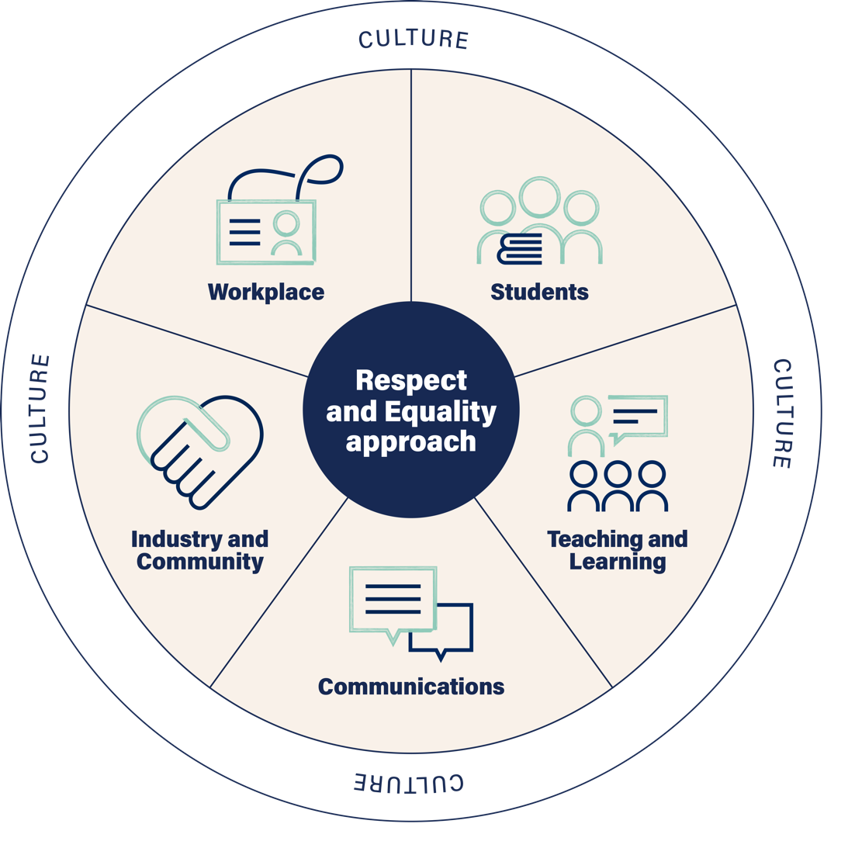

## The planning and reflection cycle

The planning and reflection cycle focuses on Steps 2 to 4 from the Respect and Equality National Guide (Steps for Implementation, pages 33-41)with the assumption that *Step 1 Connect and Align*, also referred to as *Getting Started*, has already been established.

As outlined in Steps 2 to 4, it is important to gather data and engage with key staff so that when you develop your action plan, it is tailored to your specific organisational needs and resources.

It is up to you how often you review your action plan – you may do it in one-, two- or three-year cycles. With each cycle, you should stop to reflect on your progress within your chosen actions and to revise your action plan. This process is outlined in Figure 2 below.

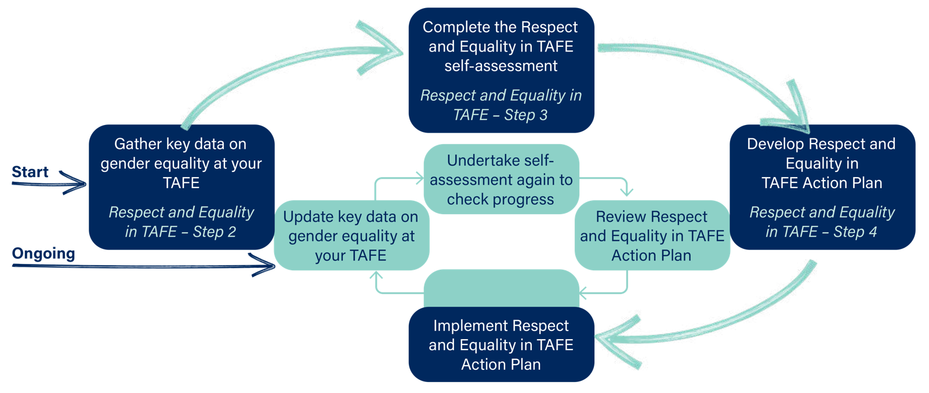Figure 2: The planning and reflection process

As shown in Figure 2, every time you want to review your action plan, it is important to understand how effective your actions have been and what changes have occurred in your institute. The key steps to help monitor your progress and review your action plan will mirror those taken to develop your first action plan:

* Step 2 – update key data on gender equality in your TAFE, VET or dual sector
* Step 3 – undertake self-assessment again to check progress
* Step 4 – review Respect and Equality action plan.

This guide will help you consider what information will be useful to gather at each of the review steps and demonstrates how you can use the action plan template to ensure you are collecting appropriate monitoring data.

When reviewing your action plan, it is useful to revisit [*Change the story: A shared framework for the primary prevention of violence against women and their children in Australia*](https://www.ourwatch.org.au/change-the-story/). This framework outlines four expressions of gender inequality (called ‘gendered drivers’) that consistently predict higher rates of violence against women in a society:

1. The condoning of violence against women (e.g., excusing or trivialising violence, victim blaming)
2. Men’s control of decision making and limits to women’s independence in public and private life (e.g., attitudes that men should be in charge and make better leaders than women)
3. Rigid gender stereotyping and dominant forms of masculinity (e.g., the notion that men should be strong, and women should be caring)
4. Men bonding with each other by disrespecting women and others (e.g., locker room talk)

While not all initiatives will seek to change every driver outlined in [*Change the story,*](https://www.ourwatch.org.au/change-the-story/) it is crucial that any review investigates whether and how an initiative engages with and contributes to shifting the intersecting drivers targeted by an initiative.

## Planning for monitoring and reflection

### Considerations before you begin

To support monitoring and reflection you should consider the following questions from the start:

#### Who is responsible for leading the monitoring?

The review and reflection process should only be undertaken if there is a genuine commitment to implementing and updating the action plan. The gender equality lead may be best placed to lead monitoring, but they cannot do it alone. They should seek to engage with members of the Respect and Equality Working Group (see Step 1 of the Respect and Equality National Guide, page 34) and draw on other expertise that exists in your TAFE. If you have staff in your institute with expertise in monitoring and tracking change, whether they be educators, quality, project management or administration staff, engage them in this process.

#### How often will you review your action plan?

Your action plan timeframes will typically span anywhere from 1 to 5 years with individual actions accorded their own timeframe e.g., ‘Our leadership group demonstrates a commitment to gender equality and prevention of violence against women through the issuing of a public commitment in all TAFE communications to staff and students’, might have a timeframe of 12 months. Whereas reviewing policies and procedures with a gender lens may have a timeframe of 2 years. Employing a cyclic review and monitoring process including self-assessments will allow you to monitor your action plan regularly. It is a good idea to align and incorporate your review of your action plan to existing planning and reporting cycles such as those for your operating or strategic plans.

#### How will you involve stakeholders in reflecting on and learning from progress against your Respect and Equality action plan?

Working Group members have a significant role in reviewing the action plan, but they are not the only people to involve. It is important to identify key stakeholders within your TAFE who can bring a wealth of insight and expertise across the five domains. Reflect on the characteristics of your staff and student populations and be conscious of the fact that people experience different forms of power, privilege and oppression, based on their identity and social status.

Women do not only experience sexism. Women may also experience racism, classism, ableism, heterosexism, colonialism, ageism and more. These multiple forms of discrimination interact and intersect, so there are not only inequalities between women, men and gender diverse people, but also inequalities between groups of women. For more on Intersectionality, see [Intersectionality in Practice: A Guide for TAFE](https://www.ourwatch.org.au/tafe/resources).

Think about the action plan goals and ask yourself, who in TAFE can offer insights into whether the particular goal has been achieved or what may be the barriers to its achievement? For example, if you have a goal of ‘we have structural support for women’s leadership, including the provision of leadership and promotional opportunities for part-time staff’, the stakeholders in this case would be women who work part-time, recognising that this group is not homogenous.

You want to gather the diverse perspectives of your staff population which means involving casual educators, women in various positions and levels of authority, Aboriginal and Torres Strait Islander staff, staff members with carer responsibilities, women with disability, women of colour and gender diverse people. The broader the representation of women you involve in the monitoring and reflection, the greater the richness of the insights you will gather.

### Types of data collection

You will need to collect data to measure and track progress, and the impact of your activities. There are two main types of data collection: quantitative and qualitative.

Quantitative information refers to numbers or percentages. This can include the number of people who have completed surveys, attended activities, contributed to planning, responded to questionnaires.

Qualitative information refers to opinions, views and experiences. This can include people’s stories of their experience with the initiative, views about whether they think they have more knowledge or a better understanding, reflections about whether they now think or act differently, and changes to practices across the TAFE.

Information can be collected using a range of different methods. Consider the types of data you are already collecting as an organisation, what methods of data collection are available to you and why you want to collect certain pieces of data. Collection methods can include:

* questionnaires or surveys
* in-depth interviews
* focus group discussions
* case studies
* lessons learned
* observation
* secondary data (e.g., documented changes to policies, curriculum resources and practices, production of resources/documents, documentation of the development of new initiatives and governance structures, diary/reflection journal).

### Ensuring safety when consulting staff and students

Consultation with staff and students can be great opportunities to increase understanding of gender equality and prevention of violence against women and to learn about how effective your action plan is. However, while conversations about gender equality and violence are necessary and useful, they can be uncomfortable and bring up sensitive issues. It is important to make sure that anyone gathering information is equipped to:

* appropriately respond to any disclosures of violence
* assist a person to access the appropriate supports within your TAFE and/or the broader community

answer common questions and concerns that arise. It is also vital that confidentiality is considered and safe and supportive opportunities for people to speak frankly are provided.

You should make sure that anyone gathering information has the backing of the leadership group and is provided with opportunities to debrief.

### Identifying data to collect

Your self-assessment, which is one of the first steps in the Respect and Equality framework, will support you to understand and identify the data you need to collect to monitor your progress when implementing your Respect and Equality action plan.

Before you implement your action plan, identify what data you will collect to support monitoring and reflection and note it in the action plan table. An example is below.

Table 1: Example of monitoring data you could collect against example actions

| Goal (from self-assessment) | Example action | Responsibility | How it will be achieved | Time frame | Monitoring data |
| --- | --- | --- | --- | --- | --- |
| * 1. Our TAFE leadership demonstrates proactive commitment to gender equality and preventing violence against women. | Leadership group to develop and communicate a statement clearly articulating TAFE’s commitment to gender equality and expectations of all staff to promote gender equality | With coordination support from the gender equality lead.  Senior leadership group  Managers | Senior leadership group dedicate time to creating a leadership statement at the executive meeting  Leadership group statement is published on the staff intranet and student facing website  Leadership group statement is shared via email to staff and students  Leadership group statement and expectations of staff are discussed at team and staff meetings | 3 months | Minutes from team and staff meetings discussing the statement  Leadership group statement published on the staff intranet and student facing websites  Staff have knowledge of the leadership group statement  Staff are aware of expected behaviour to promote gender equality  All members of the leadership group can confidently explain and communicate the statement |
| * 1. Our engagement with students reflects our commitment to promoting gender equality and the prevention of violence against women. | Consult with students to identify their current experiences relating to gender inequality at TAFE, and explore opportunities to address inequalities and enhance the student experience | Respect and Equality Working Group  Managers, Student Services and Engagement  Student Association | Members of the Working Group meet with Students Services to gain a thorough understanding of the level of student engagement, current initiatives to support students and their understanding of student concerns  Students invited to participate in a focus group exploring their current experience at TAFE and for them to share what practices or programs would further support them  Invitations to the focus group are distributed via social media, the student newsletter and via posters  Targeted invitations distributed to existing student groups e.g., Student ambassadors  Students receive a free lunch for participating in the focus group  Recommendations from the student focus group are collated into a report and shared with the Respect and Equality Working Group  The Working Group identifies achievable actions from the report and integrates into the Respect and Equality action plan. | 12 months | No. of focus groups held  No of students participating in focus groups  Development of report summarising recommendations from students  Respect and Equality action plan integrated with actions |
| * 1. All teaching and learning staff feel confident and prepared to integrate evidence-based gender equality messages and actions into their teaching practice. | Refer to action 1.4 All education staff are encouraged to utilise the *Respect and Equality: A Practice Guide for TAFE Educators* resource | Respect and Equality Working Group  Managers  Course Coordinators  Educators | See action in 3.1 and 3.2  Course Coordinators shares the *Respect and Equality: A Practice Guide for TAFE Educators* resource with all educators  The *Respect and Equality: A Practice Guide for TAFE Educators* resourceis discussed at team educator meetings | 18 months | No of workshops delivered  No of educators participating in training  Changes in participant knowledge  Changes to educators teaching practice  Staff can identify the *Respect and Equality: A Practice Guide for TAFE Educators* resource  Staff have utilised the *Respect and Equality: A Practice Guide for TAFE Educators* resource |
| * 1. All external  communication materials reflect our commitment to gender equality and preventing violence against women | Develop a Respect and Equality Communications Plan | Respect and Equality Working Group  Communications team | Members from the Respect and Equality Working Group socialise the Respect and Equality action plan with the communications team  Members from the Communications teams are invited to the Respect and Equality Working Group meeting to develop key messages and a communications plan  Utilising the Respect and Equality *Key messages* resource, the Respect and Equality Working Group and members of the communications team develop a communications plan relating to all internal and external communications at TAFE. | 3 years | Key messages relating to gender equality are developed  Communications plan is developed  Staff have knowledge of communications plan |
| * 1. We partner with industry in a strategic and meaningful way that actively promotes gender equality and the prevention of violence  against women. | Members of the Respect and Equality Working Group actively participate in local violence against women prevention networks and partner with family violence services | Respect and Equality Working Group | Respect and Equality Working Group map existing local family violence services and networks  Members of the Working Group make contact with networks, seeking participation at network meetings and membership by sharing commitment to gender equality  Develop relationships with local service providers through participation on networks | 12 months | Map of local networks and service providers  Attendance at network meetings  Relationship development |

## Ongoing monitoring of your action plan

### Step 1: Update key data on gender equality in TAFE

Before you develop your first action plan, you should undertake a gender equality ‘stocktake’. This will include collecting and reviewing data about gender equality within your TAFE. As shown in Step 2 of the Respect and Equality National Guide*,* this may include data on things like:

* ratio of men to women in leadership and management positions
* changes in staff perception of workplace culture as measured by annual staff surveys
* the percentage of male, female and gender diverse students, overall and by course enrolment and completion
* student perceptions of TAFE culture as measured by annual surveys such as ‘student experience surveys’, if available*
* student perceptions on educators applying a gendered lens to their teaching practices*

*When undertaking any surveys or consultations with staff or students, expert advice should be sought to ensure data is requested and collected safely, and managed and stored in line with privacy and data protection obligations. Adequate processes should be in place to respond appropriately to any disclosures of experiences of violence or harassment.

When you review your action plan, you should revisit this ‘stocktake’ and update data to ensure you are tracking what may have changed over time. This is likely to require a desktop review of policies and procedures as well as consultation with key Human Resources, data custodians and Student Services staff.

### Step 2: Undertake self-assessment again to check progress

When you commence work onthe Respect and Equality approach, you will also be asked to undertake a self-assessment on your TAFE. It is useful to undertake a self-assessment again when you review your action plan. Depending on the length of your review cycle, you may decide to undertake a full self-assessment again or to only assess your TAFE against the domains that you prioritised or focused on for your action plan.

### Step 3: Review your Respect and Equality action plan

Once you have updated key data on gender equality in your TAFE and you have undertaken the self-assessment you can review your action plan. Some guiding questions that may be useful to help you reflect on progress include:

* Progress or achievements of (specific indicators/goals/domains) of the unit/group?
* What worked and what didn’t work? Why?
* What factors helped to make actions successful or effective? How can we build on these?
* What factors worked as barriers to change? How can we address these?
* Who was engaged? Who was not? Why? How can we make sure the actions we take are accessible and appropriate for all staff and/or students?
* What lessons have we learned?
* What have we learned from other TAFEs that we can apply in our TAFE?

As you choose actions to amplify strengths or address challenges, remember that attitudes, practices and structures towards gender equality take time to transform so actions may need to build over time to create change.

## Evaluation

Evaluating the impact of primary prevention initiatives in the TAFE setting requires more in-depth activities that would build on the monitoring processes described in this guide.

Evaluation aims to **assess the overall impact** of a social change intervention against an explicit set of goals and objectives. Evaluation involves the **systematic collection** and **analysis** of data to help us discover if, how, and why a particular intervention or set of interventions worked or did not…Evaluations can be conducted before (formative), during (developmental), and after (summative) an intervention is implemented for the **purposes of program, project, or policy improvement, knowledge building, or learning.**

Association for Women’s Rights in Development (AWID), 2010[1]

You consider employing the support of experts if your institute chooses to undertake an evaluation of particular initiatives or their whole of institute approach. These resources can support those seeking to better understand quality approaches to the evaluation of primary prevention initiatives:

[Section 9: Evaluating your work and building the evidence for prevention in *Putting the prevention of violence against women in practice: How to change the story*](https://www.ourwatch.org.au/change-the-story/prevention-practice)

* [*Evaluation quick guides*](https://www.anrows.org.au/publication/evaluation-quick-guides/)

[*Diversity Council Australia*](https://www.dca.org.au/sites/default/files/dca_annual_report_2021_final30may_1.pdf)*. Myth Busting Domestic and Family Violence at Work*

* [*Gender Impact Assessment Toolkit*](https://www.genderequalitycommission.vic.gov.au/sites/default/files/2021-02/DPC%202011%20CGEPS_GIA-Toolkit_FA-Web_0%20%284%29.pdf)
* [*Data Collection Standards*](https://www.vic.gov.au/victorian-family-violence-data-collection-framework/data-collection-standards-aboriginal-and-torres) *– Aboriginal and Torres Strait Islander Communities*

1. Association for Women’s Rights in Development (AWID), Capturing Change in Women’s Realities A Critical Overview of Current Monitoring & Evaluation Frameworks and Approaches 2010