Respect and Equality icon and the Our Watch brand logo.

INSTRUCTION PAPER FOR TAFES

Our Watch  
Respect and Equality

Action Plan

Our Watch acknowledges the support of the Victorian Government in the development of the Respect and Equality Framework.

Our Watch acknowledges the support of the Department of Social Services.

© Our Watch 2025

A hand drawn map of Australia and the Torres Strait Islands.

Our Watch acknowledges the Traditional Owners of the land across Australia on which we work and live. We pay respects to Elders past and present and recognise the continuing connection Aboriginal and Torres Strait Islander people have to land, culture, knowledge, and language for over 65,000 years.

As a non-Aboriginal organisation, Our Watch understands that violence against Aboriginal and Torres Strait Islander women and children is an issue for the whole community. As highlighted in Our Watch’s national resource Changing the picture, the evidence clearly shows the intersection between racism, sexism, and violence against Aboriginal and Torres Strait Islander women.

Our Watch has an ongoing commitment to the prevention of violence against Aboriginal and Torres Strait Islander women and children, who continue to suffer from violence at a significantly higher rate than non-Aboriginal women. We acknowledge all Aboriginal and Torres Strait Islander people and organisations who continue to lead the work of sharing knowledge with non-Indigenous people and relentlessly advocate for an equitable, violence-free future in Australia.

# Acknowledgement of Country

# Contents

Acknowledgement of Country 2

Contents 3

A tool to guide your TAFE’s plan to progress gender equality across the five key domains of Respect and Equality 4

Short term vs long term actions 5

Short-term goals 5

Longer term goals 5

Assessing progress across the five domains 6

Measuring progress 6

Tracking progress 7

Respect and Equality action plan template 8

Vision 8

Alignment 8

Context 9

## A tool to guide your TAFE’s plan to progress gender equality across the five key domains of Respect and Equality

The Respect and EqualityAction Plan outlines the process for creating a TAFE environment where all staff and students feel safe, respected and valued. An action plan enables TAFEs to move beyond an ad-hoc ,programmatic approach to gender equality and ensures investment in gender initiatives is targeted through a whole-of-institution approach.

Having a shared understanding of the action plan increases commitment to the initiatives and enables all parts of the institute to work together towards achieving shared objectives. The action plan provides a blueprint for accountability against measurable objectives – outlining who will execute tasks and by when.

Whilst this template provides a guide to developing an action plan, no two TAFEs are the same, and each TAFE may choose a different approach to creating a plan that meets their needs and aligns with their current context. Taking this into consideration, an effective approach to promoting gender equality should be:

* tailored to suit the individual resources, capacity and cultural needs of the TAFE
* owned and driven by the TAFE
* driven and modelled by leadership
* supported by a long-term strategy
* aligned to existing organisational policies and initiatives
* evidence based
* focused on changing organisational culture
* a process of continual improvement.

#### Figure 1: The five key domains of the Respect and Equality approach

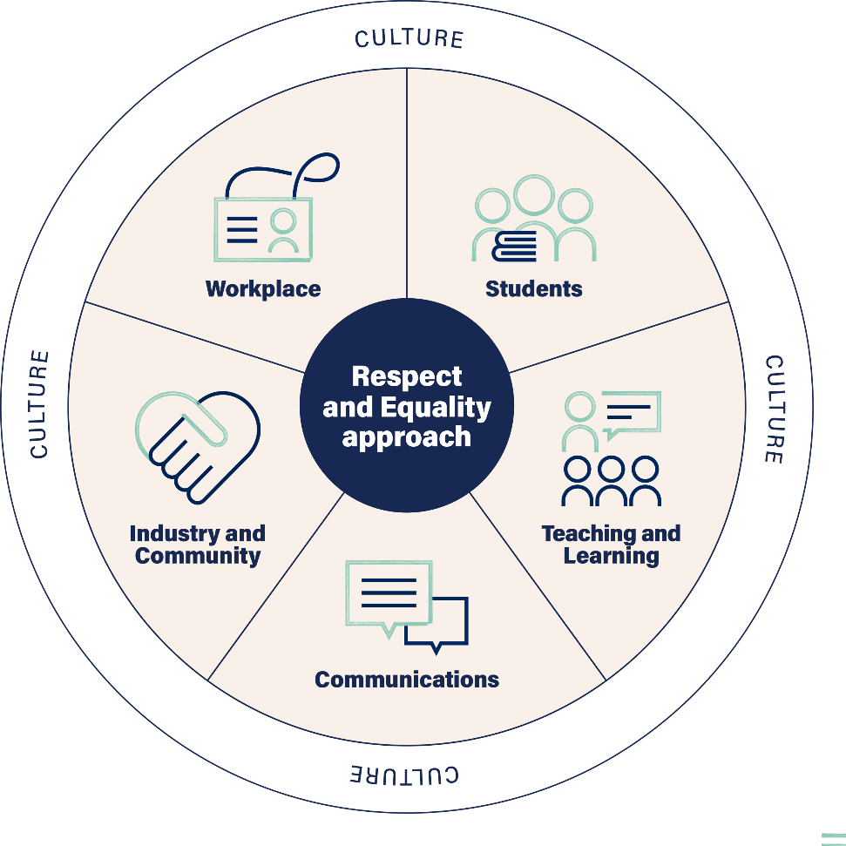

This action plan template will help you to outline tailored strategies to focus your efforts, the timeframes in which you plan to complete them and who will drive the actions.

The development of the Respect and Equality action plan should be guided by steps 1–3 of Respect and Equality: Working together to prevent violence against women, including the self-assessment workshop(s), which would have highlighted good work already occurring across the five domains, documented the evidence of this work and illuminated further opportunities to progress gender equality.

## Short term vs long term actions

Changing something as entrenched as gender inequality will not happen quickly or easily. It requires sustained effort to drive generational change to deeply entrenched beliefs and behaviours in our culture, society, communities and daily lives. It will not be quick, but it is possible if we all work together. TAFEs can use this organisational change process to create an environment where all people are not only safe but also respected, valued and treated as equals.

A typical Respect and Equality action plan time frame will span between two to five years. Actions and initiatives need to be distributed over time to ensure cost-effective delivery outcomes, and time frames need to be identified for each action.

The self-assessment process will also have identified priority areas to focus on, including those that can be achieved in the short term and those that will require a longer timeframe and greater resourcing.

### Short-term goals

If this is your institute’s first Respect and Equality action plan, many of the actions may be focused on setting your TAFE up to succeed and achieve lasting change. The first stage of organisational change often starts with an increase in investment in gender equality, and infrastructure to support it.

Proven and promising practice from other workplace organisational change programs and gender equality programs can be scaled up and embedded into your TAFE system and institutional practices (visit the [Our Watch website](https://www.ourwatch.org.au/) and the [Our Watch *Prevention Handbook* website](https://handbook.ourwatch.org.au/) for further examples and resources). Members of your workforce may require training to build their understanding, and tools and resources may need to be developed.

#### Examples of short-term goals your TAFE may strive towards in the first 12 months of the Respect and Equality action plan:

* Leadership commitment secured
* Establishment or review of policies and procedures to prioritise staff and student safety
* Staff and students have awareness of their TAFE’s commitment to gender equality
* A skilled prevention workforce begins to emerge, as staff and students increase their understanding of the prevention of violence against women
* Establishment of coordination, governance and quality assurance mechanisms
* Establishment of shared monitoring, accountability and reporting frameworks

### Longer term goals

Once initial strategies are implemented and embedded over successive years, signs of progress will begin to emerge. You may choose to broaden your focus now that internal policies, practices and structures have been implemented, and engage with your external stakeholders to deepen this work through community engagement, and utilising new and existing partnerships.

Emerging evidence from consultation, feedback from staff and students, practice experience and monitoring should be incorporated into the continuation or discontinuation of actions, as well as inform the design of new prevention initiatives.

Coordination and governance mechanisms should be reviewed and adapted when opportunities to improve arise. TAFEs may also wish to focus on fostering and supporting the next generation of staff and student leaders in this phase.

#### Examples of longer-term goals your TAFE may strive towards over the course of your action plan:

* More staff and students are empowered to challenge the drivers of violence against women and promote gender equality - personally, professionally and socially
* All policies and procedures have been reviewed with a gender lens, and new initiatives take into consideration the impact on all members of the TAFE community, particularly those from marginalised groups
* New and innovative prevention activity, programs and strategies, specific to the TAFE context are implemented in different domains
* Proven initiatives are scaled up across TAFE
* Current partnerships reviewed, identifying opportunities to promote gender equality with industry partners
* Creating safe, respectful environments begins to become core business across the five domains

## Assessing progress across the five domains

Wherever you enter this process, it is important to ensure the gender equality activities at your TAFE involve the entire institute and over the long term your initiatives address all five domains:

* Workplace
* Students
* Teaching and learning
* Communications
* Industry and community

### Measuring progress

Some attitudes, practices and structures towards gender equality may transform quickly, whilst others may take time. Each individual, team and area of your workplace will go through different stages of change, so regular monitoring and reflecting will help make sure your actions are appropriate to support sustained change. Goals are things that we can measure and are markers of progress and impact. Indicators are necessary to help determine what data needs to be collected to assess the progress of the action plan and if it is on track to achieving its goals and objectives. Your indicators should be SMART: specific, measurable, achievable, realistic and timely.

Process indicators relate to different aspects of the process of implementation: who was ‘touched’ by the different activities (individuals, teams, students, the wider community) and the quality and appropriateness of the way activities were conducted, including their planning. It investigates the process of implementing your actions.

Process indicators for measuring progress and participation could include:

* the number of workshops delivered and number of participants in each workshop
* the rates of participation for different groups within the TAFE community
* the levels of satisfaction
* development of a Respect and Equality Working Group
* number of meetings held by the Respect and Equality Working Group
* information about Respect and Equality is uploaded onto the TAFE website and staff intranet.

Impact indicatorspoint to the desired changes that could be expected in individuals, teams or organisational culture by the end of the initiative or after specific activities had been completed. Impact indicators are broader and assess the overall effects.

Indicators for measuring impact could include:

* changes in individual attitudes and knowledge about gender inequality and violence against women
* increased confidence in talking about gender equality and violence against women
* increased staff understanding of the TAFEs commitment to gender equality
* changes to teaching practices and materials to promote gender equality
* increase in staff adopting flexible work practices
* external communications material (website, brochures etc) is free from gender stereotypes and have considered inclusivity and diversity
* gender equality is integrated in the selection criteria for all new tenders

### Tracking progress

You will need to collect data to measure and track the progress and impact of your activities. There are two main types of data collection: quantitative and qualitative.

*Quantitative information* refers to numbers or percentages. This can include the number of people who have completed surveys, attended activities, contributed to planning, responded to questionnaires or changed their readiness levels.

*Qualitative information* refers to opinions, views and experiences. This can include people’s stories of their experience with the initiative, views about whether they think they have more knowledge or a better understanding, reflections about whether they now think or act differently, and changes to practices across the TAFE.

Information can be collected using a range of different methods. Before you start, consider the types of data you are already collecting as a TAFE, what methods of data collection are available to you and why you want to collect certain pieces of data. Collection methods can include:

* questionnaires or surveys
* participant numbers
* diary/reflection journal
* interviews
* focus groups
* feedback forms
* observation
* documented changes to policies, curriculum resources and practices
* production of resources/documents
* documentation of the development of new initiatives and governance structures.

## Respect and Equality action plan template

### Vision

A clear, agreed direction is the backbone of your action plan. A vision provides staff, students and the community with greater clarity and motivation about the need to address the gendered drivers of violence against women. A vision should clearly describe ‘where’ you want to be and ‘what’ you want to become to ensure you direct resources and focus action to achieve that desired future state.

*Insert your vision for respect and equality at your TAFE.*

### Alignment

As specified in step one of the Respect and Equality: Working together to prevent violence against womenNational Guide, it is useful for the action plan to leverage off existing pieces of organisational activity and strategic directions to enhance buy in and outcomes.

*List any existing policies or strategies that this action plan aligns to.*

For example:

*The Respect and Equality action plan has strong ties to existing organisational activities that challenge inequality and discrimination, and is aligned to our strategic direction of creating a TAFE that is innovative and enhances the social and economic futures of individuals, industry and communities. This includes alignment to our:*

* *Reconciliation Action Plan*
* *Strategic Plan*
* *Organisational Values: Collaboration, Integrity, Leadership, Innovation*

### Context

Step 2 of the Respect and Equality approach asks TAFEs to conduct a gender equality ‘stocktake’ of your TAFE, to understand what already exists and identify where opportunities may lie for improvement. Briefly outline the sources of data that were used, the data collected and current status of gender equality at your TAFE, as well as any consultation that took place with staff.

For example:

*The following data sources have been collected and have been examined with a gender lens to inform our self-assessment and Respect and Equality action plan.*

Table 1: Example gender equality ‘stocktake’

| Domain | Sources of data |
| --- | --- |
| *Workplace* | *Our TAFE has the following staff policies:*  *Equal Opportunity Policy*  *Discrimination and Harassment Policy*  *Family Violence Leave Policy*  *Staff employment data indicates female staff:*  *comprise 3/8 Directors*  *comprise 45% of leadership positions*  *are 2x more likely to be employed in short-term contract roles*  *are 3x more likely to be employed part-time*  *Links to the results of the People Matter survey* |
| *Students* | *Student enrolment data confirms:*  *Male dominated courses such as plumbing, electrical and carpentry are heavily dominated by male students, comprising 93% of the student cohort*  *Female dominated courses have an even greater contrast, with females comprising 96% of the student cohort*  *4% of the student population identified as Aboriginal or Torres Strait Islander*  *Link to Student code of conduct*  *Link to Student Ambassador Program*  *Student counselling is offered through student services* |
| *Teaching and learning* | *Consultation with teaching staff indicates:*  *Students who use disrespectful language and behaviour towards teachers and other students in the classroom (in particular male students towards female students and staff) suffer few consequences.*  *Educators have received limited training about gender equality and prevention of violence and how it relates to their role as trainers/assessors.*  *Most course work does not incorporate materials that are gender sensitive or topics related to gender equity or the prevention of violence.* |
| *Communications* | *There have been efforts to increase diversity in student recruitment in male dominated courses*  *Links to marketing materials representing females in trades, and production of case studies from female graduates* |
| *Industry and partnerships* | *The Horticultural Cadetship program developed and implemented in partnership with local industry providers, has a key focus on increasing representation of female students in this program* |