Report card:  
Tracking progress in the primary prevention of violence against women

July 2024

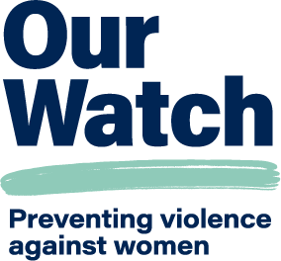

# Acknowledgement of Country

Our Watch acknowledges the Traditional Owners of the land across Australia on which we work and live. We pay respects to Elders past and present and recognise the continuing connection Aboriginal and Torres Strait Islander people have to land, culture, knowledge, and language for over 65,000 years.

As a non-Aboriginal organisation, Our Watch understands that violence against Aboriginal and Torres Strait Islander women and children is an issue for the whole community. As highlighted in Our Watch’s national resource Changing the picture, the evidence clearly shows the intersection between racism, sexism, and violence against Aboriginal and Torres Strait Islander women.

Our Watch has an ongoing commitment to the prevention of violence against Aboriginal and Torres Strait Islander women and children, who continue to suffer from violence at a significantly higher rate than non-Aboriginal women. We acknowledge all Aboriginal and Torres Strait Islander people and organisations who continue to lead the work of sharing knowledge with non-Indigenous people and relentlessly advocate for an equitable, violence-free future in Australia.

Contents

Acknowledgement of Country 2

Tracking progress in the primary prevention of violence against women 4

Key findings 4

Progress towards prevention: snapshot of key data items 5

Progress in building the foundations for prevention 6

Conclusion 10

Appendix 1 11

Endnotes 13

# Tracking progress in the primary prevention of violence against women

Key findings

* There have been slow but significant improvements across many of the **key measures of progress** in the prevention of violence against women.
* Australians’ attitudes and understandings of violence against women and gender inequality have **improved significantly since 2013**.
* While violence against women remains a national emergency, the prevalence of **physical and intimate partner violence has decreased over the past decade**.
* There is **still significant work to do across Australia to end violence** against women and their children.

**This report card provides key data updates on progress towards the primary prevention of violence against women in Australia.**

Primary prevention means stopping violence against women from occurring in the first place by addressing its underlying drivers.

Measuring progress in prevention is more than just tracking the prevalence of violence against women, it also means tracking changes in awareness and understanding, attitudes and behaviours. This is important because research shows that attitudes and behaviours are related. For example, men who hold rigid ideals of masculinity are five times more likely to have perpetrated physical violence against their partner than those who do not hold these ideals.1

Measuring progress in prevention also involves tracking structural, legislative and policy changes that support and build the foundations of a more equal society.

[*Tracking progress in prevention: A national monitoring report on progress towards the primary prevention of violence against women and their children in Australia*](https://www.ourwatch.org.au/change-the-story/tracking-progress-in-prevention) is a world-first document that tracked national progress towards reducing violence against women over a decade (2009-2019). This is an update with new data from 2020 to 2023.

Monitoring progress towards the prevention of violence against women is critical because it:

* enables the tracking of progress against the objectives of primary prevention and of key plans, strategies and frameworks and can inform decision-making around priorities for action and resource allocation
* deepens understanding of where progress has been significant, stagnated or going backwards, enabling investigation into the factors that influence progress and the refinement of approaches and interventions
* can highlight the role all parts of society have to play in preventing violence against women, from governments to workplaces and community organisations to individuals.

# Progress towards prevention: snapshot of key data items

|  |  |  |
| --- | --- | --- |
| Domains | Measures | Progress |
| Gendered driver: condoning of violence | Australians’ attitudes and understandings of violence against women and gender inequality have improved significantly since 2013. | **Good Progress** |
| 90% of Australians agree that gender equality is important and 91% of Australians agree that violence against women is a problem in Australia. | **Good Progress** |
| Between 2017 and 2021, there were significant improvements in Australians’:   * understanding of violence against women * attitudes rejecting gender inequality * attitudes rejecting sexual violence. | **Good Progress** |
| A very high proportion (around 90%) of Australians reject many aspects of violence against women. | **Good Progress** |
| Attitudes rejecting domestic violence plateaued from 2017 to 2021. | **Stable** |
| Gendered driver: rigid gender roles | Attitudes rejecting domestic violence plateaued from 2017 to 2021. | **Good Progress** |
| In 2023, a lower proportion of Australian men aged 18 to 30 years felt social pressure to conform to rigid ideals of masculinity | **Stable** |
| Prevalence | The rate of women being killed by a current or former partner has decreased significantly since 1989-90 (from 0.95 per 100,000 to 0.32 per 100,000 in 2022-23). | **Good Progress** |
| There have been significant reductions in the proportion of women experiencing physical violence in the previous 12 months from all perpetrators including intimate partners since 2012. | **Good Progress** |
| The incidence of sexual violence in the previous 12 months increased between 2012 and 2016 and did not change significantly from 2016 to 2021-22. | **Stable** |

Note: Data sources for this table are provided on page 8 and 10. Refer to **Appendix 1** for selected graphs.

# **Progress in building** the foundations for prevention

**Primary prevention is one of the four focus areas under the *National Plan to End Violence against Women and Children 2022-2032*. It sits alongside early intervention, response, and recovery and healing.**

Effective primary prevention requires developing strong foundations (or ‘prevention infrastructure’) including the creation of the necessary systems, processes, activities, strategies, and leadership to support ongoing, comprehensive action to prevent violence against women. In addition to changes in awareness, attitudes and behaviour, there have been positive legislative, policy, institutional and system reforms since 2019. Some of these are listed below.

Actions and activities

## Sustained political leadership

* *National Plan to End Violence Against Women and Children 2022-2032*
* National Strategy to Achieve Gender Equality
* Implementation of the Set the Standard Report recommendations in Commonwealth Parliamentary workplaces
* Women’s Economic Equality Taskforce
* Federal Women’s Budget Statements and gender impact assessments as well as progress in gender responsive budgeting.

## Policy and legislative reform

* Affirmative consent laws in various jurisdictions
* Significant legislative, policy and regulatory reform in line with Respect@Work, including positive duty
* Development of domestic, family and sexual violence plans/strategies, including a focus on prevention across jurisdictions
* Commitment to consent and respectful relationships education in the national curriculum and in some state curriculums
* Ending Gender-based Violence in Higher Education Action Plan
* Significant reform and leadership across education, sport, local government, and media.

## Mechanisms for collaboration and coordination

* Domestic, Family and Sexual Violence Commission (DFSV) established
* National Plan Advisory Group established
* National Respectful Relationships Education Expert Working Group re-established, with Commonwealth funding
* National Agreement for Closing the Gap.

## Mechanisms for prevention workforce development

* Our Watch and others support for the prevention workforce, including release of *Growing with change* report
* Development of state and territory prevention workforce and sector development plans and strategies.

## Strong evidence base

* Ongoing work to strengthen and build the evidence base, including publication of *Change the story* (2nd edition), *Changing the landscape* and *Men in focus*
* ABS Time Use Survey funded on an ongoing basis from 2024
* 2023 Man Box Study released
* Funding for new approach to measure violence against Aboriginal women and children under Closing the Gap Outcome 13
* Australian Child Maltreatment Study
* Wiyi Yani U Thangani (Women’s Voices): Securing Our Rights, Securing Our Future Report
* Funding and support for first study of perpetration of domestic, family and sexual violence.

## National monitoring and reporting

* The Outcomes Framework and Performance Measurement Plan developed under the *National Plan to End Violence against Women and Children*
* Strengthened Workplace Gender Equality Agency reporting
* DFSV Commissioner annual reporting (forthcoming)
* AIHW Family, domestic and sexual violence sub-site to include *National Plan* monitoring (forthcoming)
* National Gender Equality Strategy reporting (forthcoming).

Most Australians know gender inequality and violence against women are significant issues

* **Recent population-level data indicates that 90% of Australians agree that gender equality is important,2 and 91% of Australians agree that violence against women is a problem in Australia.3**
* However, only 47% of Australians agreed that violence against women is a problem in their suburb or town (with 22% unsure),4 highlighting the ongoing need to connect broad awareness with understanding of the nature and dynamics of violence against women.

Australians’ understanding of, and attitudes towards, violence against women and gender inequality are improving

* The National Community Attitudes towards Violence against Women Survey (NCAS) shows that Australians’ overall understanding and rejection of gendered violence and inequality increased significantly since 2013.5
* It also shows that a very high proportion (around 90%) of Australians reject many aspects of violence against women.6
* The NCAS collects data against nine scales which include measures of Australians’ understandings of, and attitudes towards, violence against women and gender inequality. On all NCAS scales, except attitudes rejecting domestic violence, there were significant improvements between 2017 and 2021.7
* This is significant because there is connection between attitudes about gender equality and gender roles and violent behaviour. For example:
  + The 2023 Man Box study found that men who most strongly agreed with rigid ideas of masculinity were significantly more likely to have perpetrated intimate partner violence. Two-thirds (66%) of young men with the highest endorsement of rigid ideals of masculinity have perpetrated intimate partner violence.8
  + In addition, in recent research, respondents with a high level of endorsement of sexist and gender-discriminatory attitudes were over 15 times more likely to report engagement in workplace technology facilitated harassment.9

Young men report lower social pressure to conform to rigid ideals of masculinity, however one-quarter continue to strongly endorse rigid ideals of masculinity

* The 2023 Man Box study showed that 37% of men aged 18 to 30 years feel social pressure to conform to rigid ideals of masculinity, which decreased from 49% of survey respondents in 2018.10
* One-quarter (26%) of men aged 18 to 30 years personally believed in the rigid ideals of masculinity (this has decreased from 30% in 2018), and 22% of men aged 31 to 45 years old personally agreed with rigid ideals of masculinity (this data from this age cohort was not collected in 2018).11
* This is concerning because men who held these rigid ideals of masculinity were 17 times more likely to say they had hit a partner and 6 times more likely to have forced a partner to do something sexual that is degrading or humiliating.12

Violence against women has decreased over the past 10 years

* The Australian Bureau of Statistics’ Personal Safety Survey (PSS) shows that since 2005 there has been a significant decrease in women experiencing physical violence (both threats and assault) in the previous 12 months from all perpetrators.13
* The incidence of sexual violence in the previous 12 months increased significantly between 2012 and 2016 but did not change significantly from 2016 to 2021-22.14 Similarly, in 2021-22 there was a decrease in the proportion of women experiencing intimate partner (physical) violence but no change in intimate partner sexual violence.15
* There was an overall decrease in women experiencing sexual harassment by a male in the previous 12 months from 2016 to 2021-22 (from 16% to 12%).16 Note: This data is likely to have been affected by the COVID-19 pandemic response.
* Importantly, available data highlights that people who experience other forms of discrimination experience higher levels of violence. However, there is limited trend data and significant opportunities to strengthen data collection and disaggregation to appropriately reflect the experiences and trends for Aboriginal and Torres Strait Islander women, women with disability, refugee and migrant women and LGBTIQA+ people.

Reporting of violence to police/ authorities has increased

* Most women who experience male violence do not report the incident to the police.17
* As awareness about domestic, family and sexual violence increases, responses to reporting improve and social norms around the unacceptability of violence are strengthened, women can become more confident to seek help. This is an indicator of positive change.
* The rate of reported sexual assault for women and girls increased between 2010 and 2023 from 143.8 to 227.1 victims per 100,000 persons.18
* For jurisdictions which provide data, the women’s rate of reporting experiences of family and domestic violence has increased significantly since 2014.19

There has been a significant decrease in the number of women murdered each year over the past three decades

* The rate of women killed by a current or former partner has decreased significantly since 1989-90 (from 0.95 to 0.32 per 100,000 in 2022-23).20
* However, the 2022-23 data on intimate partner homicide showed an increase over the previous two years from 27 women in 2020-21 to 34 women in 2022-23.21 In the first half of 2024, there has been a high number of women murdered.
* Aboriginal and Torres Strait Islander women and girls are murdered at significantly higher rates than non-Aboriginal females (3.07 Aboriginal and Torres Strait Islander women and girls per 100,000 females compared to 0.45 for non-Aboriginal women and girls).22 However, due to ongoing data limitations in relation to the experiences of Aboriginal and Torres Strait Islander people, there is limited ability to determine a trend from the data over time.

# Conclusion

Violence against women is a serious and widespread problem in Australia. Yet, violence against women is not inevitable. It is preventable.

There have been many **significant improvements that show progress towards** ending violence against women.

Australians’ **understanding of and attitudes towards violence against women** have shown positive changes.

Violence against women **has decreased over the past ten years** and there have been **significant steps towards building the foundations** necessary for effective primary prevention work.

**However, there is still significant work to do.**

Our Watch will continue to work with governments, businesses, practitioners, and the community to address the drivers of violence in all settings where people live, learn, work and socialise **to achieve our shared vision of an Australia where women and their children are free from violence.**

# Appendix 1: Progress towards the primary prevention of violence against women

## Minimising violence against women and shifting blame (selected subscale items), 2009 to 2021, per cent disagree

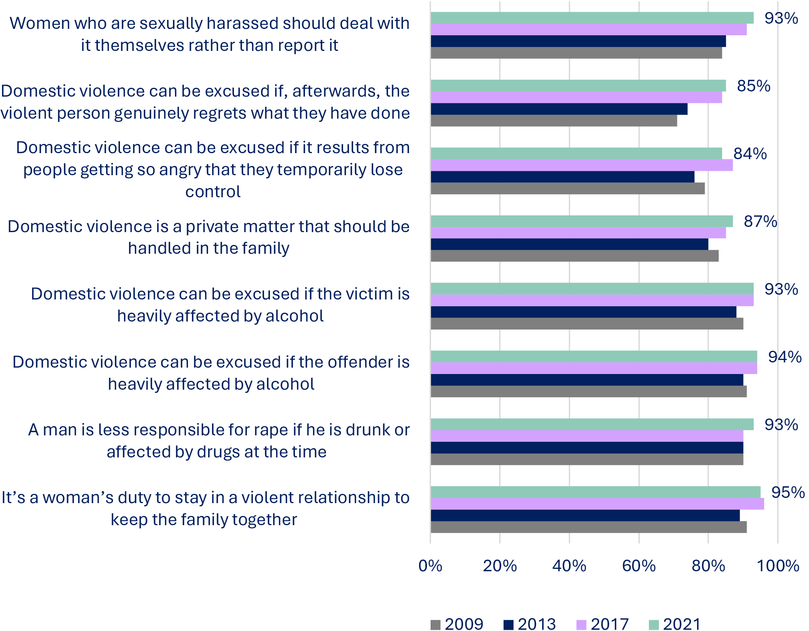

Source: Coumarelos, C. et al. (2023). [Attitudes matter: The 2021 National Community Attitudes towards Violence against Women Survey (NCAS), Findings for Australia](https://anrows-2019.s3.ap-southeast-2.amazonaws.com/wp-content/uploads/2023/03/04130433/NCAS-2021-Findings-for-Australia-main-report-FINAL.pdf). (Research report 02/2023). ANROWS.

## Women who experienced physical or sexual violence in the past 12 months, proportion of women

Source: Australian Bureau of Statistics. (2023). [Personal Safety, Australia: 2021-22](https://www.abs.gov.au/statistics/people/crime-and-justice/personal-safety-australia/latest-release), Table 3.1 Persons aged 18 years and over, Experiences in the last 12 months.

## Women and female children killed and women killed by intimate partners, rate per 100,000

Source: Australian Institute of Criminology (2024). [Homicide in Australia 2022-23](https://www.aic.gov.au/publications/sr/sr46): National Homicide Monitoring Program.

# Endnotes

1. The Men’s Project & Flood, M. 2024. [The Man Box 2024: Re-examining what it means to be a man](https://cdn.jss.org.au/wp-content/uploads/2024/02/05144735/The-Man-Box-2024-7.1-LR.pdf?_gl=1%2A1ivdus8%2A_ga%2AMTY3MTc5OTI3My4xNjk3NjgwMTcy%2A_ga_D84XPJZM02%2AMTcxNTgzMDYyNS4yMi4wLjE3MTU4MzA2MjUuNjAuMC4w)  [in Australia](https://cdn.jss.org.au/wp-content/uploads/2024/02/05144735/The-Man-Box-2024-7.1-LR.pdf?_gl=1%2A1ivdus8%2A_ga%2AMTY3MTc5OTI3My4xNjk3NjgwMTcy%2A_ga_D84XPJZM02%2AMTcxNTgzMDYyNS4yMi4wLjE3MTU4MzA2MjUuNjAuMC4w). Melbourne: Jesuit Social Services. p. 12.
2. Plan International. (2023). [Gender Compass: A segmentation of Australia’s views on gender equality](https://www.plan.org.au/wp-content/uploads/2023/09/GenderCompass_Report.pdf). Plan International. p. 30.
3. Coumarelos, C. et al. (2023). [Attitudes matter: The 2021 National Community Attitudes towards](https://anrows-2019.s3.ap-southeast-2.amazonaws.com/wp-content/uploads/2023/03/04130433/NCAS-2021-Findings-for-Australia-main-report-FINAL.pdf)  [Violence against Women Survey (NCAS), Findings for Australia](https://anrows-2019.s3.ap-southeast-2.amazonaws.com/wp-content/uploads/2023/03/04130433/NCAS-2021-Findings-for-Australia-main-report-FINAL.pdf). (Research report 02/2023). ANROWS.
4. Ibid.
5. Ibid.
6. Ibid.
7. Ibid.
8. The Men’s Project & Flood, M. 2024. [The Man Box 2024: Re-examining what it means to be a man in Australia](https://cdn.jss.org.au/wp-content/uploads/2024/02/05144735/The-Man-Box-2024-7.1-LR.pdf?_gl=1*1ivdus8*_ga*MTY3MTc5OTI3My4xNjk3NjgwMTcy*_ga_D84XPJZM02*MTcxNTgzMDYyNS4yMi4wLjE3MTU4MzA2MjUuNjAuMC4w). Melbourne: Jesuit Social Services. p 161.
9. Flynn, A. et al. (2024). [Workplace technology-facilitated sexual harassment: Perpetration, responses](https://anrows-2019.s3.ap-southeast-2.amazonaws.com/wp-content/uploads/2024/04/29153522/SH.22.03_FLYNN_REPORT-Workplace-technology-facilitated-sexual-harassment-Perpetration-responses-and-prevention.pdf) [and prevention (Research report, 03/2024)](https://anrows-2019.s3.ap-southeast-2.amazonaws.com/wp-content/uploads/2024/04/29153522/SH.22.03_FLYNN_REPORT-Workplace-technology-facilitated-sexual-harassment-Perpetration-responses-and-prevention.pdf). ANROWS. p 12.
10. The Men’s Project & Flood, M. 2024. [The Man Box 2024: Re-examining what it means to be a man](https://cdn.jss.org.au/wp-content/uploads/2024/02/05144735/The-Man-Box-2024-7.1-LR.pdf?_gl=1%2A1ivdus8%2A_ga%2AMTY3MTc5OTI3My4xNjk3NjgwMTcy%2A_ga_D84XPJZM02%2AMTcxNTgzMDYyNS4yMi4wLjE3MTU4MzA2MjUuNjAuMC4w)  [in Australia](https://cdn.jss.org.au/wp-content/uploads/2024/02/05144735/The-Man-Box-2024-7.1-LR.pdf?_gl=1%2A1ivdus8%2A_ga%2AMTY3MTc5OTI3My4xNjk3NjgwMTcy%2A_ga_D84XPJZM02%2AMTcxNTgzMDYyNS4yMi4wLjE3MTU4MzA2MjUuNjAuMC4w). Melbourne: Jesuit Social Services.
11. Ibid. p. 10 and 116.
12. Ibid. p. 64.
13. Australian Bureau of Statistics (ABS). (2023). [Personal Safety, Australia: 2021-22: Physical violence](https://www.abs.gov.au/statistics/people/crime-and-justice/physical-violence/2021-22#socio-demographic-characteristics), ABS.
14. Australian Bureau of Statistics (ABS). (2023). [Personal Safety, Australia: 2021-22: Sexual violence](https://www.abs.gov.au/statistics/people/crime-and-justice/sexual-violence/latest-release), ABS.
15. Australian Bureau of Statistics (ABS). (2023). [Personal Safety, Australia: 2021-22: Partner violence](https://www.abs.gov.au/statistics/people/crime-and-justice/partner-violence/2021-22), ABS.
16. Australian Bureau of Statistics (ABS). (2023). [Personal Safety, Australia: 2021-22: Sexual harassment](https://www.abs.gov.au/statistics/people/crime-and-justice/sexual-harassment/latest-release), ABS.
17. Refer to the Australian Bureau of Statistics (2023), Personal Safety Survey sections on [support seeking](https://www.abs.gov.au/statistics/people/crime-and-justice/sexual-violence/2021-22#support-seeking-and-police-contact)  [and police contact for sexual violence](https://www.abs.gov.au/statistics/people/crime-and-justice/sexual-violence/2021-22#support-seeking-and-police-contact) and [Partner violence: police reporting and restraining orders](https://www.abs.gov.au/statistics/people/crime-and-justice/partner-violence/2021-22#violence).
18. Australian Bureau of Statistics (ABS). (2024). [Recorded Crimes – Victims: 2023](https://www.abs.gov.au/statistics/people/crime-and-justice/recorded-crime-victims/latest-release). ABS.
19. Australian Bureau of Statistics (ABS). (2024). [Recorded Crimes – Victims: 2023](https://www.abs.gov.au/statistics/people/crime-and-justice/recorded-crime-victims/latest-release), Table 30 Victims of family and domestic violence related offences by sex, States and territories, 2014–2023 ABS.
20. Miles, H & Bricknell, S. (2024). [Homicide in Australia 2022–23: Statistical Report 46](https://www.aic.gov.au/sites/default/files/2024-04/sr46_homicide_in_australia_2022-23.pdf). Australian Institute of Criminology
21. Ibid.
22. Ibid.

**ourwatch.org.au**