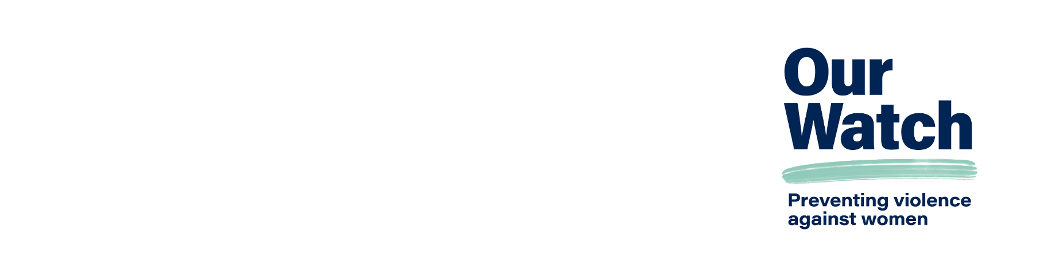

Checklist: Sexual harassment as a workplace health and safety risk

With the introduction of the Respect@Work amendments (including the positive duty to take ‘reasonable and proportionate’ measures to eliminate sexual harassment and sex discrimination in your workplace), sexual harassment is now recognised as a risk and psychological hazard under workplace health and safety law. This brief overview of actions is meant for OHS practitioners who are responsible for demonstrating that their workplace has taken all reasonable and proportionate actions to mitigate the risk of sexual harassment.

Please note that this checklist is for general information only and does not constitute legal advice or material that is tailored specifically for your organisation or circumstances.

# Checklist for Occupational Health and Safety (OHS) teams

* Examine the existing control measures in your health and safety management system to prevent sexual harassment and consider how they could be improved. Include it if it is not already an element of your health and safety management systems.
* Provide a safe physical and online work environment. Engage experts to assess if you do not have the internal capacity to recognise what this might look like (particularly in the digital and/or work-from-home spaces).
* Implement workplace behaviour policies and practices that promote respectful and inclusive workplace culture across all levels of staff.
* Introduce measures to prevent third-party sexual harassment from customers, clients and members of the public (where applicable).
* Address unwanted or offensive behaviour early, and be clear on the consequences.
* Encourage workers to report sexual harassment and provide safe, confidential and clear avenues to do so, including anonymous reporting.
* Respond to reports of sexual harassment in a way that focuses on supporting the worker and is sensitive to any trauma to minimise further risk to health and safety.
* Apply appropriate consequences for sexual harassment, with disciplinary action consistent with other workplace misconduct and accountability for managers, to create a safe and respectful workplace free from sexual harassment.
* Monitor and review the effectiveness of control measures and respond to the outputs appropriately (aiming for continuous improvement).

# Further information

**For more information, tools and resources** on how to prevent sexual harassment in your workplace, visit [Our Watch – Workplace Equality and Respect](https://workplace.ourwatch.org.au) <workplace.ourwatch.org.au>

**For more information and frameworks on addressing sexual harassment as a workplace risk**, visit [Our Watch – Practice guidance: Reducing risk in workplace initiatives to prevent violence against women](https://workplace.ourwatch.org.au/resource/practice-guidance-reducing-risk-in-workplace-initiatives-to-prevent-violence-against-women) <workplace.ourwatch.org.au/  
resource/practice-guidance-reducing-risk-in-workplace-initiatives-to-prevent-violence-against-women>

# Acknowledgements

Our Watch acknowledges the Traditional Owners of the land across Australia on which we work and live. We pay our respects to Aboriginal and Torres Strait Islander peoples past and present, and we value Aboriginal and Torres Strait Islander histories, cultures, and knowledge.

Our Watch acknowledges the support of the Australian Government.

Australian Government

© Our Watch 2024