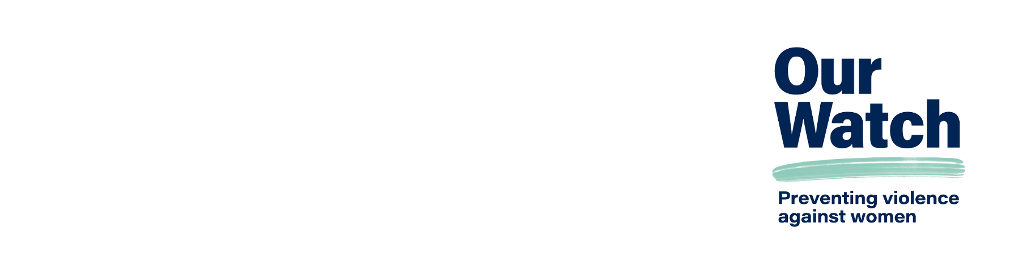

Positive duty to prevent sexual harassment and sex-based harassment at work

# What is the new positive duty legislation?

The [*Respect@Work: Sexual harassment national inquiry report*](https://www.respectatwork.gov.au/resource-hub/respectwork-sexual-harassment-national-inquiry-report) found that the existing frameworks relating to workplace sexual harassment are complex, difficult to navigate, overly reactive (focusing on response rather than stopping harassment before it starts) and place a significant burden on individuals who experience sexual harassment to make a complaint.

The [Anti-Discrimination and Human Rights Legislation Amendment (Respect at Work) Bill 2022 (Cth)](https://www.aph.gov.au/Parliamentary_Business/Bills_Legislation/bd/bd2223a/23bd027#:~:text=Work)%20Bill%202022-,Anti%2DDiscrimination%20and%20Human%20Rights%20Legislation%20Amendment,Respect%20at%20Work)%20Bill%202022&text=The%20Anti%2DDiscrimination%20and%20Human,of%20the%20Respect%40Work%20Report.) requires employers to focus on prevention (stopping sexual harassment before it starts) and address the drivers of sexual harassment.

This means employers are responsible for proactively preventing sexual harassment and hostile workplaces and putting in place ‘reasonable measures’ to eliminate, as far as possible, specified forms of unlawful sex discrimination under the Sex Discrimination Act 1984.

In line with workplace health and safety (WHS) laws, the new amendments require workplaces to foster and maintain a ‘psychologically safe’ workplace that does not ‘subject another person to a workplace environment that is hostile on the ground of sex’. It is intended that the model WHS laws and positive duty in the Sex Discrimination Act would operate in a mutually reinforcing way to build safer and more respectful workplaces.

# What do employers need to do?

Employers will need to ‘re-examine their frameworks for the oversight and management of sexual harassment. Similar to the obligations that arise in the work, health and safety space, it will require that organisations have an end-to-end framework that identifies specific sexual harassment risks, with reference to company, cultural and industry drivers, and apply appropriate controls to eliminate or minimize those risk factors.’[1]

Employers will need to put in place ‘reasonable and proportionate measures’ to eliminate discrimination, sexual harassment and victimisation in the workplace as far as possible (Respect@Work Report recommendation 17). Reasonable measures account for the diversity of workplaces in Australia and their needs. This may involve implementing policies and procedures, collecting and monitoring data, providing appropriate support to workers and employees, and delivering ongoing training and education on positive duty and sexual harassment.

Our Watch’s [Workplace Equality and Respect Standards](https://workplace.ourwatch.org.au/resource/workplace-equality-and-respect-standards) can assist employers in achieving safer and more respectful workplaces and organisations.

# Mutually reinforcing obligations and frameworks to embed positive duty and gender equality

There are a number of legislative frameworks and policies regarding industrial relations and employment that support and mutually reinforce positive duty requirements and the prevention of sexual harassment. These have undergone recent reforms as well.

Figure 1: Overview of key legislations   
on preventing workplace sexual harassment

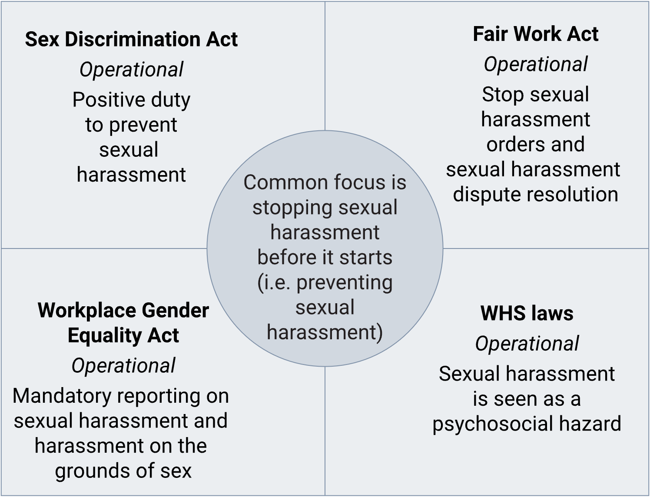

# Workplace Gender Equality Amendment (Closing the Gender Pay Gap) Bill 2023

The recent [amendments to the Workplace Gender Equality Act](https://www.wgea.gov.au/about/our-legislation/Closing-the-gender-pay-gap-bill-2023) and Agency include mandatory reporting on a number of elements, including sex-based harassment and harassment on the grounds of sex or discrimination in the workplace.

Employers with 500 or more employees are required to develop policies/strategies for each of the six gender equality indicators, including sexual harassment on the grounds of sex or discrimination. These must address workplace accountabilities for preventing and responding to sexual harassment, the provision of training, its frequency and content, the disclosure process and management of disclosures, and leadership statements or communications demonstrating leadership commitment to prevention and response.

While these provisions will directly contribute to the positive duty obligations, there are other elements of these reforms that will also address essential prevention actions, for example closing the gender pay gap through greater reporting and accountability mechanisms with respect to remuneration, and setting and achieving gender equality targets.

# Fair Work Legislation Amendment (Secure Jobs Better Pay) Act 2022

The Secure Jobs Better Pay amendment reforms to the Fair Work Act include a [prohibition on sexual harassment](https://www.dewr.gov.au/secure-jobs-better-pay/resources/prohibiting-sexual-harassment-fair-work-act), increasing protections against workplace sexual harassment in the Act and giving workers a new way to deal with sexual harassment complaints. Changes promote positive duty obligations by making it unlawful for a person to sexually harass another person in connection with work, and through vicarious liability, employees and agents have a responsibility to take all reasonable steps to prevent sexual harassment.

Other elements in these reforms will also address essential prevention actions. These include [equal remuneration](https://www.dewr.gov.au/secure-jobs-better-pay/resources/reforming-equal-remuneration-provisions) and [prohibiting pay secrecy](https://www.dewr.gov.au/secure-jobs-better-pay/resources/prohibiting-pay-secrecy-clauses), [strengthening protections against discrimination](https://www.dewr.gov.au/secure-jobs-better-pay/resources/strengthening-protections-against-discrimination), the right to request [flexible work arrangements](https://www.dewr.gov.au/secure-jobs-better-pay/resources/right-request-flexible-work-arrangements), and negotiating [unpaid parental leave](https://www.dewr.gov.au/secure-jobs-better-pay/resources/unpaid-parental-leave) requests.

The amendment also embeds the principles of job security and gender equality in the Fair Work Commission’s decision-making processes. It establishes [new expert panels](https://www.dewr.gov.au/secure-jobs-better-pay/resources/establishing-two-new-expert-panels-fair-work-commission), one for Pay Equity and one for the Care and Community Sector, to hear wage-related matters and help address low wages and challenging workplace conditions faced in the care and community sector. These amendments ensure [gender equality and job security](https://www.dewr.gov.au/secure-jobs-better-pay/resources/including-gender-equality-and-job-security-objects-fair-work-act) are given appropriate weight, alongside other objectives such as productivity and economic growth, throughout the workplace relations framework. Gender equality has been included in the minimum wages objective to ensure that equal remuneration, eliminating gender-based undervaluation of work (including between occupations and industries), and addressing gender pay gaps are considered.

# Workplace health and safety (WHS) model laws, regulations and codes of practice

Under the [WHS model laws](https://www.safeworkaustralia.gov.au/law-and-regulation/model-whs-laws), regulations and codes of practice, [harassment, including sexual harassment](https://www.safeworkaustralia.gov.au/safety-topic/hazards/workplace-sexual-harassment), is framed as a risk to workers, including to their psychosocial and physical safety. Thus employers have a positive duty to ensure that, as is reasonably practicable, workers and other persons are not exposed to risks to their psychological or physical health and safety. This includes the risk of sexual harassment between workers, and from other people at the workplace, like customers and clients. Penalties for failing to meet WHS duties include fines and jail terms for the most serious breaches.

# Four actions employers can take to meet these new obligations

Our Watch is helping workplaces understand their duty to prevent violence against women. We are supporting workplaces to understand the link between the prevention of sexual harassment, the social context of gender and other intersecting inequalities, and the social norms, practices and structures of workplaces.

Obligations will vary for workplaces depending on their size; however, all workplaces and employers can follow a similar approach to implement new regulatory obligations.

1. **Embed a whole-of-organisation approach to preventing violence against women**, to establish and build an organisational culture in which everyone has a responsibility to prevent sexual harassment. Our Watch’s [Workplace Equality and Respect Standards](https://workplace.ourwatch.org.au/resource/workplace-equality-and-respect-standards) can serve as guide.
2. **Conduct an audit of existing policies and address gaps** to ensure employers meet their positive duty obligations, as well as broader gender equality measures that will support other legislative obligations such as flexible leave arrangements, protections against discrimination, and unpaid parental leave.
3. **Communicate with and educate the organisation**, especially leaders at various levels, about sexual harassment and discrimination, what drives sexual harassment (gender inequality) and what positive duty means. Building understanding within the organisation will reduce resistance to the implementation of policies and strategies, and will get the workplace ready for their commitments under positive duty and gender equality obligations. Establishing an ongoing communication plan about changes taking place in the organisation will ensure transparency and staff awareness of the issue, and avoid siloing sexual harassment and discrimination issues.
4. **Provide ongoing learning and development**, especially for leaders, to ensure there is continued upskilling and understanding of violence against women, and the prevention of violence against women, and what that means for their employees.

# Acknowledgements

Our Watch acknowledges the Traditional Owners of the land across Australia on which we work and live. We pay our respects to Aboriginal and Torres Strait Islander peoples past and present, and we value Aboriginal and Torres Strait Islander histories, cultures, and knowledge.

Our Watch acknowledges the support of the Australian Government.

Australian Government

© Our Watch 2024

1. Lyras, A. (18 August 2022). [Implementing Respect@Work’s positive duty to prevent sexual harassment](https://www.claytonutz.com/insights/2022/august/implementing-respect-works-positive-duty-to-prevent-sexual-harassment).