

Understanding resistance   
to change in workplaces

Resistance to stopping sexual harassment and/or violence against women before it starts is both collective and individual.

Resistance is pushback against progressive programs, policies and perspectives by those advantaged by the status quo.[1] In other words, people seek to prevent further change and/or reverse changes already achieved as a response to actual or perceived challenges to existing hierarchies of power.[2]

# What does resistance look like?

Resistance can take many forms. In (En)countering resistance: Strategies to respond to resistance to gender equality initiatives, VicHealth visualises the different forms of resistance as moving along a dial from passive to active.[3]

Figure: Dial of resistance

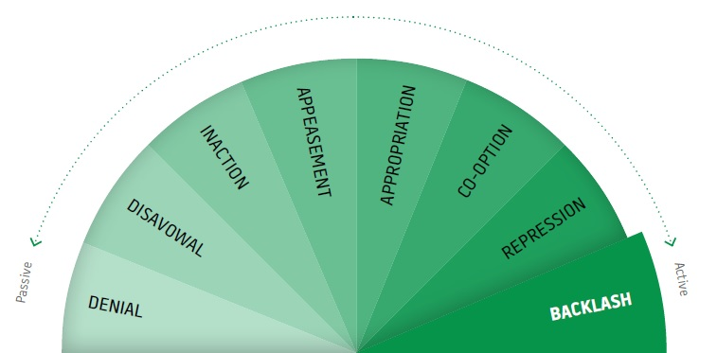

* **Denial**: denying a problem exists and/or challenging the credibility of the case for change.
* **Disavowal**: refusing to take responsibility.
* **Inaction**: refusing to take action, or delaying taking action.
* **Appeasement**: placating or pacifying those advocating for change in order to limit their impact.
* **Appropriation**: appearing to be supportive, but covertly undermining change.
* **Co-option**: using language or frameworks that are progressive but for reactional ends (for example, Yes, I support gender equality, but what about men’s rights? Men are also victims of violence).
* **Repression**: reversing or dismantling change initiatives.
* **Backlash**: aggressive, attacking responses to change.

At an organisational level, resistance is defined as patterns of action or inaction in response to change processes and initiatives that suggest collective resistance to change. These can be actions and structures that seek to halt or roll back the realisation of gender equality, but also include inactions, absences and silences, such as a stated commitment to a policy but with inadequate human and financial resourcing, or leadership distancing themselves from the change process.. Institutionalised resistance can be difficult to spot and has become increasingly sophisticated due to the unacceptability of openly challenging the norms of gender equality in countries such as Australia.[4]

**Resistance in the workplace often presents as:**

* open hostility or aggression about the workplace’s commitment and efforts to promote gender equality and prevent violence against women and sexual harassment
* attempts to discredit evidence about gender inequality or the prevalence, severity and gendered nature of violence against women
* complaints about the unfairness of actions and strategies put in place to support women’s career advancement
* ignoring or trivialising complaints or allegations of gender-based discrimination and sexual harassment in the workplace
* undermining, trivialising or de-prioritising initiatives and actions aimed at increasing gender equality
* justifying existing workplace gender inequality and refusing to investigate reasons for inequality or develop strategies for change
* refusing to participate in training, or being distracted or disruptive in training or consultation sessions.

# What drives resistance?[5]

Resistance is often rooted in fear and anxiety about changes in privilege and power, for example uncertainties about the future, the relinquishment of the familiarity and comfort of the status quo, and frustration due to the lack of control people may feel.

It can stem from a lack of understanding about what gender is and how it influences men’s disproportionate perpetration of violence and women’s victimisation/experiences to violence, or an unwillingness to recognise how gender shapes individual and collective lives and relationships.

It can be reinforced by strict adherence to stereotyped constructions of masculinity and femininity and strong attachment to patriarchal gender relations that drive violence.

Resistance can also be driven by people’s insecurity around how the primary prevention of violence against women will impact their jobs and their social and professional relationships. Or they may be concerned about organisational behaviours and practices that will no longer be acceptable, and other organisation-related factors. Resistance can come from a perceived loss of face, where people associated with the previous status quo in an organisation become defensive of what was once accepted, and unwilling to change.

Changes to the existing status of privileged groups or the accepted way of doing things can threaten perceptions of individual status in gender hierarchies. For example, staff in male-dominated sectors may reject processes put in place to encourage more diversity through targeted recruitment initiatives to bring more women and marginalised groups into an organisation and fast-track them into decision-making positions.

# Acknowledgements

Our Watch acknowledges the Traditional Owners of the land across Australia on which we work and live. We pay our respects to Aboriginal and Torres Strait Islander peoples past and present, and we value Aboriginal and Torres Strait Islander histories, cultures, and knowledge.

Our Watch acknowledges the support of the Victorian Government and the Australian Government.

 Australian Government

© Our Watch 2024

1. VicHealth. (2018). (En)countering resistance: Strategies to respond to resistance to gender equality initiatives. Victorian Health Promotion Foundation.
2. Flood, M., Dragiewicz, M., & Pease, B. (2021). Resistance and backlash to gender equality. Australian Journal of Social Issues, 56(3): 393–408.
3. VicHealth. (2018). (En)countering resistance.
4. Our Watch. (2022). Understanding, monitoring and responding to resistance and backlash. Respect Victoria and Our Watch.
5. Our Watch. (2022). Understanding, monitoring and responding to resistance and backlash.