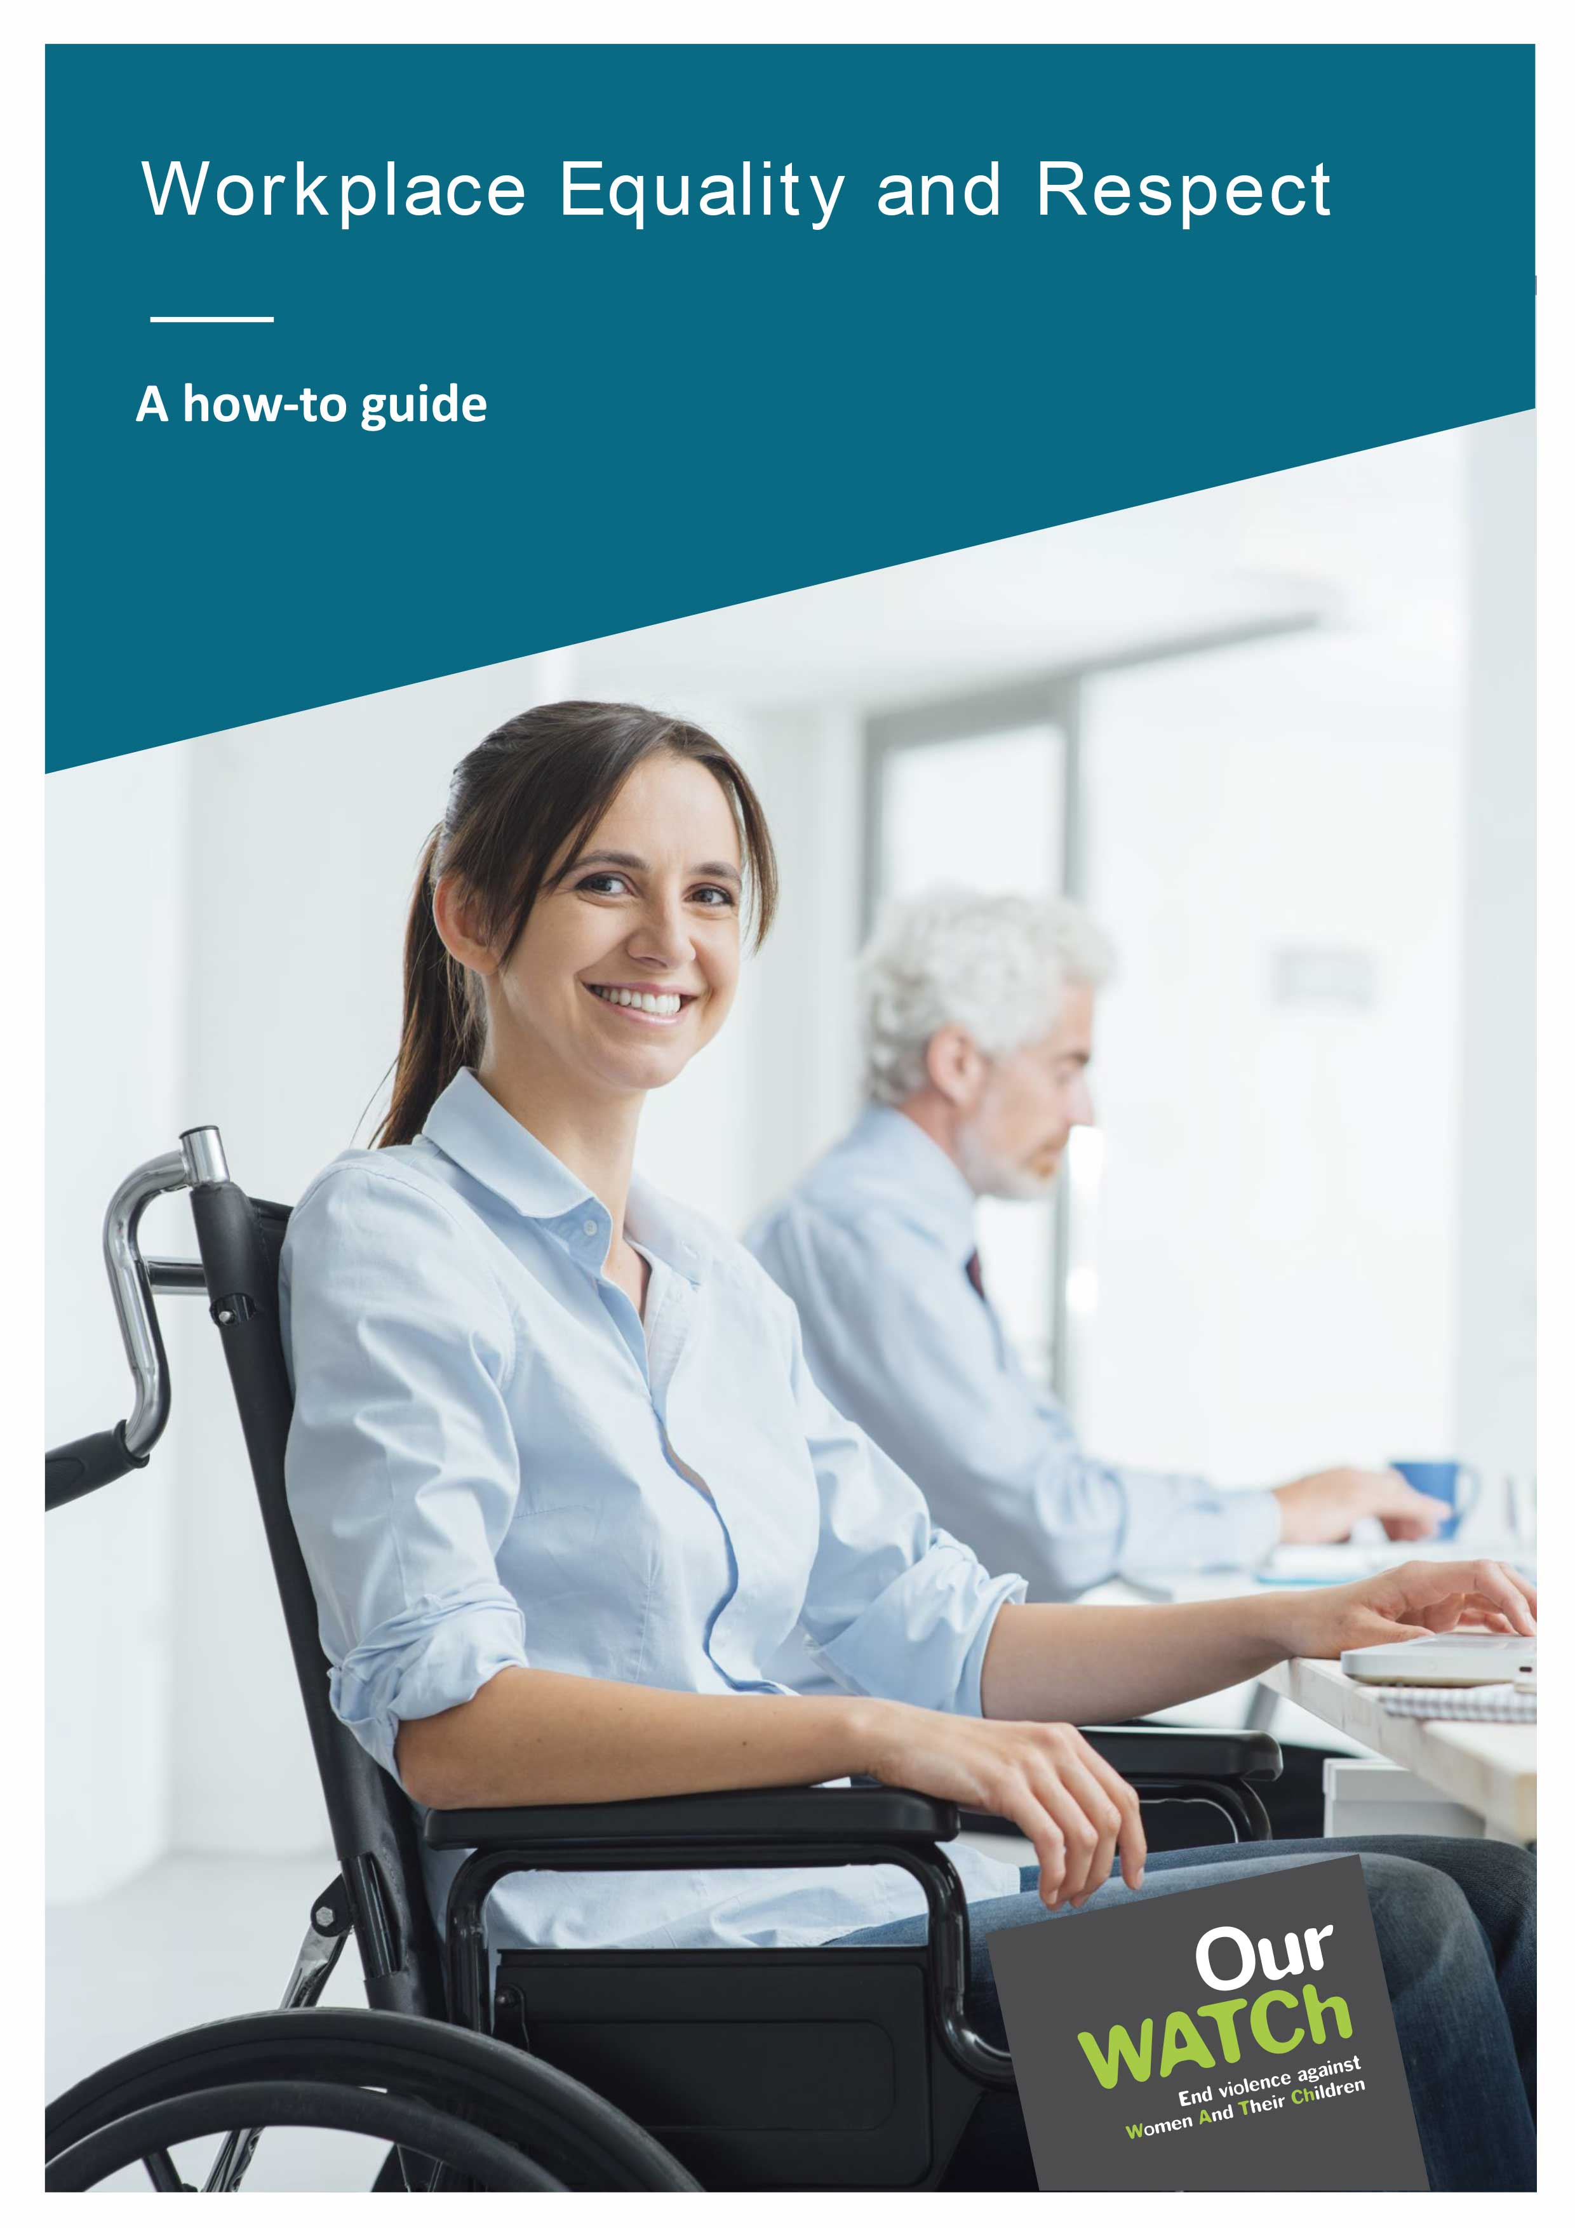

**Acknowledgements**

Our Watch acknowledges the Traditional Owners of the land across Australia on which we work and live. We pay our respects to Aboriginal and Torres Strait Islander peoples past and present, and we value Aboriginal and Torres Strait Islander histories, cultures, and knowledge.

Our Watch acknowledges the support of the Victorian Government and the Australian Government.

 Australian Government

© Our Watch 2022

## Introduction

More organisations are recognising the need to promote gender equality, prevent sexual harassment in the workplace and support people who may be experiencing domestic and family violence. Policies promoting gender equality and addressing sexual harassment and domestic and family violence are becoming more common. Yet, sexual harassment and gender-based violence persist. Why?

Gender inequality, sexual harassment and domestic and family violence are about power. Unequal power dynamics in workplaces and society allow gender inequality, sexual harassment, and domestic and family violence to persist. To change this, we must address the underlying power imbalance and behavioural expectations that make up an organisation’s culture.

Organisational culture is, most simply, shared assumptions that define what is appropriate or expected behaviour for various situations.[1] Workplace culture expresses social norms about leadership, office behaviour, and gender, among other things. Addressing sexual harassment in the workplace requires unpacking an organisation’s core beliefs, attitudes, and norms about gender and gender equality. This is because gender inequality is the key power disparity that drives sexual harassment.

Our Watch’s Workplace Equality and Respect tools and resources support organisations to unpack their core beliefs, attitudes, and norms. Organisations can then use the tools and resources to develop a plan to address workplace gender inequality and the gendered drivers of sexual harassment and other forms of gender-based violence, including domestic and family violence.

By focusing on cultural change, tracking your progress, and regularly reflecting on learning from the experience, you can make lasting change in your workplace.

This guide walks you through the key steps to secure commitment, communicate and consult effectively, identify needs and priority areas, and prepare an action plan to create a gender-equitable and inclusive workplace for people of all genders.

### The process at a glance

No two workplaces are the same. An effective approach to preventing sexual harassment and gender-based violence in the workplace must be tailored to suit your workplace’s resource and capacity needs.

There are four steps in your organisation’s journey to implement Workplace Equality and Respect. A summary of these steps is outlined below.

**Table 1:** The four steps in an organisation's journey to implement Workplace Equality and Respect

| **Your stage in the journey** | **What steps to take** | **Key questions this step will answer** | **Resources and tools to support this step** |
| --- | --- | --- | --- |
| **You have identified that workplace equality and respect are important for your organisation, but you don’t know where to start** | Do a readiness assessment | Is your organisation ready undertake this work? | [*Workplace Equality and Respect Standards*](https://workplace.ourwatch.org.au/tools-and-resources/): these set out what is required to develop a more equal and respectful workplace  [*Readiness assessment tool*](https://workplace.ourwatch.org.au/tools-and-resources/): this has five questions to help you determine if your organisation meets the minimum requirements to continue |
| **You have a done a readiness assessment. You need to think about what implementing the Workplace Equality and Respect tools and resources looks like in your organisation** | Develop a project plan | What does your organisation need to consider operationally? | [*Leadership commitment checklist*](https://workplace.ourwatch.org.au/tools-and-resources/): this helps you determine whether organisational leaders show the commitment required  [*Communications guide*](https://workplace.ourwatch.org.au/tools-and-resources/): this helps you craft your internal and external messaging about your organisation’s commitment to advancing gender equality |
| **You have a project plan in place. You need to understand the current state of equality and respect in your organisation** | Undertake benchmarking and diagnostics | Where is your organisation now?  What are the gaps, challenges, and priorities for improvement?  What do your employees think are the key challenges and priority areas for improving workplace equality and respect? | Workplace benchmarking and diagnostic tools will help you create an organisational snapshot. They include:  [*People survey tool*](https://workplace.ourwatch.org.au/tools-and-resources/)  [*Employee focus group tool*](https://workplace.ourwatch.org.au/tools-and-resources/)  [*Workplace gender equality indicators*](https://workplace.ourwatch.org.au/tools-and-resources/)  [*Project Management Group assessment tool*](https://workplace.ourwatch.org.au/tools-and-resources/)  [*Organisational snapshot template*](https://workplace.ourwatch.org.au/tools-and-resources/): bring all the information gathered from your benchmarking and diagnostics into this template |
| **You have an organisational snapshot and want to know what you can do to progress towards workplace equality and respect** | Develop an action plan | What actions will your organisation resource/implement to improve Workplace Equality and Respect? | [*Action plan template*](https://workplace.ourwatch.org.au/tools-and-resources/): this will assist you with planning, prioritising, and reviewing the actions you wish to take. |

## **Step 1:** Readiness assessment

Familiarise yourself with the [*Workplace Equality and Respect Standards*](https://workplace.ourwatch.org.au/tools-and-resources/)*.* They will help you identify areas of strength and opportunities for progress within your organisation.

A significant first step is to assess your workplace’s readiness to engage with these standards. The [*Readiness assessment tool*](https://workplace.ourwatch.org.au/tools-and-resources/) can assist with this. It has five questions to help you determine if you are ready to continue undertaking a program to promote gender equality and prevent sexual harassment and gender-based violence. The questions cover issues such as training, support for employees, and resources available to undertake the work required.

If you answer ‘no’ to any of the readiness assessment questions, it’s advised that you establish what is necessary before proceeding to step 2.

## **Step 2:** Project planning

A project plan sets you up for success, outlining the actions you need to take and when they need to be completed.

Recommended key actions for inclusion in your project plan:

### Securing commitment from board members/senior executives

This may include training to ensure they understand violence against women and the role of the workplace in prevention, discussing the business case for workplace gender equality, and connecting gender equality to the vision and goals of the organisation. The [*Leadership commitment checklist*](https://workplace.ourwatch.org.au/tools-and-resources/) will help you assess leadership commitment. Until you can tick every item on the list, it’s worth investing time and energy to help leaders understand that your workplace has the power and responsibility to prevent violence against women.

Email [equalityandrespect@ourwatch.org.au](mailto:%20equalityandrespect@ourwatch.org.au?subject=Workplace%20Equality%20and%20Respect) to discuss training and other resources/options to support your work to promote gender equality and prevent sexual harassment in your workplace.

### Establishing your cross-organisational Project Management Group (PMG)

To effectively promote workplace gender equality and prevent sexual harassment and gender-based violence, an organisation needs strong leadership endorsement, supportive governance structures, and a workplace culture that consciously seeks and supports equality and respect.

An essential step in building a gender-equitable and inclusive workplace and undertaking prevention initiatives is identifying who is best placed to lead the change process. Employees involved must be in positions where they have access to resources and can make decisions regarding changes to organisational strategies, policies, and procedures.

The development and implementation of prevention initiatives require a team effort. This team might include the CEO and/or senior executives and/or managers or human resources staff, and others in the organisation responsible for developing workplace policies and procedures about equality, diversity, inclusion, and staff health and wellbeing.

Below is a checklist to help guide the establishment of your PMG.

Is there representation from across the organisation?

Does the PMG have the authority, mandate and resourcing it needs to carry out its tasks?

Is there a gender balance?

Is there diversity in representation – people with diverse gender identities, people with disability, Aboriginal and Torres Strait Islander peoples, people from migrant and refugee backgrounds?

Has a clear a Terms of Reference been developed and approved by all members and senior executives?

Many people know that workplace gender inequality, sexual harassment, and gender-based violence are serious issues. Still, there are many myths and misunderstandings about the causes and how we can prevent them. It’s essential to ensure the members of your PMG are adequately trained. This is not just so you have a solid shared understanding of what to address and key steps to take, but so everyone is equipped to respond appropriately to questions, concerns, and feedback. Training should include information on the gendered drivers of sexual harassment and gender-based violence; how to respond to disclosures of violence; the role of workplaces in preventing gender-based violence; and Our Watch’s Workplace Equality and Respect process.

Email [equalityandrespect@ourwatch.org.au](mailto:%20equalityandrespect@ourwatch.org.au?subject=Workplace%20Equality%20and%20Respect) to discuss support with training.

### Developing a communications strategy/plan

Communication is a fundamental part of building any culture. To prevent sexual harassment and gender-based violence, workplaces need to create a culture where employees feel confident to speak up if they see or hear about sexism, harassment, discrimination, or violence.

Your communications strategy/plan aims to ensure that everyone in the workplace understands what they can do to achieve gender equality and why they should do it. Everyone should understand the link between gender equality, sexual harassment, and gender-based violence.

You can use the [*Communications guide*](https://workplace.ourwatch.org.au/tools-and-resources/) to develop your communications strategy/plan. It includes suggested key messages, communication channels, opportunities to align with international and national campaigns, and links to helpful resources.

In addition to the key actions mentioned above, your project plan should include when you anticipate undertaking benchmarking and diagnostic activities (step 3) and action planning and review (step 4). You may also wish to have any approvals or resourcing you need to progress to the next stage of action.

## **Step 3:** Benchmarking and diagnostics

### Benchmarking

Each organisation will require different types of information to prioritise and plan strategies for change. The [*Workplace gender equality indicators*](https://workplace.ourwatch.org.au/tools-and-resources/) will help you assess your organisation’s engagement with the [*Workplace Equality and Respect Standards*](https://workplace.ourwatch.org.au/tools-and-resources/). These indicators have been selected from the Workplace Gender Equality Agency’s (WGEA) list of gender equality indicators. You may already collect data on [*Workplace gender equality indicators*](https://workplace.ourwatch.org.au/tools-and-resources/) for WGEA reporting. Extracting and analysing some of this data will help your PMG establish a benchmark and provide information that can be discussed in the employee focus groups.

**Consider what the indicators are telling you about:**

* the gender composition of your workforce
* the gender composition of key governing roles in your organisation
* equal remuneration in your organisation
* flexible working arrangements and working arrangements supporting carers in your organisation, disaggregated by gender
* sexual harassment and discrimination in your organisation, disaggregated by gender.

### Diagnostics

The PMG can lead in mapping organisational policies, practices, and programs related to gender equality and addressing gender-based violence, including sexual harassment and domestic and family violence. This can help the organisation understand what has already been done and still needs to be done. This assessment includes noting what support may be required to implement Workplace Equality and Respect initiatives. You can use the [*Project management group assessment tool*](https://workplace.ourwatch.org.au/tools-and-resources/) *to* help with this assessment.

The [*People survey tool*](https://workplace.ourwatch.org.au/tools-and-resources/) will assist you in getting a better understanding of workplace culture and practices. You may already conduct an annual people survey – you could (a) draw on this data and/ or (b) integrate relevant questions from the *People survey tool* into your annual people survey.

Effective consultation with your people at each stage will help you increase readiness for change, build support for action and understand and manage resistance from staff and stakeholders. It will also assist you in understanding what needs to change, why staff should be asked questions about the current situation and how they see the future. Without employee feedback and input, gender inequality, sexual harassment, and domestic and family violence will remain hidden, unchallenged, and unsupported.

You can organise an employee focus group to provide opportunities for feedback on their workplace experiences, identify the ways gender influences and shapes their working lives and their ideas for how the workplace can promote gender equality and respect. The [*Employee focus group tool*](https://workplace.ourwatch.org.au/tools-and-resources/) can help you structure your discussions.

Conversations about gender equality and violence are necessary and valuable, but they can be uncomfortable and bring up sensitive issues. Therefore, you must ensure confidentiality and provide safe and supportive opportunities for people to speak frankly. This might be done using interactive tools like Mural, Miro or Mentimeter, or Aha slides or engaging a third party to conduct the focus group discussions.

You should also ensure that those gathering information are equipped to answer common questions and concerns, have the support of your leaders, and have opportunities to debrief.

Email [equalityandrespect@ourwatch.org.au](mailto:%20equalityandrespect@ourwatch.org.au?subject=Workplace%20Equality%20and%20Respect) to discuss support for benchmarking and diagnostics.

### Developing a snapshot of your workplace

The PMG’s review, information from your [*People survey*](https://workplace.ourwatch.org.au/tools-and-resources/) and your [*Employee focus groups*](https://workplace.ourwatch.org.au/tools-and-resources/) and the data collected against the [*Workplace gender equality indicators*](https://workplace.ourwatch.org.au/tools-and-resources/) will have yielded rich information that will help you understand your workplace culture.

**The** [*Organisational snapshot template*](https://workplace.ourwatch.org.au/tools-and-resources/) **can help you bring all these different pieces of information together and ask:**

* What does this tell me about gender equality and respect in my organisation?
* What are we doing well?
* What are the gaps?
* What can we do better?
* Have any ideas emerged on what we could be doing?
* What kind of resourcing is required?

At a minimum, you should collect annual data to map your progress against the [*Workplace gender equality indicators*](https://workplace.ourwatch.org.au/tools-and-resources/) and regularly conduct a people survey. How often you organise employee focus groups will depend on the action plan you develop, the resourcing available, and what you assess as reasonable.

## **Step 4**: Action planning and review

Planning processes are as diverse as workplaces, so the scope and form are up to your organisation. You can use your organisation’s planning processes and templates, or the [*Action plan template*](https://workplace.ourwatch.org.au/tools-and-resources/)*,* to prioritise actions you will take to address the issues and gaps you have identified through the benchmarking and diagnostics process.

**Regardless of your planning process, it is essential to:**

* base your plan on the completed organisational snapshot
* integrate information that emerged from your [*People survey*](https://workplace.ourwatch.org.au/tools-and-resources/) and your [*Employee focus groups*](https://workplace.ourwatch.org.au/tools-and-resources/), and the [*Workplace gender equality indicators*](https://workplace.ourwatch.org.au/tools-and-resources/)
* ensure the plan for change builds over time
* include targets against baseline measures using the data you have gathered throughout the Workplace Equality and Respect process
* use available evidence / best practice to develop actions to achieve the desired outcomes
* appropriately resource the planned activities
* consider the safety of all employees participating in workplace gender equality initiatives (including supporting those people who are responsible for program implementation).

It is essential to ensure that actions are deliberate and appropriate for your organisation and include a mix of short-term and long-term initiatives.

**Other things to consider:**

* engage leaders and sponsors in finalising actions
* keep long-term sustainability in mind as you design your actions
* map out how one action or achievement leads to the next – for example, employees may need the training to call out sexist behaviours. To do this safely, disclosure procedures are required
* where there is an existing organisational diversity and inclusion strategy or a gender equality strategy, consider how to leverage and dovetail into this
* doing everything at once may not be realistic – think about what resources you have, prioritise actions and identify smaller steps that will support long-term goals
* make time annually to reflect and assess progress against the long-term strategy and use this information to prioritise actions for the coming year
* celebrate key activities as they occur and progress more generally, at least annually
* integrate actions to identify and mitigate backlash
* share your experience with others, within and outside of your workplace, to foster new ideas and facilitate collaborative learning.

1. Ravasi, D., & Schultz, M. (2006). Responding to Organizational Identity Threats: Exploring the Role of Organizational Culture. *The Academy of Management Journal*, 49(3), 433–458. <http://www.jstor.org/stable/20159775>