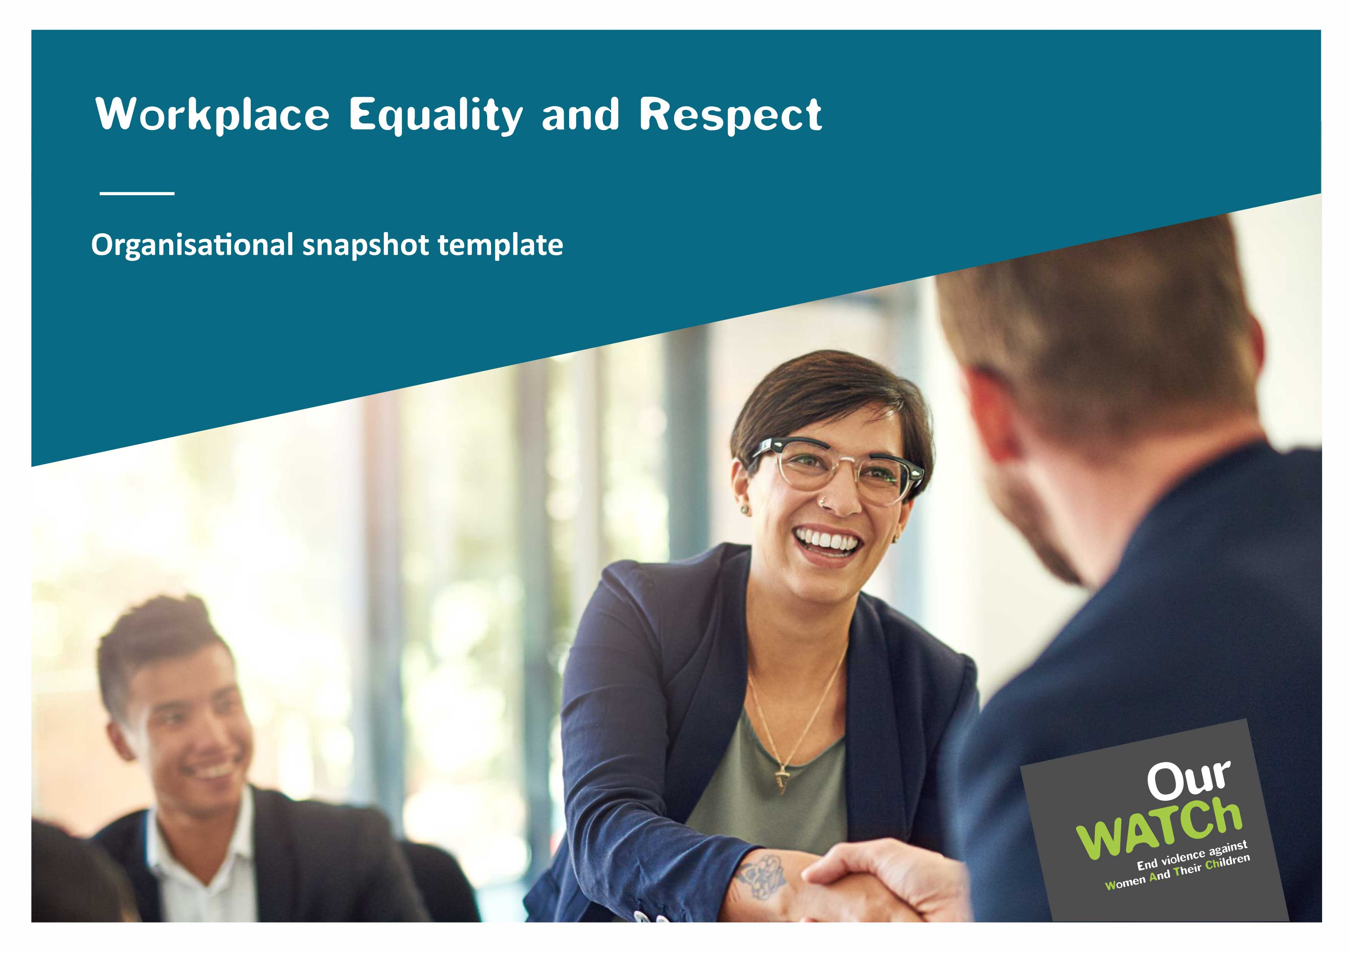

**Acknowledgements**

Our Watch acknowledges the Traditional Owners of the land across Australia on which we work and live. We pay our respects to Aboriginal and Torres Strait Islander peoples past and present, and we value Aboriginal and Torres Strait Islander histories, cultures and knowledge.

Our Watch acknowledges the support of the Victorian Government and the Australian Government.

 Australian Government

© Our Watch 2022

# Introduction

The *Organisational snapshot template* can be used by the Project Management Group (PMG) to bring together and summarise all the information gathered from the benchmarking and diagnostics step.

# The five standards

## Commitment

We demonstrate an ongoing commitment to workplace gender equality and preventing sexual harassment and other forms of gender-based violence.

### What does this look like?

* **Leadership:** Our leaders, including board members and senior executives, take responsibility for promoting gender equality, and the prevention of sexual harassment and other forms of gender-based violence as a priority.
* **Policy and practice:** We have a resourced strategy/plan to promote gender equality that includes the prevention of sexual harassment and other forms of gender-based violence.
* **Communications:** We articulate our commitment to gender equality and expectations of workplace behaviour in all internal and external communications.
* **Accountability and reporting:** Our senior leaders’ key performance indicators (or equivalent performance assessment processes) recognise and reward efforts to promote gender equality and prevent sexual harassment and other forms of gender-based violence.

| **Activity** | **Task** |
| --- | --- |
| [*Workplace gender equality indicators*](https://workplace.ourwatch.org.au/tools-and-resources/) | Summarise or graphically present data on the composition of employees overall and by departments/teams and gender composition at the executive level, at the senior management level, at the middle management level and board members |
| [*Project management group assessment tool*](https://workplace.ourwatch.org.au/tools-and-resources/) | Summarise the group’s assessment of current policies/strategies/programs/initiatives |
| [*People survey tool*](https://workplace.ourwatch.org.au/tools-and-resources/) | Summarise responses to questions 1–4 (disaggregate by sex/gender) |
| [*Employee focus group tool*](https://workplace.ourwatch.org.au/tools-and-resources/) | Commitment score:Summarise the group’s discussion on what is working well and what more needs to be done – use the summary section of the [*Employee focus group template*](https://workplace.ourwatch.org.au/tools-and-resources/) to complete this section |
| Overall summary | What’s the overall picture – what are we doing well, and what needs to improve? |
| Recommended priority actions |  |

## Conditions

We apply a gender lens to our workplace policies and practices to ensure they are fair and equitable.

### What does this look like?

* **Leadership:** Our leaders sponsor policies and procedures that support our commitment to gender equality and the prevention of sexual harassment and other forms of gender-based violence so employees of all genders feel safe and supported.
* **Policy and practice:** Our people management processes, and practices (including recruitment, promotion, and remuneration) are transparent and seek to eliminate bias.
* **Accountability and reporting:** We benchmark, monitor, and promote key gender equality indicators in our organisation against clear goals/targets.

| **Activity** | **Task** |
| --- | --- |
| [*Workplace gender equality indicators*](https://workplace.ourwatch.org.au/tools-and-resources/) | Summarise or graphically present data on:   * Gender composition by level and department of new hires and internal promotions * Base and remuneration gaps by sex and gender overall, by department * Gender composition of staff who access flexible work arrangements, paid parental leave, non-leave based measures to support employees with families and caring responsibilities, domestic violence leave, and those who return from parental leave with continued employment for 12 months * Reported incidence of sex-based discrimination and sexual harassment (this can also be taken from your organisation’s people survey or the [*People survey tool*](https://workplace.ourwatch.org.au/tools-and-resources/)) |
| [*Project management group assessment tool*](https://workplace.ourwatch.org.au/tools-and-resources/) | Summarise the group’s assessment of current policies/strategies/programs/initiatives |
| [*People survey tool*](https://workplace.ourwatch.org.au/tools-and-resources/) | Summarise responses to questions 5–6 (disaggregate by sex/gender) |
| [*Employee focus group tool*](https://workplace.ourwatch.org.au/tools-and-resources/) | **Conditions score:** Summarise the group’s discussion on what is working well and what more needs to be done – use the summary section of the [*Employee focus group template*](https://workplace.ourwatch.org.au/tools-and-resources/) to complete this section |
| Overall summary | What’s the overall picture – what are we doing well and what needs to improve? |
| Recommended priority actions |  |

## Culture

We promote a workplace culture where all people feel safe, confident, and supported to actively challenge gender bias and discrimination, gender stereotypes and harmful gender norms without adverse consequences.

### What does this look like?

* **Leadership:** Our leaders role model inclusive leadership and being respectful in all interactions.
* **People support and engagement:** Our people recognise and challenge harmful behaviours without fear of adverse consequences.
* **Communications:** Our internal and external communications use inclusive language and images that proactively challenge stereotypes and harmful gender norms.
* **Accountability and reporting:** We regularly listen to and act on feedback from our people about their experiences and perspectives on gender equality, sexual harassment, and other forms of gender-based violence.

| **Activity** | **Task** |
| --- | --- |
| [*Project management group assessment tool*](https://workplace.ourwatch.org.au/tools-and-resources/) | Summarise the group’s assessment of current policies/strategies/programs/initiatives |
| [*People survey tool*](https://workplace.ourwatch.org.au/tools-and-resources/) | Summarise responses to questions 7–13 (disaggregate by sex/gender) |
| [*Employee focus group tool*](https://workplace.ourwatch.org.au/tools-and-resources/) | Culture **score:** Summarise the group’s discussion on what is working well and what more needs to be done – use the summary section of the [*Employee focus group template*](https://workplace.ourwatch.org.au/tools-and-resources/) to complete this section |
| Overall summary | What’s the overall picture – what are we doing well and what needs to improve? |
| Recommended priority actions |  |

## Support

We listen to, respect and support people who experience sexual harassment and gender-based violence (including domestic and family violence) through policies and practices that consider the impact of trauma.

### What does this look like?

* **Policy and practice:** 
  + We have policies and procedures that support the safety and wellbeing of our people who have experienced sexual harassment, and domestic and family violence.
  + We provide appropriate referral pathways to specialist support for our people experiencing domestic and family violence, sexual harassment, or other forms of gender-based violence.
* **People support and engagement:**
  + We regularly review policies and procedures related to gender-based discrimination, sexual harassment, and domestic and family violence based on feedback from our people.
  + We invest in building the awareness and confidence of our people in applying and following these policies and procedures.
  + Our managers and/or identified key contact employees are trained to respond promptly and appropriately to requests for support and disclosures from our people experiencing domestic and family violence and sexual harassment.
* **Communications:** Our policies and procedures are always easily accessible to all staff – e.g., available on the internal website and shared in internal communications (intranet, newsletter, employee meetings, or emails).
* **Accountability and reporting:** We regularly monitor and track complaints regarding sexual harassment and workplace gender-based violence and response times.

| **Activity** | **Task** |
| --- | --- |
| [*Project management group assessment tool*](https://workplace.ourwatch.org.au/tools-and-resources/) | Summarise the group’s assessment of current policies/strategies/programs/initiatives |
| [*People survey tool*](https://workplace.ourwatch.org.au/tools-and-resources/) | Summarise responses to questions 14–20 (disaggregate by sex/gender) |
| [*Employee focus group tool*](https://workplace.ourwatch.org.au/tools-and-resources/) | **Support score:** Summarise the group’s discussion on what is working well and what more needs to be done – use the summary section of the [*Employee focus group template*](https://workplace.ourwatch.org.au/tools-and-resources/) to complete this section |
| Overall summary | What’s the overall picture – what are we doing well andwhat needs to improve? |
| Recommended priority actions |  |

## Core business

We promote gender equality in our external engagement with customers, stakeholders, and the community.

### What does this look like?

* **Leadership:** We seek opportunities to positively influence gender equality in all our engagements with clients, customers, suppliers, and the communities with which we work.
* **Policy and practice:** We regularly review our service delivery and external corporate engagement to ensure they reflect our commitment to promote gender equality and prevent sexual harassment and other forms of gender-based violence.
* **People support and engagement:** We actively support peers/partners to promote gender equality and prevent sexual harassment and other forms of gender-based violence by sharing the lessons we have learned from our efforts.
* **Communications:** Our stakeholder engagement activities, public statements and external communications reflect our commitment to promoting gender equality, rejecting sexism, and challenging attitudes that justify, minimise, trivialise or excuse sexual harassment and other forms of gender-based violence.
* **Accountability and reporting:** We regularly and publicly report on our performance against gender equality indicators and our efforts to prevent sexual harassment and other forms of gender-based violence.

| **Activity** | **Task** |
| --- | --- |
| [*Project management group assessment tool*](https://workplace.ourwatch.org.au/tools-and-resources/) | Summarise the group’s assessment of current policies/strategies/programs/initiatives |
| [*Employee focus group tool*](https://workplace.ourwatch.org.au/tools-and-resources/) | **Core business score:** Summarise the group’s discussion on what is working well and what more needs to be done – use the summary section of the [*Employee focus group template*](https://workplace.ourwatch.org.au/tools-and-resources/) to complete this section |
| Overall summary | What’s the overall picture – what are we doing well andwhat needs to improve? |
| Recommended priority actions |  |