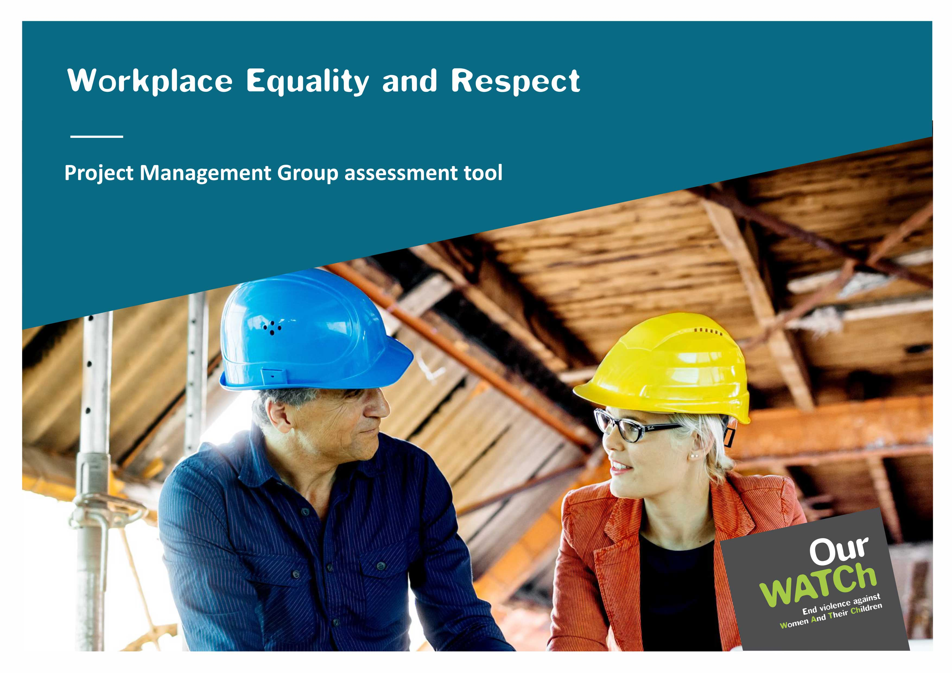

**Acknowledgements**

Our Watch acknowledges the Traditional Owners of the land across Australia on which we work and live. We pay our respects to Aboriginal and Torres Strait Islander peoples past and present, and we value Aboriginal and Torres Strait Islander histories, cultures, and knowledge.

Our Watch acknowledges the support of the Victorian Government and the Australian Government.

 Australian Government

© Our Watch 2022

# Table of contents

Introduction 4

1. Clarifying the role of the Project Management Group (PMG) 4

2. Policy checklist 4

3. Assessing your organisation against the five *Workplace Equality and Respect Standards*: 4

Workplace Equality and Respect *Project Management Group assessment tool* 5

1. Clarifying the role of the Project Management Group (PMG) 5

2. Policy Checklist 7

3. Assessing your organisation against the five *Workplace Equality and Respect Standards* 9

Next Steps 17

# Introduction

This tool is designed to support your organisation to establish a Workplace Equality and Respect Project Management Group (PMG) that will lead the roll out of workplace equality and respect processes and activities. This tool also guides the PMG through a reflection and assessment process against the five [*Workplace Equality and Respect Standards*](https://workplace.ourwatch.org.au/tools-and-resources/) to identify areas where you are already doing well, as well as opportunities for action. This tool has three sections:

## Clarifying the role of the PMG

* 1. The role of the PMG and its readiness to assess the organisation’s current practices against the five [*Workplace Equality and Respect Standards*](https://workplace.ourwatch.org.au/tools-and-resources/)
  2. Engaging employees to participate in workplace equality and respect processes and activities

## Policy checklist

A list of policies for the PMG to review and identify priority policy gaps to address during action planning.

## Assessing your organisation against the five *Workplace Equality and Respect Standards*:

The PMG is responsible for supporting the organisation in assessing current workplace practices against the five [*Workplace Equality and Respect Standards*](https://workplace.ourwatch.org.au/tools-and-resources/) listed below. The methods to achieve this will depend on the information required to make this assessment.

**Commitment:** We demonstrate an ongoing commitment to workplace gender equality and preventing sexual harassment and other forms of gender-based violence.

**Conditions:** We apply a gender lens to our workplace policies and practices to ensure they are fair and equitable.

**Culture:** We promote a workplace culture where all people feel safe, confident, and supported to actively challenge gender bias and discrimination, gender stereotypes and harmful gender norms without adverse consequences.

**Support:** We listen to, respect and support people who experience sexual harassment and gender-based violence (including domestic and family violence) through policies and practices that consider the impact of trauma.

**Core business:** We promote gender equality in our external engagement with customers, stakeholders, and the community.

# Workplace Equality and Respect *Project Management Group assessment tool*

This tool assists the Project Management Group (PMG) in assessing the organisation against the five [*Workplace Equality and Respect Standards*](https://workplace.ourwatch.org.au/tools-and-resources/)*.* This assessment forms part of the benchmarking and diagnostics step and should be completed before commencing employee focus groups. Ideally, this assessment process should take place after you have already collected critical workplace data, including information from:

* [*Workplace gender equality indicators*](https://workplace.ourwatch.org.au/tools-and-resources/)
* your organisation’s people survey and/or the [*People survey tool*](https://workplace.ourwatch.org.au/tools-and-resources/)
* other data that is useful to bring to the discussion, including Workplace Gender Equality Agency (WGEA) data and any organisational plans and policies related to gender equality, gender-based violence (including sexual harassment) and other forms of equality and inclusion.

You can use the above data to inform your answers against the five [*Workplace Equality and Respect Standards*](https://workplace.ourwatch.org.au/tools-and-resources/) and use the assessment process as an opportunity to consolidate and ‘dive deeper’ into the data. Remember that some questions may remain unanswered or incomplete – these should be noted in your actions section, which can help inform your actions planning process.

## Clarifying the role of the PMG

| * 1. **Roles and readiness to assess** | **Notes** |
| --- | --- |
| 1. Do you understand how the workplace equality and respect process works?   Yes  No |  |
| 1. Do you understand the five [*Workplace Equality and Respect* *Standards*](https://workplace.ourwatch.org.au/tools-and-resources/)?   Commitment  Conditions  Culture  Support  Core Business |  |
| 1. What roles will each member of the PMG take on?   Communications  Data collection  Reporting up / engaging leadership  Reporting to the broader organisation and participants  Logistical support  Other as identified by the PMG |  |
| 1. Have you collected sufficient data to assess your organisation adequately? For example:   Data on the workplace gender equality indicators  Data on the experiences of sexism/gender inequality  Data on gender-based violence (including sexual harassment)  Data on the diversity of employees’ experiences, including the intersection of gender with factors such as race, ethnicity, faith, ability, sexuality, and class |  |
| **Next steps for the PMG:** |  |
| **1.2 Engaging employees to lead and participate in the workplace equality and respect process** | **Notes** |
| 1. How and when will you communicate key messages from this project to all employees, senior leaders, and other executives? |  |
| 1. Employee focus groups:  * Who will facilitate the focus groups, and what resources are required? * How will you select participants? * Who are key stakeholders to engage? Consider a mix of key influencers, roles and individuals committed to progressing workplace gender equality. * What information do participants need to be prepared? |  |
| 1. What resistance or backlash might occur throughout the workplace equality and respect process? How will you manage this? |  |
| **Next steps for the PMG:** |  |

## Policy Checklist

This policy checklist, drawn from the Workplace Gender Equality Agency's [*Employer of Choice for Gender Equality Criteria*](https://www.wgea.gov.au/what-we-do/employer-of-choice-for-gender-equality), will prompt you to consider how gender equality is already integrated into existing policies and processes and identify gaps that may be addressed through the workplace equality and respect process.

| **We have a policy/policies/strategy in place supporting gender equality that covers:** | **Notes/next steps to address gaps** |
| --- | --- |
| Gender balance in leadership |  |
| Gender balance across the organization |  |
| Promotions |  |
| Performance review processes |  |
| Recruitment – internal and external recruitment consultants are provided with gender equality guidelines for the recruitment process |  |
| Restructures and significant operational changes, including planned redundancies |  |
| Independent contractors and casuals |  |
| Training for people managers on how to deal with potential fears and concerns about gender equality objectives/policies (e.g., resistance to gender equality initiatives) |  |
| A policy or strategy that includes learning and development, including leadership and/or career development training, for people of all genders |  |
| A remuneration policy and strategy that contains specific gender pay equity objectives |  |
| A policy and strategy to support employees with family and caring responsibilities |  |
| A policy or strategy to support those who are experiencing family or domestic violence |  |
| A flexible working policy and flexible working strategy |  |
| A policy on the prevention of gender-based harassment and discrimination, sexual harassment and bullying, with a formal grievance process in place |  |
| Procurement guidelines that encourage gender equality across the supply chain |  |

## Assessing your organisation against the five [*Workplace Equality and Respect Standards*](https://workplace.ourwatch.org.au/tools-and-resources/)

| 1. **Commitment:** We demonstrate an ongoing commitment to workplace gender equality and preventing sexual harassment and other forms of gender-based violence. | **Notes** |
| --- | --- |
| 1. **Leadershi**p:  * What commitment to undertaking workplace equality and respect has the senior leadership team made, and how will they continue to be involved? |  |
| 1. **Policy and practice:**  * Do you have a resourced strategy or plan to promote gender equality? If not, is there a commitment to developing one based on the outcomes of the workplace equality and respect process you are commencing? |  |
| 1. **Communications:**  * How do your internal and external communications currently reflect your commitment to gender equality (e.g., challenging gender stereotypes or promoting respectful behaviours)? * What is required to ensure gender equality is business as usual in communications? |  |
| 1. **Accountability and reporting:**  * How do senior leaders’ KPIs recognise and reward efforts to promote gender equality and prevent sexual harassment and other forms of gender-based violence? |  |
| **Additional considerations**   1. What is driving/motivating your organisation to implement workplace equality and respect? |  |
| 1. How do your organisational values and strategic plan frame or align with gender equality? |  |
| 1. How does the organisation currently report on progress made towards workplace gender equality? |  |

**Actions:** ______________________________________________________________

| 1. **Conditions:** We apply a gender lens to our workplace policies and practices to ensure they are fair and equitable. | **Notes** |
| --- | --- |
| 1. Leadership:  * How do leaders demonstrate an ongoing commitment to ensuring an intersectional gender lens is applied to policies, programs, and practices? What do leaders need to be able to do this consistently in the future? |  |
| 1. Policy and practice:  * How do people-focussed processes and practices (including recruitment, promotion, and remuneration) seek to eliminate bias? |  |
| 1. Accountability and reporting:  * What gender-disaggregated data is collected to regularly assess the progress of gender equality across the organisation? * What gender targets are already established? |  |
| **Additional considerations**   1. What support already exists specifically to support women’s leadership, including deliberate strategies to recruit, train, mentor and retain women? |  |
| 1. Can all employees access flexible work options (including part-time and job share)? Do leaders of all genders model and encourage flexible work options, including part-time, job share and parental leave? |  |
| 1. Do leaders of all genders model and encourage flexible work options, including part-time, job share and parental leave? |  |
| 1. Do all employees have access to parental leave (regardless of gender)? |  |
| 1. How does the organisation seek to identify and reduce the gender pay gap? |  |
| 1. Do all employees have access to domestic and family violence leave? |  |

**Actions:** ______________________________________________________________

| 1. **Culture:** We promote a workplace culture where all people feel safe, confident, and supported to actively challenge gender bias and discrimination, gender stereotypes and harmful gender norms without adverse consequences | **Notes** |
| --- | --- |
| 1. Leadership:  * Are leaders reflective of their behaviour in eliminating gendered stereotypes, including those that interact with ageism, racism, homophobia, and ableism? What would assist in improving this? * When leaders observe gendered and discriminatory behaviours in the workplace, how do they address them? |  |
| 1. Policy and practice:  * Is there a consistent organisational understanding of what constitutes gender inequality across the full spectrum of behaviours and attitudes? * Do people feel safe challenging gendered behaviours when they experience them from leaders and other employees? * How comfortable and safe do employees feel raising issues of gender inequality to HR / their leader? |  |
| 1. Communications:  * Do internal and external communications use inclusive language and images that proactively challenge stereotypes and harmful gender norms? * What else could be done (e.g., team meetings or internal communications)? |  |
| 1. Accountability and reporting:  * How do you collect employee feedback about their experiences and perspectives on gender equality, sexual harassment, and other forms of gender-based violence? * What happens with this information? Do you analyse it for gendered patterns or review workplace processes and practices? |  |
| **Additional considerations**   1. How are respectful and equal relationships modelled by employees and reflected in codes of conduct, work plans, performance plans or position descriptions? |  |
| 1. What workplace training on gender equality and preventing violence against women has already occurred in the workplace? Who has been trained? Who still needs training?   (It is recommended that all employees receive violence prevention and gender equality training. If training all employees is not possible, employees should receive communications with information and access to learning resources.) |  |
| 1. Have employees in the organisation participated in training/workshops on:  * Unconscious bias * Bystander interventions or * Gender equality * Workplace respect * Diversity and inclusion * Cultural competency   What are priority areas for training moving forward? |  |

**Actions:** ______________________________________________________________

| 1. **Support:** We listen to, respect and support people who experience sexual harassment and gender-based violence (including domestic and family violence) through policies and practices that consider the impact of trauma.) | **Notes** |
| --- | --- |
| 1. Policy and practice:  * What policies and procedures support people experiencing sexual harassment and domestic and family violence? Is the safety and well-being of the person impacted by this violence a central consideration? Do they include:   + Paid domestic and family violence leave   + Responding to disclosures policy and procedure safety plans * What safe and culturally appropriate referral pathways are provided to specialist support for people experiencing domestic and family violence, sexual harassment, or other forms of gender-based violence? |  |
| 1. People support and engagement:  * How are policies and procedures related to gender-based discrimination, sexual harassment, and domestic and family violence reviewed based on employee feedback? * How are employees who implement these policies and procedures supported to build their confidence and skills to apply them? Who has been trained, and who still needs to be trained? At a minimum, all line managers and HR teams must undertake training on gender equality, sexual harassment, and domestic and family violence. * How are managers and/or identified key contact employees trained to respond promptly and appropriately to disclosures and requests for support from our people experiencing domestic and family violence and sexual harassment? |  |
| 1. Communications:  * Are employees able to always access relevant policies easily - e.g., available on the internal website and shared in internal communications (intranet, newsletter, employee meetings, or emails)? |  |
| 1. Accountability and reporting:  * How are complaints regarding sexual harassment and workplace gender violence and subsequent response times tracked? Is this information analysed for trends or patterns? To whom is this information provided? |  |
| **Additional considerations**   1. What policies and procedures exist to support employees who disclose their experience/use of domestic and family violence appropriately and promptly? 2. What other workplace policies need to be reviewed or developed to ensure the safety of employees who disclose an experience of violence and in a way that aligns with preventing gender-based violence, e.g., bullying and OHS? |  |

**Actions:** ______________________________________________________________

| 1. **Core Business:** We promote gender equality in our external engagement with customers, stakeholders, and the community. | **Notes** |
| --- | --- |
| 1. Leadership:  * How does the organisation positively influence gender equality in engagements with clients, customers, suppliers, and the community? |  |
| 1. Policy and practice:  * How are community and customer-facing work reviewed to ensure that the allocation of resources supports men, women, and diverse gender identities equally and reflects a commitment to gender equality and preventing sexual harassment and other forms of gender-based violence? What are some additional opportunities to do this? |  |
| 1. People support and engagement:  * How do you actively support peers/partners to promote gender equality and prevent sexual harassment and other forms of gender-based violence by sharing the lessons learned from your efforts? |  |
| 1. Communications:  * How do stakeholder engagement activities, public statements and external communications reflect the commitment to promoting gender equality, rejecting sexism, and challenging attitudes that justify, minimise, trivialise or excuse sexual harassment and other forms of gender-based violence? |  |
| 1. Accountability and Reporting:  * What regular and public reporting occurs against gender equality indicators and efforts to prevent sexual harassment and other forms of gender-based violence? |  |
| **Additional considerations**   1. Do leaders regularly acknowledge their commitment to gender equality and the prevention of gender-based violence (e.g., public statements, ongoing external messaging, support of external campaigns, etc.)? |  |
| 1. When the workplace is represented in public events and forums, do you consider the diversity of representation (e.g., gender but also race, age, ability, sexual orientation, etc.)? |  |
| 1. Is gender (and other forms of) equality considered in decision-making about external partnerships/relationships? |  |
| 1. Are gender equality targets/goals built into your organisational strategies/plans/values? |  |
| 1. Have you recently supported or engaged with any campaigns or initiatives related to equity and diversity? |  |

**Actions:** ______________________________________________________________

## Next Steps

Once you have completed this assessment tool you can input critical reflections and actions into the [*Organisational snapshot template*](https://workplace.ourwatch.org.au/) to support your action planning process.