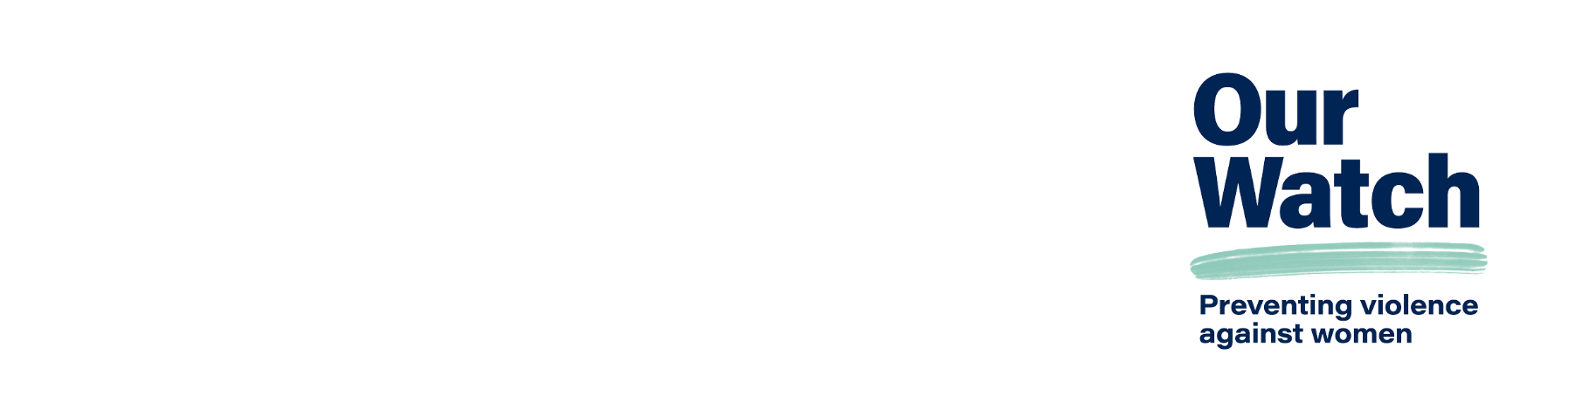

What drives sexual harassment   
in the workplace?

This resource provides information on the drivers of sexual harassment in workplace settings and additional workplace risk factors.

# What drives sexual harassment?

Violence against women, including sexual harassment, is preventable. Research shows that sexual harassment in workplaces is driven by gender inequality.

Stopping sexual harassment is not just about addressing the behaviour of individuals but about changing the culture and environment of the workplaces in which it occurs.

By understanding what drives sexual harassment and taking action to change the conditions that allow it to occur, you and your workplace can help create an Australia free from violence.

Our Watch’s [*Change the Story*](https://www.ourwatch.org.au/change-the-story) is an evidence-based framework for a coordinated and effective national approach to preventing violence against women, including sexual harassment. Change the Story has been recognised in many international contexts as a world-leading contribution to the prevention of violence against women and has inspired work towards similar approaches in other countries.

According to Change the Story, there are four drivers of sexual harassment:

* **Driver 1**: In workplaces, excusing or minimising violence against women and sexual harassment (e.g. dismissing women’s experiences of sexual harassment, or sexually suggestive comments, or jokes that intimidate or offend), or trying to justify why the violence occurred.
* **Driver 2**: Gender inequality in workplaces resulting in men dominating decision-making (e.g. gender pay gaps, lack of women in leadership, lack of respect for women, including women from marginalised groups).
* **Driver 3**: Rigid gender stereotyping which limits the ways people can express themselves (e.g. making assumptions that certain types of work are better suited for women or men).
* **Driver 4**: Male peer relations at work that disrespect women and each other (e.g. ‘locker-room talk’, unwanted touching, or sexual gestures, readily excusing a peer’s disrespectful behaviour, discouraged from taking a stand because they fear rejection by their peers).

**There are additional risk factors that increase the likelihood of sexual harassment, including:**

* Lack of diversity in workplaces can perpetuate toxic work environments. Alongside gender inequality, other forms of inequality and disadvantage also create power imbalances in the workplace. Power disparities also stem from various factors, including race, disability, age, visa status, economic vulnerability, geographic location and career stage. When there is less diversity in the workplace, people identifying with the dominant group hold more power – promoting groupthink and in-group bias. Dominant groups tend to apply stereotypes more readily, feel prejudice toward, and discriminate against those they see as different. One of the significant issues with the lack of diversity in the workplace is when sexual harassment occurs, the person experiencing the harassment might feel isolated, leading to an unwillingness to report issues. Safe-to-speak cultures are essential for reporting. Lack of reporting can create a hostile workplace as employees may assume that their workplace accepts discriminatory practices.
* Workplaces organised according to a hierarchical structure.
* A workplace culture that supports or tolerates sexual harassment, including where other forms of harassment are accepted. This can include microaggressions, bullying, small acts of disrespect and discrimination and reports of sexual harassment or inappropriate behaviours not being taken seriously.
* The use of alcohol in a work context and attendance at conferences and social events as part of work duties, including overnight travel.
* Workers who are isolated, in restrictive spaces like cars, working at residential premises, living in employer-provided accommodation, working from remote locations with limited supervision, or have restricted access to help and support.
* Working from home, which may provide an opportunity for sexual harassment to occur online or through phone communication.
* Worker interactions with clients, customers or members of the public (either face-to-face or online), which may give rise to third-party sexual harassment.
* Poor understanding among workplace leaders of the nature, drivers and impacts of sexual harassment.

# What can workplaces do to prevent sexualharassment?

With the introduction of the Respect@Work amendments (including the positive duty to take ‘reasonable and proportionate’ measures to eliminate sexual harassment and sex discrimination in the workplace), sexual harassment is now recognised as a risk and psychological hazard under workplace health and safety law. As an Australian workplace, you must demonstrate that your workplace has taken all reasonable and proportionate actions to mitigate the risk of sexual harassment. Failing to do so may make you liable for complaints and action through the Australian Human Rights Commission.

## Actions you can take to prevent sexual harassment in your workplace

### Action 1: Challenge sexism in the workplace

Example: Support your staff to be active bystanders who challenge attitudes and practices that justify or downplay inappropriate workplace behaviours.

### Action 2: Promote inclusive gender equality, safety and respect

Example: Increase the representation of women (with diverse backgrounds and life experiences) in formal and informal decision-making roles.

### Action 3: Challenge gender stereotyping

Example: Promote and support gender-equitable domestic and parenting practices through workplace initiatives.

### Action 4: Support and engage men to promote positive masculinities and supportive male peer relationships in workplaces

Example: Set up male allyship initiatives that promote representations of men modelling respectful, fair, ethical, safe and inclusive behaviours in the workplace.

# Further information and support

**For more information, tools and resources** on how to prevent sexual harassment in your workplace, visit [Our Watch – Workplace Equality and Respect](https://workplace.ourwatch.org.au) <workplace.ourwatch.org.au>

**For more information and frameworks on addressing sexual harassment as a workplace risk effectively**, visit [Our Watch – Practice guidance: Reducing risk in workplace initiatives to prevent violence against women](https://workplace.ourwatch.org.au/resource/practice-guidance-reducing-risk-in-workplace-initiatives-to-prevent-violence-against-women) <workplace.ourwatch.org.au/resource/practice-guidance-reducing-risk-in-workplace-initiatives-to-prevent-violence-against-women>

**For support, contact** Our Watch’s Workplace Team at [equalityandrespect@ourwatch.org.au](mailto:equalityandrespect@ourwatch.org.au)

# Acknowledgements

Our Watch acknowledges the Traditional Owners of the land across Australia on which we work and live. We pay our respects to Aboriginal and Torres Strait Islander peoples past and present, and we value Aboriginal and Torres Strait Islander histories, cultures, and knowledge.

Our Watch acknowledges the support of the Victorian Government and the Australian Government.

 Australian Government

© Our Watch 2024