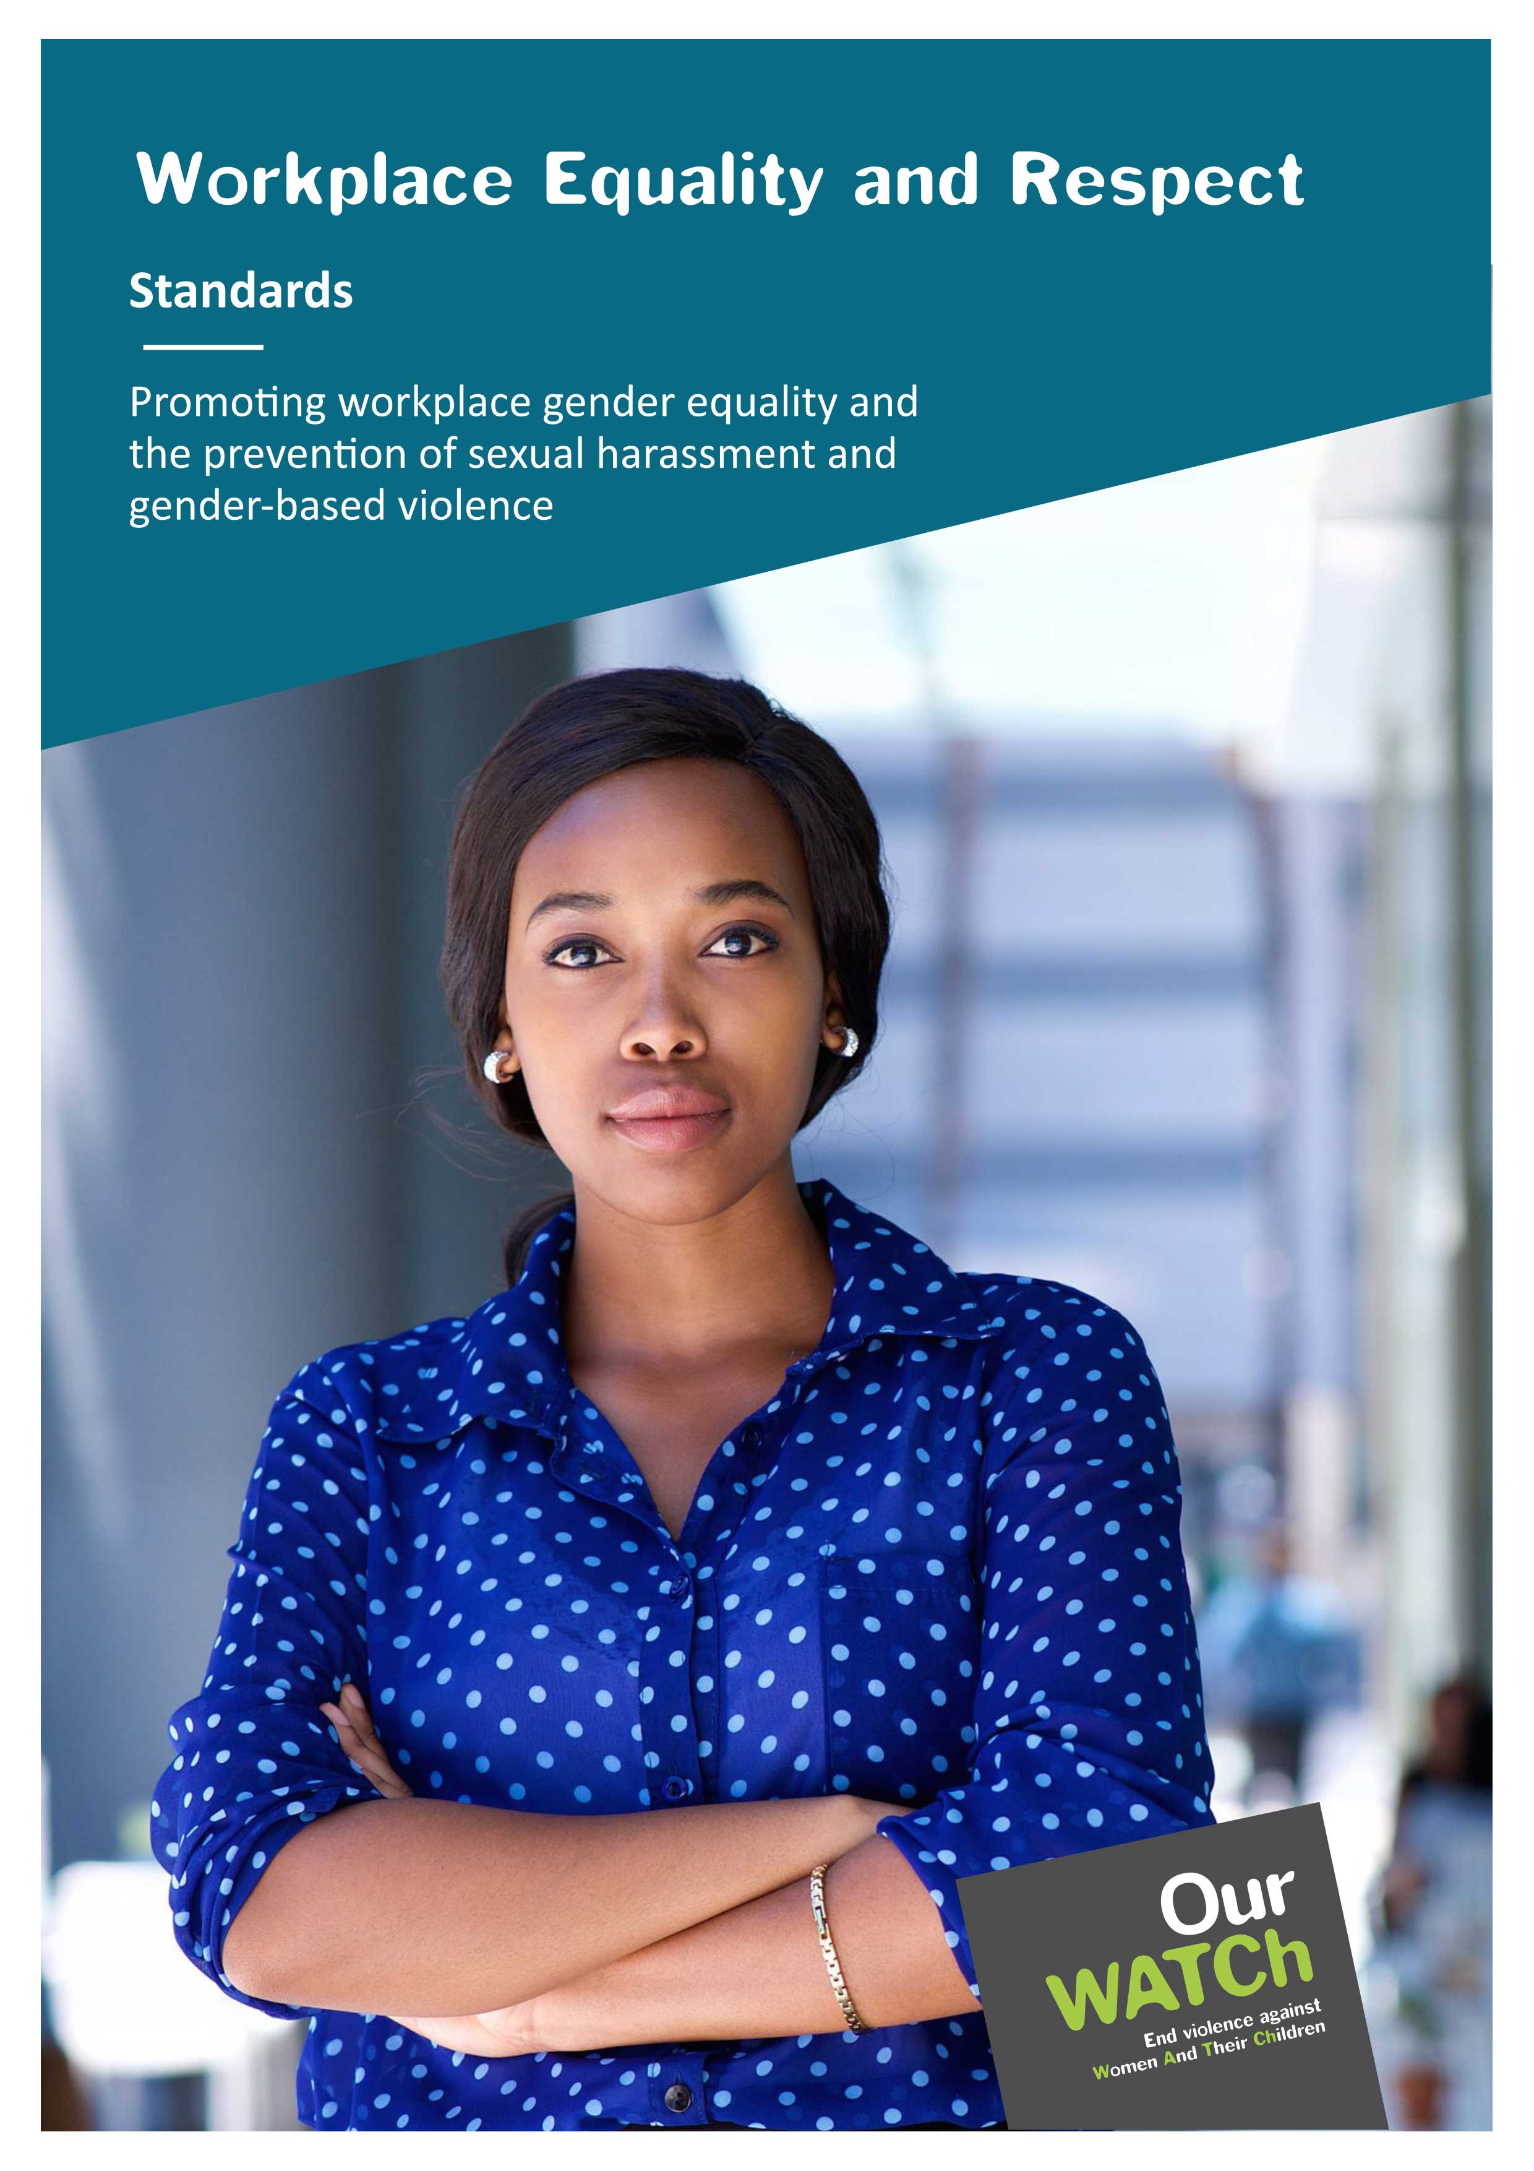

**Acknowledgements**

Our Watch acknowledges the Traditional Owners of the land across Australia on which we work and live. We pay our respects to Aboriginal and Torres Strait Islander peoples past and present, and we value Aboriginal and Torres Strait Islander histories, cultures, and knowledge.

Our Watch acknowledges the support of the Victorian Government and the Australian Government.

 Australian Government

© Our Watch 2022

# Introduction

Workplace Equality and Respect is a suite of tools and resources that supports organisations to promote workplace intersectional gender equality and prevent sexual harassment and other forms of gender-based violence (including domestic and family violence). These tools and resources are framed around five standards.

The *Workplace Equality and Respect Standards* take an intersectional approach to gender equality. An intersectional approach is ‘a lens, a prism, for seeing how various forms of inequality (resulting from, for example, sexism, racism, classism, ageism, ableism, immigration status etc.) often operate together and exacerbate each other.’[1]

## The five standards

**Commitment:** We demonstrate an ongoing commitment to workplace gender equality and preventing sexual harassment and other forms of gender-based violence.

**Conditions:** We apply a gender lens to our workplace policies and practices to ensure they are fair and equitable.

**Culture:** We promote a workplace culture where all people feel safe, confident, and supported to actively challenge gender bias and discrimination, gender stereotypes and harmful gender norms without adverse consequences.

**Support:** We listen to, respect and support people who experience sexual harassment and gender-based violence (including domestic and family violence) through policies and practices that consider the impact of trauma.

**Core business:** We promote gender equality in our external engagement with customers, stakeholders, and the community.

The standards are detailed below and can be used to identify areas of strength and opportunities for progress within your organisation.

### Commitment

We demonstrate an ongoing commitment to workplace gender equality and preventing sexual harassment and other forms of gender-based violence.

#### What does this look like?

* **Leadership:** Our leaders, including board members and senior executives, take responsibility for promoting gender equality and preventing sexual harassment and other forms of gender-based violence as a priority.
* **Policy and practice:** We have a resourced strategy/plan to promote gender equality that includes the prevention of sexual harassment and other forms of gender-based violence.
* **Communications:** We articulate our commitment to gender equality and expectations of workplace behaviour in all internal and external communications.
* **Accountability and reporting:** Our senior leaders’ key performance indicators (or equivalent performance assessment processes) recognise and reward efforts to promote gender equality and prevent sexual harassment and other forms of gender-based violence.

### Conditions

We apply a gender lens to our workplace policies and practices to ensure they are fair and equitable.

#### What does this look like?

* **Leadership:** Our leaders sponsor policies and procedures that support our commitment to gender equality and the prevention of sexual harassment and other forms of gender-based violence so employees of all genders feel safe and supported.
* **Policy and practice:** Our people management processes and practices (including recruitment, promotion, and remuneration) are transparent and seek to eliminate bias.
* **Accountability and reporting:** We benchmark, monitor, and promote key gender equality indicators in our organisation against clear goals/targets.

### Culture

We promote a workplace culture where all people feel safe, confident, and supported to actively challenge gender bias and discrimination, gender stereotypes and harmful gender norms without adverse consequences.

#### What does this look like?

* **Leadership:** Our leaders role model inclusive leadership and respect in all interactions.
* **People support and engagement:** Our people recognise and challenge harmful behaviours without fear of adverse consequences.
* **Communications:** Our internal and external communications use inclusive language and images that proactively challenge stereotypes and harmful gender norms.
* **Accountability:** We regularly listen to and act on feedback from our people about their experiences and perspectives on gender equality, sexual harassment, and other forms of gender-based violence.

### Support

We listen to, respect, and support people who experience sexual harassment and gender-based violence (including domestic and family violence) through policies and practices that consider the impact of trauma.

#### What does this look like?

**Policy and practice:**

* We have policies and procedures that support the safety and wellbeing of our people who have experienced sexual harassment and domestic and family violence.
* We provide appropriate referral pathways to specialist support for our people experiencing domestic and family violence, sexual harassment, or other forms of gender-based violence.

**People support and engagement:**

* We regularly review policies and procedures related to gender-based discrimination, sexual harassment, and domestic and family violence based on feedback from our people.
* We invest in building the awareness and confidence of our people in applying and following these policies and procedures.
* Our managers and/or identified key contact employees are trained to respond promptly and appropriately to requests for support and disclosures from our people experiencing domestic and family violence and sexual harassment.

**Communications:**

* Our policies and procedures are always easily accessible to all staff – e.g., available on the internal website and shared in internal communications (intranet, newsletter, employee meetings, or emails).

**Accountability and reporting:**

* We regularly monitor and track complaints regarding sexual harassment and workplace gender-based violence and response times.

### Core business

We promote gender equality in our external engagement with customers, stakeholders, and the community.

#### What does this look like?

* **Leadership:** Our leaders seek opportunities to positively influence gender equality in all our engagements with clients, customers, suppliers, and the communities with which we work.
* **Policy and practice:** We regularly review our service delivery and external corporate engagement to ensure they reflect our commitment to promoting gender equality and preventing sexual harassment and other forms of gender-based violence.
* **People support and engagement:** We actively support peers/partners to promote gender equality and prevent sexual harassment and other forms of gender-based violence by sharing the lessons we have learned from our efforts.
* **Communications:** Our stakeholder engagement activities, public statements and external communications reflect our commitment to promoting gender equality, rejecting sexism, and challenging attitudes that justify, minimise, trivialise, or excuse sexual harassment and other forms of gender-based violence.
* **Accountability and reporting:** We regularly and publicly report on our performance against gender equality indicators and our efforts to prevent sexual harassment and other forms of gender-based violence.

1. Steinmetz, K. (2020, February 20). She Coined the Term ‘Intersectionality’ Over 30 Years Ago. Here’s What It Means to Her Today. *Time Magazine*. <https://time.com/5786710/kimberle-crenshaw-intersectionality/>